**Name: Nidhi Pednekar**

**Class:D15B / 47**

**ADV DEVOPS PRAC 6**

**AIM: Creating S3 Bucket using terraform**

Prerequisite:

1. Install Atom Editor for Writing the Scripts from <https://atom.io/>
2. Must have an AWS Access Key ID and Secret Access Key

Step 1: Write a Terraform Script in Atom for creating S3 Bucket on Amazon AWS

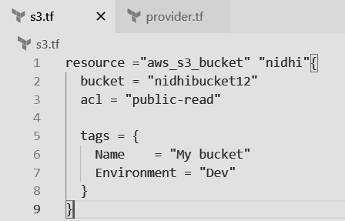

Create a new provider.tf file and write the following contents into it.

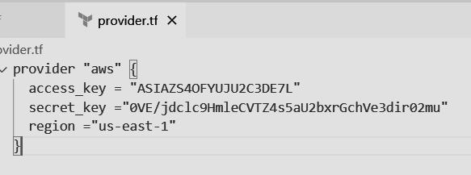

Save both the files in same directory Terraform_Scripts/S3

Step 2: Open Command Prompt and go to Terraform_Script\S3 directory where our .tf files are stored

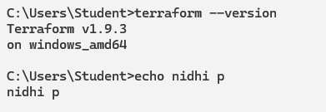

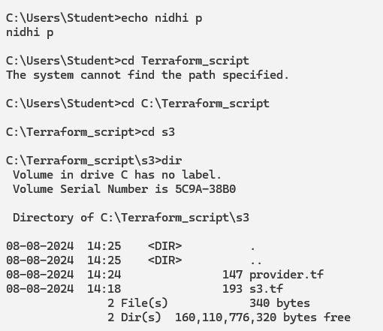

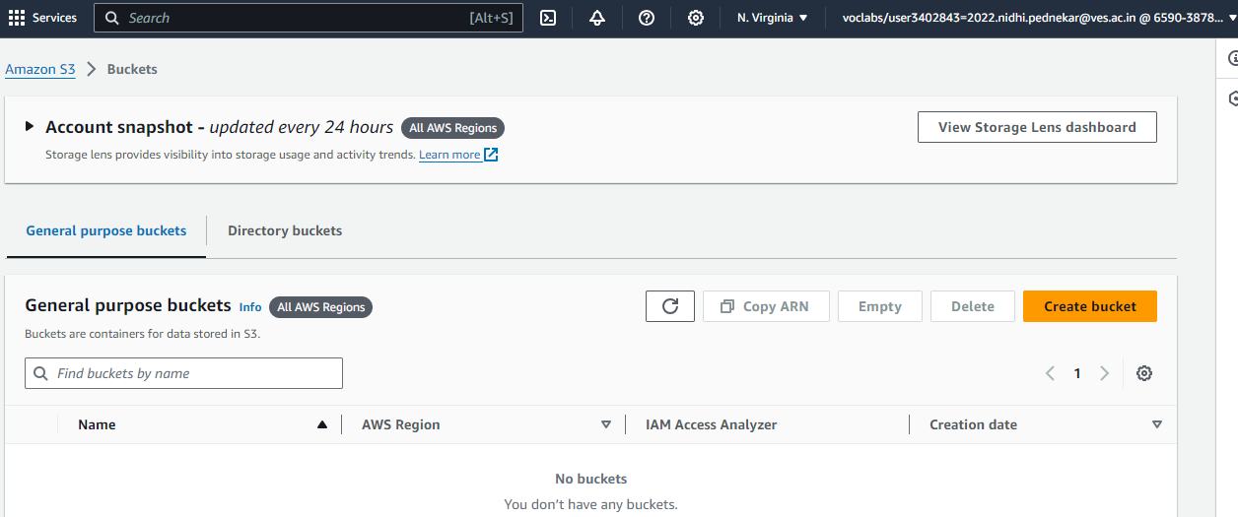

Step 3: Execute Terraform Init command to initialize the resources

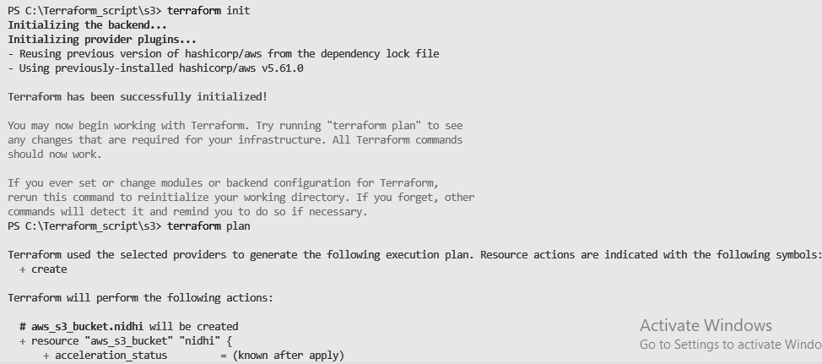

Step 4: Execute Terraform plan to see the available resources



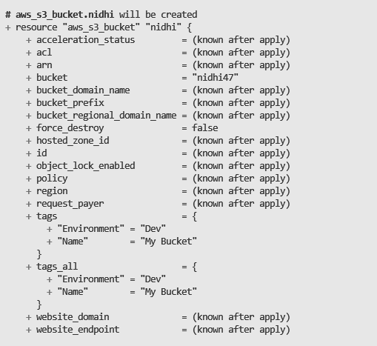

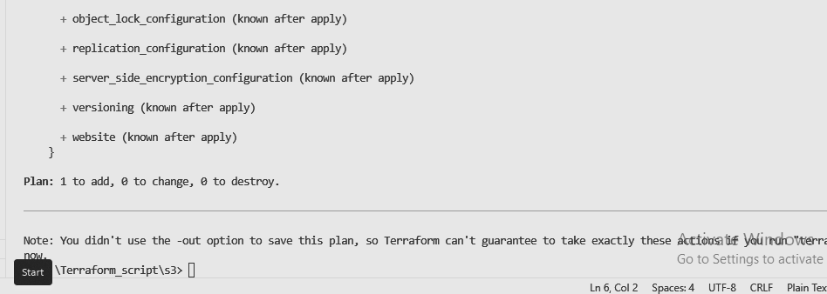

Step 5: Execute Terraform apply to apply the configuration, which will automatically create an S3 bucket based on our configuration.

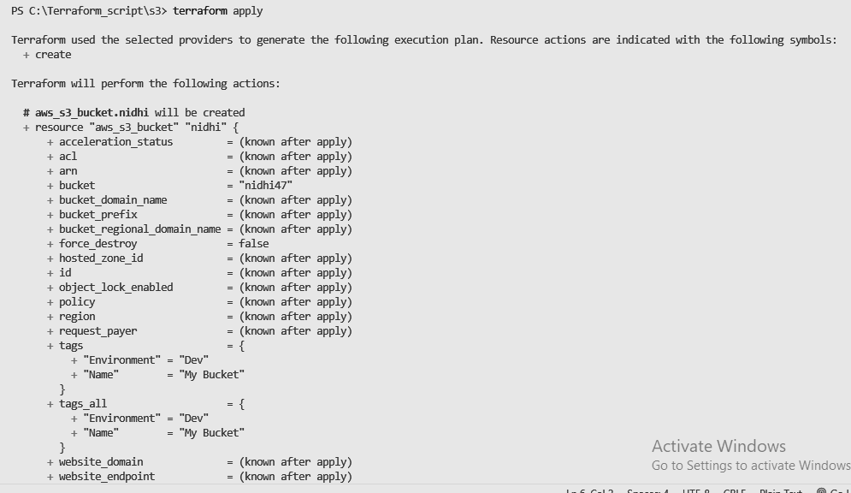

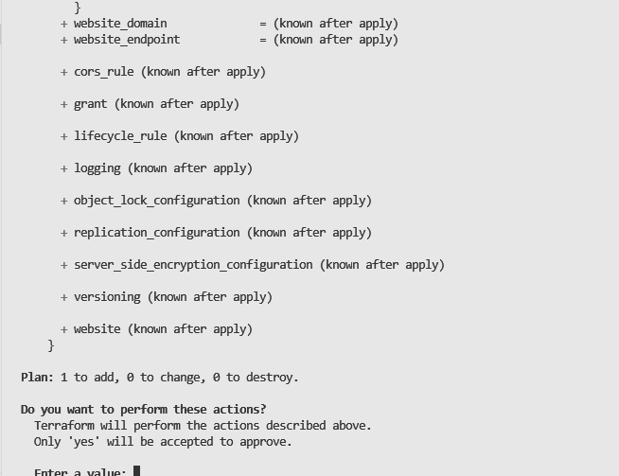

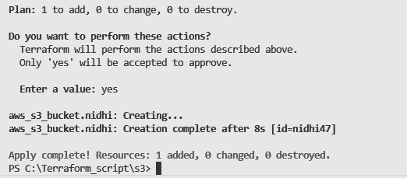

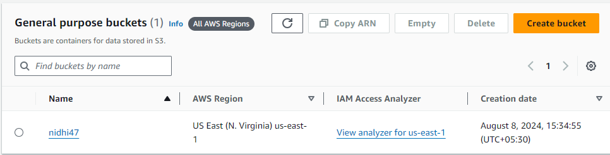

Step 6: Execute Terraform destroy to delete the configuration, which will automatically delete an EC2 instance

