**Nidhi Pednekar**

**D15B / 43**

**PWA EXP 11**

Aim: Use Lighthouse chrome extension to analyse the PWA for performance.

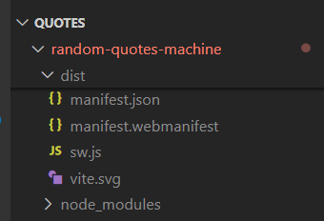

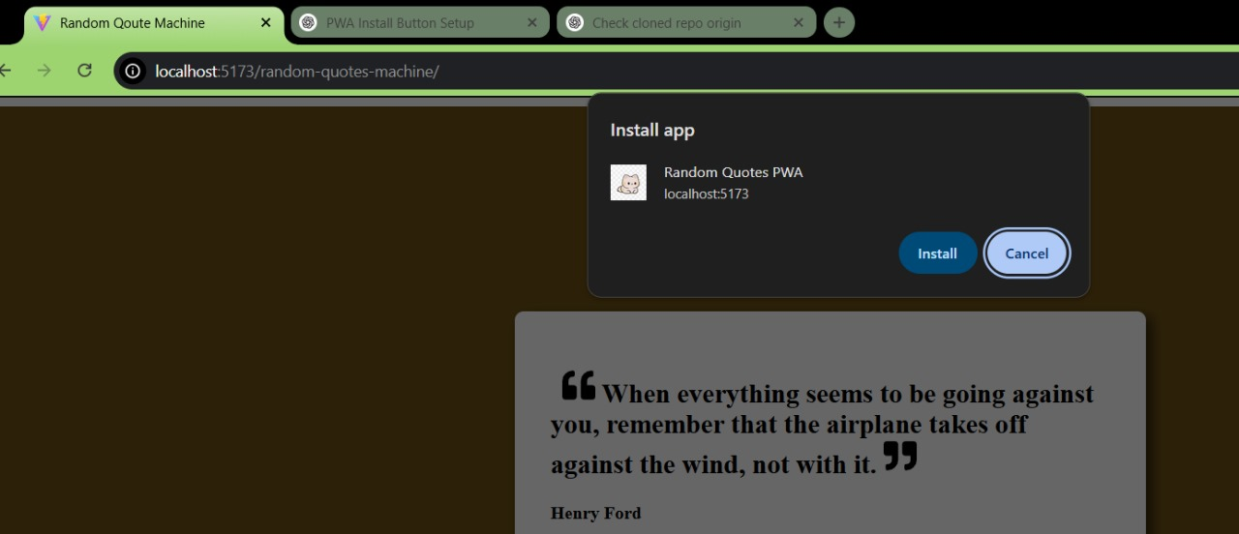

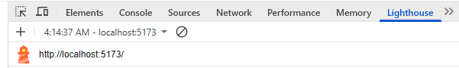

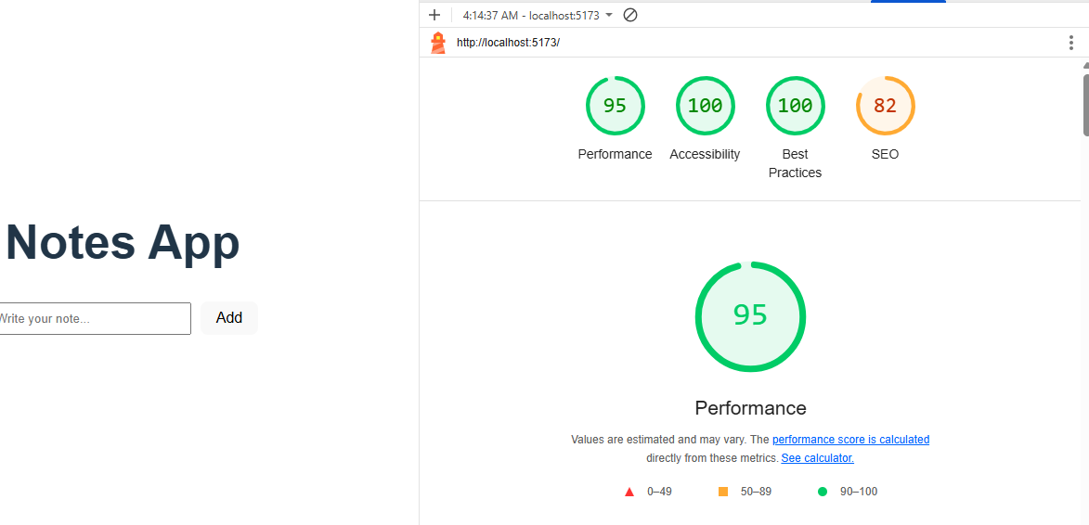

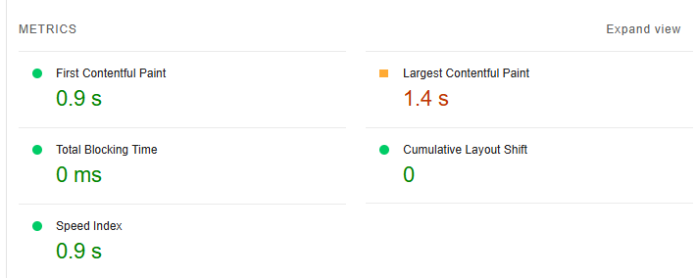

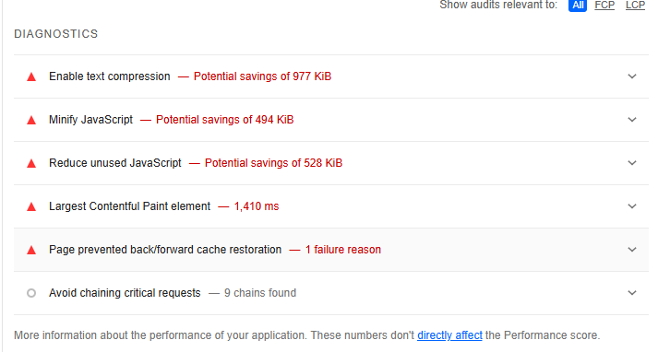

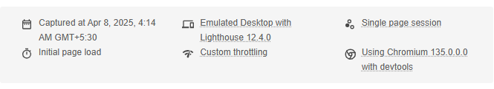

**Conclusion**: Thus we successfully used google Lighthouse PWA Analysis Tool for testing the PWA on various factors such as performance, Accessibility, and SEO.