**VISVESVARAYA TECHNOLOGICAL UNIVERSITY**

**“JNANA SANGAMA”, BELAGAVI-59001**



**A**

**Mini Project Report**

**On**

**VEHICLE PARKING MANAGEMENT**

**SUBMITTED IN PARTIAL FULFILLMENT OF THE REQUIREMENT IN 5TH SEMESTER,**

DATABASE LABORATORY WITH MINI PROJECT(17CSL58)

IN

**COMPUTER SCIENCE AND ENGINEERING**

**By**

**NIDHI ANAND DESHPANDE[1JB17CS084]**

**UNDER THE GUIDANCE OF**

**Dr.Srikantaiah K C**

**Professor**

**Dept. of CSE,SJBIT**

**Mrs.Rajatha**

**Asst. Prof.**

**Dept. of CSE, SJBIT**



**DEPARTMENT OF COMPUTER SCIENCE AND ENGINEERING**

**S.J.B INSTITUTE OF TECHNOLOGY**

**BGS HEALTH AND EDUCATION CITY**,**Kengeri-Bengaluru-560060**

**2019-2020**

**|| Jai Sri Gurudev ||**

**Sri AdichunchanagiriShikshana Trust ®**

**SJB INSTITUTE OF TECHNOLOGY**

BGS Health & Education City, Kengeri, Bengaluru – 560 060

**Department of Computer Science & Engineering**



**CERTIFICATE**

Certified that the Mini project work entitled “**VEHICLE PARKING MANAGEMENT**” carried out by **NIDHI ANAND DESHPANDE** bearing USN [**1JB17CS084]** is bonafide student of **SJB Institute of Technology** in partial fulfilment of mini project of 5th semester, DATABASE LABORATORY WITH MINI PROJECT(17CSL58) in **COMPUTER SCIENCE** as prescribed by **VISVESVARAYA TECHNOLOGICAL UNIVERSITY,BELAGAVI** during the academic year **2019-2020 .** It is certified that all corrections/suggestions indicated for Internal Assessment have been incorporated in the report deposited in the departmental library. The Mini project report has been approved as it satisfies the academic requirements in respect of Mini Project prescribed for the said degree.

**Dr.Srikantaiah K C Mrs.Rajatha**

**Professor Asst. Professor**

**Dept. Of CSE Dept. Of CSE**

**Dr.Krishna A.N**

**Professor & Head of**

**Dept. Of CSE,SJBIT**

**EXTERNAL EXAM**

**Name of Examiners Signature with Date**

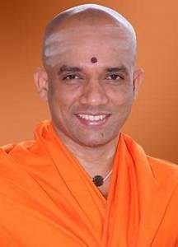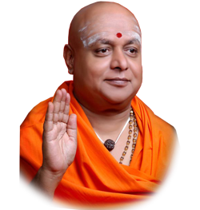



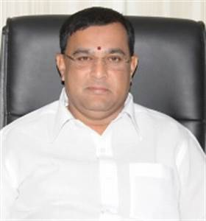

**ACKNOWLEDGEMENT**

I would like to express my gratitude to His Divine Soul **Jagadguru Padmabhushan Sri Sri Sri Dr.Balagangadharanatha MahaSwamiji**and His Holiness **Jagadguru Sri Sri Sri Dr.Nirmalanandanatha MahaSwamiji**for providing me an opportunity to pursue my academics in this esteemed institution.

I would like to express my profound thanks to **Reverend Sri Sri Sri Dr.Prakashnath Swamiji**, Managing Director, SJB Institute of Technology, for his continuous support inproviding amenities to carry out this mini project in this admired institution.

I express my gratitude to **Dr.Puttaraju**, Principal, SJB Institute of Technology, for providing an excellent facilities and academic ambience; which have helped me in satisfactory completion of mini project work.

I extend our sincere thanks to **Dr. KrishnaA N**, Head of the Department, Computer Science and Engineering; for providing an invaluable support throughout the period of mini project work.

I wish to express heartfelt gratitude to our **guides, Dr.Srikantaih K C and Mrs.Rajatha** for their valuable guidance, suggestions and cheerful encouragement during the entire period of this work.

Finally, we take this opportunity to extend our earnest gratitude and respect to our parents, Teaching & Non-teaching staffs of the department, the library staff and all our friends, who have directly or indirectly supported us during the period of this mini project work.

Regards,

**Nidhi Anand Deshpande**

**[1JB17CS084]**

**ABSTRACT**

The purpose of Vehicle parking Management is to automate the existing manual system by the help of computerizing equipments and full-fledged computer software, fulfilling requirements, so that their valuable data/information can be stored for a longer period with easy accessing and manipulation of the same. The required software and hardware are easily available and easy to work with.

Our project Parking Management includes login page to get into the home page, registering of users, parking the vehicle in particular place . Our software has the facility to park the vehicle and will get the bill according to the types of vehicles.

The Parking Management portal can be accessed using username and password of the user. The interface we have created is very user-friendly. Parking management, as described above, can lead to error free, secure, reliable and fast management system. It can assist the user to concentrate on their other activities rather to concentrate on the record keeping. Thus it will help organization in better utilization of resources. The organization can maintain computerized records without redundant entries. The data are well protected for personal use and makes the data processing very fast.

**Table of Contents**

Chapter 1  1

Introduction 1

1.1 Scope 1

1.2 Objective 1

Chapter 2 2

Literature Survey 2

2.1 Traditional File Systems 2

2.2 Pros and Cons of the Traditional Approach 2

2.3 Downfall of Traditional Management System 4

2.4 Introduction to the Database Management System 5

2.5 Indicative areas for the use of a DBMS 5

2.6 Advantages of a DBMS 6

2.7 Components of a DBMS 6

2.8 Relational Data model 7

2.9 ER to relational model mapping algorithm 8

2.10 Normalization 9

Chapter 3 11

System Requirements 11

3.1 Hardware Requirements 11

3.2 Software Requirements 11

Chapter 4 12

System Design 12

4.1 Schema Diagram 12

4.2 ER Diagram 13

4..3 Normal forms 14

Chapter 5 16

Implementation 16

5.1 HTML5 16

5.2 CSS  17

5.3 SQL (Structured Query Language) 17

5.4 Code Snippets 18

5.5 JSP 18

Chapter 6 20

Snapshots 20

6.1 The Home Page 20

6.2 The Register Form 20

6.3 The Park Form 21

6.4 Find Page 22

6.5 Bill Page 22

6.6 The Parked vehicle Page 23

6.7 Tables 23

6.8 Stored Procedure 27

6.9 Trigger 28

6.10 Testing 29

Chapter 7 30

Conclusion .30

Bibliography .31