**BLOOD BANK MANAGEMENT SYSTEM**

**TEAM MEMBERS:**

NIDHI RAI 4NM18CS103

IRAL LAVINA SALDANHA 4NM18CS066

**ABSTRACT**

The population of the world is multiplying with each coming year and so are the diseases and health issues. With an increase in the population there is an increase in the need of blood .The growth population of the world results in a lot of potential donor. There is a dire need of synchronisation between the blood banks, donors and hospital.

The blood bank management system project is designed to store , process, retrieve and analyse information concerned with the administrative and inventory management within a blood bank. This project aims at maintaining all the information pertaining to blood donors , different blood groups available in each blood bank and help them manage in a better way.

Here this system can collect blood from many donors. The blood group is analysed and stored. Later the blood is distributed to needy people who require blood.

**FRONT END**

# Hypertext Markup Language - The standard markup language for documents designed to be displayed in a web browser. It can be assisted by technologies such as Cascading Style Sheets (CSS) and scripting languages such as JavaScript.

# CSS Media Queries - A popular technique to deliver a tailored style sheet to desktops, laptops, tablets, and mobile phones by defining different style rules for different media types.

# Bootstrap - A front-end component library to build responsive, mobile-first websites. Bootstrap supports all major browsers except Internet Explorer 9.

# PHP - A server scripting language, and a powerful tool for making dynamic and interactive Web pages. PHP is a widely-used, free, and efficient alternative to competitors such as Microsoft's ASP.

**BACK END**

MySQL is a freely available open source Relational Database Management System (RDBMS) that uses Structured Query Language (SQL). SQL is the most popular language for adding, accessing and managing content in a database. It is most noted for its quick processing, proven reliability, ease and flexibility of use

**ER DIAGRAM**

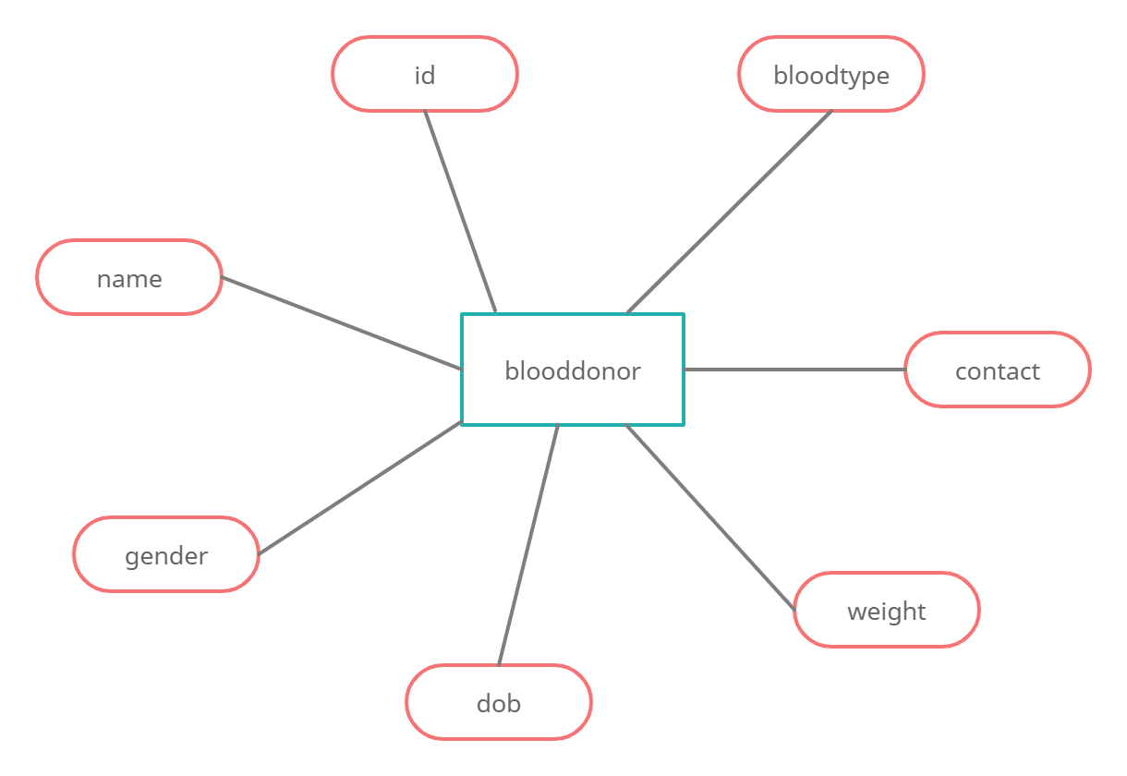

**RESULT**

