

(ISO 9001:2015 Certified), Accredited with ‘A’ Grade by NAAC

: 08258 - 281039 – 281263, Fax: 08258 – 281265

Report on Mini Project

“Simulation of Railway Station”

**Course Code: 18CS607**

**Course Name: Computer Graphics Lab**

**Semester: 6 Section: B**

**Submitted To:**

**Mr. Pradeep Kanchan**

**Assistant Professor Gd-III**

**Department of Computer Science and Engineering**

**NMAM Institute of Technology, Nitte**

**Submitted By :**

**Name: Nidhi Rai USN: 4NM18CS103**

**Name: Mahima Biswas USN: 4NM18CS087**

**Date of submission: 13/05/2021**

**Signature of Course Instructor**

**ABSTRACT**

Computer Graphics is a core technology in digital photography, film, video games, computer displays, and many specialized applications. Modelling, Geometric processing, rendering geometric transformation, visibility, simulation of light Animation of Lifelike characters, natural phenomena, their interactions and surrounding environments are some of the applications of Computer Graphics.

Simulation of Railway Station is a newly designed computer graphics mini project. This mini project begins with displaying a railway station and passengers waiting on the platform. When the signal turns red the train stops in the station and receives the passengers and departures when the signal is green. We also have night mode and day mode setup.

The project also consists of the train compartment which displays the interior along with the passengers. There are variety of scenic views like hills and rivers which can be changed as desired by the user. We have added music which enhances the overall project. This project is developed in C/C++ in Code Blocks. Keyboard and Mouse are the two input devices used which will also allow the user to interact with the application.

**TABLE OF CONTENTS**

**TITLE PAGE NO**

1. ABSTRACT 2
2. INTRODUCTION 4
3. IMPLEMENTATION 5 - 54
4. CONCLUSION 55
5. REFERENCE 56
6. APPENDIX 57 - 61

**INTRODUCTION**

Computer Graphics provides one of the most natural means of communicating with a computer, since our highly developed 2D and 3D pattern recognition abilities allow us to perceive and process pictorial data rapidly and efficiently. Interactive computer graphics is the most important means of producing pictures since the invention of photography and television. It has the added advantage that, with the computer, we can make pictures not only of concrete real-world objects but also of abstract, synthetic objects, such as mathematical surfaces and of data that have no inherent geometry, such as survey results.

OpenGL, short for “Open Graphics Library” is an application programming interface (API) designed for rendering 2D and 3D graphics. OpenGL was developed by Silicon Graphics Inc. (SGI) in 1992 and is widely used in CAD, virtual reality, scientific visualization, information visualization and flight simulation. It is also used in video games, where it competes with direct 3D on Microsoft Windows Platforms It provides a common set of commands that can be used to manage graphics in different applications and on multiple platforms.

OpenGL serves for two main purposes firstly, to hide the complexities of interfacing with different 3D accelerators, by presenting programmer with a single, uniform API. Secondly, to hide the differing capabilities of hardware platforms, by requiring that all implementations support the full OpenGL feature set. OpenGL has historically been influential on the development of 3D accelerator, promoting a base level of functionality that is now common in consumer level hardware.

**IMPLEMENTATION**

The project “Simulation of railway station” is created by using a set of functions for the respective components of the railway station.

**1: void display()** function displays the names in the introductory window:

void display(void)

{

glClear(GL_COLOR_BUFFER_BIT);

glColor3f(1.0,0.0,0.0);

drawstring(400,515,0.0,"Simulation of Railway Station");

glColor3f(1.0,0.0,0.0);

drawstring(250,280,0.0,"Mahima Biswas");

drawstring(250,250,0.0,"Nidhi Rai");

glColor3f(1.0,0.0,0.0);

drawstring(600,280,0.0,"4NM18CS087");

drawstring(600,250,0.0,"4NM18CS103");

drawstring(380,150,0.0,"*Click on this page and Press enter*");

glFlush();

}

**2: void man()** has the code for the men standing in platform and compartment.

void man()

{

face(320,271);

glColor3ub(0,0,0);

glBegin(GL_LINES);

glVertex2i(540-220,195+76);

glVertex2i(540-220,190+76); //nose

glVertex2i(531-220,200+76);

glVertex2i(537-220,200+76);//eyebrow

glVertex2i(543-220,200+76);

glVertex2i(549-220,200+76);//eyebrow

glEnd();

//ear right

glBegin(GL_POLYGON);

glColor3ub(255,191,128);

glVertex2i(540-14-220,194+1+76);

glVertex2i(540-14-220,190+1+76);

glVertex2i(538-14-220,189+1+76);

glVertex2i(538-14-220,195+1+76);

glEnd();

//ear left

glBegin(GL_POLYGON);

glColor3ub(255,191,128);

glVertex2i(554-220,195+76);

glVertex2i(556-220,196+76);

glVertex2i(556-220,191+76);

glVertex2i(554-220,190+76);

glEnd();

//hair

glBegin(GL_POLYGON);

glColor3ub(0,0,0);

glVertex2i(527-220,203+76);

glVertex2i(553-220,203+76);

glVertex2i(547-220,210+76);

glVertex2i(533-220,210+76);

glEnd();

// eyes

glBegin(GL_POLYGON);

glVertex2i(533-220,198+76);

glVertex2i(535-220,198+76);

glVertex2i(535-220,196+76);

glVertex2i(533-220,196+76);

glEnd();

glBegin(GL_POLYGON);

glVertex2i(545-220,198+76);

glVertex2i(547-220,198+76);

glVertex2i(547-220,196+76);

glVertex2i(545-220,196+76);

glEnd();

// mouth

glBegin(GL_POLYGON);

glVertex2i(535-220,187+76);

glVertex2i(540-220,185+76);

glVertex2i(545-220,187+76);

glVertex2i(540-220,187+76);

glEnd();

//beard

glBegin(GL_POLYGON);

glColor3ub(0,0,0);

glVertex2i(538-220,180+76);

glVertex2i(542-220,180+76);

glVertex2i(542-220,184+76);

glVertex2i(538-220,184+76);

glEnd();

glBegin(GL_POLYGON);

glVertex2i(575-220,153+76);

glVertex2i(556-220,138+76);

glVertex2i(556-220,145+76);

glVertex2i(567-220,154+76);

glEnd();

glBegin(GL_POLYGON);

glVertex2i(515-220,168+76);

glVertex2i(505-220,153+76);

glVertex2i(513-220,154+76);

glVertex2i(518-220,162+76);

glEnd();

glBegin(GL_POLYGON);

glVertex2i(505-220,153+76);

glVertex2i(524-220,138+76);

glVertex2i(524-220,145+76);

glVertex2i(513-220,154+76);

glEnd();

// belt

glBegin(GL_POLYGON);

glColor3ub(150,12,30);

glVertex2i(556-220,145+76);

glVertex2i(524-220,145+76);

glVertex2i(524-220,140+76);

glVertex2i(524-220,140+76);

glVertex2i(556-220,140+76);

glEnd();

// collar

glBegin(GL_POLYGON);

glColor3ub(200,140,110+76);

glVertex2i(529-220,180+76);

glVertex2i(551-220,180+76);

glVertex2i(546-220,170+76);

glVertex2i(534-220,170+76);

glEnd();

glBegin(GL_TRIANGLES);

glColor3ub(20,140,110);

glVertex2i(540-220,177+76);

glVertex2i(545-220,170+76);

glVertex2i(535-220,170+76);

glEnd();

//buttons

glColor3ub(0,0,0);

glPushMatrix();

glTranslate(540-220,165+76,0);

glutSolidTorus(1,1,100,90);

glPopMatrix();

glPushMatrix();

glTranslatef(540-220,158+76,0);

glutSolidTorus(1,1,100,90);

glPopMatrix();

glPushMatrix();

glTranslatef(540-220,151+76,0);

glutSolidTorus(1,1,100,90);

glPopMatrix();

// pant

glBegin(GL_POLYGON);

glColor3ub(80,80,230);

glVertex2i(555-220,140+76);

glVertex2i(525-220,140+76);

glVertex2i(520-220,105+76);

glVertex2i(530-220,105+76);

glVertex2i(533-220,138+76);

glVertex2i(550-220,105+76);

glVertex2i(560-220,105+76);

glEnd();

//shoe left

glBegin(GL_POLYGON);

glColor3ub(100,10,10);

glVertex2i(530-220,105+76);

glVertex2i(530-220,96+76);

glVertex2i(512-220,96+76);

glVertex2i(520-220,105+76);

glEnd();

//shoe right

glBegin(GL_POLYGON);

glColor3ub(100,10,10);

glVertex2i(550-220,105+76);

glVertex2i(550-220,96+76);

glVertex2i(568-220,96+76);

glVertex2i(560-220,105+76);

glEnd();

}

**3: void women()** function has the code of the women seen waiting on the platform. They are also present in the train compartment.

void women()

{

face(540,295);

glColor3ub(0,0,0);

glBegin(GL_LINES);

glVertex2i(540,294);

glVertex2i(540,290); //nose

glVertex2i(531,298);

glVertex2i(532,299);

glVertex2i(532,299);

glVertex2i(537,298);//eyebrow

glVertex2i(549,298);

glVertex2i(548,299);

glVertex2i(548,299);

glVertex2i(543,298);//eyebrow

glEnd();

//ear right

glBegin(GL_POLYGON);

glColor3ub(255,191,128);

glVertex2i(540-14,294+1);

glVertex2i(540-14,290+1);

glVertex2i(538-14,289+1);

glVertex2i(538-14,295+1);

glEnd();

//ear left

glBegin(GL_POLYGON);

glColor3ub(255,191,128);

glVertex2i(554,295);

glVertex2i(556,296);

glVertex2i(556,291);

glVertex2i(554,290);

glEnd();

//ear ring right

glBegin(GL_POLYGON);

glColor3ub(255,85,90);

glVertex2i(539-14,292);

glVertex2i(542-14,285);

glVertex2i(536-14,285);

glEnd();

//ear ring left

glBegin(GL_POLYGON);

glColor3ub(255,85,90);

glVertex2i(551,285);

glVertex2i(555,292);

glVertex2i(558,285);

glEnd();

//hair

glBegin(GL_POLYGON);

glColor3ub(0,0,0);

glVertex2i(525,299);

glVertex2i(549,309);

glVertex2i(540,312);

glVertex2i(528,307);

glEnd();

glBegin(GL_POLYGON);

glColor3ub(0,0,0);

glVertex2i(540,307);

glVertex2i(549,309);

glVertex2i(552,307);

glVertex2i(555,299);

glEnd();

// eyes

glBegin(GL_POLYGON);

glVertex2i(533,296);

glVertex2i(535,296);

glVertex2i(535,294);

glVertex2i(533,294);

glEnd();

glBegin(GL_POLYGON);

glVertex2i(545,296);

glVertex2i(547,296);

glVertex2i(547,294);

glVertex2i(545,294);

glEnd();

//mouth

glBegin(GL_POLYGON);

glColor3ub(150,50,50);

glVertex2i(534,287);

glVertex2i(540,284);

glVertex2i(546,287);

glVertex2i(540,285);

glEnd();

//shirt

glBegin(GL_POLYGON);

glColor3ub(204,0,204);

glVertex2i(529,280);

glVertex2i(551,280);

glVertex2i(566,269);

glVertex2i(561,260);

glVertex2i(556,265);

glVertex2i(556,245);

glVertex2i(524,245);

glVertex2i(524,265);

glVertex2i(519,260);

glVertex2i(514,269);

glEnd();

//neck

glBegin(GL_POLYGON);

glColor3ub(255,190,128);

glVertex2i(533,280);

glVertex2i(547,280);

glVertex2i(545,271);

glVertex2i(535,271);

glEnd();

//hands

glBegin(GL_POLYGON);

glColor3ub(255,191,128);

glVertex2i(565,268);

glVertex2i(575,253);

glVertex2i(567,254);

glVertex2i(562,262);

glEnd();

glBegin(GL_POLYGON);

glVertex2i(575,253);

glVertex2i(556,238);

glVertex2i(556,245);

glVertex2i(567,254);

glEnd();

glBegin(GL_POLYGON);

glVertex2i(515,268);

glVertex2i(505,253);

glVertex2i(513,254);

glVertex2i(518,262);

glEnd();

glBegin(GL_POLYGON);

glVertex2i(505,253);

glVertex2i(524,238);

glVertex2i(524,245);

glVertex2i(513,254);

glEnd();

// belt

glBegin(GL_POLYGON);

glColor3ub(0,0,0);

glVertex2i(556,245);

glVertex2i(524,245);

glVertex2i(524,240);

glVertex2i(556,240);

glEnd();

// leg

glBegin(GL_POLYGON);

glColor3ub(255,190,128);

glVertex2i(555,240);

glVertex2i(525,240);

glVertex2i(520,205);

glVertex2i(530,205);

glVertex2i(533,238);

glVertex2i(550,205);

glVertex2i(560,205);

glEnd();

//skirt

glBegin(GL_POLYGON);

glColor3ub(0,0,0);

glVertex2i(524,240);

glVertex2i(556,240);

glVertex2i(566,210);

glVertex2i(514,210);

glEnd();

//shoe left

glBegin(GL_POLYGON);

glColor3ub(180,0,0);

glVertex2i(530,205);

glVertex2i(530,196);

glVertex2i(528,196);

glVertex2i(528,204);

glVertex2i(522,196);

glVertex2i(512,196);

glVertex2i(520,205);

glEnd();

//shoe right

glBegin(GL_POLYGON);

glColor3ub(180,0,0);

glVertex2i(550,205);

glVertex2i(550,196);

glVertex2i(552,196);

glVertex2i(552,204);

glVertex2i(558,196);

glVertex2i(568,196);

glVertex2i(560,205);

glEnd();

}

**4: void draw_object()** is used to represent the railway station and its surroundings including trees, sky, people,day mode and night mode.

void draw_object()

{

int l;

if(day==1)

{

//sky

glColor3f(0.0,0.9,0.9);

glBegin(GL_POLYGON);

glVertex2f(0,380);

glVertex2f(0,700);

glVertex2f(1100,700);

glVertex2f(1100,380);

glEnd();

//sun

for(l=0;l<=35;l++)

{

glColor3f(1.0,0.9,0.0);

draw_circle(100,625,l);

}

//plane

if(plane==1)

{

glColor3f(1.0,1.0,1.0);

glBegin(GL_POLYGON);

glVertex2f(925+n,625+o);

glVertex2f(950+n,640+o);

glVertex2f(1015+n,640+o);

glVertex2f(1030+n,650+o);

glVertex2f(1050+n,650+o);

glVertex2f(1010+n,625+o);

glEnd();

glColor3f(0.8,0.8,0.8);

glBegin(GL_LINE_LOOP);

glVertex2f(925+n,625+o);

glVertex2f(950+n,640+o);

glVertex2f(1015+n,640+o);

glVertex2f(1030+n,650+o);

glVertex2f(1050+n,650+o);

glVertex2f(1010+n,625+o);

glEnd();

}

//cloud1

for(l=0;l<=20;l++)

{

glColor3f(1.0,1.0,1.0);

draw_circle(160+m,625,l);

}

for(l=0;l<=35;l++)

{

glColor3f(1.0,1.0,1.0);

draw_circle(200+m,625,l);

draw_circle(225+m,625,l);

}

for(l=0;l<=20;l++)

{

glColor3f(1.0,1.0,1.0);

draw_circle(265+m,625,l);

}

//cloud2

for(l=0;l<=20;l++)

{

glColor3f(1.0,1.0,1.0);

draw_circle(370+m,615,l);

}

for(l=0;l<=35;l++)

{

glColor3f(1.0,1.0,1.0);

draw_circle(410+m,615,l);

draw_circle(435+m,615,l);

draw_circle(470+m,615,l);

}

for(l=0;l<=20;l++)

{

glColor3f(1.0,1.0,1.0);

draw_circle(500+m,615,l);

}

//grass

glColor3f(0.0,0.9,0.0);

glBegin(GL_POLYGON);

glVertex2f(0,160);

glVertex2f(0,380);

glVertex2f(1100,380);

glVertex2f(1100,160);

glEnd();

}

else

{

//sky

glColor3f(0.0,0.0,0.0);

glBegin(GL_POLYGON);

glVertex2f(0,380);

glVertex2f(0,700);

glVertex2f(1100,700);

glVertex2f(1100,380);

glEnd();

//moon

int l;

for(l=0;l<=35;l++)

{

glColor3f(1.0,1.0,1.0);

draw_circle(100,625,l);

}

//star1

glColor3f(1.0,1.0,1.0);

glBegin(GL_TRIANGLES);

glVertex2f(575,653);

glVertex2f(570,645);

glVertex2f(580,645);

glVertex2f(575,642);

glVertex2f(570,650);

glVertex2f(580,650);

glEnd();

//star2

glColor3f(1.0,1.0,1.0);

glBegin(GL_TRIANGLES);

glVertex2f(975,643);

glVertex2f(970,635);

glVertex2f(980,635);

glVertex2f(975,632);

glVertex2f(970,640);

glVertex2f(980,640);

glEnd();

//comet

if(comet==1)

{

for(l=0;l<=7;l++)

{

glColor3f(1.0,1.0,1.0);

draw_circle(300+c,675,l);

}

glColor3f(1.0,1.0,1.0);

glBegin(GL_TRIANGLES);

glVertex2f(200+c,675);

glVertex2f(300+c,682);

glVertex2f(300+c,668);

glEnd();

}

//Plane

if(plane==1)

{

for(l=0;l<=1;l++)

{

glColor3f(1.0,0.0,0.0);

draw_circle(950+n,625+o,l);

glColor3f(1.0,1.0,0.0);

draw_circle(954+n,623+o,l);

}

}

//grass

glColor3f(0.0,0.3,0.0);

glBegin(GL_POLYGON);

glVertex2f(0,160);

glVertex2f(0,380);

glVertex2f(1100,380);

glVertex2f(1100,160);

glEnd();

}

//track boundary

glColor3f(1.0,1.0,1.0);

glBegin(GL_POLYGON);

glVertex2f(0,150);

glVertex2f(0,160);

glVertex2f(1100,160);

glVertex2f(1100,150);

glEnd();

//platform

glColor3f(0.560784,0.560784,0.737255);

glBegin(GL_POLYGON);

glVertex2f(0,160);

glVertex2f(0,250);

glVertex2f(1100,250);

glVertex2f(1100,160);

glEnd();

//table 1

glColor3f(1.0,0.498039,0.0);

glBegin(GL_POLYGON);

glVertex2f(140,190);

glVertex2f(140,210);

glVertex2f(155,210);

glVertex2f(155,190);

glEnd();

glColor3f(0.2,0.2,0.2);

glBegin(GL_POLYGON);

glVertex2f(130,210);

glVertex2f(130,215);

glVertex2f(225,215);

glVertex2f(225,210);

glEnd();

glColor3f(1.0,0.498039,0.0);

glBegin(GL_POLYGON);

glVertex2f(200,190);

glVertex2f(200,210);

glVertex2f(215,210);

glVertex2f(215,190);

glEnd();

//below track

glColor3f(0.623529,0.623529,0.372549);

glBegin(GL_POLYGON);

glVertex2f(0,0);

glVertex2f(0,150);

glVertex2f(1100,150);

glVertex2f(1100,0);

glEnd();

//Railway track

glColor3f(0.0,0.0,0.0);

glBegin(GL_POLYGON);

glVertex2f(-100,0);

glVertex2f(-100,20);

glVertex2f(1100,20);

glVertex2f(1100,0);

glEnd();

glBegin(GL_POLYGON);

glVertex2f(-100,80);

glVertex2f(-100,100);

glVertex2f(1100,100);

glVertex2f(1100,80);

glEnd();

//track bounbary

glColor3f(0.647059,0.164706,0.164706);

glBegin(GL_POLYGON);

glVertex2f(-100,100);

glVertex2f(-100,150);

glVertex2f(1100,150);

glVertex2f(1100,100);

glEnd();

//railway station boundary (fence)

glColor3f(0.647059,0.164706,0.164706);

glBegin(GL_POLYGON);

glVertex2f(0,250);

glVertex2f(0,310);

glVertex2f(5,320);

glVertex2f(10,310);

glVertex2f(10,250);

glEnd();

glBegin(GL_POLYGON);

glVertex2f(90,250);

glVertex2f(90,310);

glVertex2f(95,320);

glVertex2f(100,310);

glVertex2f(100,250);

glEnd();

glBegin(GL_POLYGON);

glVertex2f(140,250);

glVertex2f(140,310);

glVertex2f(145,320);

glVertex2f(150,310);

glVertex2f(150,250);

glEnd();

//tree 1

glColor3f(0.9,0.2,0.0);

glBegin(GL_POLYGON);

glVertex2f(50,185);

glVertex2f(50,255);

glVertex2f(65,255);

glVertex2f(65,185);

glEnd();

for(l=0;l<=30;l++)

{

glColor3f(0.0,0.5,0.0);

draw_circle(40,250,l);

draw_circle(80,250,l);

}

for(l=0;l<=25;l++)

{

glColor3f(0.0,0.5,0.0);

draw_circle(50,290,l);

draw_circle(70,290,l);

}

for(l=0;l<=20;l++)

{

glColor3f(0.0,0.5,0.0);

draw_circle(60,315,l);

}

//railway station

glColor3f(0.647059,0.164706,0.164706);

glBegin(GL_POLYGON);

glVertex2f(400,250);

glVertex2f(400,450);

glVertex2f(950,450);

glVertex2f(950,250);

glEnd();

//roof

glColor3f(0.556863,0.419608,0.137255);

glBegin(GL_POLYGON);

glVertex2f(350,450);

glVertex2f(450,500);

glVertex2f(900,500);

glVertex2f(1000,450);

glEnd();

//window 1

glColor3f(0.196078,0.6,0.8);

glBegin(GL_POLYGON);

glVertex2f(450,300);

glVertex2f(450,375);

glVertex2f(550,375);

glVertex2f(550,300);

glEnd();

glColor3f(0.0,0.0,0.0);

glBegin(GL_LINES);

glVertex2f(450,337.5);

glVertex2f(550,337.5);

glEnd();

glColor3f(0.0,0.0,0.0);

glBegin(GL_LINES);

glVertex2f(500,375);

glVertex2f(500,300);

glEnd();

//window 2

glColor3f(0.196078,0.6,0.8);

glBegin(GL_POLYGON);

glVertex2f(800,300);

glVertex2f(800,375);

glVertex2f(900,375);

glVertex2f(900,300);

glEnd();

glColor3f(0.0,0.0,0.0);

glBegin(GL_LINES);

glVertex2f(800,337.5);

glVertex2f(900,337.5);

glEnd();

glColor3f(0.0,0.0,0.0);

glBegin(GL_LINES);

glVertex2f(850,375);

glVertex2f(850,300);

glEnd();

//door

glColor3f(0.329412,0.329412,0.329412);

glBegin(GL_POLYGON);

glVertex2f(625,250);

glVertex2f(625,375);

glVertex2f(725,375);

glVertex2f(725,250);

glEnd();

//signal

glColor3f(1.0,0.0,0.0);

glBegin(GL_POLYGON);

glVertex2f(1060,160);

glVertex2f(1060,350);

glVertex2f(1070,350);

glVertex2f(1070,160);

glEnd();

glColor3f(0.7,0.7,0.7);

glBegin(GL_POLYGON);

glVertex2f(1040,350);

glVertex2f(1040,500);

glVertex2f(1090,500);

glVertex2f(1090,350);

glEnd();

for(l=0;l<=20;l++)

{

glColor3f(0.0,0.0,0.0);

draw_circle(1065,475,l);

glColor3f(1.0,1.0,0.0);

draw_circle(1065,425,l);

glColor3f(0.0,0.0,0.0);

draw_circle(1065,375,l);

}

man();

if(man_show==1){

women();

}

if(train==1)

{

//train carrier 2

glColor3f(255.0,255.0,0.0);

glBegin(GL_POLYGON);

glVertex2f(-150+i-xm,50);

glVertex2f(-150+i-xm,300);

glVertex2f(-550+i-xm,300);

glVertex2f(-550+i-xm,50);

glEnd();

//top

glColor3f(0.309804,0.184314,0.184314);

glBegin(GL_POLYGON);

glVertex2f(-140+i-xm,300);

glVertex2f(-140+i-xm,310);

glVertex2f(-560+i-xm,310);

glVertex2f(-560+i-xm,300);

glEnd();

// carrier 2 Wheels

for(l=0;l<50;l++)

{

glColor3f(0.35,0.16,0.14);

draw_circle(-225+i-xm,50,l);

draw_circle(-475+i-xm,50,l);

}

// train carrier 1

glColor3f(0.258824,0.435294,0.258824);

glBegin(GL_POLYGON);

glVertex2f(300+i-xm,50);

glVertex2f(300+i-xm,300);

glVertex2f(-100+i-xm,300);

glVertex2f(-100+i-xm,50);

glEnd();

//top

glColor3f(0.309804,0.184314,0.184314);

glBegin(GL_POLYGON);

glVertex2f(310+i-xm,300);

glVertex2f(310+i-xm,310);

glVertex2f(-110+i-xm,310);

glVertex2f(-110+i-xm,300);

glEnd();

// Windows

glColor3f(1.0,1.0,1.0);

glBegin(GL_POLYGON);

glVertex2f(75+i-xm,175);

glVertex2f(75+i-xm,285);

glVertex2f(-85+i-xm,285);

glVertex2f(-85+i-xm,175);

glEnd();

glBegin(GL_POLYGON);

glVertex2f(285+i-xm,175);

glVertex2f(285+i-xm,285);

glVertex2f(125+i-xm,285);

glVertex2f(125+i-xm,175);

glEnd();

// carrier 1 Wheels

for(l=0;l<50;l++)

{

glColor3f(0.35,0.16,0.14);

draw_circle(-25+i-xm,50,l);

draw_circle(225+i-xm,50,l);

}

//train base

glColor3f(0.196078,0.6,0.8);

glBegin(GL_POLYGON);

glVertex2f(350+i-xm,50);

glVertex2f(350+i-xm,125);

glVertex2f(755+i-xm,125);

glVertex2f(820+i-xm,50);

glEnd();

//train control chamber

glColor3f(1.0,0.25,0.0);

glBegin(GL_POLYGON);

glVertex2f(360+i-xm,125);

glVertex2f(360+i-xm,325);

glVertex2f(560+i-xm,325);

glVertex2f(560+i-xm,125);

glEnd();

//train top

glColor3f(0.309804,0.184314,0.184314);

glBegin(GL_POLYGON);

glVertex2f(350+i-xm,325);

glVertex2f(350+i-xm,350);

glVertex2f(570+i-xm,350);

glVertex2f(570+i-xm,325);

glEnd();

//train engine

glColor3f(1.0,0.5,0.0);

glBegin(GL_POLYGON);

glVertex2f(560+i-xm,125);

glVertex2f(560+i-xm,225);

glVertex2f(755+i-xm,225);

glVertex2f(755+i-xm,125);

glEnd();

glColor3f(0.0,0.0,0.0);

glBegin(GL_POLYGON);

glVertex2f(580+i-xm,125);

glVertex2f(580+i-xm,225);

glVertex2f(590+i-xm,225);

glVertex2f(590+i-xm,125);

glEnd();

glColor3f(0.0,0.0,0.0);

glBegin(GL_POLYGON);

glVertex2f(600+i-xm,125);

glVertex2f(600+i-xm,225);

glVertex2f(610+i-xm,225);

glVertex2f(610+i-xm,125);

glEnd();

//train smoke

glColor3f(0.196078,0.6,0.9);

glBegin(GL_POLYGON);

glVertex2f(650+i-xm,225);

glVertex2f(650+i-xm,275);

glVertex2f(700+i-xm,275);

glVertex2f(700+i-xm,225);

glEnd();

glColor3f(0.309804,0.184314,0.184314);

glBegin(GL_POLYGON);

glVertex2f(640+i-xm,275);

glVertex2f(640+i-xm,300);

glVertex2f(710+i-xm,300);

glVertex2f(710+i-xm,275);

glEnd();

//train head-light

glColor3f(1.0,1.0,0.0);

glBegin(GL_POLYGON);

glVertex2f(755+i-xm,225);

glVertex2f(765+i-xm,225);

glVertex2f(765+i-xm,185);

glVertex2f(755+i-xm,185);

glEnd();

glColor3f(0.0,0.0,0.0);

glBegin(GL_POLYGON);

glVertex2f(755+i-xm,225);

glVertex2f(785+i-xm,225);

glVertex2f(755+i-xm,205);

glEnd();

//Railway Station Board

glColor3f(0.435294,0.258824,0.258824);

glBegin(GL_POLYGON);

glVertex2f(560,510);

glVertex2f(560,540);

glVertex2f(580,550);

glVertex2f(780,550);

glVertex2f(800,540);

glVertex2f(800,510);

glEnd();

glColor3f(1.0,1.0,1.0);

glRasterPos2f(570,520);

declare("RAILWAY STATION");

glFlush();}

**5: void train_comp()** represents the interior of the train having windows, seating arrangements and the passengers

void train_comp()

{ int l;

//base

glColor3f(0.6, 0.6, 0.6);

glBegin(GL_POLYGON);

glVertex2f(0,0);

glVertex2f(400,360);

glVertex2f(700,360);

glVertex2f(1100,0);

glEnd();

//borderbase

glColor3f(0.0,0.0,0.0);

glBegin(GL_POLYGON);

glVertex2f(400,350);

glVertex2f(400,360);

glVertex2f(700,360);

glVertex2f(700,350);

glEnd();

//front

glColor3f(0.6, 0.6, 0.6);

glBegin(GL_POLYGON);

glVertex2f(400,360);

glVertex2f(400,1250);

glVertex2f(700,360);

glVertex2f(700,1250);

glEnd();

//borderfront1

glColor3f(0.0,0.0,0.0);

glBegin(GL_POLYGON);

glVertex2f(390,350);

glVertex2f(390,1250);

glVertex2f(400,350);

glVertex2f(400,1250);

glEnd();

//borderfront2

glColor3f(0.0,0.0,0.0);

glBegin(GL_POLYGON);

glVertex2f(700,350);

glVertex2f(700,1250);

glVertex2f(710,1250);

glVertex2f(710,350);

glEnd();

//left

glColor3f(0.0, 0.4, 1.0);

glBegin(GL_POLYGON);

glVertex2f(0,0);

glVertex2f(0,1250);

glVertex2f(390,1250);

glVertex2f(390,350);

glEnd();

//right

glColor3f(0.0, 0.4, 1.0);

glBegin(GL_POLYGON);

glVertex2f(710,350);

glVertex2f(710,1250);

glVertex2f(1100,1250);

glVertex2f(1100,0);

glEnd();

//Left window 1

//blue

glColor3f(0.0, 255.0, 1.0);

glBegin(GL_POLYGON);

glVertex2f(20,275);

glVertex2f(20,500);

glVertex2f(155,575);

glVertex2f(155,380);

glEnd();

//white

glColor3f(1.0,1.6,1.8);

glBegin(GL_POLYGON);

glVertex2f(25,300);

glVertex2f(25,475);

glVertex2f(150,550);

glVertex2f(150,395);

glEnd();

//tree 1

glColor3f(0.9,0.2,0.0);

glBegin(GL_POLYGON);

glVertex2f(70,335);

glVertex2f(70,400);

glVertex2f(90,400);

glVertex2f(90,350);

glEnd();

for(l=0;l<=30;l++)

{

glColor3f(0.0,0.5,0.0);

draw_circle(60,400,l);

draw_circle(100,400,l);

}

for(l=0;l<=25;l++)

{

glColor3f(0.0,0.5,0.0);

draw_circle(70,440,l);

draw_circle(90,440,l);

}

for(l=0;l<=20;l++)

{

glColor3f(0.0,0.5,0.0);

draw_circle(80,470,l);

}

//Left grills 1

glColor3f(0.0,0.0,0.0);

glBegin(GL_LINES);

glVertex2f(25,350);

glVertex2f(150,435);

glEnd();

glColor3f(0.0,0.0,0.0);

glBegin(GL_LINES);

glVertex2f(25,390);

glVertex2f(150,475);

glEnd();

glColor3f(0.0,0.0,0.0);

glBegin(GL_LINES);

glVertex2f(25,430);

glVertex2f(150,515);

glEnd();

//Right window 1

//blue

glColor3f(0.0, 255.0, 1.0);

glBegin(GL_POLYGON);

glVertex2f(930,380);

glVertex2f(930,570);

glVertex2f(1070,500);

glVertex2f(1070,275);

glEnd();

//white

glColor3f(1.0,1.6,1.8);

glBegin(GL_POLYGON);

glVertex2f(940,390);

glVertex2f(940,545);

glVertex2f(1060,480);

glVertex2f(1060,305);

glEnd();

//tree

glColor3f(0.9,0.2,0.0);

glBegin(GL_POLYGON);

glVertex2f(990,355);

glVertex2f(990,455);

glVertex2f(1010,455);

glVertex2f(1010,340);

glEnd();

for(l=0;l<=30;l++)

{

glColor3f(0.0,0.5,0.0);

draw_circle(980,420,l);

draw_circle(1020,410,l);

}

for(l=0;l<=25;l++)

{

glColor3f(0.0,0.5,0.0);

draw_circle(990,450,l);

draw_circle(1010,450,l);

}

for(l=0;l<=20;l++)

{

glColor3f(0.0,0.5,0.0);

draw_circle(1000,480,l);

}

//right grills 1

glColor3f(0.0,0.0,0.0);

glBegin(GL_LINES);

glVertex2f(940,500);

glVertex2f(1060,435);

glEnd();

glColor3f(0.0,0.0,0.0);

glBegin(GL_LINES);

glVertex2f(940,465);

glVertex2f(1060,400);

glEnd();

glColor3f(0.0,0.0,0.0);

glBegin(GL_LINES);

glVertex2f(940,430);

glVertex2f(1060,360);

glEnd();

//seats 7 left3

glPushMatrix();

glTranslatef(-10,-100,0);

glColor3f(0.647059,0.164706,0.164706);

glBegin(GL_POLYGON);

glVertex2f(300,350);

glVertex2f(310,410);

glVertex2f(470,410);

glVertex2f(480,350);

glEnd();

glColor3f(0.647059,0.164706,0.164706);

glBegin(GL_POLYGON);

glVertex2f(300,350);

glVertex2f(280,330);

glVertex2f(460,330);

glVertex2f(480,350);

glEnd();

//seat legs

glColor3f(0,0,0);

glBegin(GL_LINES);

glVertex2f(480,350);

glVertex2f(480,300);

glEnd();

glColor3f(0,0,0);

glBegin(GL_LINES);

glVertex2f(460,330);

glVertex2f(460,300);

glEnd();

glColor3f(0,0,0);

glBegin(GL_LINES);

glVertex2f(280,330);

glVertex2f(280,280);

glEnd();

glColor3f(0,0,0);

glBegin(GL_LINES);

glVertex2f(300,330);

glVertex2f(300,300);

glEnd();

glPopMatrix();

man();

women();

//seats 8 right4

glPushMatrix();

glTranslatef(280,0,0);

glColor3f(0.647059,0.164706,0.164706);

glBegin(GL_POLYGON);

glVertex2f(300,350);

glVertex2f(310,410);

glVertex2f(470,410);

glVertex2f(480,350);

glEnd();

glColor3f(0.647059,0.164706,0.164706);

glBegin(GL_POLYGON);

glVertex2f(300,350);

glVertex2f(280,330);

glVertex2f(460,330);

glVertex2f(480,350);

glEnd();

//seat legs

glColor3f(0,0,0);

glBegin(GL_LINES);

glVertex2f(480,350);

glVertex2f(480,300);

glEnd();

glColor3f(0,0,0);

glBegin(GL_LINES);

glVertex2f(460,330);

glVertex2f(460,300);

glEnd();

glColor3f(0,0,0);

glBegin(GL_LINES);

glVertex2f(280,330);

glVertex2f(280,280);

glEnd();

glColor3f(0,0,0);

glBegin(GL_LINES);

glVertex2f(300,330);

glVertex2f(300,300);

glEnd();

glPopMatrix();

//seats 1 right3

glPushMatrix();

glTranslatef(330,-100,0);

glColor3f(0.647059,0.164706,0.164706);

glBegin(GL_POLYGON);

glVertex2f(300,350);

glVertex2f(310,410);

glVertex2f(470,410);

glVertex2f(480,350);

glEnd();

glColor3f(0.647059,0.164706,0.164706);

glBegin(GL_POLYGON);

glVertex2f(300,350);

glVertex2f(280,330);

glVertex2f(460,330);

glVertex2f(480,350);

glEnd();

//seat legs

glColor3f(0,0,0);

glBegin(GL_LINES);

glVertex2f(480,350);

glVertex2f(480,300);

glEnd();

glColor3f(0,0,0);

glBegin(GL_LINES);

glVertex2f(460,330);

glVertex2f(460,310);

glEnd();

glColor3f(0,0,0);

glBegin(GL_LINES);

glVertex2f(280,330);

glVertex2f(280,280);

glEnd();

glColor3f(0,0,0);

glBegin(GL_LINES);

glVertex2f(300,330);

glVertex2f(300,300);

glEnd();

glPopMatrix();

//seats 2 right2

glPushMatrix();

glTranslatef(380,-200,0);

glColor3f(0.647059,0.164706,0.164706);

glBegin(GL_POLYGON);

glVertex2f(300,350);

glVertex2f(310,410);

glVertex2f(470,410);

glVertex2f(480,350);

glEnd();

glColor3f(0.647059,0.164706,0.164706);

glBegin(GL_POLYGON);

glVertex2f(300,350);

glVertex2f(280,330);

glVertex2f(460,330);

glVertex2f(480,350);

glEnd();

//seat legs

glColor3f(0,0,0);

glBegin(GL_LINES);

glVertex2f(480,350);

glVertex2f(480,300);

glEnd();

glColor3f(0,0,0);

glBegin(GL_LINES);

glVertex2f(460,330);

glVertex2f(460,310);

glEnd();

glColor3f(0,0,0);

glBegin(GL_LINES);

glVertex2f(280,330);

glVertex2f(280,280);

glEnd();

glColor3f(0,0,0);

glBegin(GL_LINES);

glVertex2f(300,330);

glVertex2f(300,300);

glEnd();

glPopMatrix();

glFlush();

}

**6: void hill()** is used to display the hills along with the sky in the morning along with a house.

void hill()

{

int l;

//sky

glColor3f(0.0,0.9,0.9);

glBegin(GL_POLYGON);

glColor3f(1,1,1 );

glVertex2f(0,380);

glColor3f(0.3,0.2,1 );

glVertex2f(0,700);

glVertex2f(1100,700);

glColor3f(1,1,1 );

glVertex2f(1100,380);

glEnd();

//sun

for(l=0;l<=35;l++)

{

glColor3f(1.0,0.9,0.0);

draw_circle(300,625,l);

}

//hills

glColor3f(0.6,0.3,0.1);

glBegin(GL_TRIANGLES);

glVertex2f(0,420);

glVertex2f(150,640);

glVertex2f(300,420);

glEnd();

glColor3f(0.6,0.3,0.1);

glBegin(GL_TRIANGLES);

glVertex2f(280,420);

glVertex2f(430,640);

//grass

glColor3f(0.4,0.8,0.0);

glBegin(GL_POLYGON);

glVertex2f(0,160);

glVertex2f(0,420);

glVertex2f(1100,420);

glVertex2f(1100,160);

glEnd();

//tree 1

glColor3f(0.5,0.1,0);

glBegin(GL_POLYGON);

glVertex2f(50,245);

glVertex2f(50,355);

glVertex2f(70,355);

glVertex2f(70,245);

glEnd();

for(l=0;l<=30;l++)

{

glColor3f(0.0,0.2,0.0);

draw_circle(40,350,l);

draw_circle(80,350,l);

}

for(l=0;l<=25;l++)

{

glColor3f(0.0,0.2,0.0);

draw_circle(50,390,l);

draw_circle(70,390,l);

}

for(l=0;l<=20;l++)

{

glColor3f(0.0,0.2,0.0);

draw_circle(60,415,l);

}

//house

//roof

glColor3f(0.6,0.2,0.12);

glBegin(GL_POLYGON);

glVertex2f(500,320);

glVertex2f(650,400);

glVertex2f(750,400);

glVertex2f(900,320);

glEnd();

//room

glColor3f(0.8,0.7,0.5);

glBegin(GL_POLYGON);

glVertex2f(550,200);

glVertex2f(550,320);

glVertex2f(850,320);

glVertex2f(850,200);

glEnd();

//door

glColor3f(0.196078,0.6,0.8);

glBegin(GL_POLYGON);

glVertex2f(670,200);

glVertex2f(670,300);

glVertex2f(730,300);

glVertex2f(730,200);

glEnd();

glColor3f(0.0,0.0,0.0);

glBegin(GL_LINES);

glVertex2f(670,200);

glVertex2f(670,300);

glEnd();

glColor3f(0.0,0.0,0.0);

glBegin(GL_LINES);

glVertex2f(670,300);

glVertex2f(730,300);

glEnd();

glColor3f(0.0,0.0,0.0);

glBegin(GL_LINES);

glVertex2f(730,300);

glVertex2f(730,200);

glEnd();

glColor3f(0.0,0.0,0.0);

glBegin(GL_LINES);

glVertex2f(700,200);

glVertex2f(700,300);

glEnd();

//window1

glColor3f(0.196078,0.6,0.8);

glBegin(GL_POLYGON);

glVertex2f(570,250);

glVertex2f(570,300);

glVertex2f(650,300);

glVertex2f(650,250);

glEnd();

glColor3f(0.0,0.0,0.0);

glBegin(GL_LINES);

glVertex2f(570,275);

glVertex2f(650,275);

glEnd();

glColor3f(0.0,0.0,0.0);

glBegin(GL_LINES);

glVertex2f(610,250);

glVertex2f(610,300);

glEnd();

train();

glFlush();

}

**7: void river()** displays the view of river along with trees, bushes, boats and sunset.

void river()

{

int l;

//sky

glBegin(GL_POLYGON);

glColor3f(1,0.3,0.2);

glVertex2f(0,380);

glColor3f(0.2,0.4,1);

glVertex2f(0,700);

glVertex2f(1100,700);

glColor3f(1,0.3,0.2);

glVertex2f(1100,380);

glEnd();

//sun

for(l=0;l<=35;l++)

{

glColor3f(1,0.5,0);

draw_circle(580,380,l);

}

//grass

glBegin(GL_POLYGON);

glColor3f(0.1,0.3,0);

glVertex2f(0,160);

glVertex2f(0,380);

glVertex2f(1100,380);

glVertex2f(1100,160);

glEnd();

//river

glBegin(GL_POLYGON);

glColor3f(0.3,0,0.8);

glColor3f(0.3,0,1);

glColor3f(0.3,0.1,0.9);

glVertex2f(0,160);

glColor3f(1,0.6,0.4);

glVertex2f(400,380);

glVertex2f(800,380);

glColor3f(0.3,0,1);

glColor3f(0.3,0.1,0.9);

glVertex2f(1100,160);

glEnd();

//boat

glBegin(GL_POLYGON);

glColor3f(0,0,0);

glVertex2f(460,240);

glVertex2f(410,270);

glVertex2f(580,270);

glVertex2f(520,240);

glEnd();

glBegin(GL_POLYGON);

glColor3f(0,0,0);

glVertex2f(470,270);

glVertex2f(490,300);

glVertex2f(510,270);

glEnd();

glBegin(GL_POLYGON);

glColor3f(0,0,0);

glVertex2f(720,330);

glVertex2f(890,330);

glVertex2f(850,305);

glVertex2f(770,305);

glEnd();

glBegin(GL_POLYGON);

glColor3f(0,0,0);

glVertex2f(780,330);

glVertex2f(805,350);

glVertex2f(830,330);

glEnd();

//tree 1

glColor3f(0.5,0.1,0);

glBegin(GL_POLYGON);

glVertex2f(50,245);

glVertex2f(50,355);

glVertex2f(70,355);

glVertex2f(70,245);

glEnd();

for(l=0;l<=30;l++)

{

glColor3f(0.0,0.2,0.0);

draw_circle(40,350,l);

draw_circle(80,350,l);

}

for(l=0;l<=25;l++)

{

glColor3f(0.0,0.2,0.0);

draw_circle(50,390,l);

draw_circle(70,390,l);

}

for(l=0;l<=20;l++)

{

glColor3f(0.0,0.2,0.0);

draw_circle(60,415,l);

}

train();

glflush();

}

**CONCLUSION**

In this project we have demonstrated the simulation of a train. There is a railway station surrounded by trees and bushes and passengers waiting for the train. The train is simulated with the help of signal. We have shown the passengers get into the train and it passes by several hills and rivers. Also the interior of the train is displayed along with the passengers.

OpenGL is a low-level graphics library specification. It makes available to the programmer a small set of geometric primitives - points, lines, polygons, images, and bitmaps. OpenGL provides a set of commands that allow the specification of geometric objects in two or three dimensions, using the provided primitives, together with commands that control how these objects are rendered (drawn).

OpenGL supports enormous flexibility in design and the use of OpenGL graphics programs. The Presence of many built in classes methods take care of much functionality and reduce the job of coding as well as makes the implementation simpler. We have implemented the project making it user-friendly and error free as possible.

**REFERENCES**

* <https://www.opengl.org/resources/>
* <https://learnopengl.com/Advanced-OpenGL/Advanced-Data>
* <http://www.opengl-tutorial.org/beginners-tutorials/tutorial-1-opening-a-window/>
* <https://open.gl/transformations>
* <http://www.cs.uccs.edu/~ssemwal/indexGLTutorial.html>

**APPENDIX**

**Figure 1: Introductory page - Name USN**

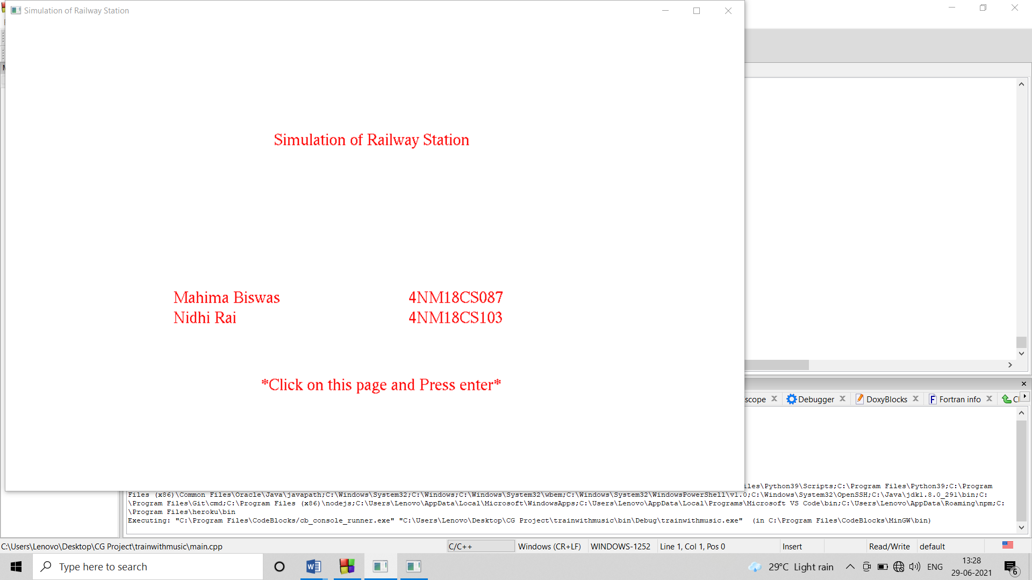

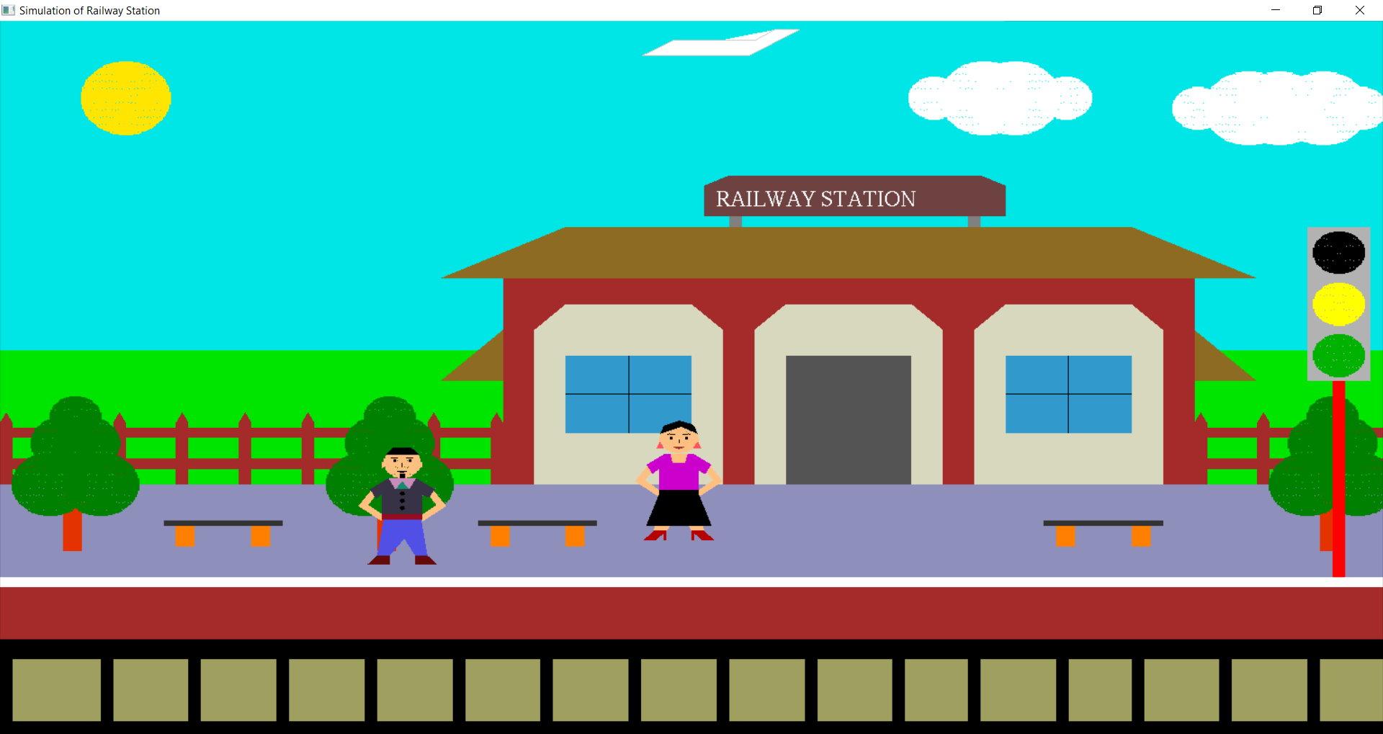

**Figure 2 : View of railway station with Aeroplane in day mode**

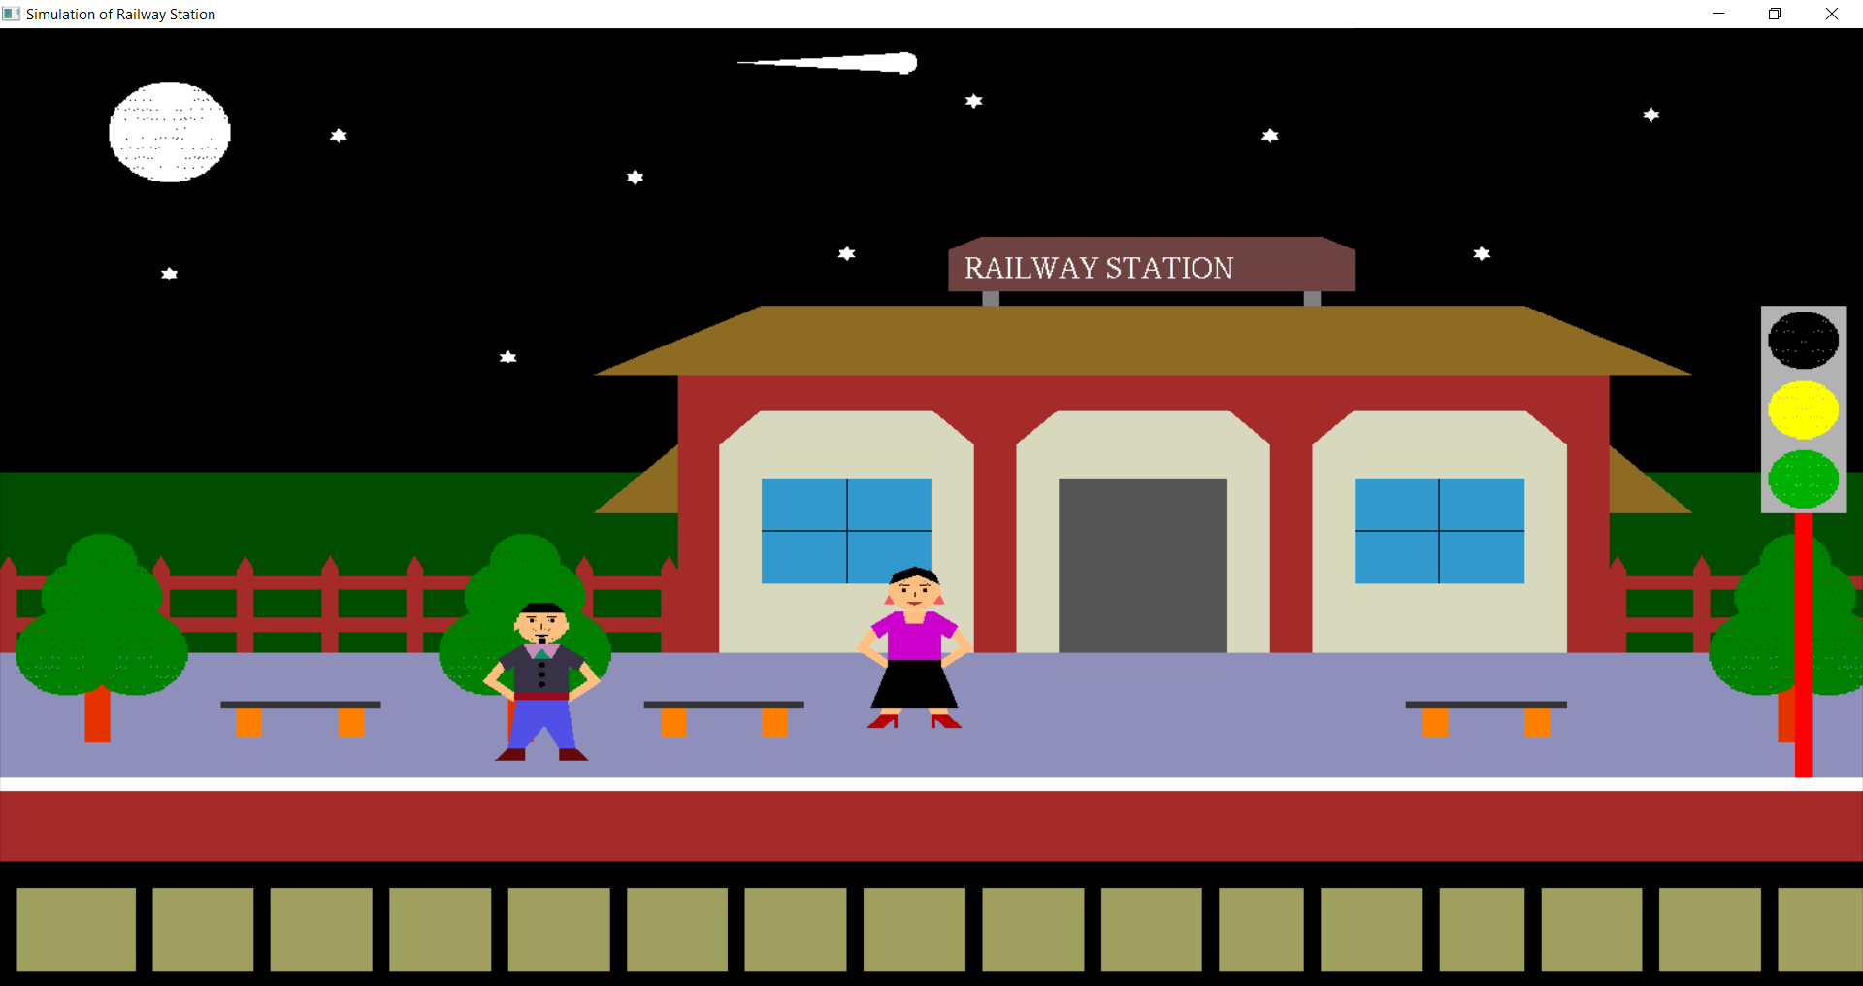

**Figure 3: Night Mode along with moon,stars and comet**

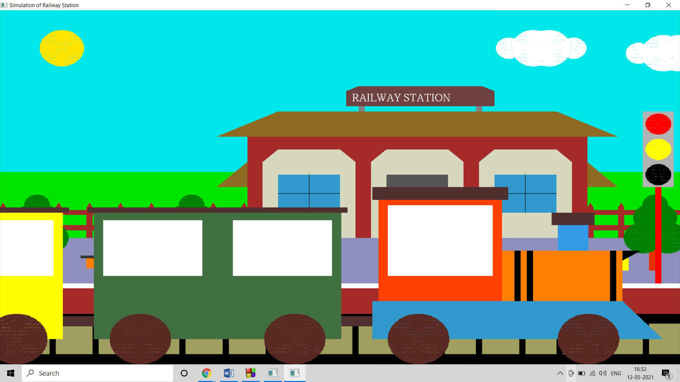

**Figure 4: Train stops when the signal turns red and passengers get into train**

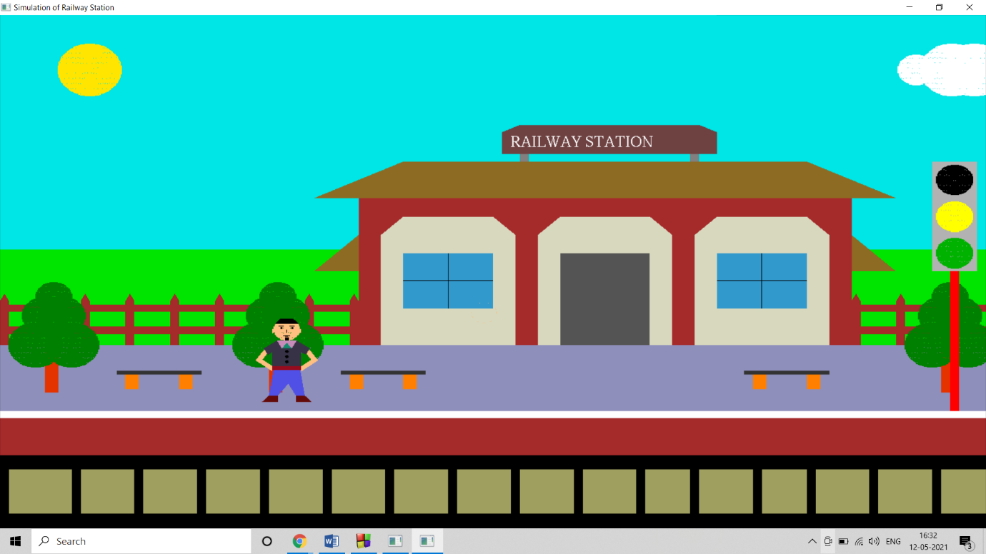

**Figure 5: View of railway station after departure of train with passenger**

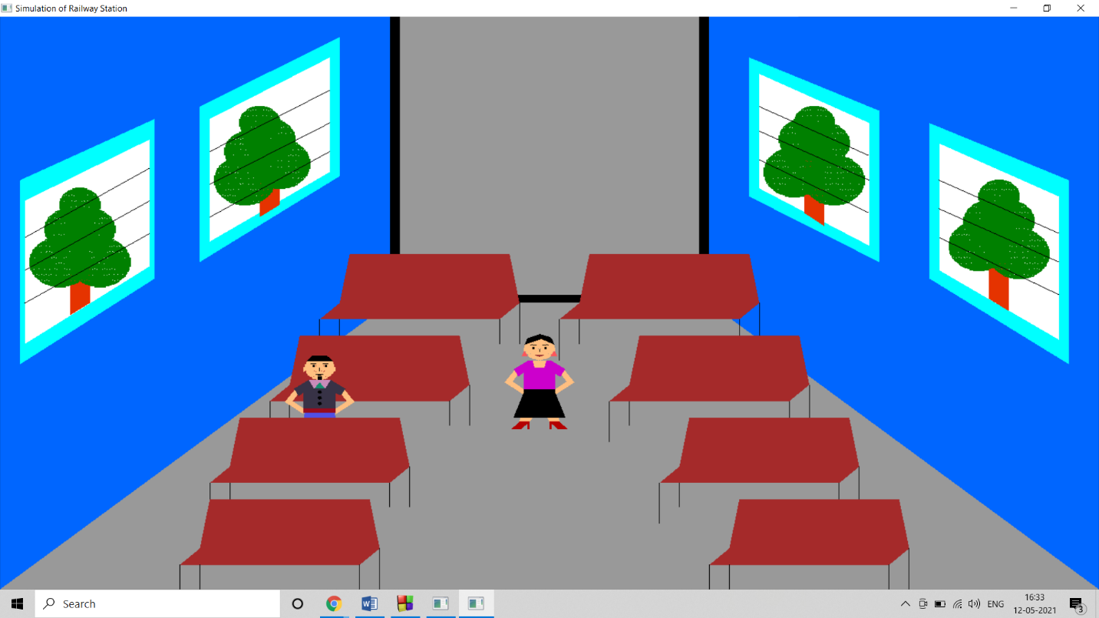

**Figure 6: Train compartment along with passengers**

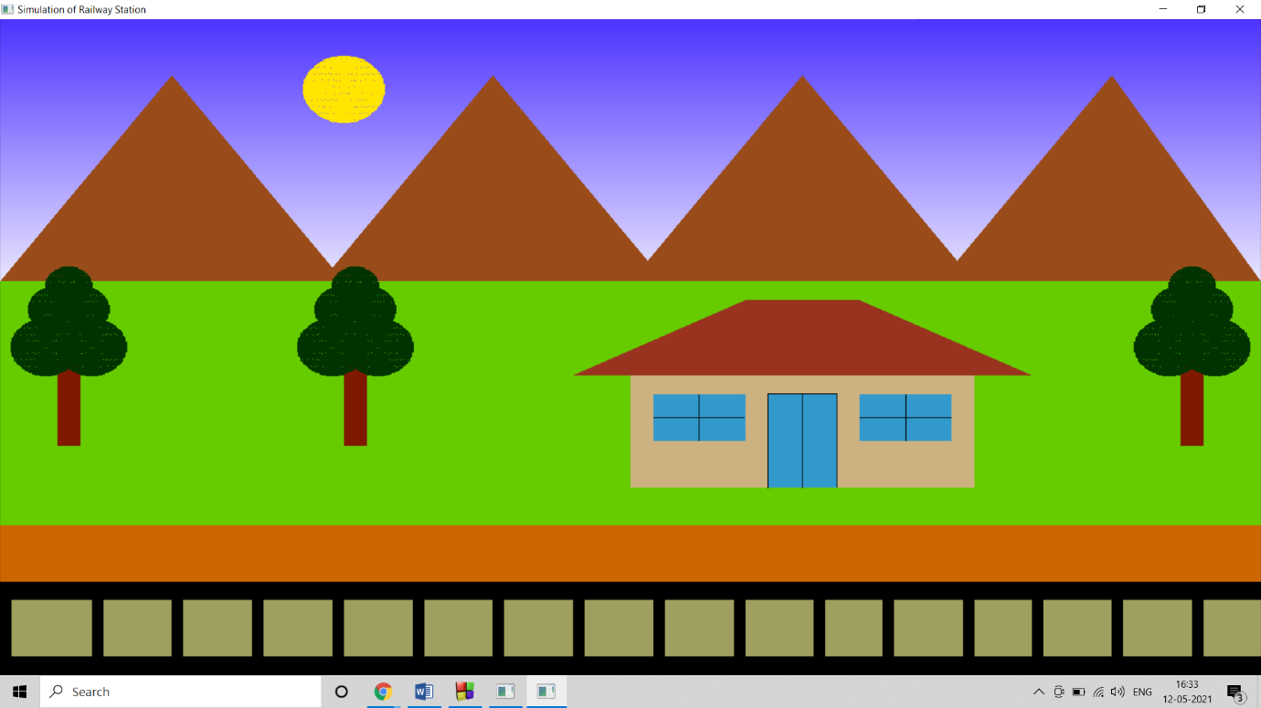

**Figure 7: Early morning view of village having trees,hills and house**

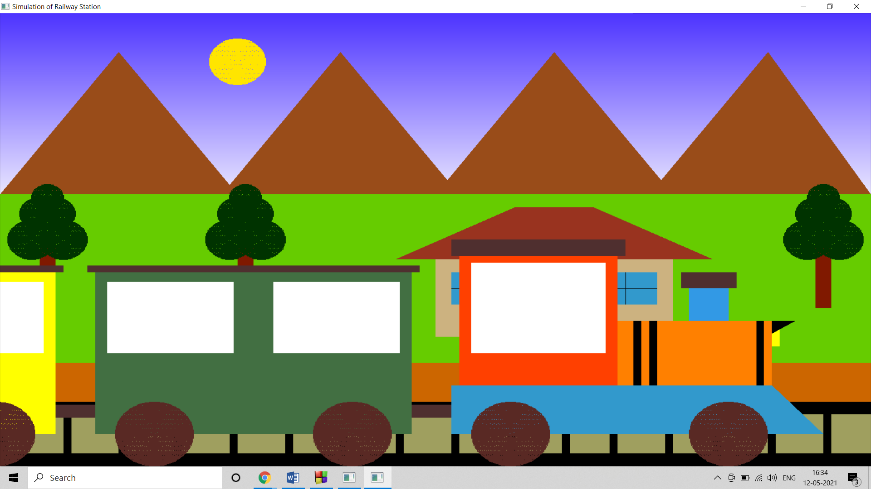

**Figure 8: Train passing by the village**

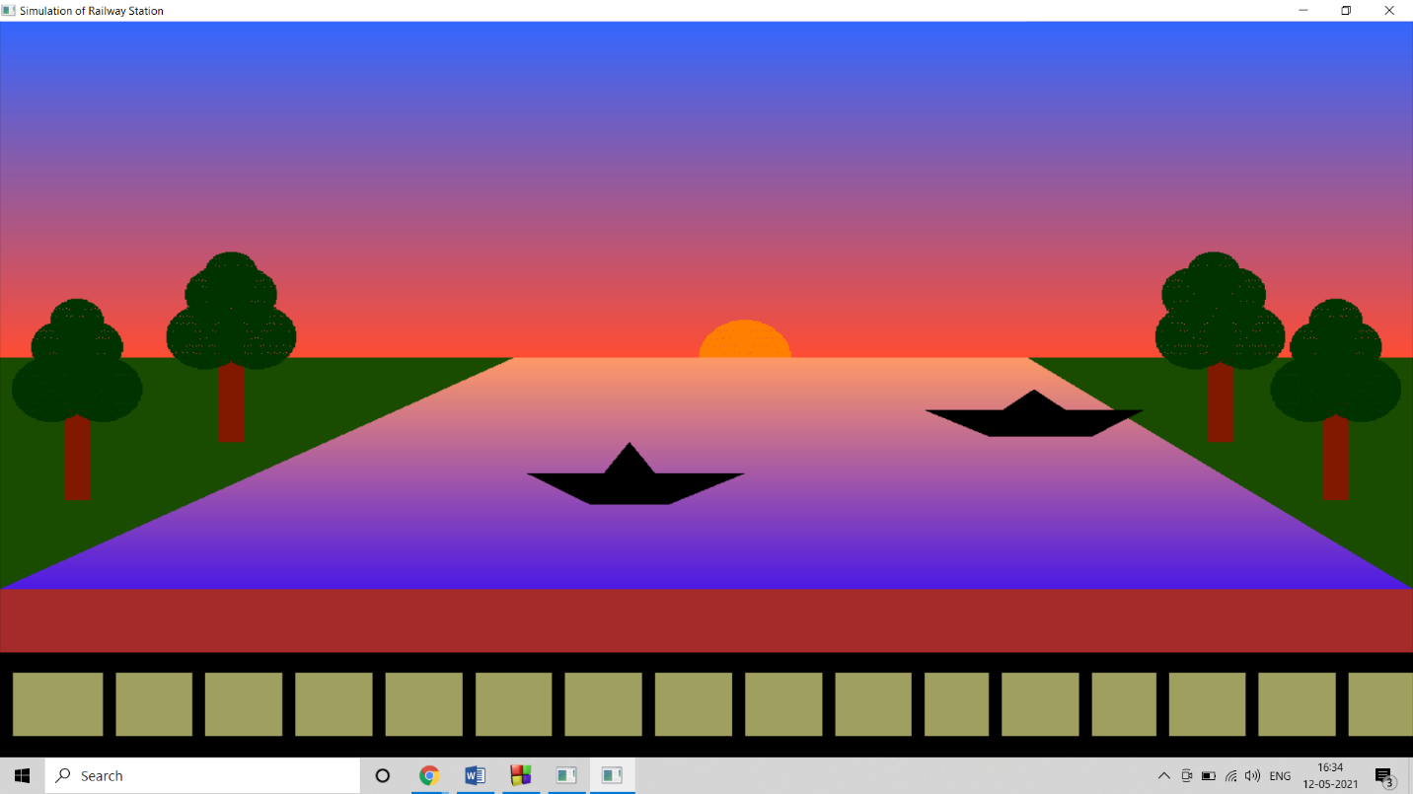

**Figure 9: View of river during sunset**

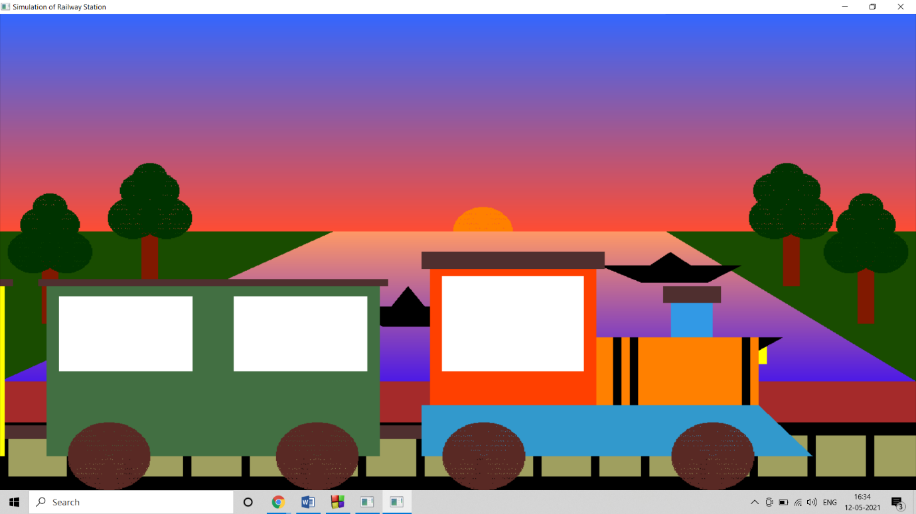

**Figure 10: Train crossing the river**