**SYMMETRY DETECTION:**

* Nidhi Ravishankar

**INTRODUCTION:**

Symmetry is a pervasive phenomenon presenting itself in all forms and scales in natural and man-made environments, from galaxies to biological structures. Mathematically, in geometry, the study of symmetry is the study of a space that is invariant under a given transformation group. Simply put, in geometry, an object has symmetry if there is an operation or transformation that maps the figure/object onto itself. Thus, a symmetry can be thought of as an immunity to change. [1]

However, in Computer Science, the most intuitive way to understand symmetry is similarity. A symmetric image will have features that are similar to each other. Though there has been a lot of research in fields such as anomaly detection and pattern recognition, symmetry detection continues to be a rather unexplored field.

The objective of this internship was to explore the possibility of a cognitive vision system to identify symmetry in images.

**EXPLORATION:**

There are several naive methods that work on images with only global symmetry, or one line of symmetry or methods that require pre-existing knowledge (such as how many lines of symmetry exist in the image). For example, Yodogawa (1982) used basis functions such as the Walsh function for identifying mirror-symmetry and rotational-symmetry. Different basis functions are used for different types of symmetry. Summing the Walsh coefficients, a vector of four values is obtained representing the symmetries of an image. An overall evaluation of symmetry is obtained for the image by taking the entropy of these four values. [2]

Loy and [Eklundh](https://www.researchgate.net/profile/J_O_Eklundh) (2006) use a combination of matching feature points generated by feature techniques such as SIFT to find symmetric pairs of features. A similarity matrix is constructed to quantify the similarity between feature points and the Euclidean distance between the SIFT descriptors is considered. Then, a voting mechanism is used to identify the best line of symmetry in the image. However, based on the votes, the line of symmetry has to be manually chosen by giving the appropriate ‘r’ and ‘theta’ values. Symmetries over all orientations and radii are considered but one dominant line of symmetry is chosen. [3]

The following images depicts the line of symmetry is inferred by the above software on two images from the bridge dataset (one background image and one image with a defect):

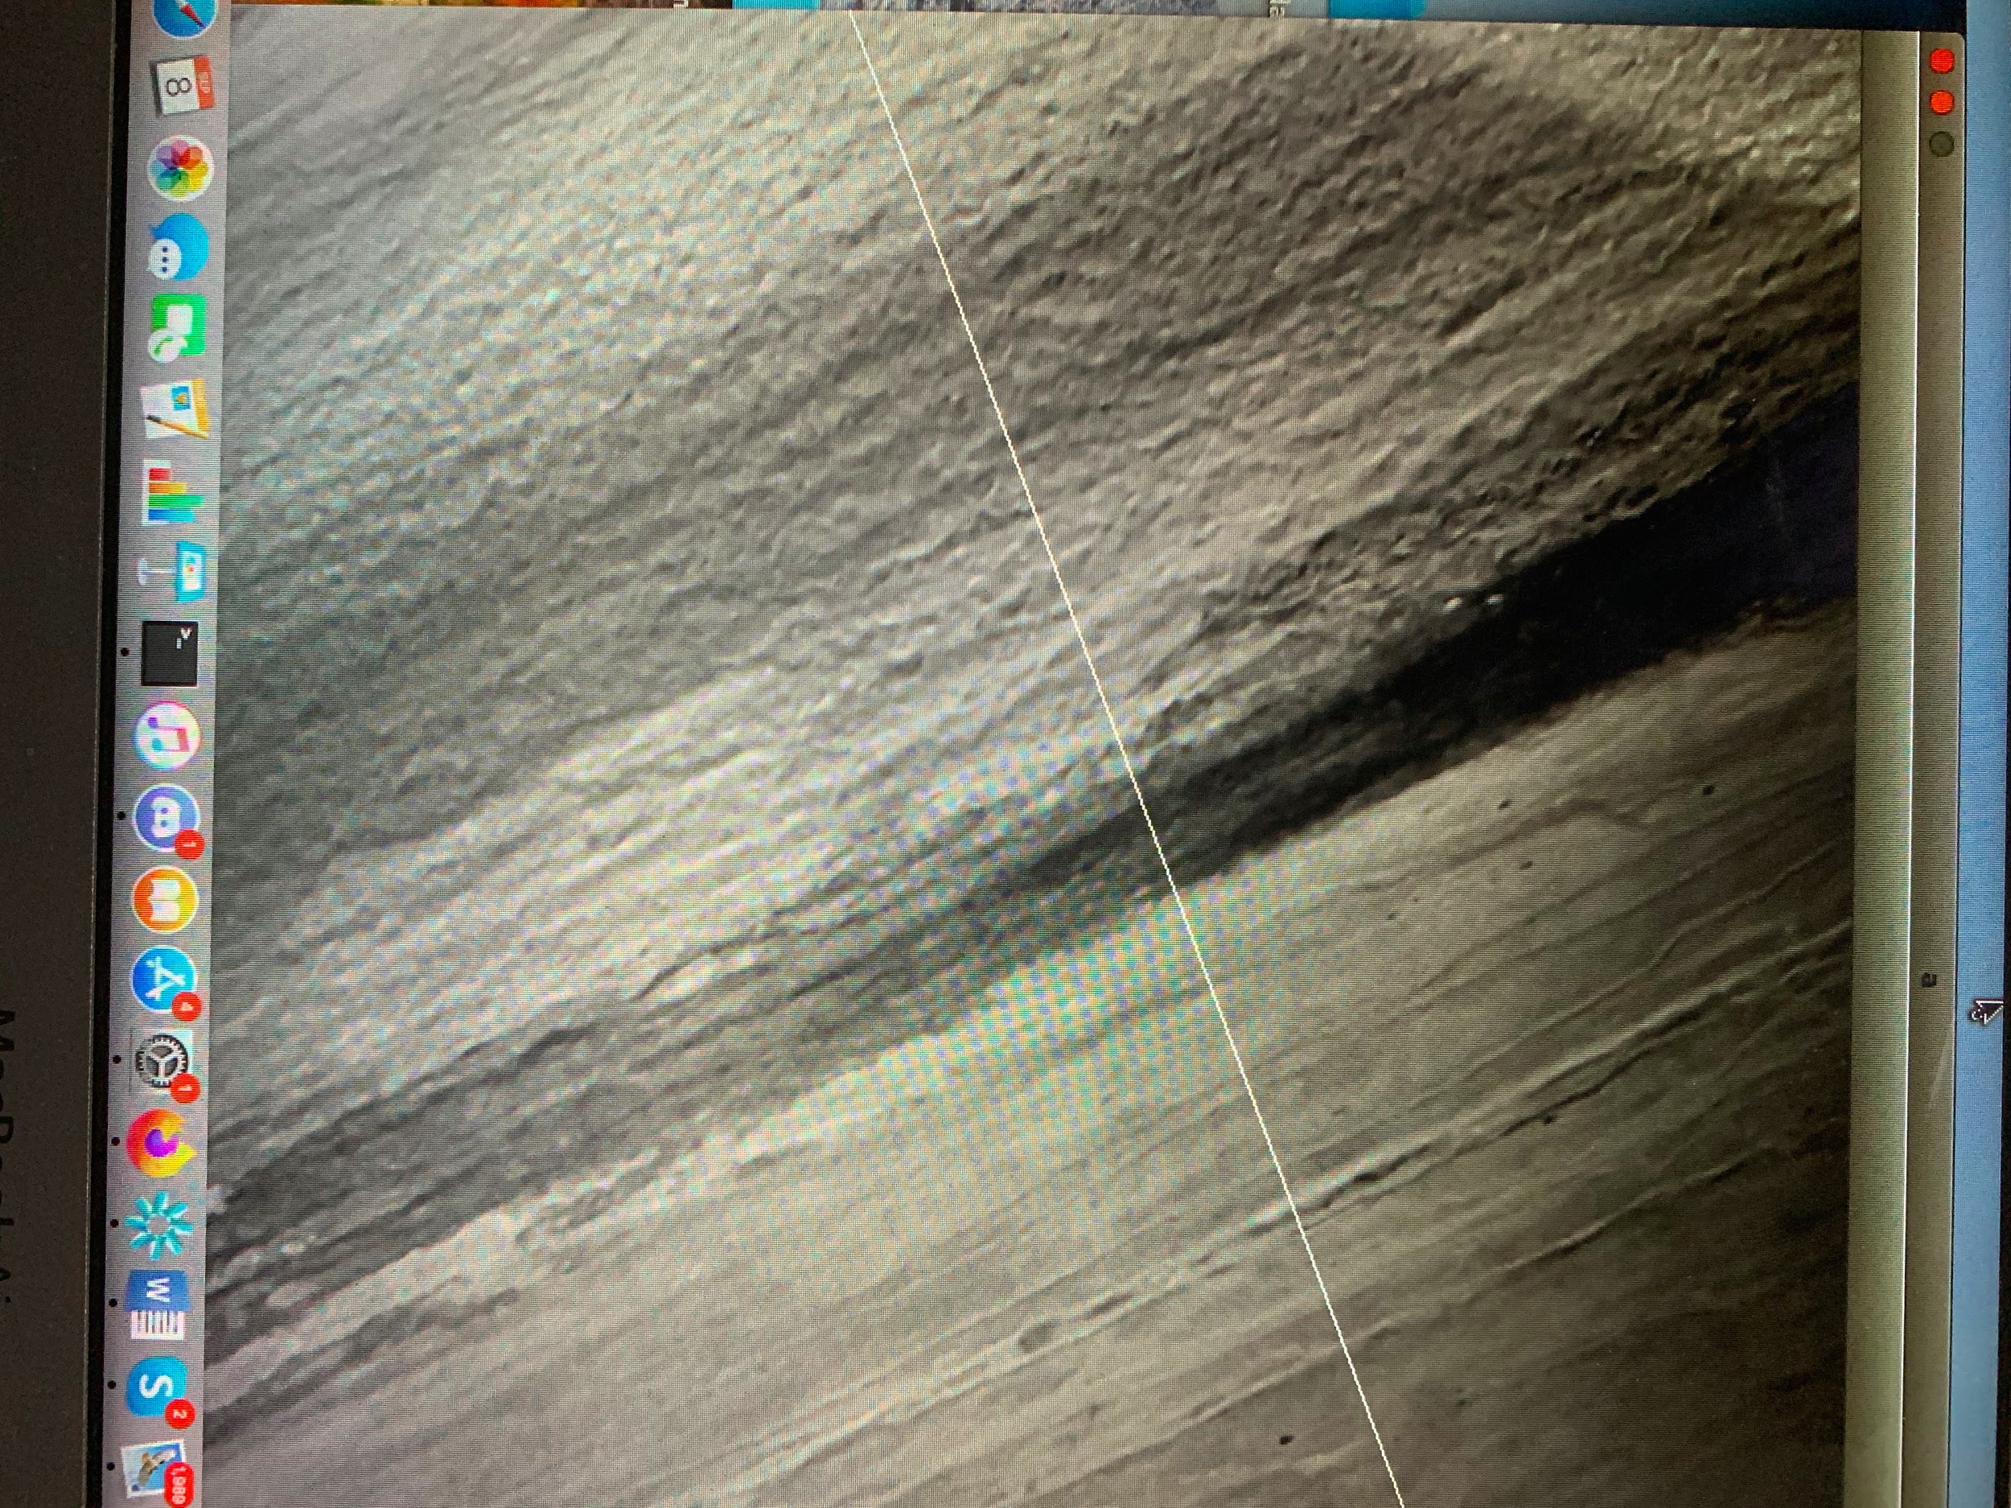

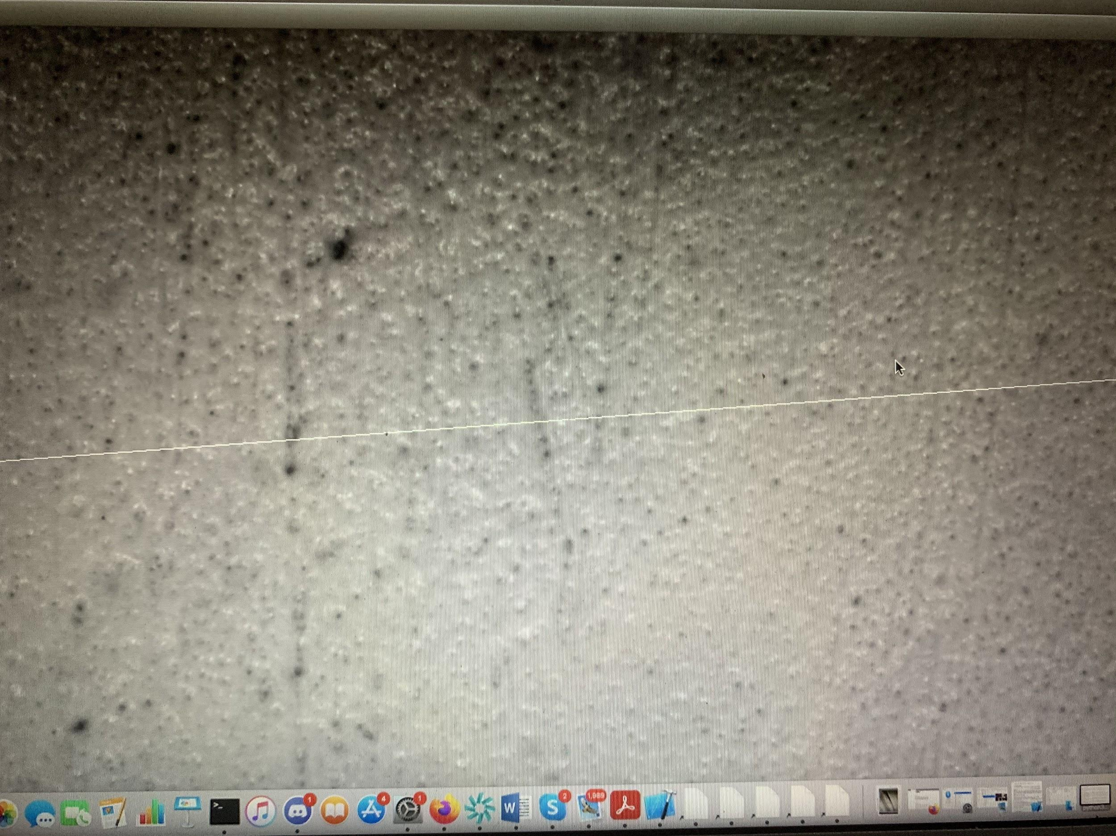

Tsogkas and Kokkinos (2012) propose a more generalized method of identifying symmetries in an image. To extend the usual method and broaden the range of applications to find local and approximate reflection symmetry, they focus on ribbon-like structures (the symmetry axes in the image). They also extract features representing multiple complementary cues, such as grayscale structure, color, texture, and spectral clustering information. Finally, supervised learning is used to combine these cues and Multiple Instance Learning (MIL) is used to accommodate the unknown scale and orientation of the symmetric structures. [4]

In MIL, the learner receives a set of labeled bags, each containing many instances. In the simple case of multiple-instance [binary classification](https://en.wikipedia.org/wiki/Binary_classification), a bag may be labeled negative if all the instances in it are negative. In this context, features are scale and orientation dependent (with respect to symmetry). If every image pixel represents a bag of features (feature vectors at all orientations and scales), the probability of symmetry at every pixel and every scale and orientation combination can be estimated. This way, the scale and orientation with the highest orientation can be found.

Another interesting approach to symmetry detection is density estimation and probability. Probability distributions can be extremely useful when it comes to measuring similarity. For example, algorithms like CADE (Classifier Adjusted Density Estimation) hypothesize the probability distribution of an image, and identify the points or objects that deviate from this density. This algorithm can be used to find anomalies in images, particularly in images that have a fairly homogenous structure. Hence, it can find points that are dissimilar to other points in the image. In the same way, symmetry can be thought of in terms of similarity. For example, reflection symmetry means that the points, or the distribution of the points on one side of the mirror line, is similar to the points or their distribution on the other side of the mirror line. Several symmetry detection algorithms compare the histograms of two parts of the image to identify the similarity between them. This method can be to identify similarity in color, brightness or texture.

Tancik et al (2020) used Neural Tangent Kernel (NTK) theory, Fourier feature mapping and the coordinate based Multilayer Perceptron (MLP) to model functions in low dimensions. They are able to successfully represent complex 3D objects using low dimensional coordinate-based data. Fourier feature mapping improves performance because the parameters offer control over the frequency falloff of the combined NTK. An important use of this method is in Computed Tomography (CT).

In CT, the integral projections of the density field are not directly measured but are observed. In this paper, the MLP is trained using 2D pixel coordinates (the low dimensional data) and the volume density associated with that location is predicted. The network is indirectly supervised by the loss between a sparse set of ground-truth integral projections and integral projections computed from the network. [5]

This paper hypothesizes that randomly chosen locations in the image are likely to have potentially similar values. Hence, Fourier feature based regression is a form of a symmetry hypothesis and the idea of symmetry and equivalence is essential in this work. The random Fourier feature mappings are sampled from different distribution families such as Gaussian, uniform etc.(this can be seen in the images below) and the network is trained with these different mappings. This is done to featurize the input coordinates before passing them through a coordinate-based MLP. In the mapping function used (for example, a sinusoid), a certain combination of points will have the same value (X values), and can be grouped if they also have the same Y values. This forms groups of similar points. By training this data (MLP), the symmetries that are actually represented in the dataset can be picked out, and a weighted combination of those can be used in the final representation of the image. In very simple words, the image can be represented based on the symmetries present in it. Therefore, there is an equivalence between this formulation and kernel regression (which is essentially kernel-weighted combinations from particular locations). Additionally, the methods in this paper can be used to identify density information based on pixel coordinates, which could be important in symmetry detection.

The following images depicts the line of symmetry is inferred by the above software (provided by the authors of this paper) on two images from the bridge dataset (one background image and one image with a defect respectively). The CPU time taken was 44 seconds and the total run time 2 mins 54 seconds to run this code (on google colab) for the background image and the CPU time and run time for the defect image was 42 seconds and 5 mins 30 seconds respectively.

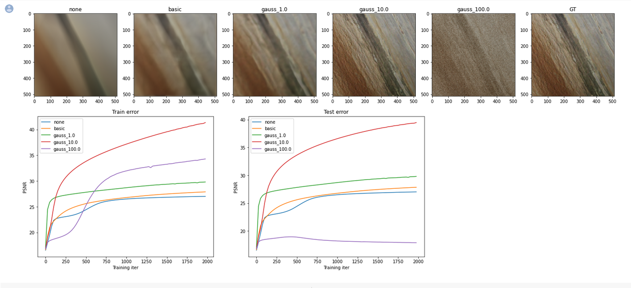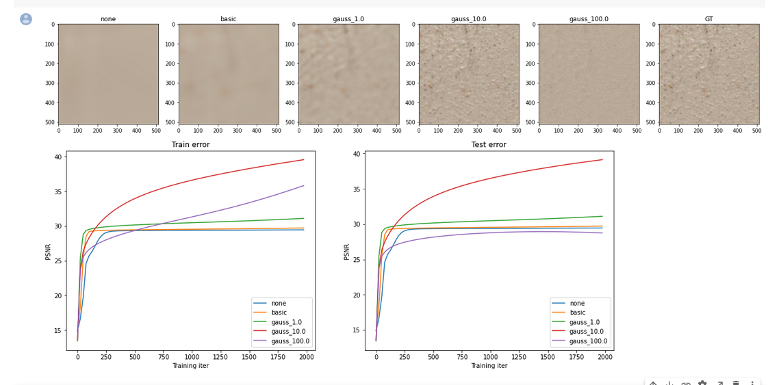

The field of symmetry detection is fairly unexplored, but using concepts such as density estimation as well as concepts from pattern recognition and anomaly detection could prove to be very useful in the development of a generalized cognitive vision system for symmetry detection.

# **REFERENCES**

|  |  |
| --- | --- |
| [1] | Y. Liu, H. Hel-Or, C. S. Kaplan and L. V. Gool, "Computational Symmetry in Computer Vision and Computer Graphics," *Foundations and Trends in Computer Graphics and Vision,* vol. 5, no. 1-2, pp. 1-195, 2009. |
| [2] | E. Yodogawa, "Symmetropy, an entropy-like measure of visual symmetry," *Perception & Psychophysics,* vol. 32, no. 230-240. |
| [3] | G. Loy and J.-O. Eklundh, "Detecting Symmetry and Symmetric Constellations of Features," *Computer Vision – ECCV 2006,* vol. 3952, 2006. |
| [4] | S. Tsogkas and I. Kokkinos, "Learning-Based Symmetry Detection in Natural Images," in *European Conference on Computer Vision*, Heidelberg, 2012. |
| [5] | M. Tancik, P. P. Srinivasan, B. Mildenhall, S. Fridovich-Keil, N. Raghavan, U. Singhal, R. Ramamoorthi, J. T. Barron and R. Ng, "Fourier features let networks learn high frequency functions in low dimensional domains," *arXiv preprint arXiv:2006.10739 ,* 2020. |