Building a Small-Scale Foundation Model from Scratch
Assignment 2 — Report
Name: Nidhi Rawal | Course: [Your Course Code] | Date: [Date]

1. Model Architecture and Parameters
A decoder-only mini-GPT was implemented from scratch in PyTorch (no nn.TransformerEncoder shortcuts): a token embedding plus a learned positional embedding feed into a stack of pre-LayerNorm transformer blocks, each consisting of causal multi-head self-attention followed by a 4x-expansion feed-forward (MLP) block, with residual connections around both sub-layers. A final LayerNorm and a linear head project back to vocabulary-sized logits for next-token prediction. The causal mask ensures position t can only attend to positions <= t, which is required so the model cannot see the token it is being asked to predict.
Hyperparameter | Value (baseline config)
n_layer (transformer blocks) | 2
n_embd (embedding dim) | 128
n_head (attention heads) | 4
block_size (sequence length) | 64
Total parameters | 13.27M
Note: total parameter count scales with vocab_size (50,257 for the GPT-2 BPE tokenizer used here), since the token embedding and output head are each vocab_size x n_embd — with this tokenizer, those two layers alone account for roughly 12.9M of the 13.27M total, so vocabulary size dominates parameter count far more than depth or width at this scale.

2. Dataset Details
The dataset is the cleaned, tokenized corpus produced in Assignment 1: approximately 1 GB of raw text streamed from three Hugging Face sources spanning three domains (Wikipedia/encyclopedic, CC-News/news, OpenWebText/general web), roughly 350 MB per domain. After HTML/markdown stripping, whitespace normalization, a 50-word minimum length filter, and exact-duplicate removal via content hashing, 265,775 of 303,233 collected documents were kept (21,691 dropped as too short, 15,767 dropped as exact duplicates). The surviving text was encoded with the GPT-2 byte-pair-encoding tokenizer (vocab_size = 50,257), with documents concatenated using an end-of-sequence separator and packed into a single flat token stream of 225,962,938 tokens. This assignment's training pipeline holds out the last 10% of that stream as a validation split, with the remaining 90% used for training.

3. Training Setup and Hyperparameter Experiments
The model was trained with the AdamW optimizer (weight_decay=0.01, gradient clipping at norm 1.0) using cross-entropy loss for next-token prediction, on a MacBook Air CPU (no GPU available for this run). Because the training corpus (226M tokens) is far larger than a full epoch could reasonably cover on CPU, each "epoch" here is defined as a fixed budget of 200 random training steps sampled across the whole corpus, rather than one literal linear pass — batches are drawn uniformly at random from the full 90% training split at every step regardless, so this does not bias which data the model sees.

3.1 Baseline training configuration
batch_size=32, learning_rate=3e-4, max_epochs=10 (baseline single run); the hyperparameter sweep below used max_epochs=5 per configuration to keep total sweep time manageable on CPU. The baseline 10-epoch run reduced validation perplexity from an initial ~7,256 (step 50) to 509.2 (final), with training and validation loss decreasing together throughout — no sign of overfitting at this scale/data budget.

3.2 Hyperparameter experiment results
Each row changes exactly one hyperparameter from the shared baseline (n_layer=2, n_embd=128, n_head=4, block_size=64, batch_size=32, learning_rate=3e-4, max_epochs=5), so differences in the last two columns isolate that parameter's effect:
Experiment | Changed Parameter | Final Val Loss | Final Val Perplexity
lr_1e-3 | learning_rate=1e-3 | 6.288 | 537.8
lr_5e-4 | learning_rate=5e-4 | 6.389 | 595.2
batch_16 | batch_size=16 | 6.847 | 940.8
batch_64 | batch_size=64 | 6.393 | 597.8
1_layer | n_layer=1 | 6.599 | 734.4
2_layer | n_layer=2 | 6.545 | 695.9
embd_64 | n_embd=64 | 6.897 | 989.0
embd_256 | n_embd=256 | 6.344 | 569.3

Figure 1 (below) shows loss and perplexity across epochs for all eight runs, produced by visualize.py from the CSV logs.
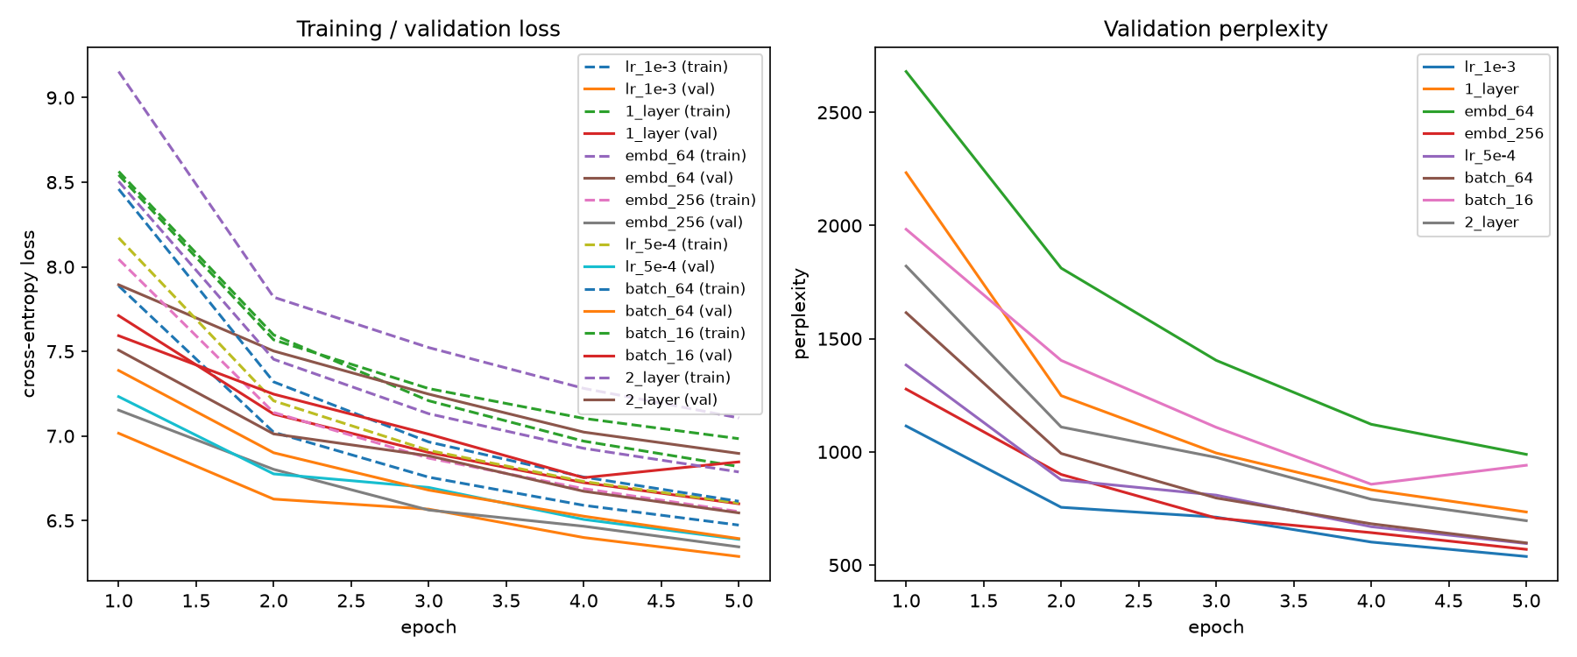

4. Observations and Challenges

4.1 Which hyperparameters mattered most
Ranking all eight runs by final validation perplexity (lower is better): lr_1e-3 (537.8) < embd_256 (569.3) < lr_5e-4 (595.2) < batch_64 (597.8) < 2_layer (695.9) < 1_layer (734.4) < batch_16 (940.8) < embd_64 (989.0).
- Embedding dimension had the single largest effect: n_embd=256 (perplexity 569.3) massively outperformed n_embd=64 (989.0) — nearly a 2x difference — showing that at this data scale, representational capacity per token was a bigger bottleneck than depth.
- Learning rate mattered more than expected within only 5 epochs of budget: 1e-3 clearly outpaced 5e-4 (537.8 vs 595.2), suggesting the smaller rate simply hadn't converged as far yet in the same step budget, not that it is a worse rate in the long run.
- Batch size showed the widest spread (batch_64 at 597.8 vs batch_16 at 940.8), but this comparison is confounded: because each "epoch" is a fixed 200 steps rather than a fixed token budget, batch_64 processed 4x as many tokens per epoch as batch_16. Much of its advantage is plausibly just more data seen, not purely gradient-noise reduction — a fairer comparison would fix total tokens processed rather than step count.
- Number of layers had the smallest effect of the four parameters tested (695.9 vs 734.4 for 2 vs 1 layer) — at this small scale and short training budget, adding depth helped only marginally.

4.2 Overfitting / underfitting
Across every run, training and validation loss decreased together with validation loss consistently at or below training loss and no divergence between them — the clear signature of underfitting (the model has not yet exhausted what it can learn from the data) rather than overfitting. This is expected given the short step budget (200-2,000 steps) relative to a 226M-token corpus; none of these runs trained long enough to reach the point where memorization would start to hurt held-out performance.

4.3 Practical challenges encountered
- The provided Assignment 1 script's own internal DataLoader sanity-check step (num_workers=2) crashed with a pickling error on Python 3.14 on macOS (a numpy module reference stored on the dataset object couldn't be pickled for multiprocessing). This was cosmetic to Assignment 1's own demo step — tokenize_corpus() had already written tokens.bin and meta.json successfully before the crash, so Assignment 2's pipeline was unaffected once pointed directly at those files.
- Defining "epoch" as a full linear pass over the corpus was infeasible on a CPU laptop given 226M tokens (roughly 99,000 steps/epoch at batch_size=32); switching to a fixed per-epoch step budget, with batches still drawn randomly across the full corpus, kept training tractable while still exercising the whole dataset over enough steps.
- One sweep run's wall-clock time was inflated by roughly 3 hours due to the laptop going to sleep mid-training (visible as an anomalous jump in per-epoch elapsed time for lr_5e-4); the loss/perplexity values themselves are unaffected since training simply paused and resumed, but the timing column for that run is not representative of actual compute time.

Appendix: Repository Structure
config.py — hyperparameters | data.py — dataset loading & batching | model.py — MiniGPT architecture | train.py — training loop, logging, checkpointing | sweep.py — hyperparameter experiments | visualize.py — plotting | generate.py — text generation demo

