🔹 Problem ko simple words mein samjho (Story Mode)
- Anton ek grid room mein khada hai
→ room ka size = n rows × m columns
- Anton ki current position = (i, j)
- Riley 2 yo-yos fenkta hai (same cell bhi ho sakte hain)
- Anton:
  - Pehle yo-yo 1 uthayega
  - Phir yo-yo 2
  - Aur wapis apni starting position (i, j) pe aayega
- Anton sirf up, down, left, right ja sakta hai
- Anton hamesha shortest path lega (wo bevkoof nahi hai 😄)
👉 Riley ka goal:
Yo-yos aise jagah feko ki Anton ko maximum distance chalni pade
👉 Tumhara kaam:
Sirf yo-yo ke coordinates print karne hain, distance nahi.

🔹 Important Observation (Very Very Important 💡)
Constraints dekho:
- n, m ≤ 10^9
- t ≤ 10^4
👉 Matlab:
- Grid banana ❌
- BFS / DFS ❌
- Simulation ❌
💥 Sirf O(1) solution hi chalega
Iska matlab:
Answer observe karna padega, calculate nahi.

🔹 Movement ka funda (Manhattan Distance)
Grid mein shortest path ka formula hota hai:
$$distance=∣x_{1}-x_{2}∣+∣y_{1}-y_{2}∣$$
Anton hamesha isi rule se chalega.

🔹 Step 1: Pehla yo-yo kaha daalein?
Socho:
- Anton kisi bhi cell pe khada ho
- Sabse door kaunsa cell hoga?
👉 Corners 🔥
Corners hamesha maximum Manhattan distance dete hain.
Grid ke 4 corners:
- (1,1)
- (1,m)
- (n,1)
- (n,m)
👉 Pehla yo-yo kisi corner mein hi hona chahiye.

🔹 Step 2: Doosra yo-yo kaha daalein?
Ab imagine karo:
- Anton pehla yo-yo utha chuka hai
- Ab wo corner pe khada hai
Corner se sabse door kaunsa cell hota hai?
👉 Diagonal opposite corner
Example:
- Agar pehla yo-yo (1,1) pe hai
→ doosra (n,m) pe hona chahiye
Ya phir:
- (1,m) ↔ (n,1)

🔹 Final Golden Observation ✨
💡 Best placement hamesha 2 diagonally opposite corners hote hain
Aur sabse simple pair:
(1,1) and (n,m)
Chahe Anton kahin bhi khada ho —
distance maximum hi aayega, kyunki:
- Horizontal movement = (m−1) twice
- Vertical movement = (n−1) twice
Total distance:
2 × (n − 1) + 2 × (m − 1)
Isse zyada possible hi nahi.

🔹 Kya (1,m) aur (n,1) bhi chalenge?
✔️ YES
Problem clearly bolta hai:
“If there are multiple answers, print any.”
Toh ye bhi valid hai:
(1,m) and (n,1)
Par hum simplest use karte hain:
(1,1) and (n,m)

🔹 Isliye i, j ka use hi nahi hota 😮
Notice karo:
- Code mein i aur j kahin use hi nahi hue
Reason:
- Chahe Anton kahin bhi ho,
- Corners always dominate distance

🔹 Tumhara Java Code – Perfectly Correct ✅
System.out.println(1 + " " + 1 + " " + n + " " + m);
✔ Logic correct
✔ Constraints safe
✔ O(1) time
✔ O(1) space
✔ Competitive programming approved 💯

🔹 One-line intuition (Yaad rakhne ke liye 🧠)
Grid mein maximum chalwana ho →
Dono yo-yo ko diagonally opposite corners mein feko

Agar tum chaho next step mein:
- ✏️ dry run ek custom example ka
- 📐 distance formula ka mathematical proof
- ❓ why only corners work (deep logic)
bas bolna 💙
Kya aap thoda aur visualize karke acche se samjha sakte hain mujhe abhi bhi thoda confusion hai
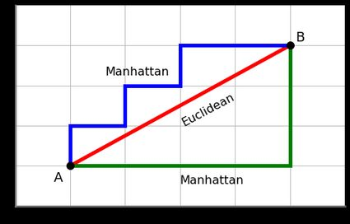
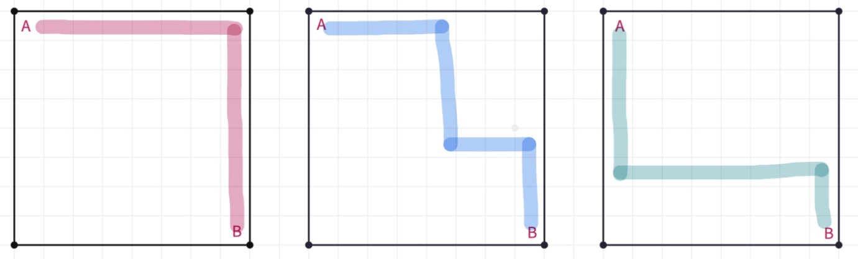
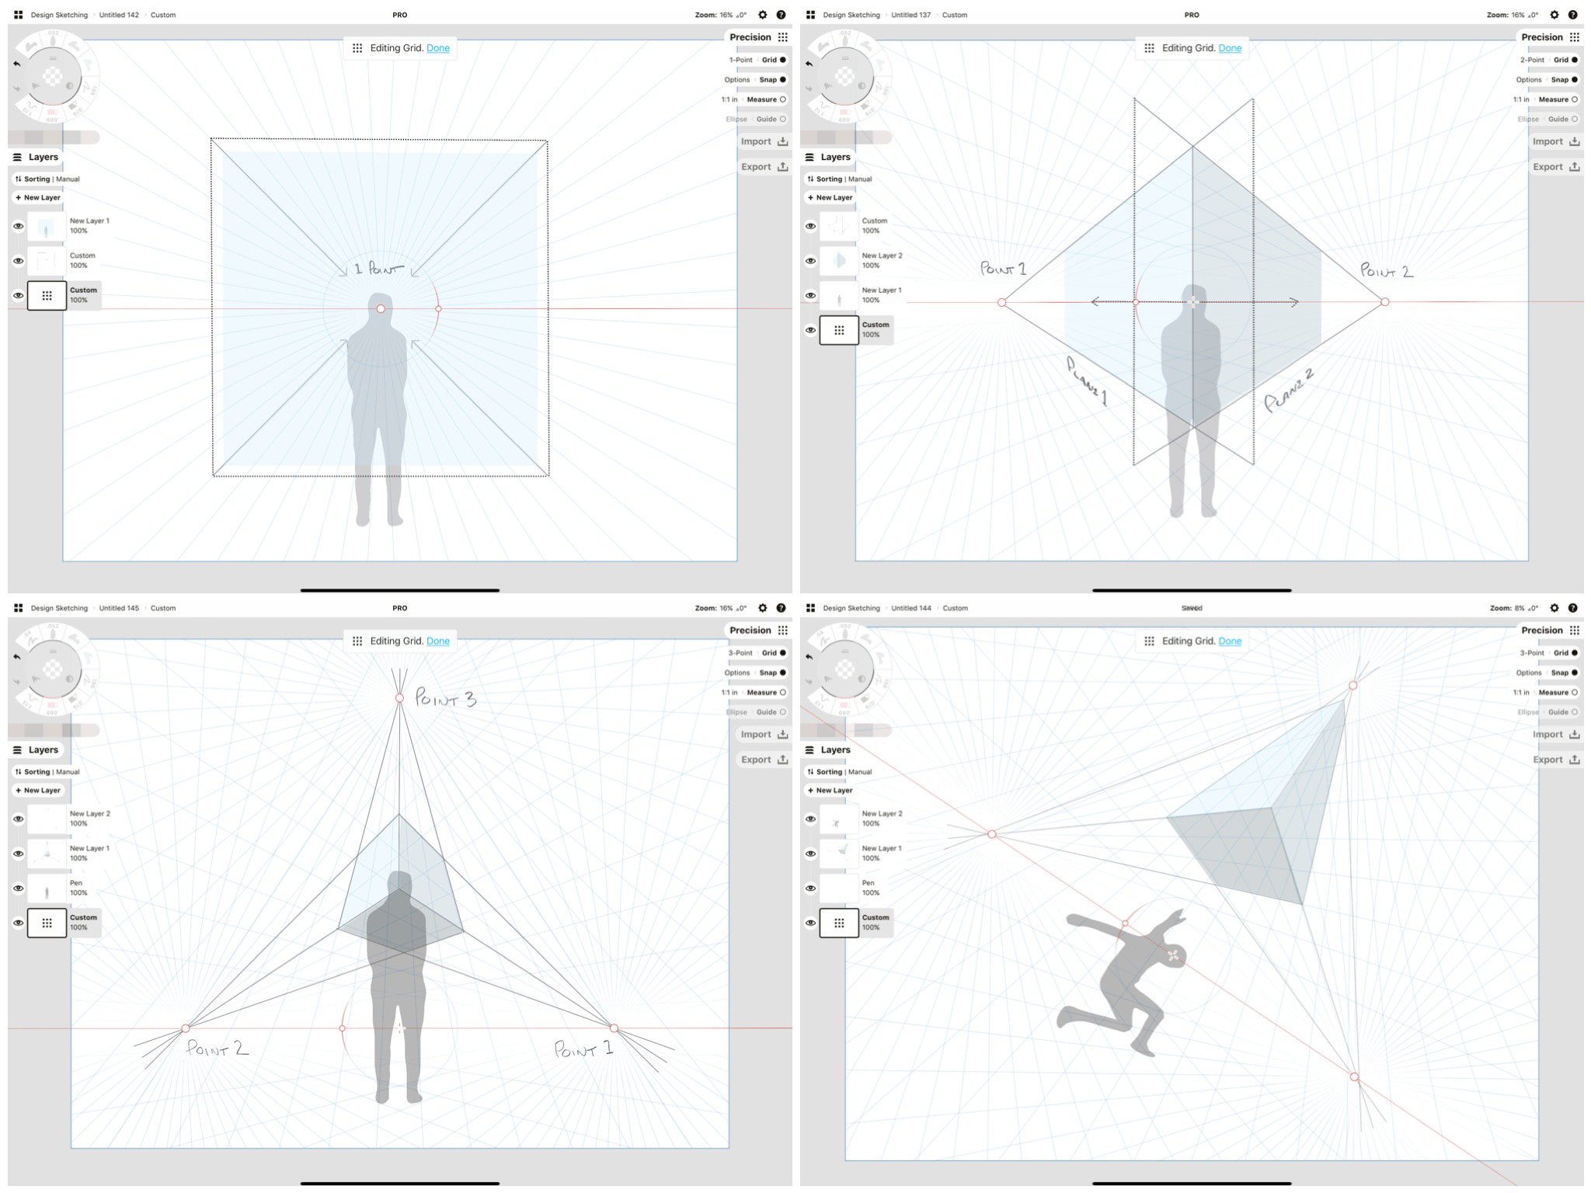
Bilkul Nidhi 💙
Chalo aur zyada slow + visual + step-by-step tareeke se samajhte hain.
Is baar main aapko dimag ke andar picture banana sikhaungi, taaki confusion completely zero ho jaye.

🧠 Step 0: Dimag mein ek chhota room banao
Socho ek room = grid
Main chhota example leti hoon (taaki clear ho):
n = 4 , m = 5
Grid dikhegi kuch aisi (rows × columns):
(1,1) (1,2) (1,3) (1,4) (1,5)
(2,1) (2,2) (2,3) (2,4) (2,5)
(3,1) (3,2) (3,3) (3,4) (3,5)
(4,1) (4,2) (4,3) (4,4) (4,5)
👉 Sirf upar, neeche, left, right ja sakte ho
👉 Diagonal ❌

🧍 Step 1: Anton kahaan khada hai – ye ignore kyun ho jata hai?
Maan lo Anton kahin bhi khada ho, jaise:
Anton at (2,3)
Ab Riley ko 2 yo-yo phenkne hain.
Anton:
- Pehla yo-yo uthayega
- Doosra yo-yo uthayega
- Wapas (2,3) aayega
Aur hamesha shortest path lega.

📏 Step 2: Distance ka simple rule (VERY IMPORTANT)
Grid mein shortest distance hota hai:
|x1 − x2| + |y1 − y2|
Iska matlab:
- Rows ka difference
- Columns ka difference
- Dono add

🔴 Step 3: Sabse door jagah kaunsi hoti hai?
Main aapse ek simple real-life question poochti hoon 👇
Agar aap room ke beech mein khade ho,
sabse door jagah kaunsi lagegi?
🧠 Answer:
➡️ Room ka corner
Grid mein bhi same logic 🔥
Anton kahin bhi ho, farthest cells = corners
Corners:
- (1,1)
- (1,5)
- (4,1)
- (4,5)

🪀 Step 4: Pehla yo-yo corner mein kyun?
Maan lo pehla yo-yo humne daala:
Y1 = (1,1)
Anton ko wahan pahunchne ke liye:
- upar + left = maximum steps
✔️ Achha decision

🪀 Step 5: Ab confusion wali jagah (IMPORTANT 👀)
Anton ab (1,1) pe aa chuka hai
Ab usse doosra yo-yo uthana hai
Main aapse phir poochti hoon:
Agar aap (1,1) corner pe khade ho,
sabse door kaunsa cell hoga?
🧠 Answer:
➡️ Diagonal opposite corner
Yani:
(4,5)
Kyun?
- Maximum rows move (1 → 4)
- Maximum columns move (1 → 5)
- Dono directions ka full use

🔁 Step 6: Poora route visualize karo (MOST IMPORTANT)
Anton ka actual chalna:
1️⃣ (2,3) → (1,1) → yo-yo 1
2️⃣ (1,1) → (4,5) → yo-yo 2
3️⃣ (4,5) → (2,3) → wapas
🧠 Notice kya ho raha hai:
- Horizontal moves maximum
- Vertical moves maximum
- Aur ye sab 2 baar ho raha hai
Isse zyada chalna possible hi nahi

🤯 Step 7: “Par (1,5) aur (4,1) kyun nahi?”
Bahut common confusion 👌
Chalo ye bhi dekhte hain.
Agar hum yo-yo daalte:
(1,5) and (4,1)
Tab bhi:
- Ek yo-yo left-top corner se door
- Doosra right-bottom corner se door
🧠 Magic point:
Ek yo-yo thoda paas aata hai
to doosra utna hi door chala jata hai
👉 Total distance SAME rehta hai.
Isliye:
- (1,1) & (n,m) ✔️
- (1,m) & (n,1) ✔️
Dono correct.

🔑 Final Lock-in Thought (Isse yaad rakho)
👉 Grid mein maximum chalwana ho
👉 Toh diagonally opposite corners choose karo
Aur simplest answer:
1 1 n m
Isliye code mein i, j ka koi role hi nahi bachta.

🧩 Ek chhota mental trick (Exam / Contest ke liye)
Room + shortest path + maximize distance
= Corners

