🔹 Problem ka Core Idea (Simple Words mein)
Mocha ke paas ek array hai.
Wo special operation use karke array ke elements ko change kar sakti hai.
👉 Operation ka result hamesha bitwise AND (&) hota hai
👉 AND operation number ko kabhi badhata nahi, ya same rakhta hai, ya kam karta hai
Goal:
Array ka maximum element jitna ho sake utna chhota karna hai

🔹 Operation ko Intuition se Samjho
Jab bhi Mocha koi interval [l, r] choose karti hai:
- a[l] ko a[l] & a[r]
- a[l+1] ko a[l+1] & a[r-1]
- … and so on (palindrome-style pairing)
👉 Matlab:
Left aur Right ke elements ka AND ho raha hai

🔹 Important Observation (Yahin se Problem Crack hoti hai)
🔑 Bitwise AND ka golden rule:
A bit remains 1
ONLY IF
that bit is 1 in ALL numbers
Agar kisi bhi ek number mein wo bit 0 hai → final AND mein wo bit 0 ho jayegi.

🔹 Sochne ka Tarika (Exam / Interview level)
Socho final answer = X
- Agar X ka koi bit = 1 hai
👉 iska matlab array ke har element mein wo bit 1 honi chahiye
- Agar kisi bhi element mein wo bit 0 hai
👉 hum operations use karke us bit ko forcefully 0 bana sakte hain
👉 Aur kyunki hume maximum ko minimum banana hai
👉 hum har possible bit ko 0 kar denge jab tak majboori na ho

🔹 Final Conclusion (MOST IMPORTANT LINE)
💡 Minimal possible maximum value = bitwise AND of all array elements
answer = a1 & a2 & a3 & ... & an
Isse neeche jaana impossible hai.

🔹 Example se Crystal Clear Samjho
Example:
[11, 7, 15, 3, 7]
Binary:
11 = 1011
7 = 0111
15 = 1111
3 = 0011
7 = 0111
Column-wise AND:
bit 0 → sabme 1 ✔
bit 1 → sabme 1 ✔
bit 2 → ek jagah 0 ❌
bit 3 → ek jagah 0 ❌
Final AND:
0011 = 3
✅ Answer = 3

🔹 Tumhare Java Code ka Review ✅
Tumhara code:
long totalAnd = a[0];
for (int i = 1; i < n; i++) {
totalAnd &= a[i];
}
System.out.println(totalAnd);
✔️ Bilkul Sahi Logic
- Exactly wahi kar raha hai jo problem demand karti hai
- No extra operations
- No simulation needed

🔹 Time & Space Complexity
Aspect | Value
Time | O(n)
Space | O(n) (array storage only)
Constraints | n ≤ 100 → super safe

🔹 Interview One-Liner (Yaad Rakhna 💡)
“Since bitwise AND can only turn bits OFF, the smallest possible maximum is the AND of all elements.”

Agar chaho to next step mein:
- ❓ Proof ko aur formal mathematical style mein
- 🧠 Why interval operations are sufficient
- 🧪 More tricky test cases
- 🧩 Why greedy works here
Bas bolo 😊
Haan deep meh batao and jo bhi apne next step meh likha hai voh bhi explain karo
Perfect 👍
Ab hum bilkul deep + step-by-step + proof level pe jaayenge — jaise exam, interview aur CP thinking ke liye chahiye.
Main isko 4 layers mein explain karungi:

🔥 A. Mocha and Math — DEEP MASTER EXPLANATION (Hinglish)
📌 Roadmap (taaki dimag clear rahe)
- Operation ka real power (sirf dekhne se zyada)
- Why maximum ko kam kar paana possible hai
- Formal proof: answer = AND of all elements
- Why interval operations are enough (yeh magical part hai)
- Greedy logic kyun fail nahi hota
- Tricky edge cases
- Exam + Interview takeaway

1️⃣ Operation ka REAL POWER (Under the hood)
Operation:
a[l+i] = a[l+i] & a[r-i]
Important baat:
- Yeh palindromic pairing hai
- Dono taraf ke elements ek dusre ko control karte hain
- AND operator kabhi number badhata nahi
👉 Matlab:
Jo bit ek baar 0 ho gayi,
wo kabhi wapas 1 nahi ban sakti

2️⃣ Bitwise AND ka Behaviour (Most Important Truth)
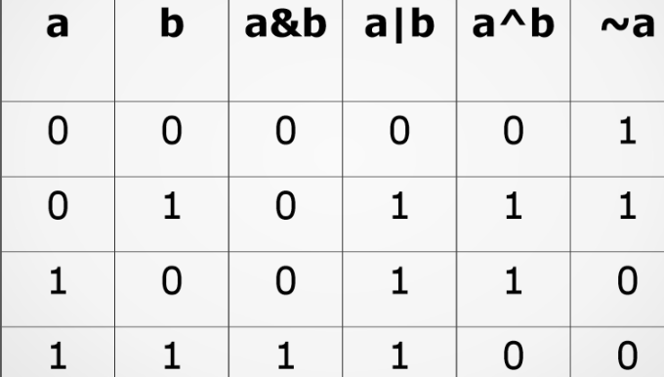
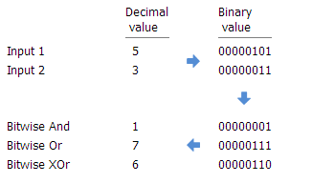
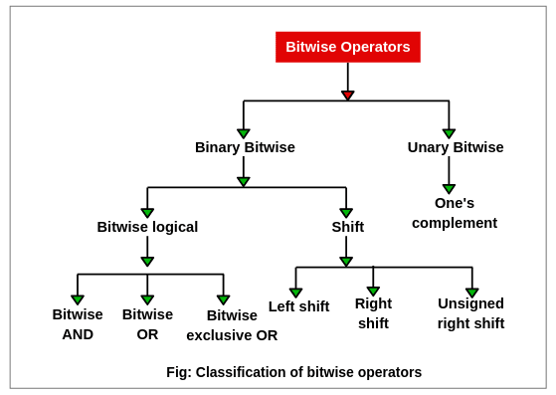
Single bit pe rule:
1 & 1 = 1
1 & 0 = 0
0 & 1 = 0
0 & 0 = 0
💡 Conclusion:
AND = weakest bit survives
Agar kahin bhi 0 mil gaya → result 0

3️⃣ Sochne ka Framework (Answer ka structure)
Assume karo final answer = X
Binary mein:
X = b_k b_(k-1) ... b_1 b_0
Ab ek bit lo, maan lo bit j
Case 1:
Agar X[j] = 1
👉 iska matlab:
har ai ka bit[j] = 1 hona hi padega
Case 2:
Agar kisi ek bhi element ka bit[j] = 0
👉 hum operations se X[j] ko 0 bana sakte hain
Aur kyunki goal hai maximum ko minimize karna,
👉 hum hamesha bit ko 0 banana prefer karenge.

4️⃣ CRUCIAL CLAIM (Proof ka heart ❤️)
🔥 Claim:
Final answer ka koi bit tabhi 1 ho sakta hai
jab array ke sabhi elements mein wo bit 1 ho

🧠 Proof (Logical + CP style)
- Agar kisi position j pe ek bhi element ka bit 0 hai
- To us element ko kisi bhi bade element ke saath AND karao
- Result: us bit ka permanent death (0)
👉 Iska matlab:
Jis bit ko hum 0 bana sakte hain,
use 1 rakhna BEWAKOOFI hogi

5️⃣ Isliye Final Answer kya banta hai?
Hum har bit ke liye puchte hain:
“Kya yeh bit sab mein 1 hai?”
- Haan → rakho
- Nahi → hata do
👉 Yeh EXACTLY karta hai:
a1 & a2 & a3 & ... & an
🎯 Isse chhota maximum possible hi nahi

6️⃣ BUT WAIT 🤯
“Sirf interval operations se kaise possible hai?”
Yahin log confuse hote hain.
Important baat:
- Tum kisi bhi element ko kisi bhi element ke saath indirectly AND kara sakti ho
- Kyunki:
  - Intervals overlap ho sakte hain
  - Operation unlimited times allowed hai
Example:
[11, 7, 15]
- 7 ke paas jo bit 0 hai
- Usse 15 ke saath AND karao
- 15 bhi gir jayega
Fir naya 15 kisi aur ko gira dega…
👉 Zero bits spread ho jaati hain (infection ki tarah) 🦠

7️⃣ Greedy kyun fail nahi hota?
Greedy rule:
“Jis bit ko 0 bana sakta hoon, bana do”
Why safe?
- Kyunki AND irreversible hai
- Koi future operation us bit ko wapas 1 nahi bana sakta
👉 No regret decision

8️⃣ Tricky Edge Cases (Exam favourite)
✅ Case 1: Single element
[5]
Answer = 5
✅ Case 2: Sab same
[7,7,7]
Answer = 7
✅ Case 3: Ek zero
[0, 10, 15]
Answer = 0
✅ Case 4: Large numbers
[10^9, 10^9, ...]
Safe (AND works bitwise)

9️⃣ Tumhara Code — Why PERFECT 💯
long totalAnd = a[0];
for (int i = 1; i < n; i++) {
totalAnd &= a[i];
}
✔ Logical
✔ Optimal
✔ Interview-ready
✔ No simulation headache

🔟 FINAL EXAM / INTERVIEW LINE ✨
“Since bitwise AND can only turn bits OFF, the minimum possible maximum equals the AND of all elements.”

