**Sign Language Detection**

Submitted in partial fulfillment of the requirements of the degree of

**BACHELOR OF COMPUTER ENGINEERING**

##### by

**Nidhi Singh(19102042)**

**Ishanee Revankar(19102040)**

**Nidhi Heniya (19102041)**

**Chirag Hegde (19102035)**

##### Guide

**Prof. Sofiya Mujawar**



**Department of Computer Engineering**

**A. P. SHAH INSTITUTE OF TECHNOLOGY, THANE**

**(2021-2022)**

**A. P. A.P SHAH INSTITUTE OF TECHNOLOGY**

# **Project Report Approval**

This Mini project report entitled **“Sign Language Recognition”**by **“Nidhi Singh (19102042), Ishanee Revankar (19102040) , Nidhi Heniya (19102041) , Chirag Hegde (19102035)”** is approved for the degree of ***Bachelor of Engineering*** in ***Computer Engineering***, ***2021-22***.

##### Examiner Name Signature

##### 1.

2. ________________________

##### Date:

Place:

**Declaration**

##### We declare that this written submission represents my ideas in my own words and where others' ideas or words have been included, I have adequately cited and referenced the original sources. I also declare that I have adhered to all principles of academic honesty and integrity and have not misrepresented or fabricated or falsified any idea/data/fact/source in my submission. I understand that any violation of the above will be cause for disciplinary action by the Institute and can also evoke penal action from the sources which have thus not been properly cited or from whom proper permission has not been taken when needed.



Nidhi Singh (19102042)



Ishanee Revankar(19102040)



Nidhi Heniya(19102041)



Chirag Hegde(19102035)

Date:

**Acknowledgement**

We have great pleasure in presenting the mini project report on **“Sign Language Recognition”.** We take this opportunity to express our sincere thanks towards our guide **Prof. Sofiya Mujawar,** Department of Computer Engineering, APSIT Thane and the project coordinator “**Prof. Rushikesh Nikam**”,Department of Computer Engineering, APSIT Thane for providing the technical guidelines and suggestions regarding line of work. We would like to express our gratitude towards his constant encouragement, support and guidance through the development of the project.

We thank **Prof. Sachin Malave, Head of Department**, Computer Engineering, APSIT for his encouragement during the progress meeting and providing guidelines to write this report.

We also thank the entire staff of APSIT for their invaluable help rendered during the course of this work. We wish to express our deep gratitude towards all our colleagues of APSIT for their encouragement.

**Student Name1: Nidhi Singh**

**Student ID1: 19102042**

**Student Name2: Ishanee Revankar**

**Student ID2: 19102040**

**Student Name3: Nidhi Heniya**

**Student ID3: 19102041**

**Student Name4: Chirag Hegde**

**Student ID4: 19102035**

#### Abstract

Sign language is the only way of communication for deaf and dumb people. Understanding human emotions is considered a pattern recognition problem. Sign languages use hand gestures, facial expression, and body movements for communication. There are many systems available for recognizing ASL, but ISL is the sign language used in India. The aim of our project is to develop a system, which recognizes ISL and converts them into human readable english text. Our focus is on recognizing 0 to 9 numbers and A-Z alphabets by training the machines with static images.  The complexity of ISL recognition system increases due to involvement of both hands.There is nearly no datasets available for ISL so we will be using our own dataset.

The proposed method uses digital image processing techniques and neural networks for recognizing different signs. In our project we will be focusing on recognizing hand movements for sign language interpretation. Mainly steps involved in sign language recognition-preprocessing are  feature extraction and classification. Our proposed method used CNN for gesture recognition and classification. Static images of hand gestures will be taken as an input to the convolutional neural network model that would predict and display the output in the form of text.

**CONTENTS**

| **Sr. no.** | **Topic** | Page no. |
| --- | --- | --- |
| 1. | Introduction | 9 |
| 2 | Literature Survey | 11 |
| 3 | Problem Statement | 16 |
| 4 | Objectives and Scope | 17 |
| 5 | Experimental Setup | 18 |
| 5.1 | Hardware requirements | 18 |
| 5.2 | Software requirements | 18 |
| 6 | System Design | 19 |
| 6.1 | Flow Diagram | 19 |
| 6.2 | Data Flow Diagram | 22 |
| 6.3 | Sequence Diagram | 23 |
| 7 | Project planning and Scheduling | 24 |
| 8 | Requirement Analysis and Methodology | 25 |
| 8.1 | Methodology | 25 |
| 8.2 | Libraries used | 28 |
| 9 | Implementation | 29 |
| 10 | Conclusion | 31 |
|  | References | 32 |
|  | Appendix | 34 |
|  | Appendix A | 34 |
|  | Appendix B | 35 |
|  | Appendix c | 36 |

**List of Figures**

| **Sr. no.** | **Figure** | **Page no.** |
| --- | --- | --- |
| 1.1 | Indian Sign language | 10 |
| 6.1.1 | Flow of modules | 19 |
| 6.1.2 | Creation of dataset | 20 |
| 6.1.3 | Working of system | 21 |
| 6.2.1 | Data Flow Diagram | 22 |
| 6.3.1 | Sequence Diagram | 23 |
| 7.1 | Gantt chart | 24 |
| 8.1.1 | CNN Architecture | 26 |
| 9.1.1 | Predicting the numbers | 29 |
| 9.1.2 | Predicting alphabets | 30 |

### 1. Introduction

Communication is an essential tool in human existence. It is a fundamental and effective way of sharing thoughts, feelings and opinions. However, a substantial fraction of the world's population lacks this ability . Many people are suffering from hearing loss, speaking impairment or both. A partial or complete inability to hear in one or both ears is known as hearing loss. On the other hand, mute is a disability that impairs speaking and makes the affected people unable to speak. If deaf-mute happens during childhood, their language learning ability can be hindered and results in language impairment, also known as hearing mutism. These ailments are part of the most common disabilities worldwide . Statistical report of physically challenged children during the past decade reveals an increase in the number of neonates born with a defect of hearing impairment and creates a communication barrier between them and the rest of the world.

Sign languages are used as a primary means of communication by deaf and hard of hearing people worldwide . It is the most potent and effective way to bridge the communication gap and social interaction between them and the able people. Sign language interpreters help solve the communication gap with the hearing impaired by translating sign language into spoken words and vice versa. However, the challenges of employing interpreters are the flexible structure of sign languages combined with insufficient numbers of expert sign language interpreters across the globe . According to the World Federation of Deaf, more than 300 sign languages are used by more than 70 million worldwide. Therefore, the need for a technology-based system that can complement conventional sign language interpreters.

This project helps mute-deaf people and people in general to communicate with each other with ease. Basic aim of this project is to detect the signs gestured by a person and convert it to English text. Considering ISL is a little complicated since both hands are used to gesture a sign, 0-9 numbers and A-Z alphabets will be detected using this project.

This project helps mute-deaf people and people in general to communicate with each other with ease. Basic aim of this project is to detect the signs gestured by a person and convert it to English text. Considering ISL is a little complicated since both hands are used to gesture a sign, 0-9 numbers will be detected using this project.

ISL for A-Z and 0-9:

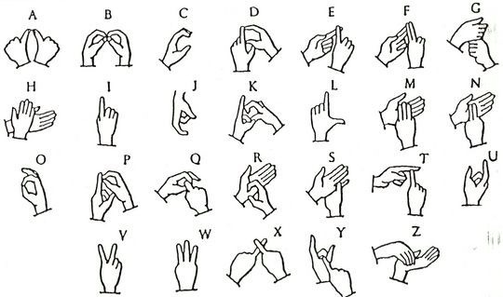

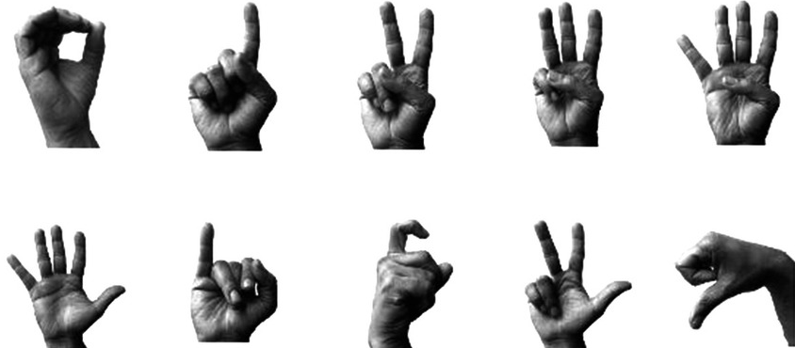

Fig 1.1 Indian Sign Language

### 2. Literature Survey

**Lionel Pigou ( B ) , Sander Dieleman, Pieter-Jan Kindermans, and Benjamin Schrauwen ELIS, “Sign Language Recognition Using Convolutional Neural Networks “,Ghent University, Ghent, Belgium:**

This will result in a representation consisting of one or more feature vectors, also called descriptors. The second step is the classiﬁcation of the action. A classiﬁer will use these representations to discriminate between the diﬀerent actions (or signs). The feature extraction is automated by using convolutional neural networks (CNNs). An artificial neural network (ANN) is used for classiﬁcation. Temporal segmentation is used to predict the begin and end frames of every gesture in the video sample. After preparing the dataset, the hand segmentation is done using a color segmentation method known as YCbCr color space. The image is converted to white and black by setting some constraints using Cb,Cr and Y values. Shape feature is derived from this binary image using distance transformation. Later row and column projector vectors are calculated from the distance transformed image.

**Adithya V. , Vinod P. R. , Usha Gopalakrishnan,”Artificial Neural Network Based Method for Indian Sign Language Recognition” ,Proceedings of 2013 IEEE Conference on Information and Communication Technologies (ICT 2013):**

Using Fourier Descriptors the handshape is represented.

The classification tool used is Artificial Neural Network . A feed forward neural network in combination with a supervised learning method is used.Accuracy achieved is 91% with less computation time.

The feature selected in this paper to reduce the recognition time is the number of finger tips in the image.

**Divya Deora ,Nikesh Bajaj,”INDIAN SIGN LANGUAGE RECOGNITION”,2012 1st International Conference on Emerging Technology Trends in Electronics, Communication and Networking**

Here thinning is done using distance transform.Corner points are found using Harris corner detection algorithm.PCA used for high dimensional data analysis (live data frames). Accuracy achieved is 94%.

After the acquisition of images, they are processed using Canny Edge Detection technique to extract edges of the palm.

P. Subha Rajam Dr. G. Balakrishnan,“Real Time Indian Sign Language Recognition

System to aid Deaf-dumb People”,J.J. College of Engineering & Technology,Trichy, Tamilnadu, India.

Various studies convey the difficulties in recognizing bare hands of the signer used to portray the signs due to noise and other hindrances .

Das, Aditya; Gawde, Shantanu; Suratwala, Khyati; Kalbande, Dhananjay (2018). [IEEE 2018 International Conference on Smart City and Emerging Technology (ICSCET) - Mumbai (2018.1.5-2018.1.5)] 2018 International Conference on Smart City and Emerging Technology (ICSCET) - Sign Language Recognition Using Deep Learning on Custom Processed Static Gesture Images.

The paper[5] presents the results obtained after retraining and testing the gesture dataset on a convolutional neural network model using Inception v3. The  developed model consists of multiple convolutional filters .

**J .  R. Balbin, D. A. Padilla, F. S. Caluyo, J. C. Fausto, C. C. Hortinela, C. O. Manlises, C. K. S. Bernardino, E. G. Finones, and L. T. Ventura, “Sign language word translator using neural networks for the aurally impaired  as  a  tool for  communication,” in Proc. 2016  6th  IEEE International Conference on Control System, Computing and Engineering (ICCSCE), 2016, pp. 425-429**

The approach taken by Balbin et al was to use colored gloves for hands. For recognizing hand gestures, input images underwent various image processing methods

This paper uses multiple image processing methods to recognize hand gestures. Initially, input images are converted into grayscale and a median filter is applied to denoise the image, the hand feature is detected and isolated from the background the model used is kohen self-organizing maps to identify patterns and groups dataset. The test accuracy of the above model is approximately 97.6%

**Fatmi, Rabeet; Rashad, Sherif; Integlia, Ryan (2019). [IEEE 2019 IEEE 9th Annual Computing and Communication Workshop and Conference (CCWC) - Las Vegas, NV, USA (2019.1.7-2019.1.9)] 2019 IEEE 9th Annual Computing and Communication Workshop and Conference (CCWC) - Comparing ANN, SVM, and HMM based Machine Learning Methods for American Sign Language Recognition using Wearable Motion Sensors.**

In the study they have compared the results of artificial neural networks ,support vector machines and hidden Markov based methods to recognize ASL Language.They collected data from Mayo armbands. A neural network was constructed with 26 features and 13 classes using  a feed-forward network .It was a fully connected network.

SVM is a binary classification technique. The comparison was based on the recognition accuracy. The individual instance classification was used for ANN and SVM while the grouped instance classification was used for the HMM. The ANN method yielded an overall accuracy of 93.79% in terms of correctly recognized test instances and the best recognition accuracy result for SVM was 89.05% .The best performance of the HMM technique is reported at 85.90% . Referring to various conducted experiments, it was concluded that ANN has a better performance compared to other techniques

**Tolentino, Lean Karlo S., et al. "Static sign language recognition using deep learning." International Journal of Machine Learning and Computing 9.6 (2019): 821-827. Vol. 9, No. 6, December 2019**

The research done in paper is based on recognizing  American sign language that includes gesture  and  alphabet recognition.The researchers have used convolutional neural networks for classification of images and keras for training. The proposed system uses skin-color modeling technique,a skin color  range is explicitly defined in order to differentiate the hand pixels from the pixels of the background .The accuracy achieved through this method was around 93.76% , 90.04% accuracy was achieved by ASL alphabet recognition ,97.52% for static word recognition and 93.44% for number recognition.According to the study SLR architecture is based on two different ways of inputs: data glove based and vision based .Using smart gloves it is easier to get the position of hands and the orientation but has limited movement . Vision based sign language recognition involves the feature extraction step, in this method image is given to the system and images are processed and features are extracted from it by image processing and computer vision method, then the recognizer learns from the patterns of the dataset of  image and through machine learning algorithm it recognizes the image.

**Sahoo, A. K. (2021). Indian Sign Language Recognition Using Machine Learning Techniques. Macromolecular Symposia, 397(1), 2000241. doi:10.1002/masy.202000241**

In the proposed system vision based approach is deployed , a web camera is used to obtain data from the signer . They converted some of the letters in ASL alphabet so that it does not affect the accuracy of the system .Thirty five words were chosen and divided into four categories: family, communication ,and transportation. The methods used in this paper are gathering training data. That was done by capturing images using python . Images were then converted into black and white then skin color was detected by using cv2.cvtColor. The convolutional layer used 16 filters with 2*2 kernel. The resulting system was tested by thirty individuals.The study in this paper is automatic sign language recognition based on a random forest machine learning algorithm.

The model is evaluated on two sign languages that are British SL and GreekSL .The system uses a low level visual features to recognize the sign language and achieved an accuracy of about 95%.

**2017 International Conference on Innovations in Information Embedded and Communication Systems (ICIIECS) Miss. Juhi Ekbote Final Year Student of ME (Computer Engineering), B.V.M, VV Nagar, Gujarat, India , Mrs. Mahasweta Joshi Assistant Professor B.V.M, VV Nagar, Gujarat, India.**

According to study, each sign consists of phonemes such as hand -shapes ,locations and movements that are made using one or both the hands . This paper uses the idea that signs can be broken into phonemes and then processed . This system uses a vision based method for sign detection. The methods used in the system are image capturing , skin detection ,feature extraction , modeling and identification of signs . The cameras are used to take the images and skin color is used to detect the hands. The problem in this case is that the perfect skin color range may not be the same for all the captured video and some objects in the background may have the same color as those of the hands. For the purpose of feature extraction the hand shapes are encoded using seven hu-moments and movements as XORs of two consecutive location grids . To encode the hand location they have used a 10 by 10 matrix with the center of the face used as reference, Viola jones face detector is used to detect the face. The size of the face is determined using data and implementation provided in Opencv library. In this study they have mentioned that ideal sign language is independent of context, content and vocabulary and robust with regard to signer identity.

To encode the types of body movements they compared the locations of hands/face in the current frame with respect to the previous frame. The motion is then captured by XORing (the absolute of pairwise element subtraction) two frame location vectors. The location vectors are obtained from the cell grids. In modeling Random forest algorithms are used that generate many decision tree classifiers and aggregate their result , the random sampling is done of features at every node that prevents from overfitting. The system is trained on 50% of the dataset and tested on the other 50% of dataset. The system was trained randomly on clips of eleven signers and tested on clips of eight singers. The model is evaluated in terms of precision, recall and F1 score and achieves an accuracy of 95% .

**Gebre, Binyam Gebrekidan; Wittenburg, Peter; Heskes, Tom (2013). [IEEE 2013 20th IEEE International Conference on Image Processing (ICIP) - Melbourne, Australia (2013.09.15-2013.09.18)] 2013 IEEE International Conference on Image Processing - Automatic sign language identification**

The research work in this system aims at developing an automatic recognition system for Indian sign language numerals . They have used their own database that consists of 1000 images, 100 images representing every sign. The system uses Shape descriptors ,Scale invariant feature transform and )and Histogram of Oriented Gradients (HOG) techniques are used for extracting desired features.

The shape descriptors are used to separate the fragmented picture and HOG descriptors are used to protest that the shape inside a picture can be depicted by the dispersion of force slopes or edge bearings.The Scale invariant feature transform algorithm is used to extricate particular invariant keypoints from images that can be utilized to perform dependable coordination between various perspectives of a question or scene since all the images have different number of keypoints, but the accuracy achieved through this method is very less. The next step is classification, Features extracted during the feature extraction phase are given as an input to classification step. Two different methods are used for classification Support vector machines that produce very accurate results and utilize bolster vectors to delineate information from info space to a high-dimensional element space which encourages the issue to be handled in straight shape.

ANN is a neural network algorithm, its network consists of one input layer, one output layer and two hidden layers. The cases are shown to the framework through the neurons in the data layer and the yield of the structure is secured by the neurons in the yield layer.

The classification of signs is done using Artificial neural network and a support vector machine. The model created achieves an accuracy of 99%. According to the given study :Static gestures and Dynamic Gestures. Static gestures consist of only poses and configurations whereas dynamic gestures contain strokes, postures and phases. The dynamic gestures frequently include movement of body parts and emotions. The system includes four major steps: Data Acquisition , processing ,segmentation and feature extraction and classification .

The database is generated by capturing videos , it consists of 10 signers and numerals range from 0 to 9 , the database is divided into two sets: training and testing. After collecting the images are processed.This step is performed before extracting the features, so that the most useful information can be produced neglecting the redundant and noisy data. In order to recognize skin shading in the picture, it is at first changed over to YCbCr shading space. This paper uses an rgb cbr to convert RGB images to YCbCr model. The resulting image is a binary image formed after segmentation. Feature extraction is done to reduce the dimension of frames. Experimental results demonstrate that a combination of HOG and ANN provides the accuracy as high as 99%.All the results have combined and an accuracy of 93% is achieved.

In this research paper A new feature extraction and selection technique using structural features and some of the best available classifiers are proposed to recognize ISL signs for better communication for computer-human interface. They have used a dataset containing 5000 images of which 500 images are present for each numeral sign. They have used Naïve bayes classifier and k-nearest neighbor for training the model.

In this paper they have used a K-mean classifier model and dataset containing 50 variations of single gesture with lighting different conditions . In this approach, the image is captured through a webcam attached to the system. First the input image is preprocessed and threshold is used to remove noise from image and smoothen the image. Features are extracted from the images using Hu moment invariant and then text is converted into speech.

### 

### 

### 3. Problem Statement

To implement a system that recognizes Indian Sign Language and converts it to readable English text in real time, making it easier for specially abled people to communicate .

### 

### 

### 

### 

### 4. Objectives and Scope

### Objectives

The objective of our project is to build a system which recognizes Indian Sign Language.

* To detect signs gestured (in ISL).
* To convert the detected signs to English language and display them.
* To detect signs for numbers 0-9.
* To detect signs for selective alphabets from A-Z

### Scope

The model is designed for ISL number and alphabet recognition. This will require a system that can detect changes with respect to the temporal space. We can develop a complete product that will help the speech and hearing impaired people, and thereby reduce the communication gap. Our system detects real time signs for numbers 0-9,and alphabets from A-Z via a webcam; these detected signs then are converted to text and get displayed on the screen.

### 5. Experimental Setup

#### Hardware requirements

* Operating Systems-Ubuntu,Windows
* High Speed RAM
* Fast Processor

#### Software requirements

1. Python: General Programming Language used to code the model, includes several libraries.
2. Python libraries: Numpy, scipy,keras,tensorflow, PIL (Python Imaging Library), pandas, os.
3. Pip:pip is the package installer for Python. You can use it to install packages from the Python Package Index and other indexes.
4. VS Code/ Anaconda: IDE to run, train and test the ML model. Plenty of extensions, open-source, cross-platform support.Visual Studio Code is a streamlined code editor with support for development operations like debugging, task running, and version control.
5. Git & GitHub: Version Control System used for collaboration.
6. TeamGantt:TeamGantt is a cloud-based Gantt chart and project planning solution for small, midsize and large enterprises. It offers project collaboration tools such as collaborative Gantt charts, time tracking, file sharing and task-level communication features.

**6. System Design**

### 6.1 Flow Diagram

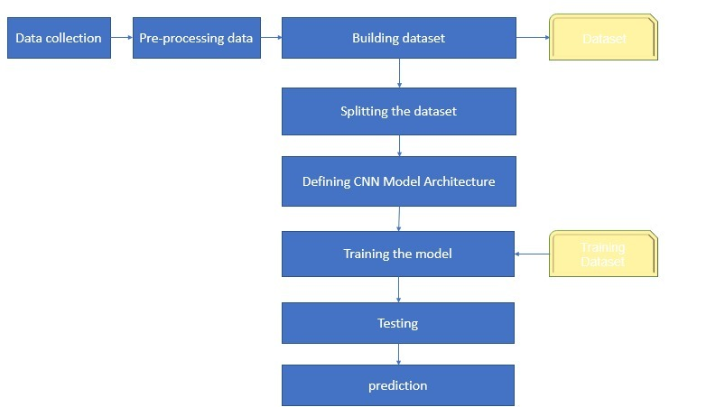

Fig 6.1.1: Flow of modules

Data is collected and pre-processed and then this pre-processed data is put together to form a dataset, this dataset is then split into training and testing sets and then passed on to the CNN model, Dataset is trained and tested and on the basis of trained dataset predictions are done.

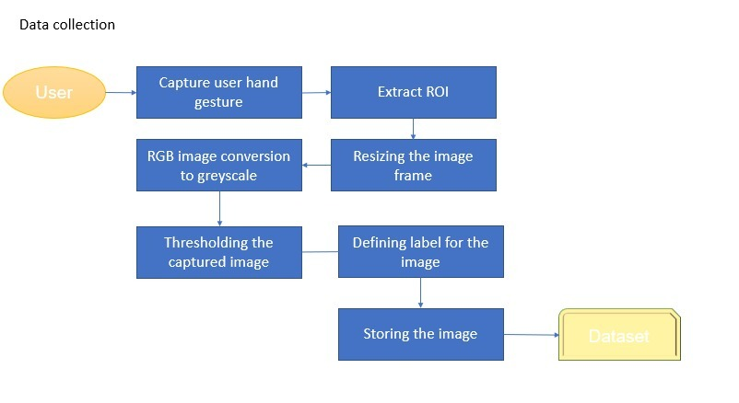

Fig 6.1.2 Creation of dataset

With the help of webcam, frames are captured, from this captured frame, ROI is extracted, then the resizing is done, this resized RGB image is converted to Grayscale and then the threshold is applied, this transformed image is then stored under a specific label into the dataset.

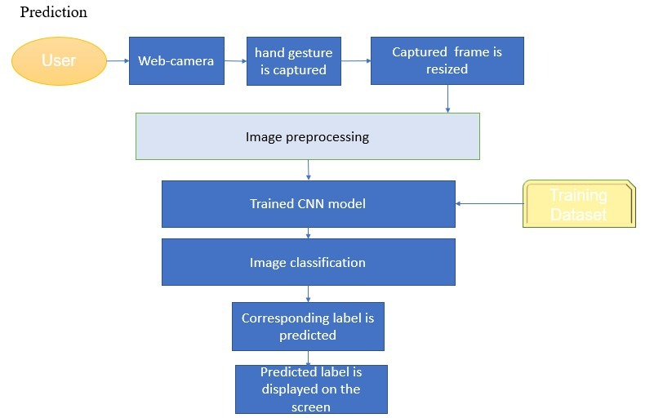

Fig 6.1.3 Working of system

User signs are captured from webcam, frame captured is resized and then the image is processed and then passed to trained CNN model prediction is done, image is classified and corresponding label of the image is displayed on the screen.

**6.2 Data Flow Diagrams**

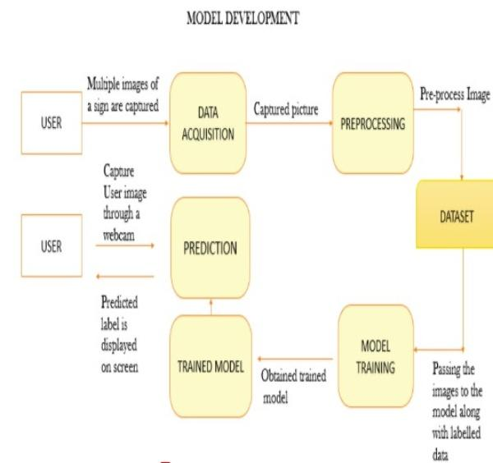

Fig 6.2.1: Data Flow Diagram

Images captured are processed and put into dataset, from there after splitting the dataset, those images are sent to the model for training, captured image is then put in the model too and prediction is done, this predicted label is then displayed on the screen.

**6.3 Sequence Diagram**

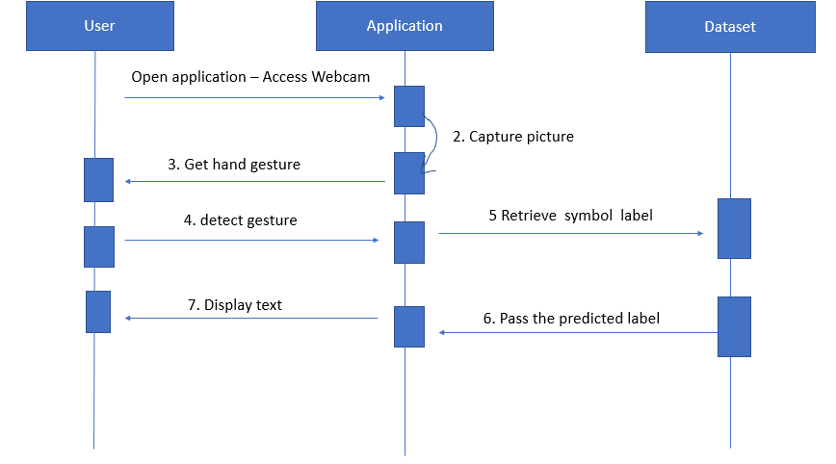

### Fig 6.3.1: Sequence Diagram

Above diagram depicts the sequence of the project.The project consists of User,Application,Dataset.

Firstly,user opens the webcam to access the application,then captures the picture ,the gestures gets recognized and displays the predicted text

### 7.Project Planning and Scheduling

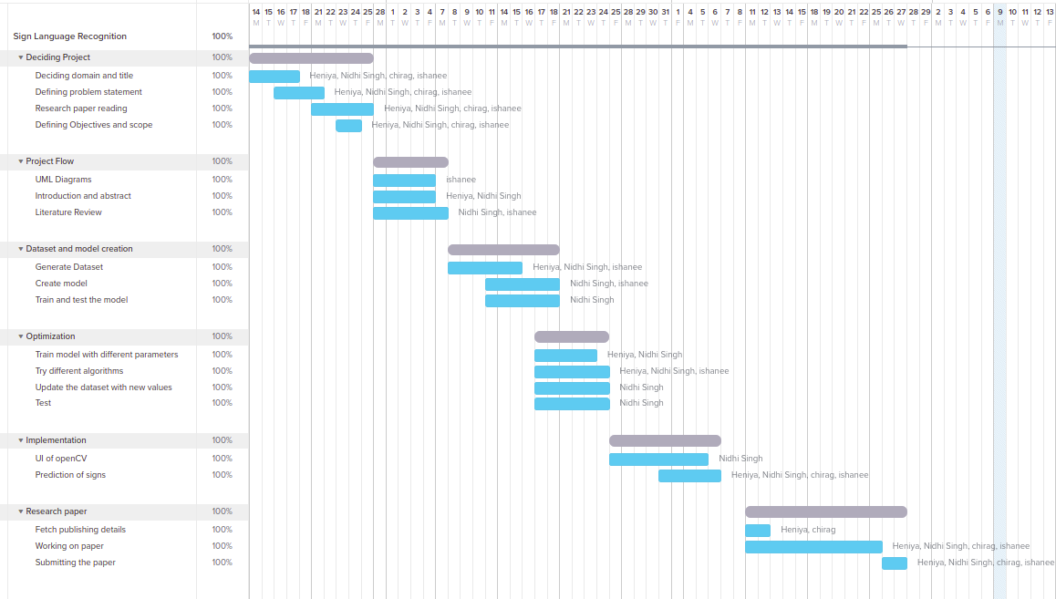

Fig 7.1 Gantt Chart

### 8. Requirement Analysis & Methodology

Operating Systems such as Windows, Linux or MAC can be used, A minimum of 4 to 8 GB RAM is required to process the heavy models. At least 2.8Ghz CPU speed would be required. Visual Studio Code is a code editor redefined and optimized for building and debugging modern web and cloud applications. For running a project in data science or data visualization, one could use Jupyter notebooks inside VS Code. Python is an interpreted, high-level and general-purpose programming language. Our project uses OpenCV to access webcam via which input in the form of signs’ frames are captured and then processed.

**8.1 Methodology:**

The system is a vision based approach. All the signs are represented with bare hands and so it eliminates the problem of using any artificial devices for interaction.

Dataset Generation:

There are various datasets available for ASL,but the availability of dataset in the form of raw images for ISL was hard to find.So we have used our own dataset

Step1:OpenCV library is used to capture the images for our dataset.We captured 120 images for each symbol ,for the train set and around 12 images for the test set.

Step 2:We capture the frame shown by the webcam.In each frame we have defined ROI(region of interest) denoted by blue rectangle

Step 3:We extract the frame inside the ROI ,which is in RGB.later we convert it into grayscale

Step 4:Apply threshold to the captured frame to get processed image

Processed image is passed through the CNN model

CNN Model:

CNN stands for convolutional neural network.It is most widely used for image classification.

In the layers of CNN, the neurons are arranged in 3 dimensions: width, height, depth. The neurons in a layer will only be connected to a small region of the layer (window size) before it, instead of all of the neurons in a fully-connected manner. Moreover, the final output layer would have dimensions (number of classes), because by the end of the CNN architecture we will reduce the full image into a single vector of class scores.

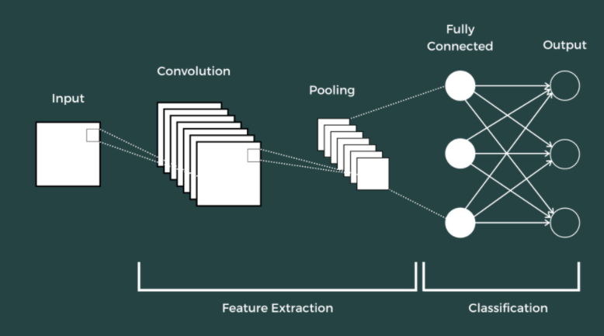

Fig 8.1.1 CNN Architecture

1. Convolution layer:

The first layer to extract information from the images in a CNN is the convolution layer.The relationship between pixels are preserved by learning the features in the images.This layer takes in two inputs:image matrix and a filter or kernel,and performs the dot product between the two.

Here we take a small window size that extends to the depth of the input matrix.During every iteration we slide the window by stride size.As we continue this process we will create a 2-Dimensional activation matrix that gives the response of that matrix at every spatial position.

2. Strides:

Stride is the number of pixels shifted over the input matrix. When the stride is 1 then we move the filters to 1 pixel at a time. When the stride is 2 then we move the filters to 2 pixels at a time and so on

3. Activation function:

The main purpose of Activation function is to introduce non-linearity into the output of neuron.Activation function makes the back propagation possible

ReLU(Rectified linear unit):

ReLU introduces non-linearity.It is implemented in hidden layers of Neural Network.

It computes the function ƒ(κ)=max (0,κ).It is basically the threshold at zero.

ReLU is better in performance in comparison to tanh or sigmoid.

4. Pooling Layer :

Pooling layer is used to decrease the size of the activation matrix and this in turn reduces the learnable parameters.

Pooling layers reduces the number of parameters when the images are too large. It helps in reducing the spatial size of the representation, which decreases the required amount of computation and weights. The pooling operation is processed on every slice of the representation individually.There are two types of pooling :

a) Max Pooling : In max pooling we take a window size , and only take the maximum of all the values.

b) Average Pooling : In average pooling we take average of all values in a window

5. Fully connected layer:

Neurons in this layer have full connectivity with all neurons in the preceding and succeeding layer. This is why it can be computed as usual by a matrix multiplication followed by a bias effect.The FC layer helps to map the representation between the input and the output.The layer we call as FC layer, we flattened our matrix into vector and feed it into a fully connected layer like a neural network.

Dataset consists of around 250 images per signs

Filter used is of size 3x3

**8.2 Libraries used:**

* OpenCV:OpenCV(Open Source Computer Vision) is an open source library of programming functions used for real-time computer-vision. It is mainly used for image processing, video capture and analysis for features like face and object recognition. It is written in C++ which is its primary interface, however bindings are available for Python, Java, MATLAB/OCTAVE.
* Tensorflow:Tensorflow is an open source software library for numerical computation. First we define the nodes of the computation graph, then inside a session, the actual computation takes place. TensorFlow is widely used in Machine Learning.
* keras:Keras is a high-level neural networks library written in python that works as a wrapper to TensorFlow. It is used in cases where we want to quickly build and test the neural network with minimal lines of code. It contains implementations of commonly used neural network elements like layers, objective, activation functions, optimizers, and tools to make working with images and text data easier.
* numpy:NumPy, which stands for Numerical Python, is a library consisting of multidimensional array objects and a collection of routines for processing those arrays. Using NumPy, mathematical and logical operations on arrays can be performed.
* pil:Python Imaging Library (expansion of PIL) is the de facto image processing package for Python language. It incorporates lightweight image processing tools that aids in editing, creating and saving images.

### 

### 

### 9. Implementation

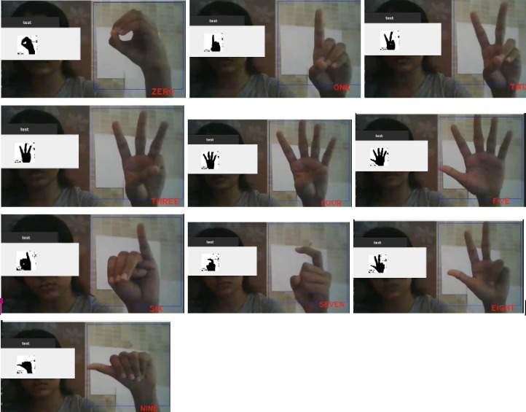

Fig 9.1.1 Predicting the numbers

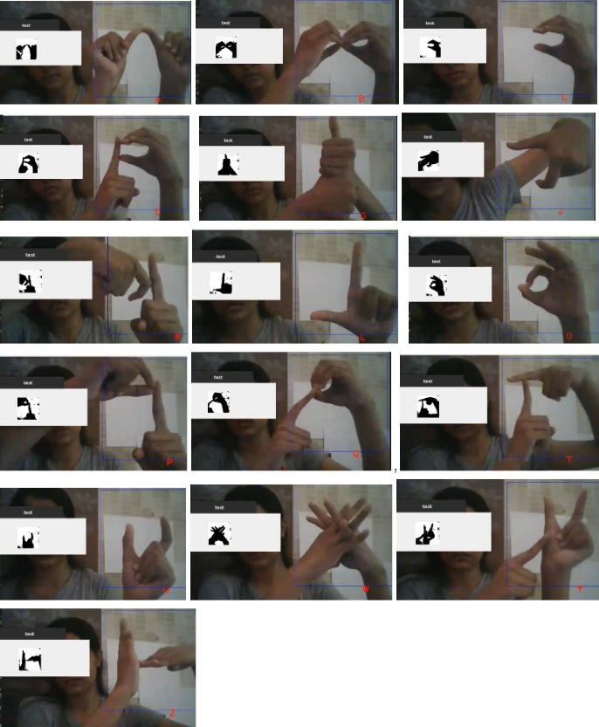

### Fig 9.1.2 Predicting alphabets

### 10. Conclusion

This project successfully detects the signs and converts it to text. In future this will be extended to detecting sign language as whole, i.e including alphabets, greetings and complete sentences. We are planning to make this system dual-side useful, i.e along with abled people, disabled people too would be able to use it. Guides to ISL and videos for basic greeting and useful signs will be included. “Reduced communication gap” is to be achieved.

### References

### 

[1] Lionel Pigou ( B ) , Sander Dieleman, Pieter-Jan Kindermans, and Benjamin Schrauwen ELIS, “Sign Language Recognition Using Convolutional Neural Networks “,Ghent University, Ghent, Belgium

[2] Adithya V. , Vinod P. R. , Usha Gopalakrishnan,”Artificial Neural Network Based Method for

Indian Sign Language Recognition” ,Proceedings of 2013 IEEE Conference on Information and Communication Technologies (ICT 2013)

[3] Divya Deora , Nikesh Bajaj,”INDIAN SIGN LANGUAGE RECOGNITION”,2012 1st International Conference on Emerging Technology Trends in Electronics, Communication and Networking

[4] P. Subha Rajam Dr. G. Balakrishnan,“Real Time Indian Sign Language Recognition

System to aid Deaf-dumb People”,J.J. College of Engineering & Technology,Trichy, Tamilnadu, India.

[5] Das, Aditya; Gawde, Shantanu; Suratwala, Khyati; Kalbande, Dhananjay (2018). [IEEE 2018 International Conference on Smart City and Emerging Technology (ICSCET) - Mumbai (2018.1.5-2018.1.5)] 2018 International Conference on Smart City and Emerging Technology (ICSCET) - Sign Language Recognition Using Deep Learning on Custom Processed Static Gesture Images.

[6] J .  R. Balbin, D. A. Padilla, F. S. Caluyo, J. C. Fausto, C. C. Hortinela, C. O. Manlises, C. K. S. Bernardino, E. G. Finones, and L. T. Ventura, “Sign language word translator using neural networks for the aurally impaired  as  a  tool for  communication,” in Proc. 2016  6th  IEEE International Conference on Control System, Computing and

Engineering (ICCSCE), 2016, pp. 425-429

[7] Fatmi, Rabeet; Rashad, Sherif; Integlia, Ryan (2019). [IEEE 2019 IEEE 9th Annual Computing and Communication Workshop and Conference (CCWC) - Las Vegas, NV, USA (2019.1.7-2019.1.9)] 2019 IEEE 9th Annual Computing and Communication Workshop and Conference (CCWC) - Comparing ANN, SVM, and HMM based Machine Learning Methods for American Sign Language Recognition using Wearable Motion Sensors.

[8]Tolentino, Lean Karlo S., et al. "Static sign language recognition using deep learning." International Journal of Machine Learning and Computing 9.6 (2019): 821-827. Vol. 9, No. 6, December 2019

[9]Vijay More Sanket Sangamnerkar Dept. of Information Technology, Dept.of Information Technology, AISSMS Institute of Information Technology AISSMS Institute of Information Technology Pune, India Pune,India vijaymore85@gmail.com sanketsangamnerkar100@gmail.com Vaibhav Thakare Dnyaneshwari Mane Dept.of Information Technology, Dept.of Information Technology, AISSMS Institute of Information Technology AISSMS Institute of Information Technology Pune,India Pune,India

[10] Sahoo, A. K. (2021). Indian Sign Language Recognition Using Machine Learning Techniques. Macromolecular Symposia, 397(1), 2000241. doi:10.1002/masy.202000241

[11] 2017 International Conference on Innovations in Information Embedded and Communication Systems (ICIIECS) Miss. Juhi Ekbote Final Year Student of ME (Computer Engineering), B.V.M, VV Nagar, Gujarat, India , Mrs. Mahasweta Joshi Assistant Professor B.V.M, VV Nagar, Gujarat, India.

[12]Gebre, Binyam Gebrekidan; Wittenburg, Peter; Heskes, Tom (2013). [IEEE 2013 20th IEEE International Conference on Image Processing (ICIP) - Melbourne, Australia (2013.09.15-2013.09.18)] 2013 IEEE International Conference on Image Processing - Automatic sign language identification

**Appendix**

**Appendix A**

**Python Download and Installation**

1. Visit the official website and go to https://www.python.org/downloads/. Click the Download button.
2. Once we click the download button, it might ask for a location to save the file. Select an appropriate location and then proceed towards the installation.
3. Double Click the downloaded .exe file and select the Add Python to PATH checkbox below to ensure it is automatically added to the Windows Environment variable. Else we have to do it later on manually. Once the box is checked, click on Install Now.
4. At the time of installation of python, the pop-up will show like the installation is in progress here.
5. Once the setup is complete, we will get a message like this. Click on the Close button to finish the installation of python.
6. Once Python is installed, go to the Windows search bar and type Python, and we will find a desktop app called Python 3.7 (32-bit). Click on that and a command prompt will open.

**Appendix B**

**VS Code Download and Installation**

1. Download VS code from<https://code.visualstudio.com/download>
2. Download the Visual Studio Code installer for Windows. Once it is downloaded, run the installer (VSCodeUserSetup-{version}.exe). Then, run the file

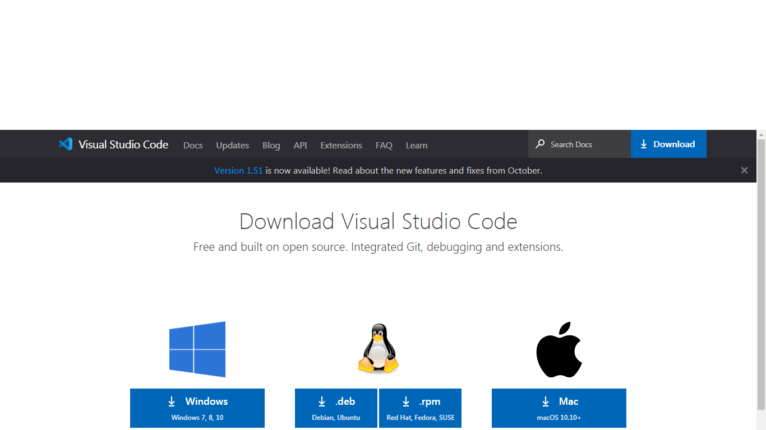

1. Accept the agreement and click “next.”
2. After accepting all the requests press the finish button. By default, VS Code installs under: **“C:\users{username}\AppData\Local\Programs\Microsoft VS Code.”**
3. If the installation is successful, you will see the following

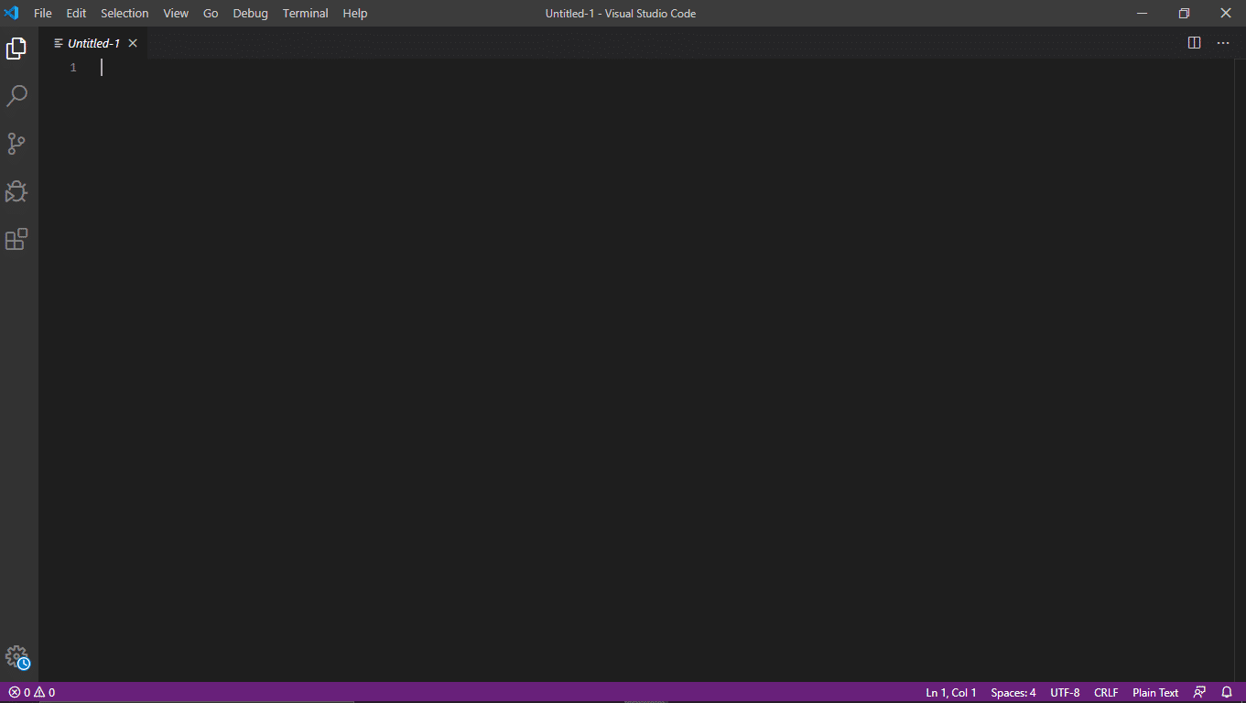

1. Install the Jupyter Extension for Visual Studio Code



**Appendix C**

**Installing necessary python libraries**

Install the following requirements using *pip install requirements.txt*

