A Mini Project Report

on

“Online Personal Counselling”

Third Year of Engineering

In

Information Technology

By

Nilesh Gond (Roll No. 23)

Aman Gupta (Roll No. 25)

Chanchal Gupta (Roll No. 26)

Hridyansh Gupta (Roll No. 27)

Nidhi Gupta (Roll No. 28)

**Information Technology**

**Thakur College of Engineering and Technology, Kandivali**

**2019-20**

**CERTIFICATE**

This is to certify that the students of Third Year **“Information Technology”**  Engineering at Thakur College of Engineering and Technology, have satisfactorily completed the requirements of the PROJECT under Employability Skills Development Programme - 2020 while working on “**Online Personal Counselling”**

**Mr. Shailesh Sangle**

**T&P Coordinator**

**Mr. Amol Dapkekar**

**Training Coordinator**

**Dr. Zahir Aalam**

**Professor (TPO)**

**Dr. B. K. Mishra**

**Principal**

**Internal Examiner:**

**Signature with Date: ……………..**

**Name: ……………………………..**

**External Examiner:**

**Signature with Date: ………….. Name: ………………………….**

PLACE: Mumbai

DATE:



INDEX

|  |  |
| --- | --- |
| **Sr No** | **Title** |
|  | Executive Summary |
|  | Problem Statement |
|  | Description |
|  | Finding |
|  | Implementation |
| 6. | Result & Discussion |
| 7. | Impact Study |
| 8. | Conclusion |
| 9. | References |

**EXECUTIVE SUMMARY**:

In order to improve the services related to counselling process, we came up with online personal counselling application which will support the people of society in getting required help about the educational ,mental counselling . Counselling is the process that includes different types of activities such as guiding students towards colleges and universities, supporting them mentally, providing full guidance in getting the information related to their education process as well as mental health. This online counselling system even gives great support to doctors , mental health experts and students to connect with each other, through which they can totally reduce the paper usage for counselling and guiding them towards their betterment. Basically this software includes different options such as registration ,login, appointment and Skype link to connect doctors and patients.

**PROBLEM STATEMENT:**

To develop an application for Online Personal Counselling.

**DESCRIPTIONS:**

Online counselling, once termed alternative therapy, is now becoming a common practice preferred by both clients and therapists . It has been praised for bridging the gap that existed with traditional face to face therapy around issues such accessibility, convenience, affordability and more.

Online counselling application is the provision of professional mental health counseling services through the Internet. Services are typically offered via email, real-time chat, and video conferencing.

Online therapy is convenient. Both the therapist and the client have the convenience of corresponding with each other at a range of variant times.

Web counselling has been shown to be more economical for both the therapist and the client.

**FINDING:**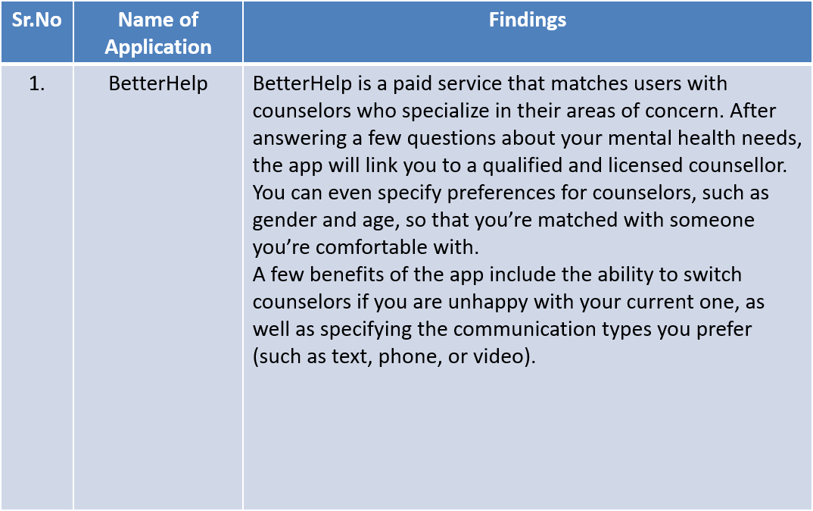

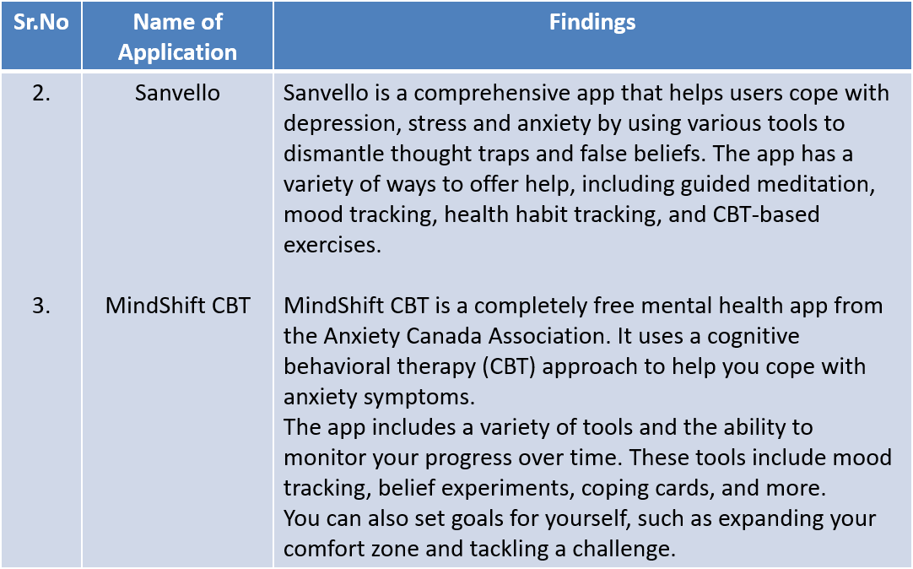

**IMPLEMENTATION:**

Software Used:

* Xampp
* Sublime Text Editor

Programming Language:

* PHP
* CSS
* Javascript
* HTML

Some GUIs:

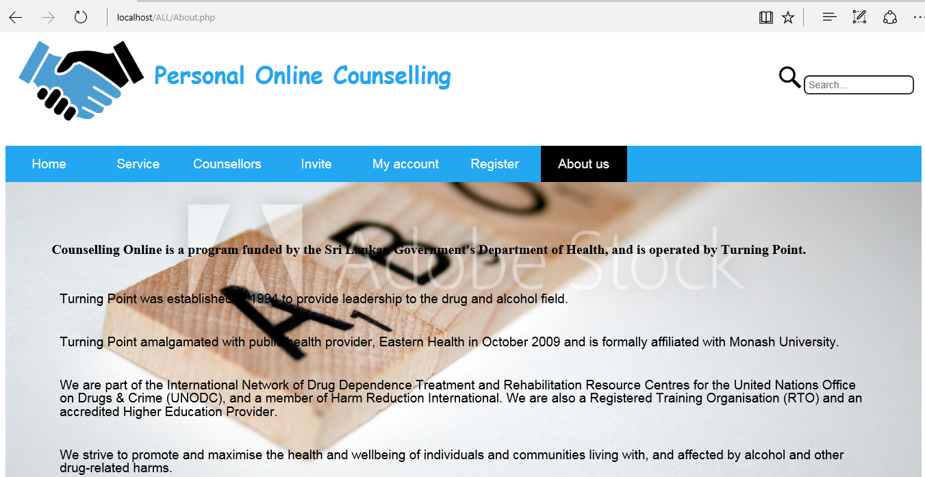

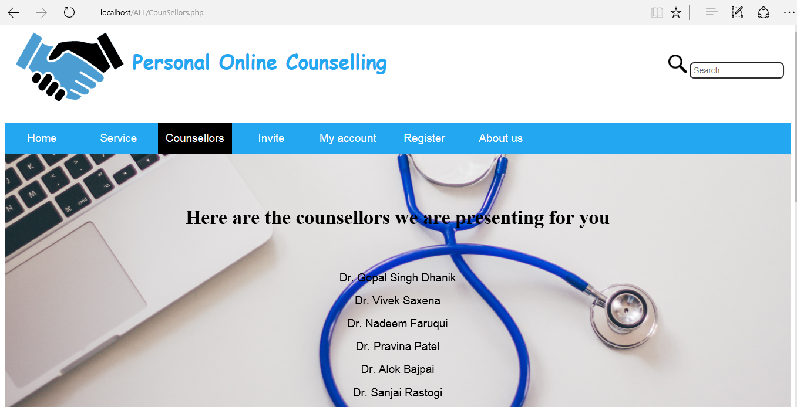

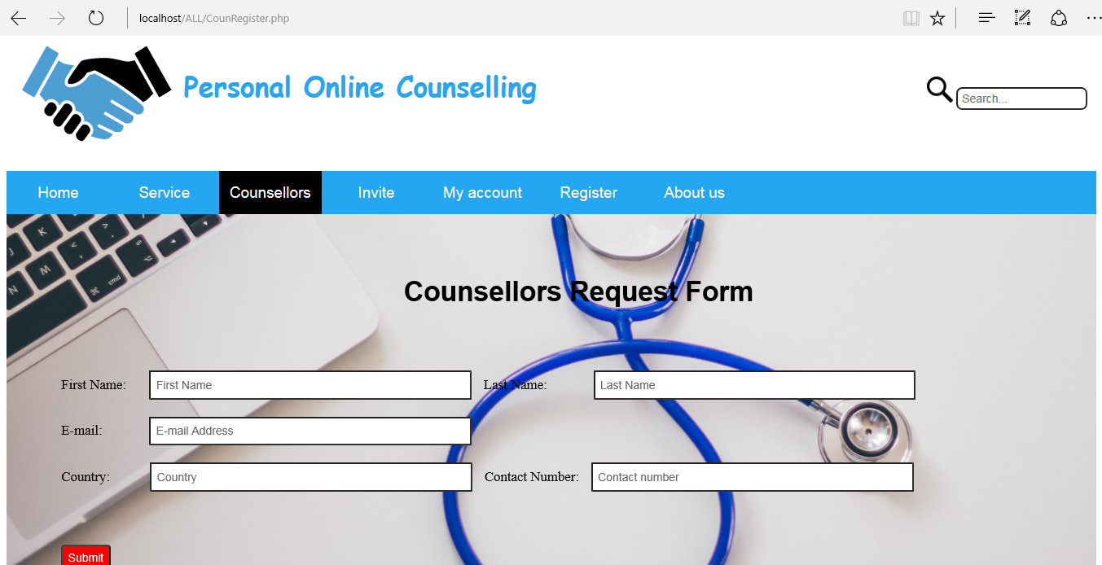

**RESULT & DISCUSSION:**

Online Personal Counseling is filling the unmet need for clients located in areas traditionally under-served by traditional counselors.It has also been observed that Online counseling has been shown to be effective for clients who may have difficulty reaching appointments during normal business hours,while decreasing the number of missed appointments for in-person therapy.

**IMPACT STUDY:**

Our application will help individuals residing in rural or remote areas where there is no counselling services so they can benefit from the accessibility of online counselling. Those that are physically disabled or unable to leave their home can also easily access such services with little inconvenience.

**CONCLUSION:**

We tried to develop online personal counselling website which is indeed a platform wherein we connect users to counsellors.

It has been found that online therapy is preferred by those who are uncomfortable with talking face to face with someone about their problems or who are suffering from social phobias, agora phobias or anxiety disorders.

**REFERENCE:**

1] [www.google.com](http://www.google.com)

2] <https://www.ibdrelief.com/mind/support-and-help/counselling-introduction>

3] <https://www.iac-irtac.org/>