PES UNIVERSITY
Department of Computer Science and Engineering
Software Engineering
Software Architecture and Design Specification
Project: Change Management Software
Team: Team 16
Version: 1.1
Authors: Nidhi S, Harshith, Uthkarsh
Date: 19-10-2026
Status: Draft

Revision History
Version | Date | Author | Change Summary
1.0 | 13-09-2026 | Team 16 | Initial draft
1.1 | 19-10-2026 | Team 16 | Added diagrams, API table and data model; aligned stack and scope with Sprint plan

Approvals
Role | Name | Signature / Date
Course Coordinator | Arpitha.K, Assistant Professor
Project Guide | Arpitha.K, Assistant Professor

1. Introduction

1.1 Purpose
This document specifies the architecture and design of the Change Management Software (CMS).

1.2 Scope
Covers the core change-management flow that will be implemented in the two sprints: login with roles, change request submission, risk fields, CAB approval, scheduling with a blackout check, implementation tracking, in-app notifications, and an audit log. Features marked as deferred in the SRS are documented but not built.

1.3 Audience
Developers, QA engineers, the project guide, and the three-member student team (Nidhi, Harshith, Uthkarsh).

1.4 Definitions
CMS, CR (Change Request), CAB (Change Advisory Board), RBAC (Role-Based Access Control), ADR (Architecture Decision Record), API (Application Programming Interface).

2. Document Overview

2.1 How to Use This Document
Provides the architecture, UML diagrams, API design, data model, and security approach for the CMS.

2.2 Related Documents
SRS, STP, RTM, and the Sprint Plan (SPRINT_PLAN.md in the repository).

3. Architecture

3.1 Goals & Constraints
Goals: simple, secure, and maintainable. Constraints: three-member student team, two one-week sprints (19-23 Oct and 26-30 Oct 2026), and role-based access on every feature.

3.2 Stakeholders & Concerns
- Requesters: easy submission and visible status
- CAB Approvers: clear risk information and a record of decisions
- Implementers: simple status updates
- Administrators: control over roles and users
- Development team: small, modular code that three people can split

3.3 Component (UML) Diagram
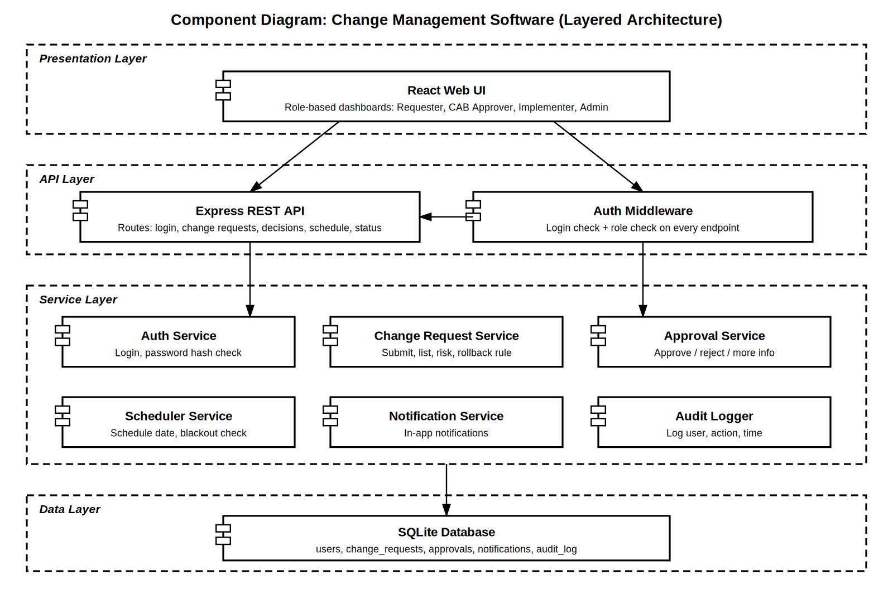

3.4 Component Descriptions
- React Web UI: role-based screens for Requester, CAB Approver, Implementer, and Admin.
- Express REST API: exposes the routes listed in section 4.3.
- Auth Middleware: checks login and role on every endpoint.
- Auth Service: verifies username and hashed password.
- Change Request Service: submit, list, risk level, and the rollback-plan rule.
- Approval Service: approve, reject, or request more information with comments.
- Scheduler Service: stores the scheduled date and checks it against blackout dates.
- Notification Service: creates in-app notifications on status changes.
- Audit Logger: records user, action, and time for each CR action.
- SQLite Database: stores users, change requests, approvals, notifications, and audit log.

3.5 Chosen Architecture Pattern and Rationale
A layered architecture (presentation, API, service, data) was chosen for clear separation of concerns and because it is easy for a small team to split work. Microservices were rejected as too complex for the project's scale.

3.6 Technology Stack & Data Stores
Backend: Node.js with Express (REST APIs). Frontend: React. Database: SQLite, using the same SQL schema that could later move to MySQL or PostgreSQL. Passwords are hashed with bcrypt and sessions use tokens.
Deviation from the first draft: the earlier version named Java Spring Boot and MySQL. Node.js/Express and SQLite are used instead to fit the two-week timeline. This will be explained at the final demo.

3.7 Risks & Mitigations
Risk | Mitigation
Limited time because of other coursework | Build only the core flow; defer lower-priority requirements and document them
Features depend on the project skeleton | Nidhi pushes the skeleton first (SETUP-01) so others can start
Merge conflicts with three people | One branch per issue, small PRs, owner reviews and merges

3.8 Traceability to Requirements
Requirement | Component
CM-F-001, CM-F-002 (login, roles) | Auth Service, Auth Middleware
CM-F-010, CM-F-012, CM-F-020, CM-F-021 (submit, list, risk) | Change Request Service
CM-F-030, CM-F-031 (approve, reject, more info) | Approval Service
CM-F-040 (schedule and blackout check) | Scheduler Service
CM-F-041, CM-F-042 (status, review notes) | Change Request Service
CM-F-050 (notifications) | Notification Service
CM-NF-003 (audit log) | Audit Logger
CM-SR-002, CM-SR-003 (hashing, role checks) | Auth Service, Auth Middleware

3.9 Security Architecture
Threat modeling (STRIDE): Spoofing: login with hashed passwords; Tampering: input validation and an audit log of actions; Information disclosure: role checks on every endpoint; Denial of service: not addressed in this version (deferred); Elevation of privilege: role checks on the server, not only the UI. TLS is planned for deployment and is a deferred requirement (CM-SR-001).

4. Design

4.1 Design Overview
The CMS uses layered modules. A single status field on each change request (Submitted, Approved, Rejected, Info Requested, Scheduled, In Progress, Completed, Failed) drives most features, which keeps the code small.

4.2 UML Sequence Diagrams
Two flows are shown: submitting a change request through CAB approval, and login with a role-based access check.
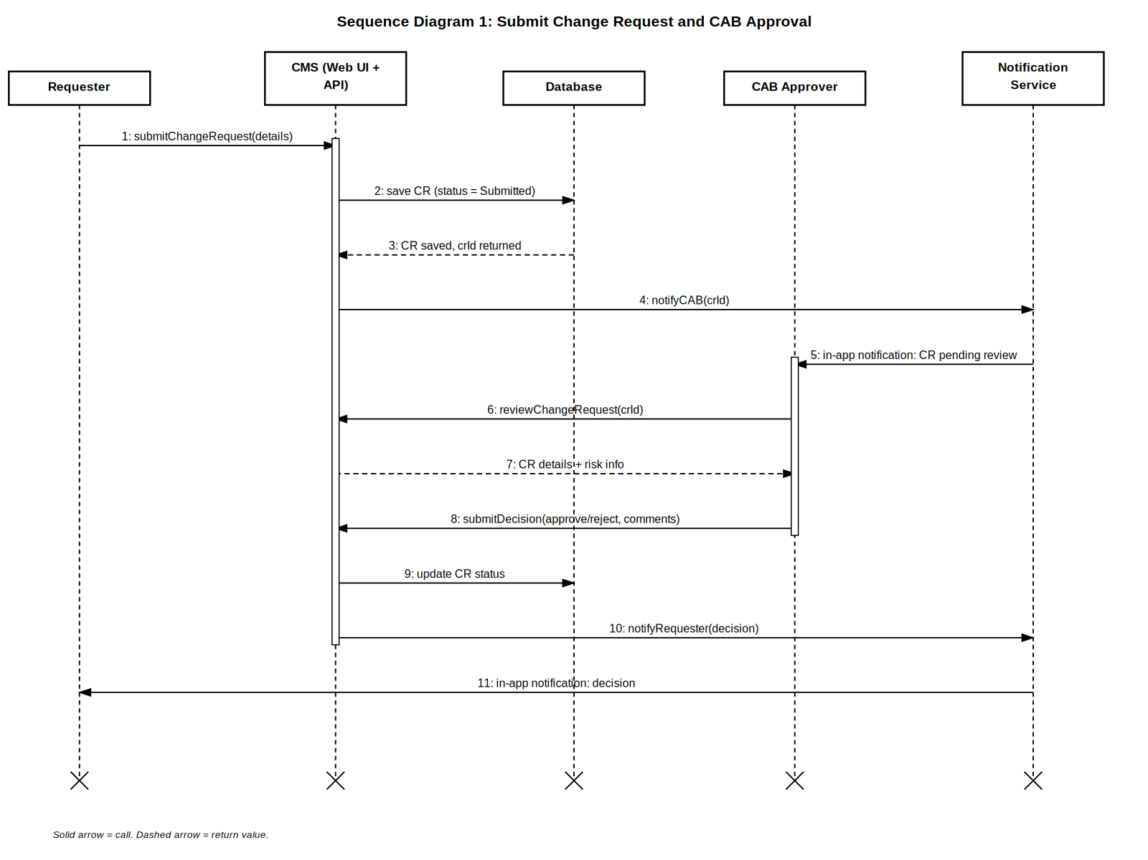
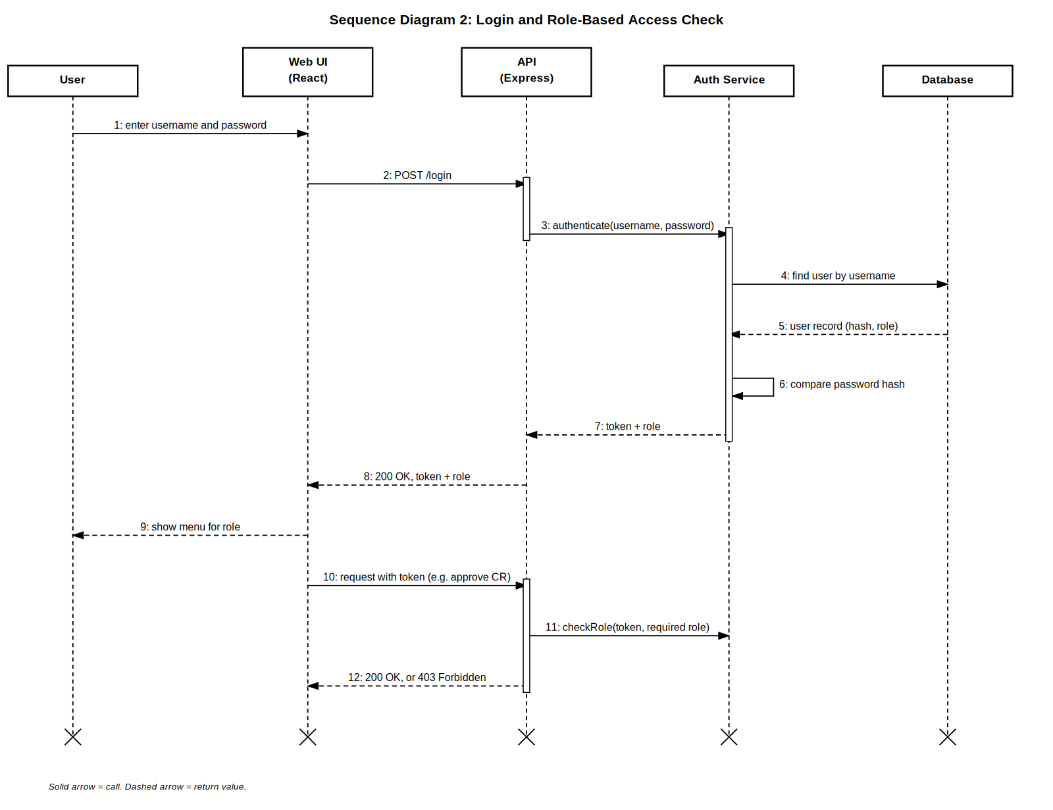

4.3 API Design
Method | Endpoint | Role | Request | Response | Errors
POST | /login | Any | {username, password} | {token, role} | 401 Invalid credentials
POST | /change-requests | Requester | {title, description, priority, riskLevel, rollbackPlan} | {crId, status} | 400 Invalid input, 400 Rollback plan required for High risk
GET | /change-requests | Any | - | [{crId, title, status, riskLevel}] | 401 Unauthorized
POST | /change-requests/{id}/decision | CAB Approver | {decision, comments} | {crId, status} | 403 Forbidden, 404 Not found
PATCH | /change-requests/{id}/schedule | CAB Approver | {date} | {crId, status} | 409 Blackout date
PATCH | /change-requests/{id}/status | Implementer | {status, notes} | {crId, status} | 403 Forbidden, 404 Not found
GET | /notifications | Any | - | [{message, crId, time}] | 401 Unauthorized

4.4 Data Model
Table | Main columns
users | id, username, passwordHash, role
change_requests | id, title, description, priority, riskLevel, rollbackPlan, status, scheduledDate, notes, requesterId
approvals | id, crId, approverId, decision, comments, time
notifications | id, userId, crId, message, time
audit_log | id, userId, action, crId, time

4.5 Error Handling, Logging & Monitoring
The API returns standard error messages with an HTTP status code. Passwords and tokens are never written to logs. Every action on a change request is stored in the audit log table. Monitoring beyond console logs is deferred.

4.6 UX Design
Simple web UI with readable font sizes, status labels shown as text (not color alone), and a different menu for each role.

4.7 Open Issues & Next Steps
Deferred and documented only: account lockout, attachments, reports, availability target, 50-user load test, accessibility audit, TLS, tamper-evident audit trail, and session expiry. Future enhancements: real email notifications, a full change calendar, and a mobile-friendly view.

5. Appendices
5.1 Glossary: CMS, CR, CAB, RBAC, ADR, API.
5.2 References: IEEE 42010, OWASP, ITIL Change Management practice.
5.3 Tools: draw.io, Postman, GitHub Projects and Actions.

