Multilingual Retrieval Fairness: English, Hindi and Malayalam
Technical report, Big Data Systems and Responsible AI Engineering (Topic 39, mini project)

TEAM:
Name: Nidhi S -PES1UG24AM919
Sanjana Shastry- PES1UG24AM916
Problem statement. Measure and reduce the retrieval-quality gap between English, Hindi and Malayalam for a public-services assistant, using the parallel Belebele benchmark, with PySpark used to show how the text-processing stage scales.

1. Introduction
A public-services assistant has to answer citizens in the language they use. Retrieval is its first step: if the right passage is not found, the answer step cannot recover it, so any gap in retrieval quality between languages becomes a gap in service. This report compares a keyword method and two multilingual embedding models on English, Hindi and Malayalam, shows where the gap appears, and describes a PySpark stage that processes the passage corpus in parallel. It reports a small demonstration-scale evaluation, not a full benchmark, and states its limits in Section 6.

2. Dataset
We use Belebele (Bandarkar et al., 2024), a multiple-choice reading-comprehension benchmark whose passages come from FLORES-200 and were translated by people into 122 languages. We use the English (eng_Latn), Hindi (hin_Deva) and Malayalam (mal_Mlym) test splits from Hugging Face (facebook/belebele). Each split has 900 questions over 488 unique passages. Row i is the same item in all three languages, so the benchmark is parallel.
For retrieval, each question is the query, the 488 unique passages of that language form the corpus, and the passage attached to the question is the single relevant document. We chose Belebele because MIRACL has no Malayalam and IndicQA has no English, so neither offers parallel queries in all three languages. Licences should be confirmed on the dataset pages; limitations are listed in the repository data card (DATA_CARD.md).

3. Method
Systems. BM25 (rank_bm25, tokens from a regular expression on word characters); multilingual-e5-small (intfloat/multilingual-e5-small) with the recommended "query:" and "passage:" prefixes; and paraphrase-multilingual-MiniLM-L12-v2 (sentence-transformers). Dense models use normalised embeddings and cosine similarity. Retrieval is same-language: Hindi queries search the Hindi corpus, and so on.
Metrics. Recall@1, Recall@5, Recall@10 and mean reciprocal rank (MRR), computed on the first 20 questions of each language. The language gap is the English value minus the Hindi or Malayalam value.
Interactive demo. The notebook lets a user choose a language, a question and a model, edit the query, and see the top five passages, the rank of the relevant passage and the retrieval time.
PySpark stage. To show big-data style processing, a job tokenises all passages (lower-case, whitespace split), counts term frequency per language (the statistics behind BM25 indexing), and runs in PySpark local[*] mode. We time it against a single-process Python version while replicating the 1,464-passage corpus (3 languages x 488) up to 146,400 documents. Spark 4.0.5 ran on a Colab machine with 2 CPU cores.

4. Retrieval results
Table 1 gives all results. Each value is based on 20 queries, so one query changes Recall by 0.05.
Table 1. Same-language retrieval on the first 20 Belebele questions per language.
Language | Model | Queries | Recall@1 | Recall@5 | Recall@10 | MRR
English | BM25 | 20 | 0.85 | 1.00 | 1.00 | 0.904
Hindi | BM25 | 20 | 0.40 | 0.60 | 0.65 | 0.500
Malayalam | BM25 | 20 | 0.45 | 0.75 | 0.90 | 0.563
English | Multilingual E5-small | 20 | 1.00 | 1.00 | 1.00 | 1.000
Hindi | Multilingual E5-small | 20 | 0.85 | 0.95 | 0.95 | 0.888
Malayalam | Multilingual E5-small | 20 | 0.85 | 0.90 | 1.00 | 0.886
English | Multilingual MiniLM | 20 | 0.80 | 0.95 | 1.00 | 0.859
Hindi | Multilingual MiniLM | 20 | 0.60 | 0.75 | 0.75 | 0.662
Malayalam | Multilingual MiniLM | 20 | 0.00 | 0.05 | 0.15 | 0.037

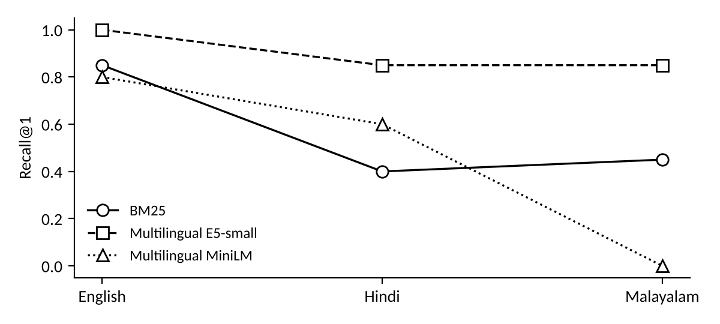
Figure 1. Recall@1 by language for each model (lines join the same model).
Table 2. Language gap (English minus language) for Hindi (hi) and Malayalam (ml).
Model | R@1 hi | R@1 ml | R@10 hi | R@10 ml | MRR hi | MRR ml
BM25 | 0.45 | 0.40 | 0.35 | 0.10 | 0.404 | 0.341
Multilingual E5-small | 0.15 | 0.15 | 0.05 | 0.00 | 0.112 | 0.114
Multilingual MiniLM | 0.20 | 0.80 | 0.25 | 0.85 | 0.197 | 0.822

Multilingual E5-small was the strongest in all three languages in this sample. It found the relevant passage first for every English query and for 17 of 20 Hindi and Malayalam queries (Recall@1 of 0.85), and its Recall@10 was 0.95 for Hindi and 1.00 for Malayalam. Its gaps to English were 0.15 at Recall@1 and at most 0.05 at Recall@10.
Multilingual MiniLM failed on Malayalam. It reached Recall@1 of 0.80 in English and 0.60 in Hindi, but only 0.00 in Malayalam (Recall@10 of 0.15, MRR of 0.037), the largest gap in the study (0.80 at Recall@1). We did not test the cause. Two plausible reasons are weak Malayalam coverage in the model and its default input limit, which may truncate long Malayalam passages; both need checking.
BM25 degraded in both Indian languages. Its Recall@1 fell from 0.85 in English to 0.40 in Hindi and 0.45 in Malayalam. Part of this may come from our tokenizer rather than from language difficulty: the regular expression for word characters splits Hindi and Malayalam words at vowel signs, which fragments the terms BM25 relies on. Its Malayalam Recall@10 (0.90) being higher than its Hindi value (0.65) also shows how noisy 20 queries are.
How much to trust the numbers. With 20 queries, a 95% Wilson interval for a Recall@1 of 0.85 is roughly 0.64 to 0.95, and for 0.40 it is 0.22 to 0.61. The English-to-Hindi difference for E5 (1.00 against 0.85) is therefore within noise. The MiniLM Malayalam result (interval 0.00 to 0.16) is the one difference that is clearly outside it.

5. Scaled processing with PySpark
Table 3. Tokenise and count terms: PySpark against single-process Python (mean of 2 timed runs after a warm-up).
Documents | Spark (s) | Python (s) | Spark time / Python time
1,464 | 0.61 | 0.04 | about 15
14,640 | 1.30 | 0.31 | 4.2
73,200 | 3.48 | 2.05 | 1.7
146,400 | 6.93 | 3.61 | 1.9

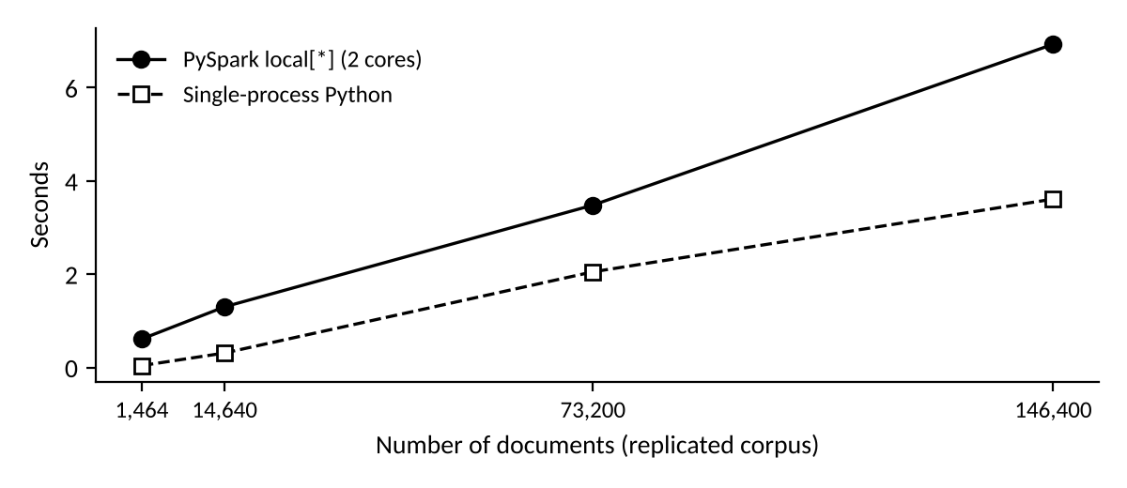
Figure 2. Execution time against corpus size.
PySpark was slower than plain Python at every size we ran. The ratio shrank from about 15 at 1,464 documents to 1.7 at 73,200 and 1.9 at 146,400, so the gap narrowed but never reversed. This is expected for a job this simple on 2 cores: Spark pays for start-up, scheduling and shuffling, and the work per document is small. Local mode is parallelism on one machine, not a cluster, and the larger corpora are copies of the same 1,464 passages. We therefore claim no speed-up. What the experiment shows is that this stage of retrieval indexing can be written as a parallel job, and where the overhead sits. The costly step in dense retrieval is encoding passages with a neural model, which this job does not measure.

6. Mitigations, cost and limitations
The repository contains scripts for query translation, hybrid BM25 and dense search with rank fusion, and contrastive fine-tuning, but this report does not include their results and draws no conclusion from them. The one comparison we can support is that, in this sample, changing the model from MiniLM to E5-small raised Malayalam Recall@1 from 0.00 to 0.85, so model choice mattered more than anything else we varied. Retrieval time per query is shown in the demo but was not recorded in a table.
Limitations:
- Only 20 questions per language, taken from the start of the test set rather than sampled at random; neighbouring questions may share a passage, so results are correlated.
- One run, no bootstrap intervals; the Wilson intervals above cover sampling of questions only.
- The BM25 tokenizer splits Indic words at vowel signs, so BM25 results for Hindi and Malayalam are probably too low. A corrected tokenizer is in the repository (src/bm25.py) but is not used in the reported numbers.
- Belebele is translated reading-comprehension text on general topics, not real citizen questions; dialects, code-mixing and romanised Hindi or Malayalam are not covered.
- The corpus has only 488 passages, so recall at 10 saturates easily. Answer quality was not evaluated.
- The PySpark benchmark is local-mode, on 2 cores, on replicated data.
Conclusion. On this small sample, a multilingual embedding model (E5-small) kept the Hindi and Malayalam gap to 0.15 at Recall@1, while BM25 and MiniLM left much larger gaps, and MiniLM was close to unusable for Malayalam. A service that serves all three languages should not assume that a model that works for English and Hindi works for Malayalam. Before any such conclusion is relied on, it should be repeated on all 900 questions with confidence intervals and with the mitigations evaluated.

References
Bandarkar, L., et al. (2024). The Belebele Benchmark: a parallel reading comprehension dataset in 122 language variants. ACL 2024.
NLLB Team (2022). No Language Left Behind: scaling human-centered machine translation (source of FLORES-200).
Wang, L., et al. (2024). Multilingual E5 text embeddings: a technical report.
Reimers, N. and Gurevych, I. (2020). Making monolingual sentence embeddings multilingual using knowledge distillation. EMNLP 2020.
Robertson, S. and Zaragoza, H. (2009). The probabilistic relevance framework: BM25 and beyond. Foundations and Trends in Information Retrieval.
Zaharia, M., et al. (2016). Apache Spark: a unified engine for big data processing. Communications of the ACM.

