**DigiPass by Fantastic Divas**

**Short description**

Generating Digi pass to ascertain employees presence in office(contactless Digi pass) using a chatbot.

**Long description**

**What's the problem?**

Part of the World Health Organization's guidance on limiting further spread of COVID-19 is to practice social distancing and to avoid common touchpoints and to limit the number of employees in Office in a day on the same floor.

**How can technology help?**

Hence, in case an employee would like to go to office, he/she should fill some standard survey (set of standard questions) and based on which a Digi pass will be generated and will be sent via email.

This also will ensure that we don’t have more than 30% of employees physically present in office.

**The idea**

Moreover Digi pass will be contactless(since it can be saved on the employee's mobile) and it also ensures social distancing at entry point as not many people will come at the same time. As soon as Digi pass is generated an automatic email will be sent to the respective manager and to the main security desk to keep them informed.

**Demo video**

<https://www.youtube.com/watch?v=2UIBoEl1DL0&feature=youtu.be>

**The architecture**

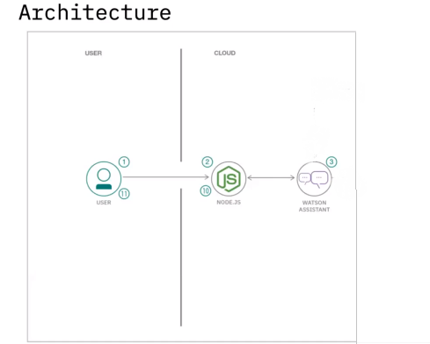

**Project roadmap**

**Day one :**

Team Discussion on how to build the final Solution and to understand which IBM services to use.

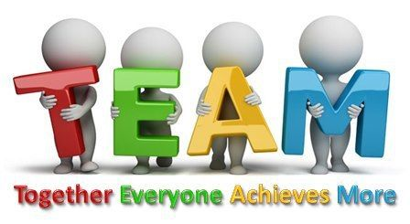

**Day two:**

Working towards creating the solution using IBM services – Watson Assistant using the Intent creation, creating JSON files and adding skills to it and the GitHub Repository.

And Test Test Test !!!



**Day Three:**

Integrating the solution to the GitHub Repository and creating the documentation for submission and finalizing everything.



**Built with**

* IBM Watson Assistant
* IBM Functions
* IBM Cloud Foundry App
* Toolchain
* GitHub Repository