1. **Are the HTML tags and elements the same thing?**

***HTML Assignment***

* HTML Tags and Elements are different things. Let’s see
* HTML TAG:
* HTML tags are used to hold the HTML element.
* All tags contain an opening and closing tag. For example, <html> is an opening tag and </html> is a closing tag.
* HTML ELEMENT:
* HTML element holds the content.
* Whatever is written within an HTML tag is an HTML element
* An HTML element is a collection of start and end tags with content inserted between them.
* An HTML element consists of text between angle brackets.

1. **What are tags and attributes in HTML?**

* Tags:
* HTML tags are keywords on a web page that define how your browser must format and display your web page.
* All tags contain an opening and closing tag. For example, <html> is an opening tag and </html> is a closing tag.
* Basic HTML tags:
* Head tag, body tag, title tag, paragraph tag, heading tag etc…
* Attributes:
* HTML attributes are used to describe the characteristics of an HTML element in detail.
* Attribute provides additional information about elements.
* HTML attributes are found only in the starting tag.
* Attributes are written as : name = “value”
* For example: The <a> tag defines the hyperlink. The href attribute specifies the URL of the page the link goes to.

1. **What are void elements in HTML? With Example.**

* A void element is an [element](https://developer.mozilla.org/en-US/docs/Glossary/Element) in HTML that cannot have any child nodes.
* Void elements only have a start tag. In HTML, a void element must not have an end tag. Example of such elements are <br>,<link>,<meta>,<input>,<hr>,<img> etc
* 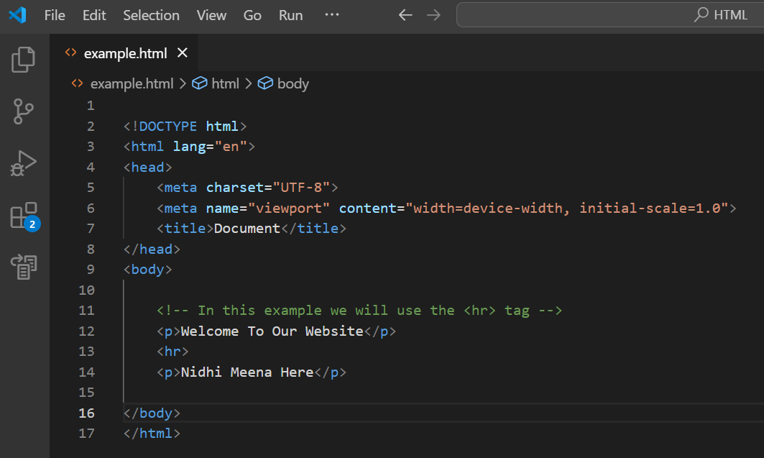EXAMPLE:

1. **What are HTML Entities? With Example.**

* HTML entities are the reserved characters that have special meaning when used in an HTML document.

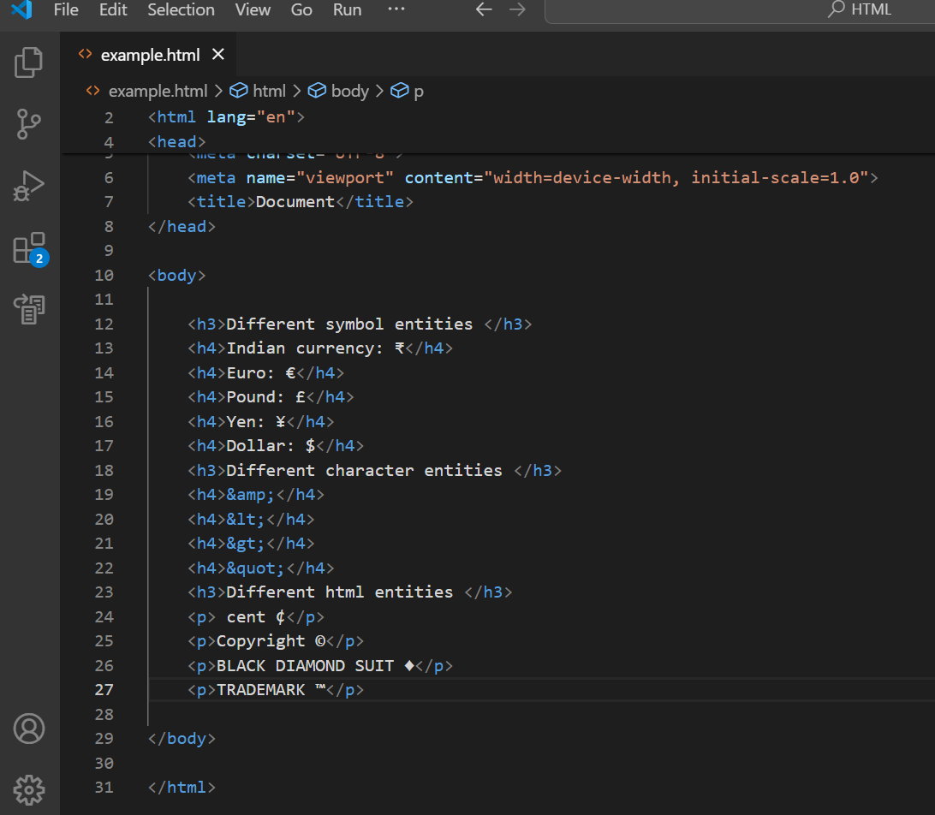

1. **What are the different types of lists in HTML? With Example.**

* There are two types of lists in html and they are ordered lists and unordered lists and also support description list:
* Unordered list:
* An unordered list starts with <ul> tag. Each list item starts with the <li> tag.
* The list items will be marked with a small circle by default.

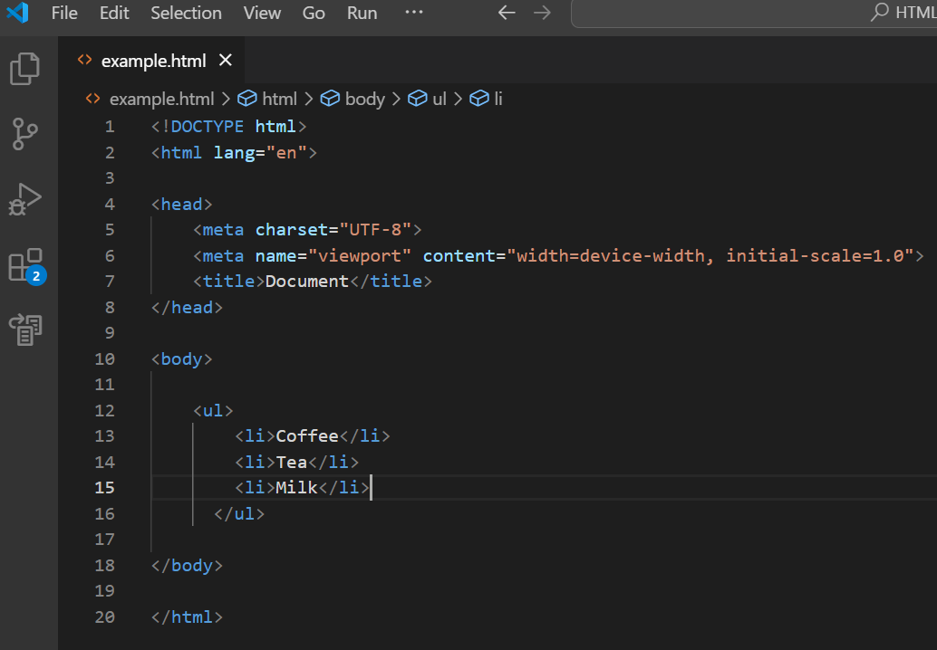

* Ordered list:
* An ordered list starts with the <ol> tag. Each list item starts with the <li> tag.
* 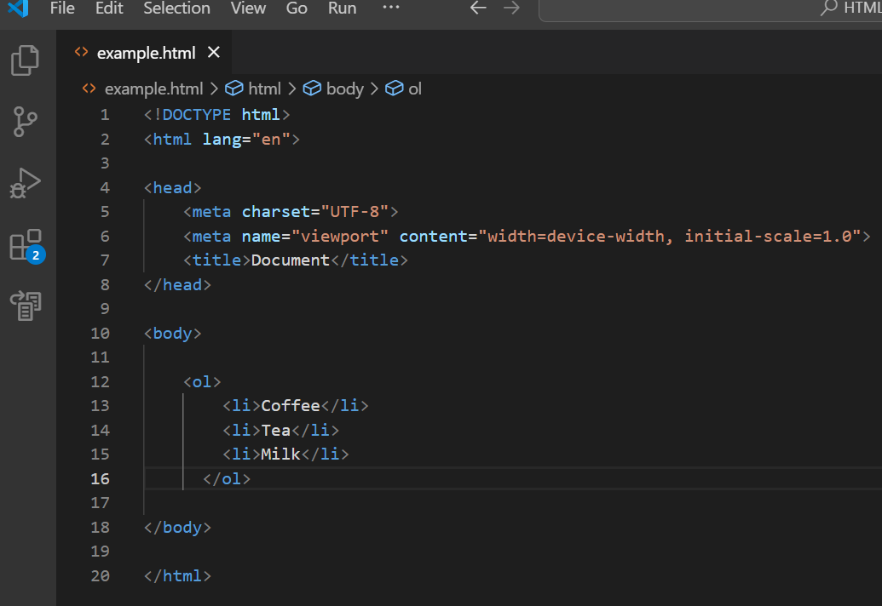The list items will be marked with numbers by default
* Description list:
* 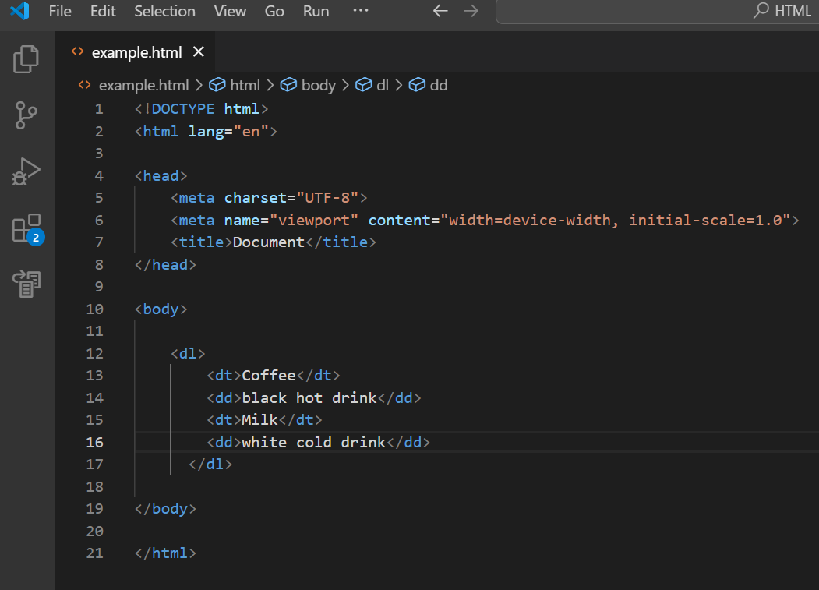The <dl> tag defines the description list, the <dt> tag defines the term (name), and the <dd> tag describes each term:

1. **What is the ‘class’ attribute in HTML? With Example.**

* The class attribute specifies one or more classes for an element.
* The class attribute can be used on any HTML element.

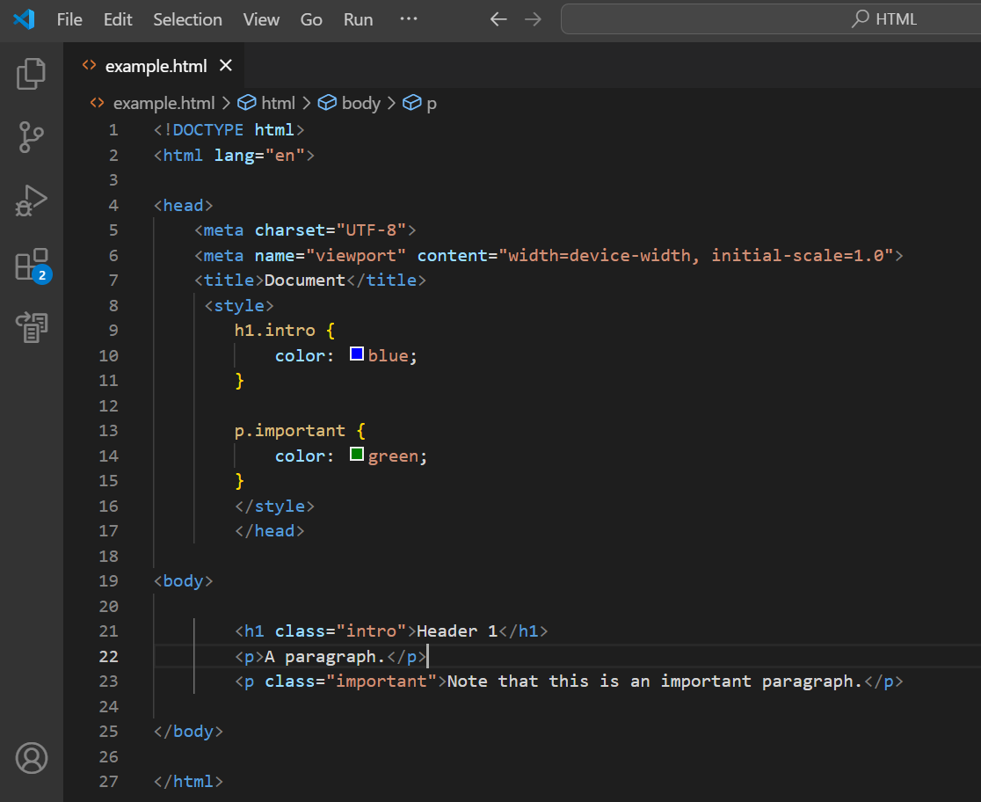

1. **What is the difference between the ‘id’ attribute and the ‘class’ attribute of HTML elements? With Example.**

|  |  |
| --- | --- |
| **ID** | **Class** |
| Each element can have only one ID. | You can use the same Class on multiple elements. |
| IDs use “#” in the CSS | Classes use a “.” in the CSS |
| Id can have only one unique value | the class can have more than one. |
|  |  |
|  |  |

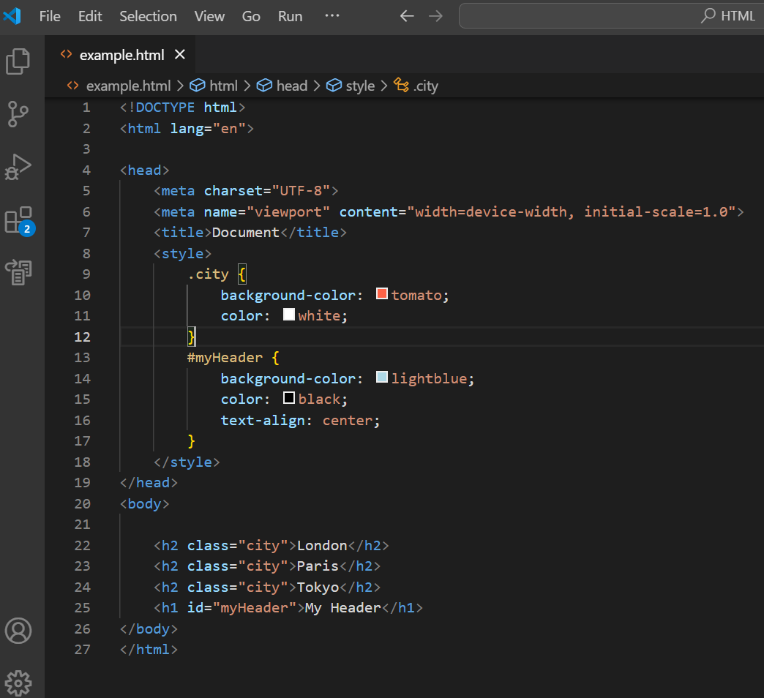

1. **What are the various formatting tags in HTML?**

* Text formatting in HTML refers to the way text is displayed on a web page. It is the process of applying various styles, colors, fonts, sizes, and other visual enhancements to text content within an HTML document.
* Examples of formatting elements include the <b>, <i>, <u>, <strong>, <em>, <s>, <sub>, and <sup> tags.
* Bold text: <b> or <strong>
* Italicized text: <i> or <em>
* Underlined text: <u>
* Strike-through text: <del> or <s>
* Superscript and subscript text: <sup> or <sub>

1. **How is Cell Padding different from Cell Spacing? With Example.**

* Cell padding and cell spacing are two different concepts in HTML.
* Cell padding is used to create a border around the content area of a web page, whereas cell spacing is used for positioning elements within that content area.
* Cell spacing refers to the distance between the cells and cell padding refers to the space around each cell.

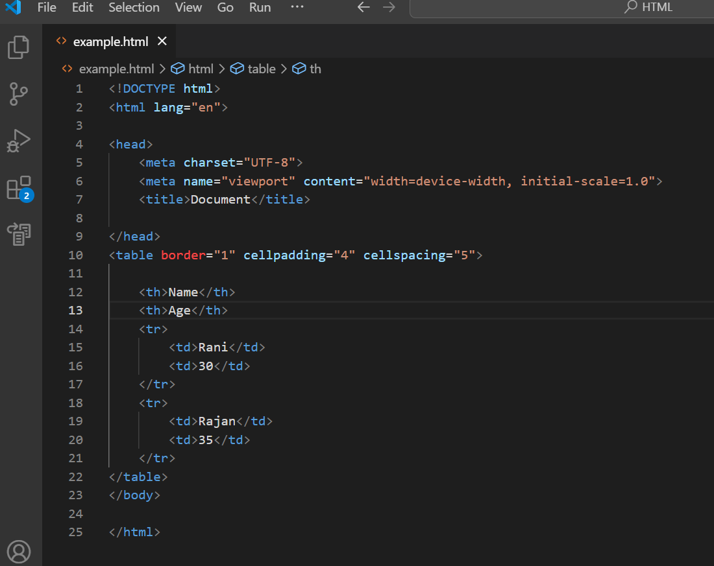

1. **How can we club two or more rows or columns into a single row**

**or column in an HTML table? With Example**

* Using  rowspan and colspan attributes we can club two or more rows or columns into a single row or column in an HTML table.
* 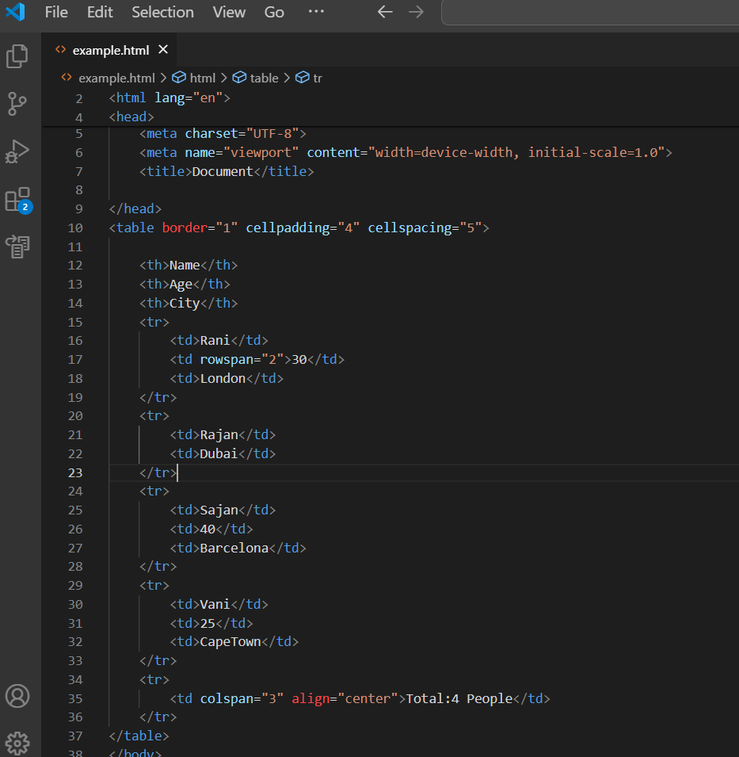By using rowspan, multiple cells in a row can be combined, while colspan enables the merging of cells in a column within an HTML table.

1. **What is the difference between a block-level element and an inline element?**

|  |  |
| --- | --- |
| **Inline** | **Block** |
| Inline elements occupy only sufficient width required. | Block Elements occupy the full width irrespective of their sufficiency. |
| Inline elements don’t start in a new line. | Block elements always start in a new line. |
| Inline elements don’t have a top and bottom margin | Block elements have top and bottom margins. |
| EX: <span> and [<a>](https://www.w3schools.com/tags/tag_a.asp) | EX: <p> and <div>. |

1. **How to create a Hyperlink in HTML? With Example.**

* By clicking on the hyperlink one can jump from one page to another.
* The HTML <a> tag defines a hyperlink. It has the following syntax:
* <a href="url">link text</a>
* Where  the href attribute indicates the link's destination.

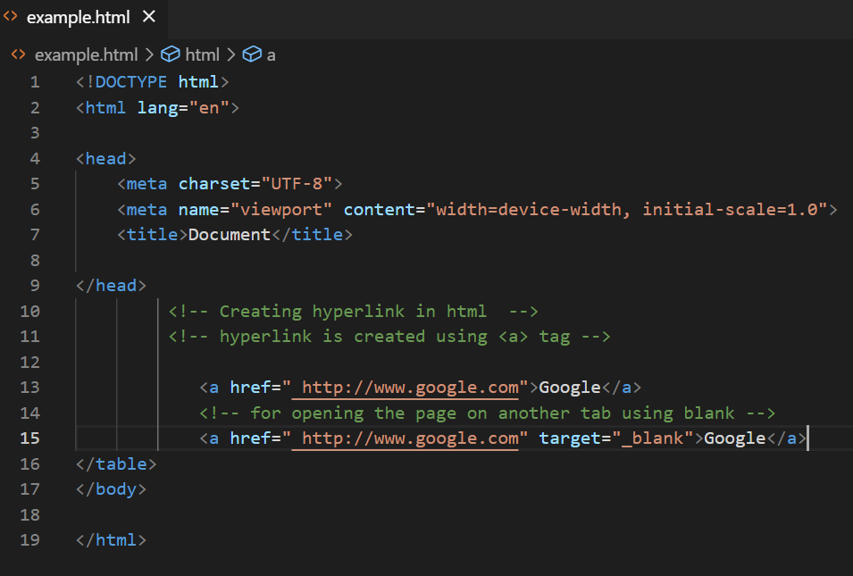

1. **What is the use of an iframe tag? With Example.**

* 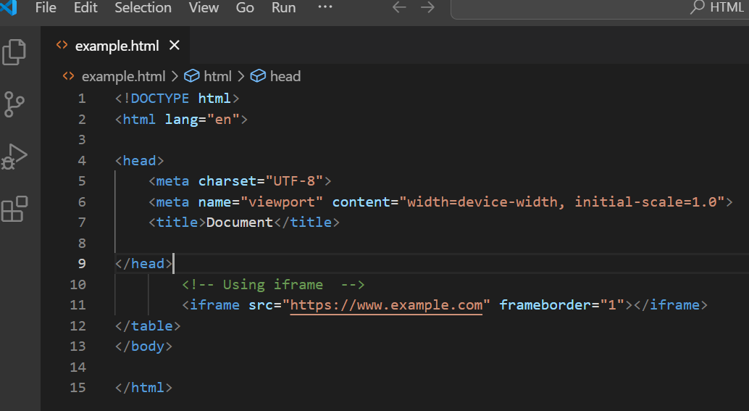The Inline frame element.
* The iframe tag in HTML stands for Inline Frame
* An iframe is an HTML document embedded inside another HTML document on a website. Think of it as a "webpage within a web page."
* Iframes are often used to embed videos, maps, and other media on a web page. You can also use them to embed another web page into a web page.
* Syntax:
* <iframe src="URL" title="description"></iframe>

1. **What is the use of a span tag? Explain with example?**

* A <span> element which is used to color a part of a text
* The <span> tag is an inline container used to mark up a part of a text, or a part of a document.
* The <span> tag is much like the [<div>](https://www.w3schools.com/tags/tag_div.asp) element, but <div> is a block-level element and <span> is an inline element.

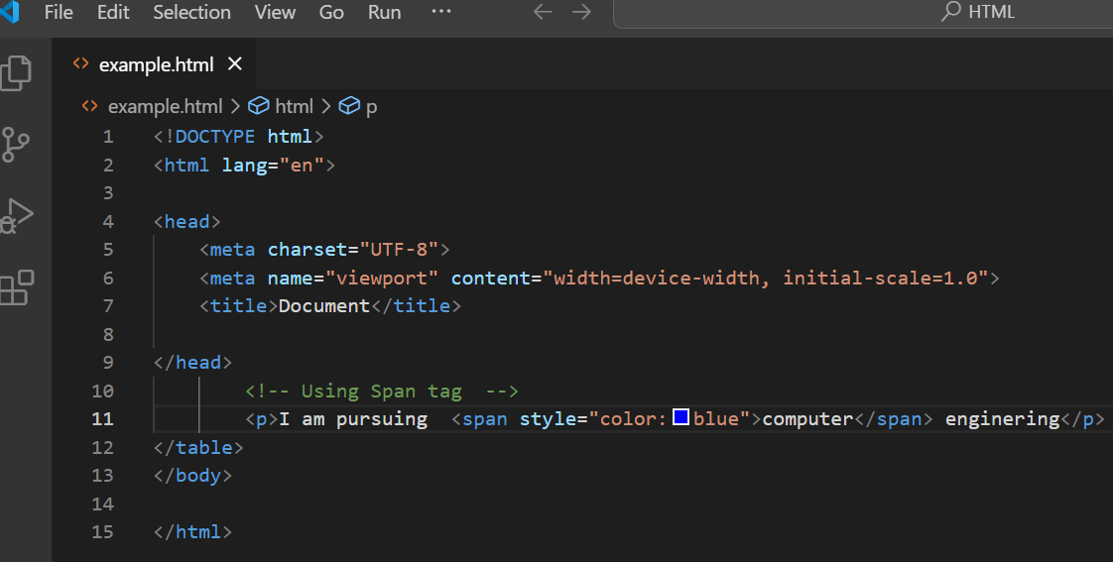

1. **How to insert a picture into a background image of a web page? With Example.**

* You can add background image in HTML using background attrubute, perform the following steps:
* Within the starting <body> tag in your Html file, type <Body background=” “>
* Give the path of the image we want to add.

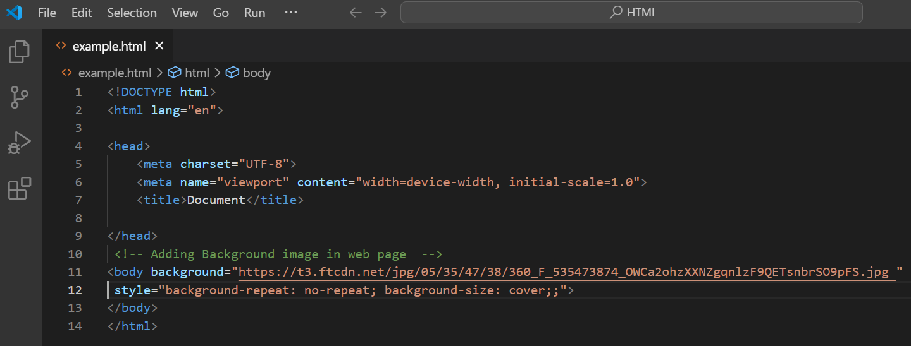

1. **How are active links different from normal links?**

* Normal Link:
* In HTML, an unvisited link is a hyperlink that is not yet clicked by the user.
* By default, the normal links will be blue in color with an underline.
* However, we can customize the style using the CSS properties.
* Visited Link:
* A visited link is a hyperlink that is clicked by the user.
* These indicate that the links have been visited previously. By default, in most of the browsers, the visited links will be in purple color and with an underline.

1. **What are the different tags to separate sections of text?**

* are the different tags to separate sections of text are as follows:

1. <br>

Insert single line breaks in a text:

The <br> tag is an empty tag which means that it has no end tag.

EX:

<p>To force <br> line breaks<br> in a text,<br> use the br<br> element.</p>

1. <p>

The <p> tag defines a paragraph.

Browsers automatically add a single blank line before and after each <p> element.

EX:

<p>This is some text in a paragraph.</p>

1. <blockquote>

The <blockquote> tag specifies a section that is quote from another source.

Browsers usually indent <blockquote> elements.

EX:

<blockquote cite="http://www.worldwildlife.org/who/index.html">  
For 50 years, WWF has been protecting the future of nature.   
</blockquote>

**18. What is SVG?**

* SVG stands for Scalable Vector Graphics.
* SVG graphics are scalable and do not lose any quality if they are zoomed or resized.
* SVG is supported by all major browsers.
* 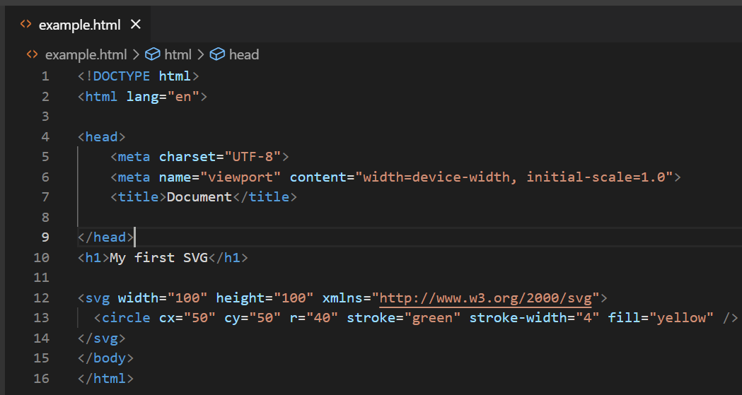You can embed SVG elements directly into your HTML pages.

**19. What is the difference between HTML and XHTML?**

|  |  |
| --- | --- |
| **HTML** | **XHTML** |
| HTML stands for Hypertext Markup Language. | XHTML stands for Extensible Hypertext Markup Language. |
| HTML will continue to be supported by web browsers. | XHTML support by web browsers is limited and it is now largely replaced by HTML5. |
| All tags and attributes are not necessarily to be in lower or upper case. | In this, every tag and attribute should be in lower case. |
| Doctype is not necessary to write at the top. | Doctype is very necessary to write at the top of the file. |
| Filename extension used are .html, .htm. | Filename extension are .xhtml, .xht, .xml. |

**20. What are logical and physical tags in HTML?**

* HTMLFormatting is a process of formatting text for better look and feel.  HTML provides us ability to format text without using CSS.
* These tags are used to make text bold, italicized, or underlined.
* In HTML the formatting tags are divided into two categories:
* Physical tag: These tags are used to provide the visual appearance to the text.
* Ex:<b>, <i>, <small>, <sub>, <sup>, <u>, <big> etc.,
* Logical tag: These tags are used to add some logical or semantic value to the text.
* EX: <address>, <abbr>, <pre>, <q>, <strong>, <del>, etc.,

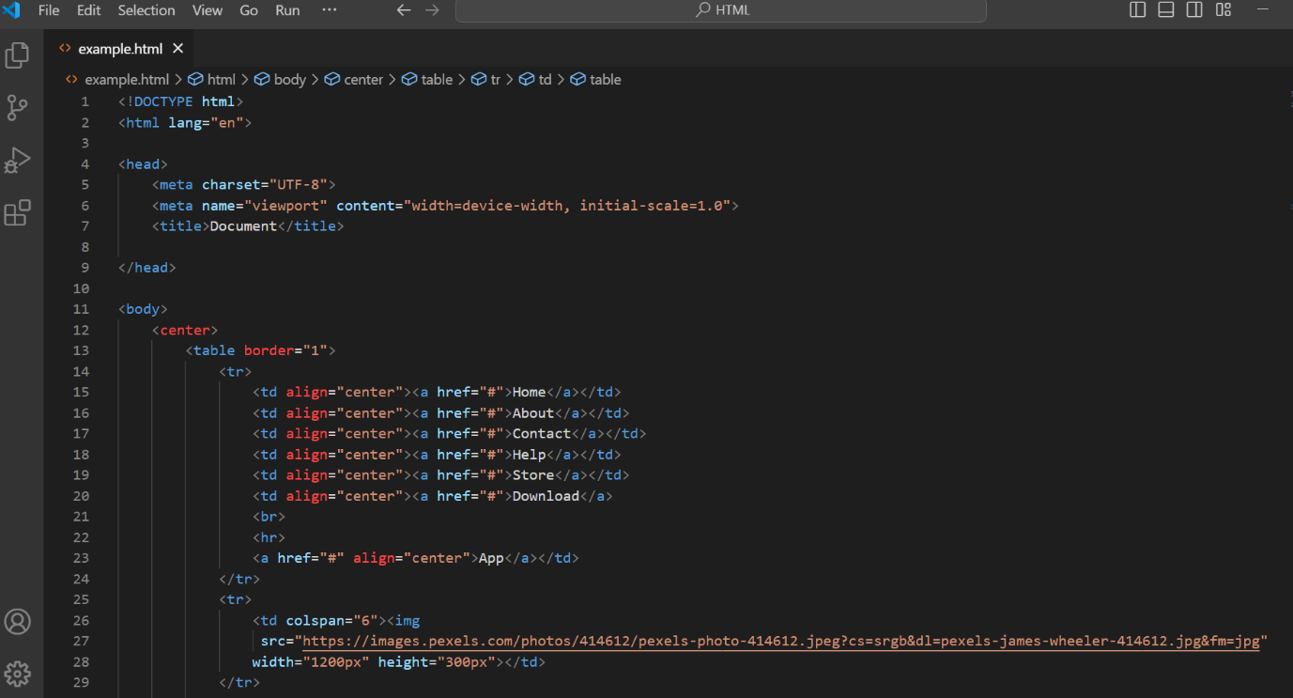**21. Create below example using only HTML tags without CSS.**

