Module - 5

1.What is jQuery?

* The purpose of jQuery is to make it much easier to use JavaScript on your website.
* jQuery is a lightweight, "write less, do more", JavaScript library.
* jQuery also simplifies a lot of the complicated things from JavaScript, like AJAX calls and DOM manipulation.
* jQuery takes a lot of common tasks that require many lines of JavaScript code to accomplish, and wraps them into methods that you can call with a single line of code.

2. How to Apply CSS using JQuery, How to add Class and Remove Class in JQuery, JQuery animation ?

* We can use jquery’s .css() method to apply CSS style on the given webpage.
* jQuery is a javascript library that helps us manipulate the DOM easily and efficiently using its various helper methods and properties.
* Syntax:
* $(selector).css(property, value)

or

$(selector).css({ property: value, property: value, … })

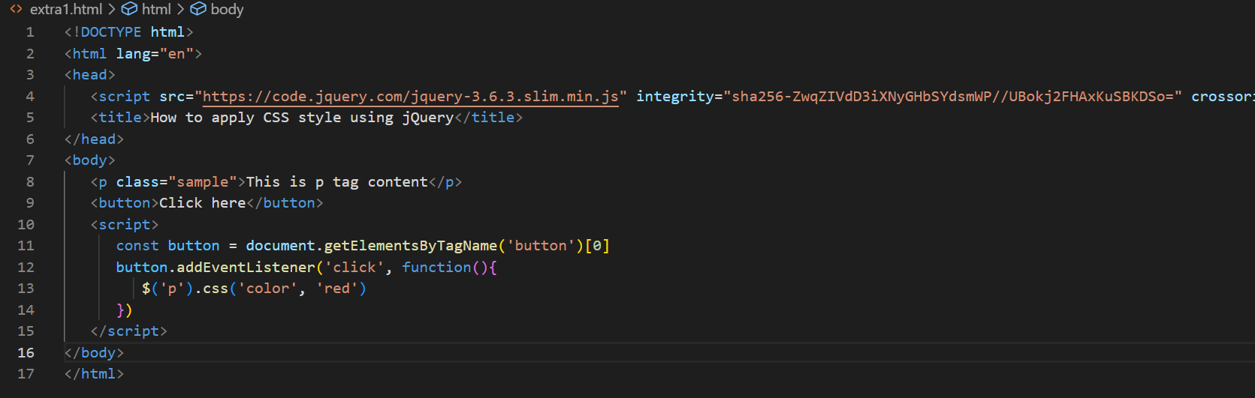

* Add Class and Remove Class in JQuery:
* The addClass() and removeClass() methods are respectively used to add and remove the CSS classes when there is a need to add or remove them from the webpage on the occurrence of an event.
* Syntax:
* // Adding class using addClass()
* $('selector').addClass(class_name);
* // Adding class using removeClass()
* $('selector').removeClass(class_name);
* JQuery animation:
* The jQuery animate() method is used to create custom animations.
* Syntax:
* $(selector).animate({params},speed,callback);

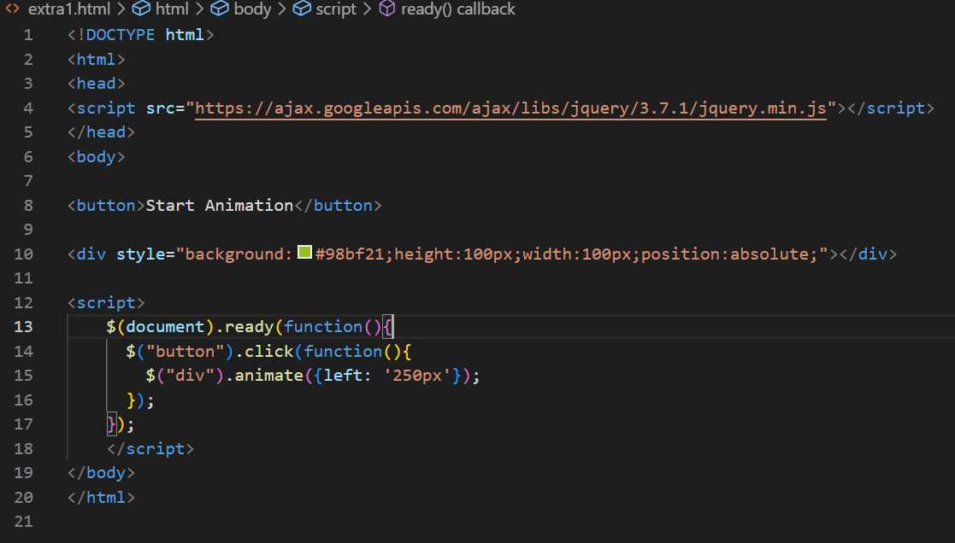

3.How to create slider with animation?

