Cycle-1

Experiment-1
Q: Familiarization to computer hardware such as CPU, Memory, Motherboard etc.
Aim: To study and understand the basic concepts of computer hardware parts.
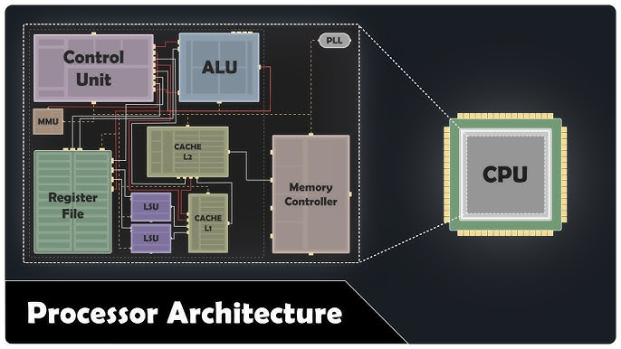
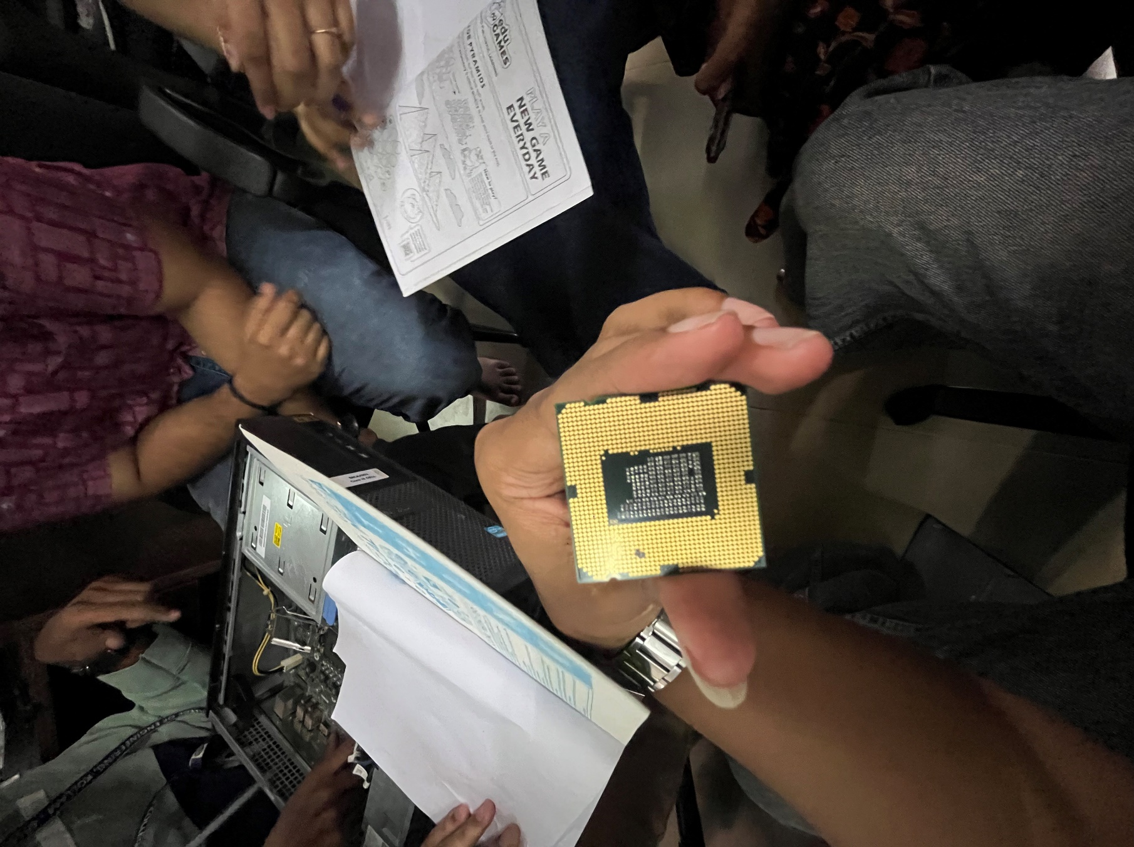
- CPU (Central Processing Unit)

The CPU is the brain of the computer. It performs all processing, calculations, and controls all the operation of the system.

It consists of:
- ALU (Arithmetic Logical Unit): Performs arithmetic and logical operations.
- CU (Control Unit): Controls the execution of the instructions.
- Registers: Small memory units for temporary data storage.
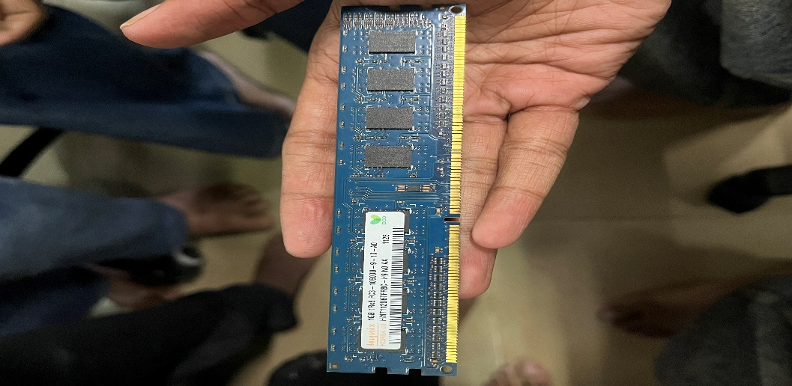
- Memory (RAM-Random access memory)

Ram is the temporary memory used to store data while programs are running. It increases system speed and performance. Data lost when power is turned off.
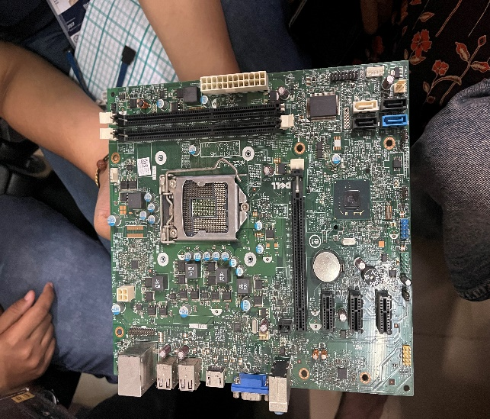
- Motherboard

The motherboard is the main circuit bord. All the components like CPU, RAM, Storage and peripherals are connected to it.

- Storage Devices

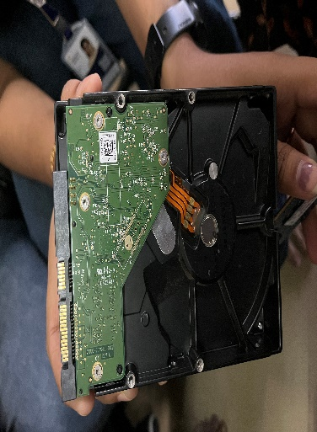
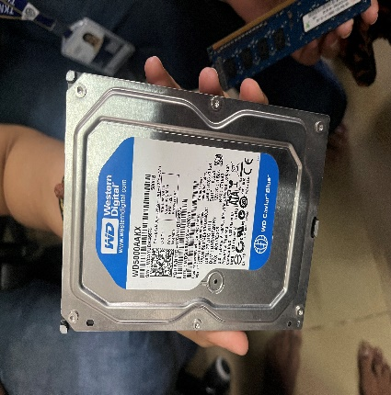
  - HDD (Hard Disk Drive)

Stored data permanently, slower speed.
  - SSD (Solid State Drive)
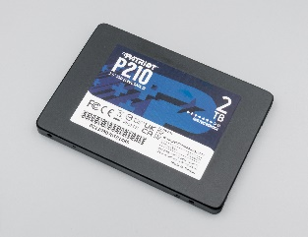
Faster storage device used in modern systems.

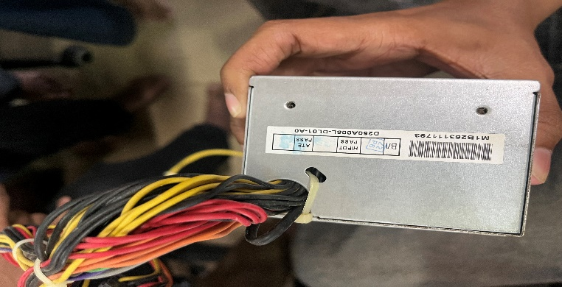
- Power Supply Unit (PSU)
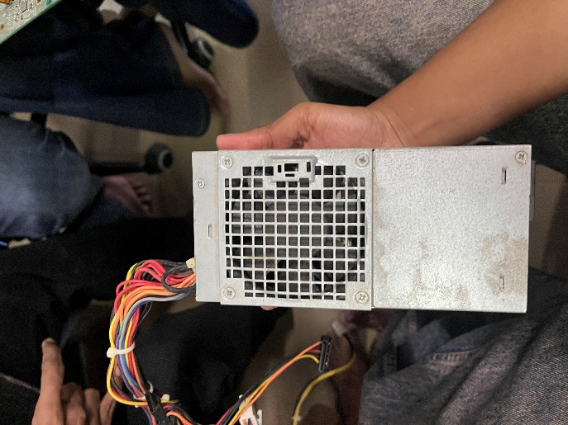
Supplies electrical power to all the internal components.
- GPU (Graphics Processing unit)
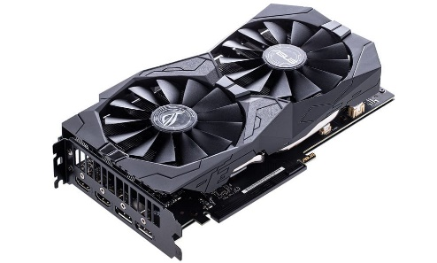

Used for graphics and display processing. Helps in gaming, video editing and graphics-heavy applications

