Grocify
Online Grocery Store System
Project Report — System Screenshots & Documentation

1. System Overview
Grocify is a web-based online grocery store application that enables customers to browse products by category, search for items, view detailed product information, and complete purchases through a streamlined shopping cart interface. The following screenshots document the key pages and features of the system.

1.1 Homepage — Hero Banner
The homepage presents a clean hero banner with the tagline "Groceries Made Easy" and a navigation bar offering access to Home, Products, and About pages, along with a search bar, Cart, and Login controls.
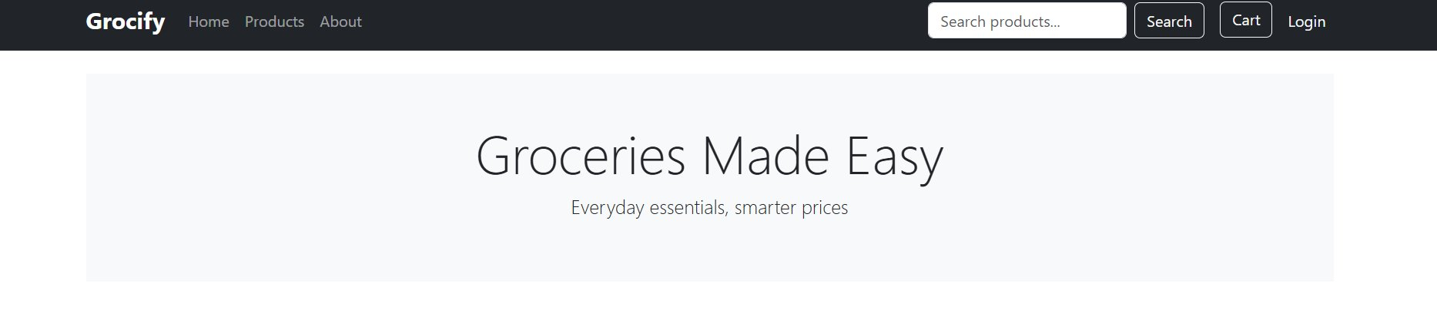
Figure 1: Grocify homepage hero banner

1.2 Homepage — Product Categories
Below the hero section, the homepage displays a "Categories" grid showcasing the main product groups available in the store, including Fruits & Vegetables, Dairy & Eggs, and Beverages, each with a representative image and a "View Products" button.
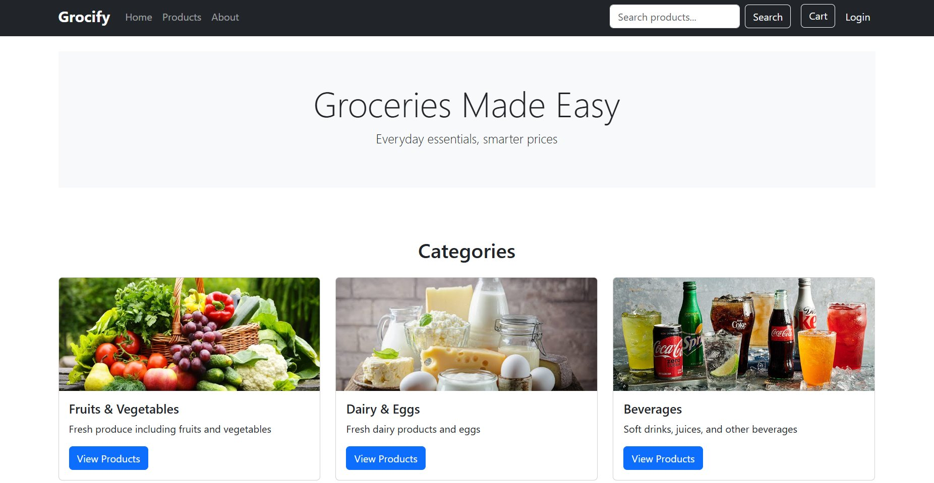
Figure 2: Homepage — product categories section

2. Product Listings
The Products page allows customers to browse the full catalogue with filtering by category. A sidebar lists all available categories, while the main panel displays product cards showing an image, name, brief description, price, stock level, and a "View Details" button.

2.1 All Products View
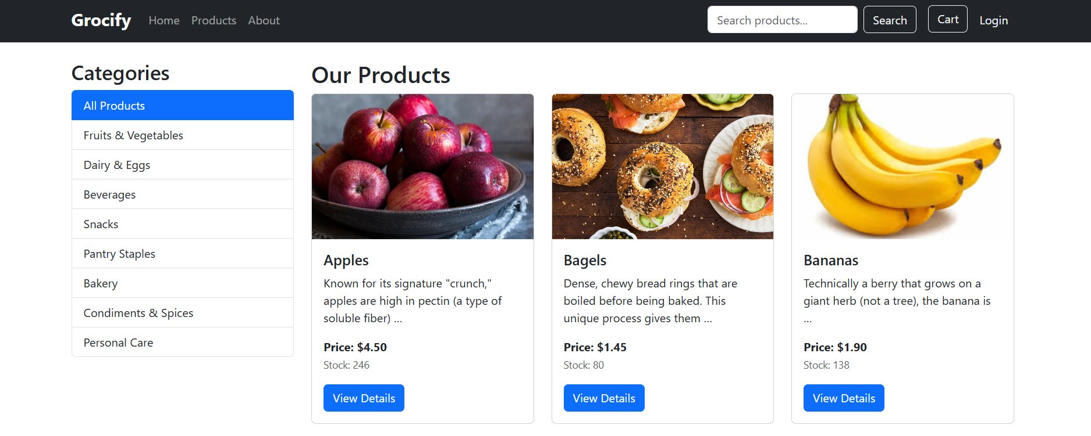
Figure 3: Products page — category sidebar and product grid

2.2 Featured Products
The homepage also highlights a "Featured Products" section showcasing a curated selection of items across different categories such as Personal Care (Moisturizer, Face Cream, Lip Balms) and household goods.
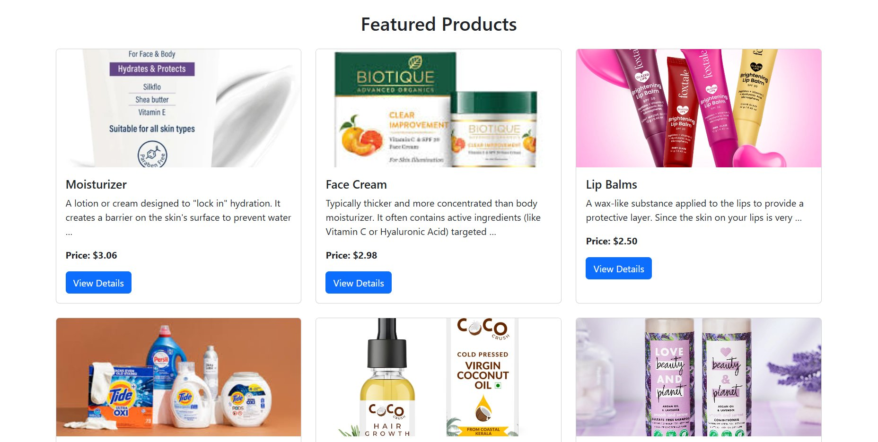
Figure 4: Featured products section on the homepage

3. Product Detail Pages
Each product has a dedicated detail page displaying a larger product image, full description, price, category, stock availability, and an Add to Cart control with a quantity selector. The following screenshots show three sample product detail pages.

3.1 Bakery — Cakes
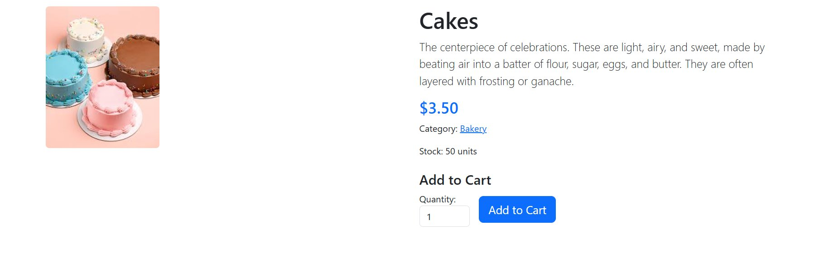
Figure 5: Product detail page — Cakes ($3.50, Bakery, 50 units in stock)

3.2 Snacks — Chips
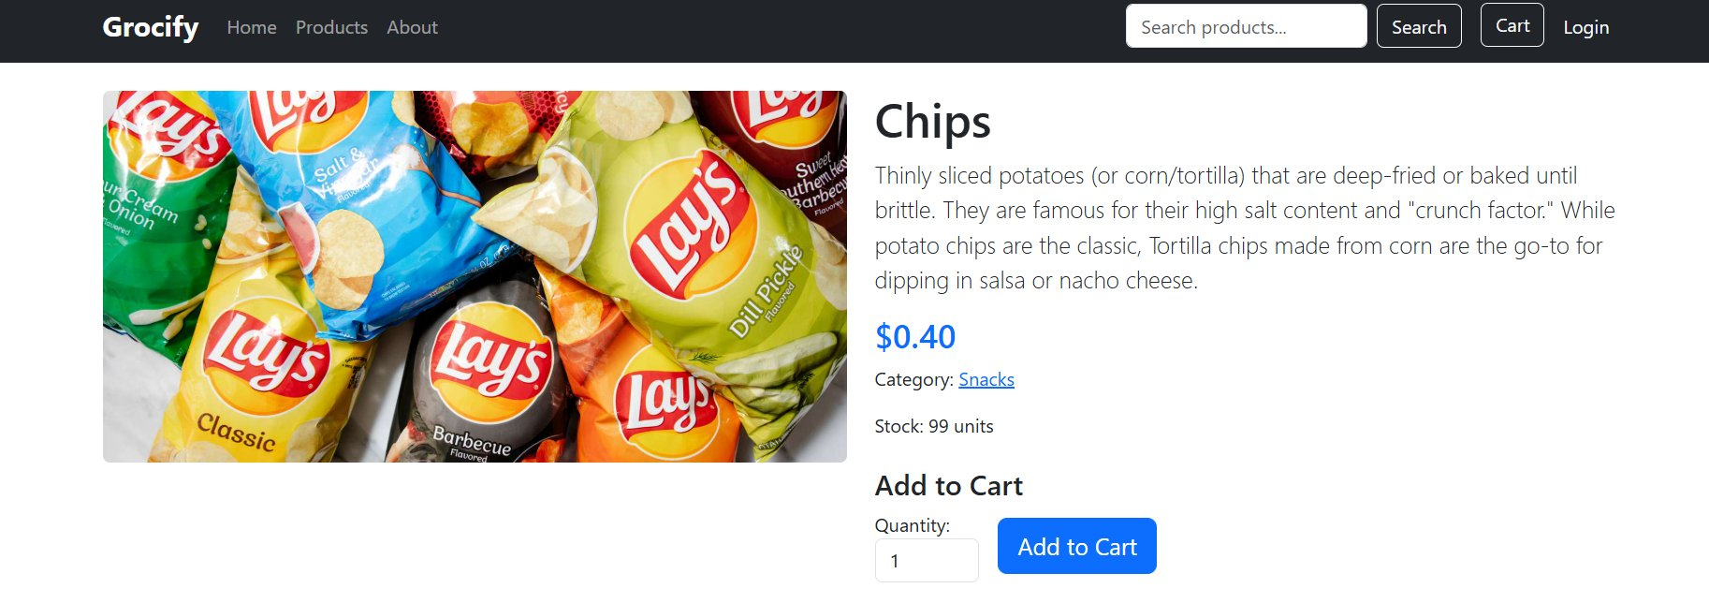
Figure 6: Product detail page — Chips ($0.40, Snacks, 99 units in stock)

3.3 Personal Care — Face Cream
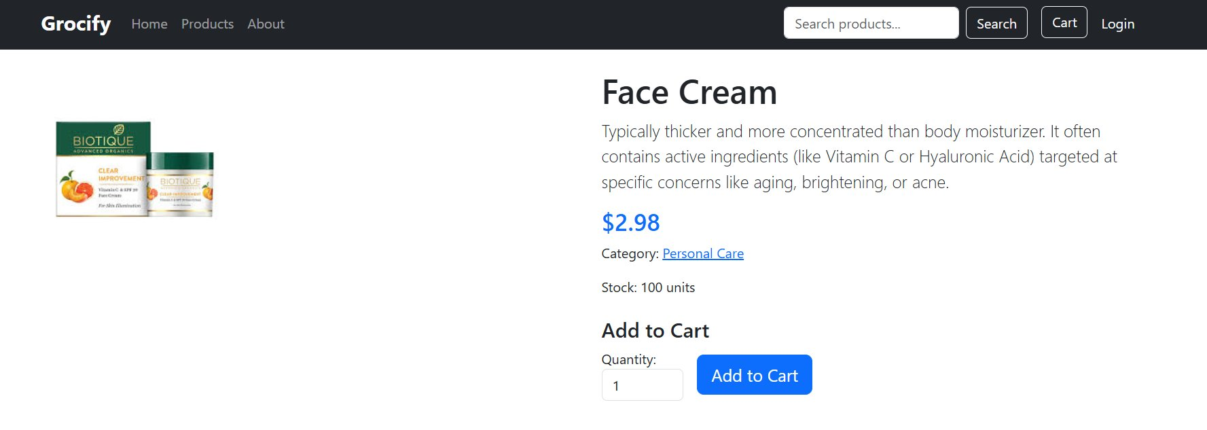
Figure 7: Product detail page — Face Cream ($2.98, Personal Care, 100 units)

3.4 Condiments & Spices — Black Pepper
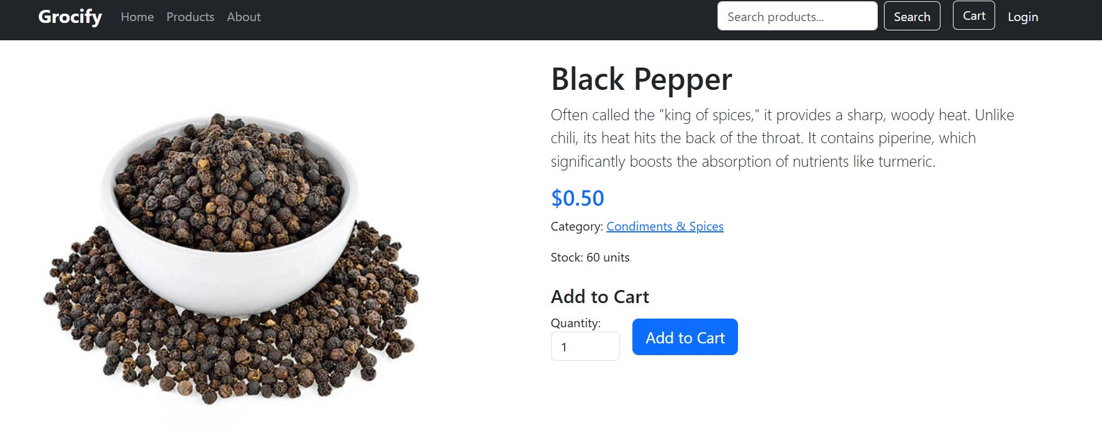
Figure 8: Product detail page — Black Pepper ($0.50, Condiments & Spices, 60 units)

4. About Page
The About page communicates the brand mission and provides contact information. It features two images — a store interior and a customer service representative — alongside sections titled "Our Mission" and "Contact", reinforcing the store's commitment to quality and accessibility.
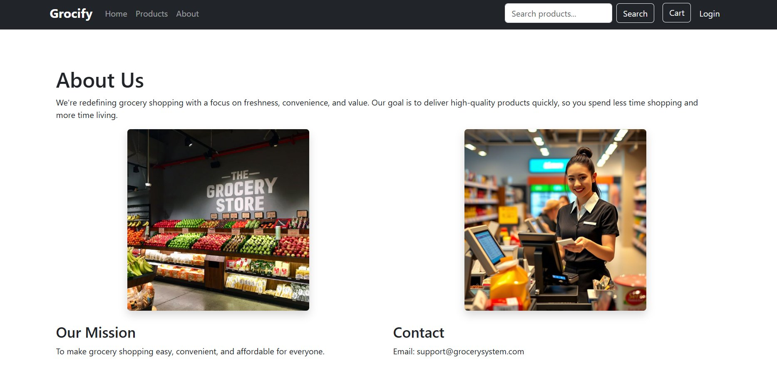
Figure 9: About page — mission statement and contact details

5. Summary of System Features
The table below summarises the key pages and features documented in this report.
Page Key Features
• Homepage: Hero banner, product categories, featured products
• Products Page: Category sidebar filter, product grid, stock & price display
• Product Detail: Full description, pricing, stock level, Add to Cart
• About Page: Brand mission, store imagery, contact information
• Navigation: Search bar, Cart, Login — accessible from all pages

