MP-1

Prompt 1 and soln1
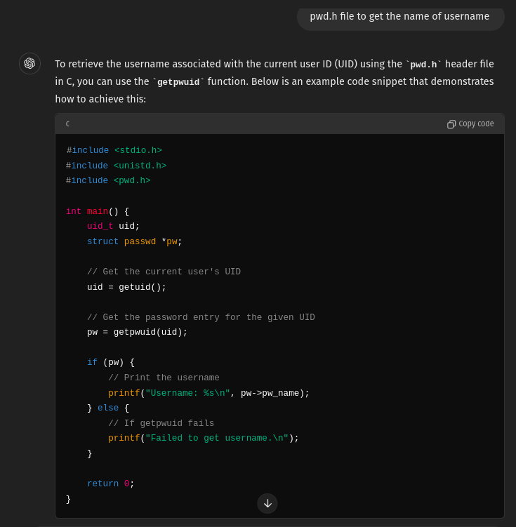

Prompt -
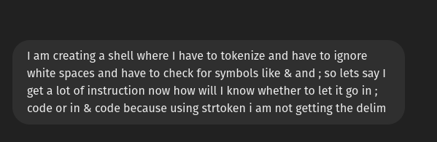

Result -
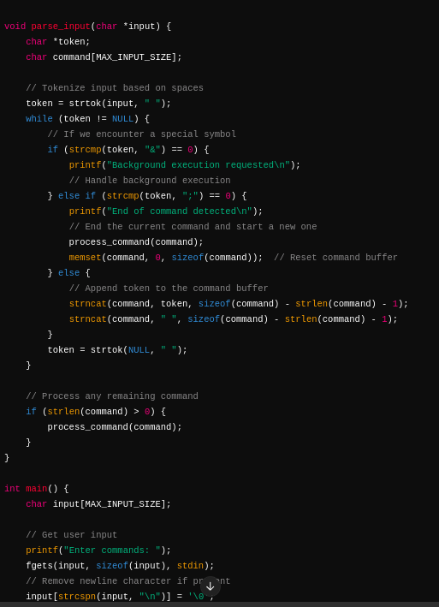

Prompt-3
regarding reading and writing in a file idea - https://chatgpt.com/share/ff20a28d-8d63-4c1b-9360-8ad5d092356d

Prompt – 4

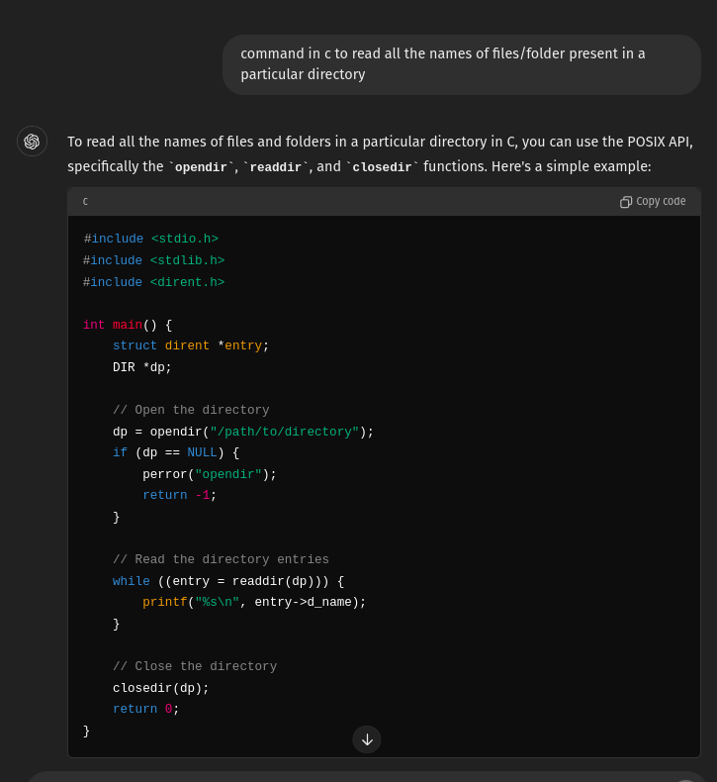
Prompt – 5
This is for reveal here I used chatgpt to know how to know the permissions and how to know the type of a file
chat link - https://chatgpt.com/share/74d5ad34-9232-445e-8b46-2a4cdb6f9425
Also how to get other details are in this
https://chatgpt.com/share/9e79dd5e-4521-422d-ad8f-8c3e4152d4aa

Prompt – 6
Learning exec and foreground- https://chatgpt.com/share/38341ea1-c8a3-43d4-b6a3-cfd78fc4a2d3

Prompt – 7
Background processes - https://chatgpt.com/share/f85971b3-ab79-485f-b2a6-855a504249c2
https://chatgpt.com/share/4988c407-61c9-4b2b-bfe4-958bddd6d3a4

Prompt – 8
Piping - https://chatgpt.com/share/f276ca34-79aa-4356-a0f5-00b412be32b7

Prompt – 9
signal - https://chatgpt.com/share/9914f52f-c103-4297-9c98-28c3f9547044

Prompt – 10
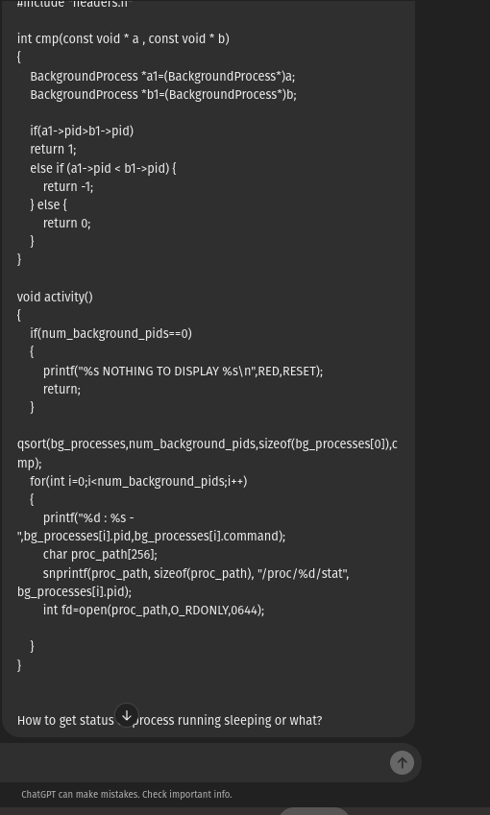
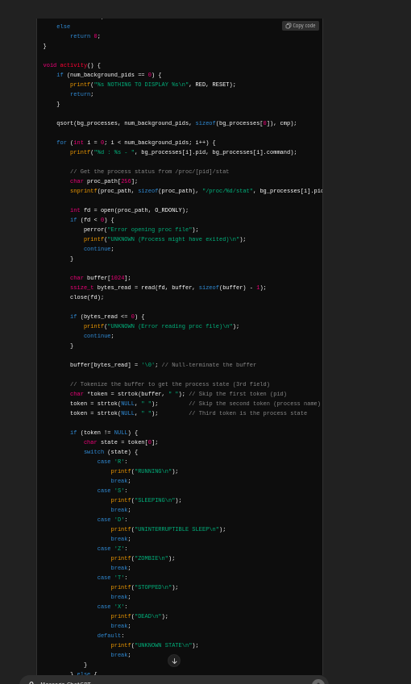
Result
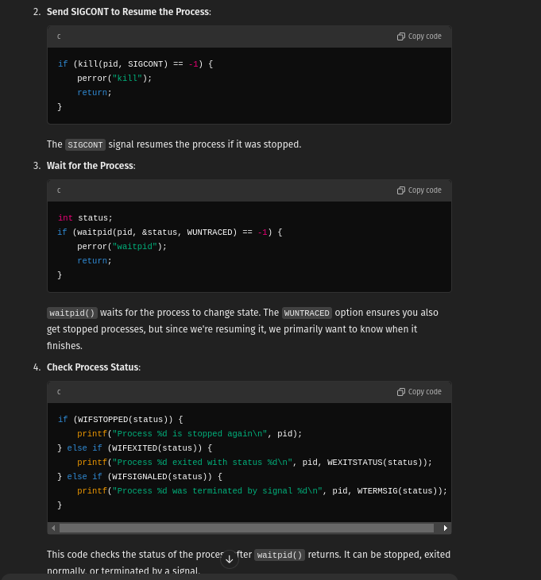
Prompt – 10

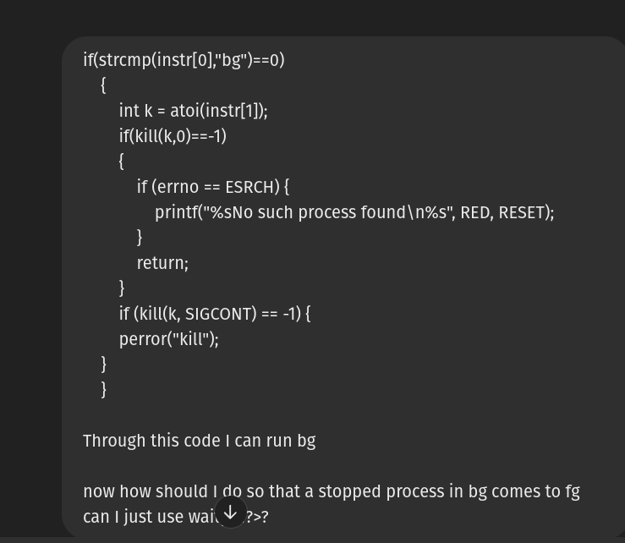

Prompt – 11

neonate- https://chatgpt.com/share/8836daf2-2245-4a41-9b1b-5c791ffc4a78

Prompt – 12
Proclore being modified learnt about how real shell gives pid and group id to the bg processes. So have modified accordingly to the codes of system_command.c and proclore.c
https://chatgpt.com/share/34ada18e-c632-4e17-a89e-f89132a605fd

Prompt – 13 - iMan
https://chatgpt.com/share/2e5a6dd2-c3d0-4401-97f5-06064063b4de

Prompt – 14 – myshrc file
https://chatgpt.com/share/f8690236-2bac-4c44-87b1-c47a5223cd8d

Prompt – 15

