OSN MP2

XV6

System Calls
1.Gotta count ‘em all -

- Made changes to syscall.c and syscall.h to add the new systemcalls like getSysCount(for this part),sigalarm,sigreturn,settickets(for others)
- Made changes in proc.h to include a array of syscall_count which will hold the number of times a syscall has been made. And changes were done in code of wait so that childs syscallc_count gets added to the parent during the time the child undergoes from being zombie to finally being removed. Initialized all to 0 in allocproc also did change in sysproc.c which simply just return the value present in the procs array.
- Made a user file syscall.c which will be calling the function getSysCount whenever the user uses it and will print the result and relevant changes were done in user.h and usys.pl file to call the functions.

2.Wake me up when my timer ends
- Made changes to proc.h to include vars like – tickcounter,handler,savedtf(to save trapframe),alarmticks,alarm flag variable and allocated them to the normal values in allocproc.
- Then made changes in the sysproc.c file which included the sys_sigalarm and sys_sigreturn function.
Sigalarm – for assigning the current proc to the input send – the alarmticks and the address and then assigning handler and making alarm flag =1
Sigreturn – will be called when the handler function returns the control again to the process and will make the alarm flag again as 1 so that function could be called again when the interval passes. Tickcounter is set to 1 to again start counting.
- Changes mainly were done in trap.c – in usertrap function in section on line 67-87 where we will use the flag p→alarm to know whether we have to handle or not(note – diff var name than gpt as earlier I was having errors so had removed that variable and later when realised it is needed I came up with simple var name alarm)
There p→ tickcounter is increased as it means after each tick the user prog has been interrupted and if it becomes greater than we simply save the state so that the process can resume again in the saved tf . Trapframe → epc is exception program counter which will point to the current function addresss so not a new process is created just pc is changed.
- Alarmtest works correctly all 3 passes

Scheduling

1.Lbs
- Changes – proc.c and proc.h proc.h now has tickets to know tickets which each process has. Also as child should also get same tickets as parent so changes done in fork code.
- Logic is to get a random number generator (xv6) does not allow us to use random functions so got one from gpt and then select one number on based of tickets and then we find a process and then among all the runnable processes find the one which has the least process this has been made earliest.
- Then just acquire it like we do in RR (got inspiration from there) and made it state running and made c→ proc = earliest so that cpu starts running that.
Regarding the questions asked -
Implication of arrival time-
This has done to ensure fairness so that a process which came early will get priority in having cpu and will not wait for longer time making this a fairer system.
Pitfall-
There is one pitfall that a new process with high number of tickets might keep coming up which will not allow other tickets having less number of tickets to use the CPU. There is high chance that the winner who gets selected will be on of the highest ticket gatherer. So application can missuse settickets option to get a high number of tickets for themselves.

Same No. of Tickets-
It will be like FCFS then as all will be having the same priority so the one who comes up earlier will be taken regardless of who is the winner selected as we search among all runnable processes and same ticket one to get the one with shortest time. So earlier one would be selected every time.

2. MLFQ
- Changes in proc.c and proc.h to know the time slice , the priority and ticks_used.
- Made array of process struct* so 4 (NQUEUES) are made which will hold the processes being spawned and array queue_sizes which will hold the size of each queue
- Then find all the places in proc where RUNNABLE processes are spawned and then enqued them eg -kill,init
- made normal functions enqueue and dequeue
- In scheduler first it checks for the first queue I.e -more prior queue and find the 0th element of it and we will run it using the normal way – acquire > then swtch > then it will return to us we will increase it ticks used basically a process will return after each tick so its tick will increase if its still less than slice we will just deque and enque it simply so that this process will now go last in its queue ensuring RR is there between process of same priority but if it runs for >= timeslice then its priority is reduced until it reaches queue 3 which is least prior (queues – 0 (most prior) - 3 (least prior))
- Also if a process is in queue but now not runnable then it will be simply dequeud.

Differences in using this in using scheduler tests -
r_time not major differnce found hardly diff of 1 – 2 ms

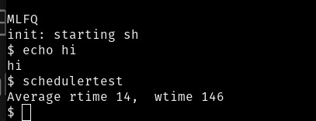Figure 1: MLFQ
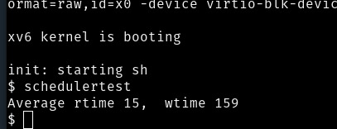Figure 2: rr
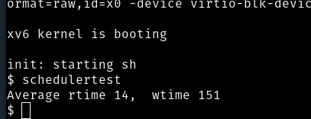Figure 3: lbs

So not much differnce in rtime but about 6-8 ms diff in wtime. (all tests on cpu = 1)

Also mlfq graph
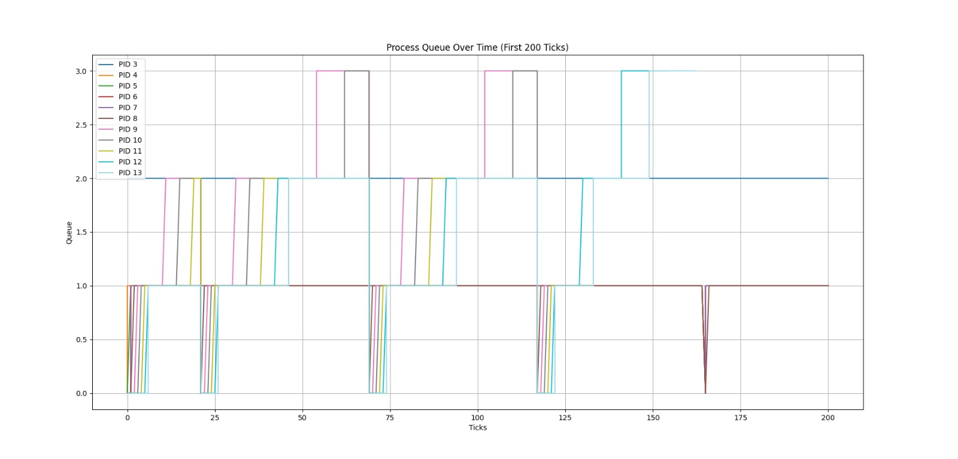
How to make – just printing the current ticks, priority(which represents queue number in my case) and pid of each runnable process.
Did changes in makefile so that to make these things work and can define 3 scheduler functions
Rest execution details ,networking in readme and prompts in prompts.odt.

Thanks for reading this till here(IDK WHY I ADDED THIS)

