**Excel Assignment – 6**

**Nidhi Shukla**

**1. What are the various elements of the Excel interface? Describe how**

**they're used.**

**Excel Interface Components**

**Excel has two main UI components: The Interface Components and the Workbook Components.**

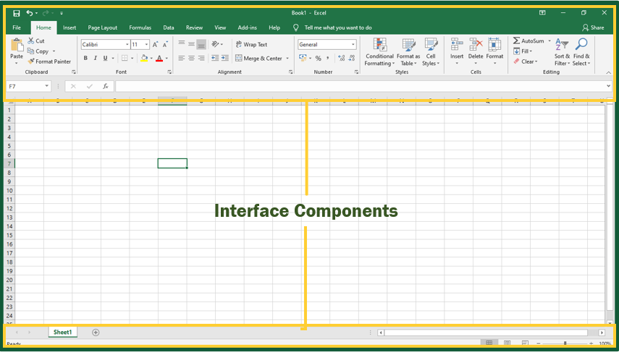

## **Interface Components**

**The interface components of Excel include the Quick Access Toolbar, Ribbon, Name Box, Formula Quick Menu, Formula Bar, Status Bar, Worksheet View Options, Zoom Slider Control, and the Zoom Percentage Indicator.**

### ***Quick Access Toolbar***

**The Quick Access Toolbar is found on the top-left of the Excel window which contains the commonly-used commands in Excel. This toolbar can be customized and lets you choose which commands you want to access easily. By default, this contains the save, undo, and redo commands.**



### ***Ribbon***

**The Ribbon interface contains the commands that are available for use in Excel. This has multiple tabs including the File, Home, Insert, Page Layout, Formulas, Data, Review, View, Add-ins, and Help tabs. There are tabs that will appear when necessary; for example, the Format tab appears when you click an inserted shape.**

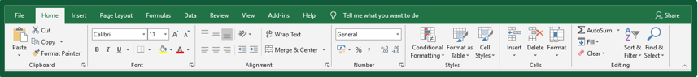

**The tabs are then subdivided in groups based on the usage of the commands. For example, in the Home tab, the commands are grouped in Clipboard, Font, Alignment, Number, Styles, Cells, and Editing.**

### ***Name Box***

**The Name Box is an input box which normally displays the name or location of the active cell on the worksheet. This is also used to directly create a named range. When you open a blank workbook, the selected cell is A1, by default.**

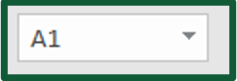

### ***Formula Quick Menu***

**The Formula Quick Menu beside the Name box is a shortcut when you want to insert a function. If you click the fx option, the Insert Function will pop-up to let you choose which Excel function would you like to use.**



### ***Formula Bar***

**The Formula Bar is found just beside the Formula Quick Menu. This allows you to enter or edit data, formula or a function that will appear in the selected cell whose name or location appears in the Name Box.**

**https://i0.wp.com/excelintuitive.com/wp-content/uploads/2020/11/word-image-82.png?resize=702%2C46&ssl=1**

### ***Status Bar***

**The Status Bar in the bottom-left corner of the Excel window displays various information about the current mode of the workbook.**



### ***Worksheet View Options***

**The Worksheet View Options lets you choose which of the 3 worksheet views you want (Normal, Page Layout, or Page Break Preview). By default, the worksheet view is set to Normal.**



### ***Zoom Slider Control***

**The Zoom Slider Control helps you zoom in and zoom out the worksheet.**

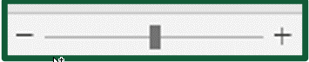

### ***Zoom Percentage Indicator***

**The Zoom Percentage Indicator displays the zoom percentage just beside the Zoom Slider Control. By default, it is set to 100%.**



**Top of Form**

**2. Write down the various applications of Excel in the industry.**

Data Entry and Storage Performing Calculations Data Analysis and Interpretation Reporting and Visualizations Accounting and Budgeting Collection and Verification of Business Data Calendars and Schedules Administrative and Managerial Duties Forecasting Automating Repetitive Tasks, etc.

**3. On the ribbon, make a new tab. Add some different groups, insert**

**commands in the groups and name them according to their commands**

**added. Copy and paste the screenshot of the steps you followed.**

**4. Make a list of different shortcut keys that are only connected to**

**formatting with their functions.**

Here are my top five Excel formatting shortcuts:

* **CONTROL + B**: Applies bold font formatting to headers
* **ALT + H + B + A**: Applies borders to the cells
* **ALT + H + B + T**: Gives an outline border to the dataset
* **ALT + H + O + W**: [Autofits](https://trumpexcel.com/autofit-excel/) column widths
* **CONTROL + 1:** Opens Format Cells dialog box

**5. What distinguishes Excel from other analytical tools?**

**Main differences between Excel and (other analytic tool) Power BI**

* Excel is used to organize data, transform it and perform mathematical operations and calculations. On the other hand, Power BI was conceived as a business intelligence and [data visualization](https://blog.bismart.com/en/data-visualization-with-power-bi) tool for businesses.
* Excel has limitations in the amount of data it can work with. In contrast, Power BI can handle much larger amounts of data.
* Power BI can connect to a large number of data sources, while Excel's connectivity capacity is limited. Also, unlike Excel, Power BI can be easily used from mobile devices.
* Power BI has faster processing than Excel.
* Power BI dashboards are [more visually appealing, interactive and customizable](https://blog.bismart.com/en/reporting-services-and-highly-visual-and-interactive-reports) than those in Excel.
* Power BI is a more powerful tool than Excel in terms of comparison between tables, reports or data files.
* Power BI is more user friendly and easy to use than Excel.

**6. Create a table and add a custom header and footer to your table.**

1. Go to **Insert** > **Header** or **Footer**.
2. Choose the header style you want to use.

**Tip:**Some built-in header and footer designs include page numbers.

1. Add or change text for the header or footer. For more info on things you can do with headers, see [Edit your existing headers and footers](https://support.microsoft.com/en-us/office/edit-your-existing-headers-and-footers-490423a3-3e5b-4080-aff0-c429ab5d6708). To edit a header or footer that's been already created, double-click on it.
2. To eliminate a header--like deleting it on the title page--select it and then check the **Different First Page** box.
3. Select **Close Header and Footer** or press Esc to exit.

To delete, select **Insert**> **Header** (or **Footer**) > **Remove Header** (or **Remove Footer**).