Day-3: Types of Testing

**Different types of testing:**

* There are many, many types of testing (more than 100).
* Each type of testing has a specific test objective, stage of implementation, actor (who is testing) etc.
* There are testing types based o techniques – static, dynamic testing.
* There are testing types based on stage – smoke, sanity, regression, performance testing etc.
* And then there are separate testing types based on actors – alpha, beta, A/B testing etc.

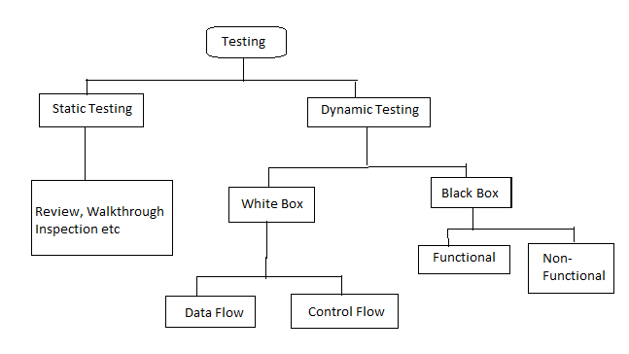

**Static and Dynamic Testing: -**

**Static Testing**: - This type of testing does not require execution of code.

It is used to check the code, requirement documents and design documents for errors. This is a “verification” testing to find defects early in the development cycle.

Types of Static Testing techniques:

1. Inspection – It is a formal type of review type of any artifact like code, test cases, documents etc. Done by a moderator using checklist.
2. Walkthrough – The owner explains the product. Participants get to know the product or document and can ask question. Scribe notes details.
3. Technical Review – A technical review of the code to ensure it meets technical specification and standards.
4. Informal Review – Documents are reviewed informally, and also informal comments are provided.

**Dynamic Testing: -** This type of testing involves execution of code. The tester provides an input, records the output value and compares it with expected output. Apart from checking functional behavior, the performance, usability, security etc. of the system can also be checked.

Types of Dynamic Testing:

1. White Box Testing: In this method, the internal structure of system is known. It is done by the developer. Types of white box testing are statements coverage, loop coverage, path coverage etc.
2. Black Box Testing: In this method, the internal structure of the system is not known. It is done mainly by testers: and by BA or even end users. Types of black box testing are functional and non-functional testing.

|  |  |
| --- | --- |
| Static Testing | Dynamic Testing |
| Done without execution of code | Done by execution of code |
| Done at early stage of development | Done at later stage of development |
| Checks the code, requirements\ documents, design documents | Checks functional working of software along with performance, security etc. |
| This is “verification” testing | This is “validation” testing |
| Helps to prevent defects | Helps to find & fix defects |
| Artifacts are checklist, meeting notes | Artifacts are test cases/scripts |

**Functional Testing:**

This type of testing verifies each “function” of the application under test, to verify it works according to the desired requirements. It uses black box technique.

Types of Functional testing:

1. Unit Test – Testing of individual modules, done by developer
2. Integration Test – Testing of interface between two modules when they are joined.

Terms- stub and driver

(If integrate Bottom-Up module use Driver for missing modules)

(If integrate Top-Down module use Stub for missing modules)

1. System Test – Testing performed on the whole system after all modules are done and integrated. Done by designated testing team.
2. Acceptance Test – Testing performed to verify user’s requirement are met. Done by BA or at real user’s end.
3. Smoke Test – Quick testing of most critical functionalities done on a new build, to determine its stability.
4. Sanity Test – Time-bound testing of most critical functionalities to determine health of overall application, done after a release. Sub-set of regression testing.
5. Regression Test – Testing done to determine any new changes or fixes haven’t broken an existing feature. Done to make sure existing functionality is working fine.
6. Exploratory Test – Undocumented testing on-the-fly, based on experience of tester. Usually done after formal testing is over or when there is no clear requirement.
7. Risk based Test – Testing based on risks identified to product quality. Risk assessment can also be used to determine priority of test cases.

**Non-Functional Testing:**

This type of testing verifies non-functional features of the application under test, such as its performance, security, usability etc.

Types of non-functional testing (most common) are:

1. Load Test – Testing of a systems performance in expected real-world user load, to determine response time.

-To test what is response time to log in 1500 users, what is performance of system.

1. Stress Test – Testing of a system with more than expected user load, to determine how it behaves in extreme conditions.

-To test with more users than in load testing.

1. Volume Test – Testing performed with huge volumes of data, to determine system performance.
2. Security Test – testing to uncover vulnerabilities, threats or risks in a system. Done by testers or third party specialized companies.

-If website uses credit card, then it should be secure.

1. Usability Test – Testing performed to determine “ease of usage” of a system to a user. Usually done by end users.

-User friendly test

1. Accessibility Test – Testing of a systems usability to people with disabilities. Several tools are available to check this.
2. Compliance Test – Testing to confirm adherence to standards, procedures and guidelines. Done by third party rating agencies.

Difference Between Functional & Non-functional testing:

|  |  |
| --- | --- |
| Functional Testing | Non-functional Testing |
| Checks behavior of system | Checks non-functional attributes like performance, security etc. |
| Driven by “requirements” | Driven by “expectations” |
| Done before non-functional testing | Done after functional testing |
| Done using functional specs | Done using baselines, best practices |
| Can be done manually | Requires tools |

**User Acceptance Testing:**

This type of testing is done by the end-user or client of a system, to validate the software against the business requirements, and decide whether it’s acceptable.

Types of UAT are:

1. Alpha Test – When UAT is carried out at developers site.
2. Beta Test – When UAT is carried out at client location or end users of product.
3. A/B Test (Split test) – A/B testing creates two versions of the product to determine which one meets business and acceptance more effectively.

Difference Between:

|  |  |
| --- | --- |
| Smoke Testing | Sanity Testing |
| Verify basic things on a new build - general check up | Verify around new functionality/bugs, or do a daily check of the system – Specialized check-up |
| Objective is to verify “stability” of the new build, before starting testing. | Objective is to verify “health” of overall system before running full regression, or validate after a release. |
| Done by developers or testers | Done by testers |
| Very small subset of testing | Subset of regression testing |
| Can be automated (and tied to new build generation – CI/CD model) | Can be automated to run on a frequent basis (daily etc) |

|  |  |
| --- | --- |
| Regression Testing | Re-Testing |
| Verify a recent change has not affected “existing functionality” | Verify test cases which failed earlier are getting passed after defect is fixed |
| Done on “existing” feature | Done on the “fixed” feature |
| Includes impacting test cases | Includes only failed test cases |
| These are best candidate for automation | Cannot automate test cases for retesting |
| Follows re-testing | Done before regression testing |