**Requirement analysis and Test planning**

* Requirement analysis is the first phase of STLC
* Misunderstanding of requirements or a miss in capturing requirements will lead to incorrect testing, or inadequate scope.

e.g. Facebook business requirement is to login “email” and password, but testing team understood to login by “mobile” and password.

* Requirements can be functional or non-functional.
* Requirements come from business analyst, system architect, technical manager etc.

How are requirements formed?

* Requirements may come from many sources – group sessions, in-house ideation, third party consultants, competitors etc.
* The initial discussions work around a high level requirement (Project vision documents with use cases)
* The use cases are then translated into low level requirements (Functional requirements)
* The low level requirements are written down into “stories” with “acceptance criteria” (Agile) breaking based on complexity.

**Use case for Online shopping Site**

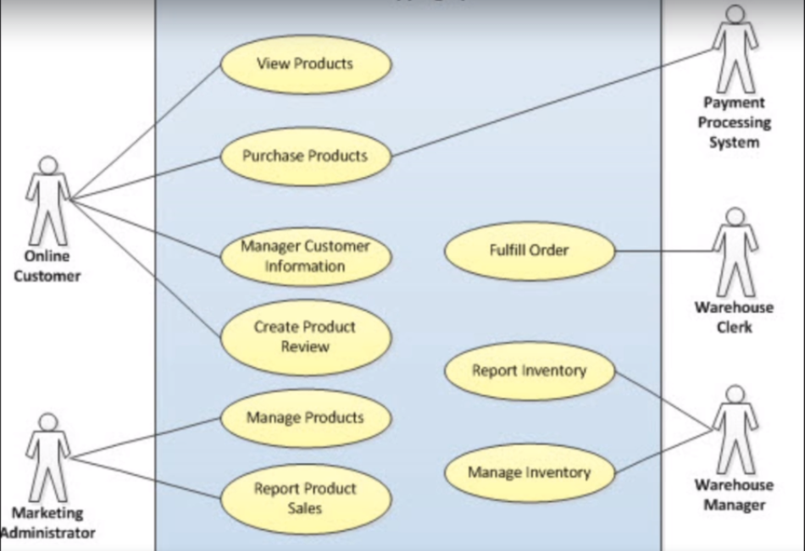

How to understand and translate requirements?

* Requirements are the foundation of effective testing
* Requirements should be:

1. **Complete** – It should contain all information needed to clarify things and avoid “assumptions”.
2. **Clear** – It should be written in a way that is transparent and clear.
3. **Correct** – It should not have contradict each other
4. **Testable** – It should be testable.

* Both the functional and nonfunctional requirements should be addressed. Testers have complete knowledge of system, So they are very useful assets in formulating the requirement.
* Never assume things, always ask questions.
* Always insist on documented requirements. So people do not remember a verbal discussion.
* wear the "user" hat . Think like a user. Design it in a way a user will like.
* use a tracking method like a Requirement Traceability Matrix (RTM). So the RTM is very effective in making sure we capture all the requirements into test scenarios and

**Requirement Traceability Matrix**

* Traceability Matrix is used to map requirements into test cases and trace them for coverage analysis.
* purpose of RTM is to make sure that all requirements are covered
* Basic RTM should have – Req ID, Description, Test case ID.
* We can record other fields also, like who wrote the test case, what was the date on which the test case was written, who reviewed the test cases, etc.
* Requirement traceability can be:

Forward traceability – requirements >> test cases

Backward traceability –test cases >> requirements

Bi-Directional Traceability – both ways.

**Test coverage**

* It is a measurement of amount of testing, performed by a set of test cases.
* Helps us to identify requirements covered and check the quality of product.
* Not to be confused with code coverage that is done by developers.
* test coverage can be covered by static reviews, code insight, defect check, test management

tool, etc.

* An ideal test coverage should include:

Product coverage – which areas of product tested?

Risk coverage – which risks are tested?

Requirements coverage – which requirements are tested?

**Test Planning**

* Test planning is a very important and strategic phase of STLC, defining all testing plans
* It is first practical phase of STLC.
* Define the scope of testing, the estimations, the resource planning, the tools, etc., that
* The output of test planning phase is well documented test plan that serves as reference guide for the next stages of STLC.
* The test plan we create here will serve as reference guide for all future stages of STLC.
* Even with so much importance, something test plan is not written due to lack of time. This is very bad practices.

**Test Planning Objectives**

* Determine scope of testing – what/what not
* Document strategy
* Plan for testing activities
* Estimate, resourcing, roles & responsibilities.
* Entry & exit criteria
* Point out risks
* Reporting metrics

**Advantages of having a test plan**

* Roadmap for entire testing
* Keep a track on estimates, schedule, resourcing
* Guide for roles & responsibilities
* Clear out things for other stakeholders – business, development, client etc.
* Serves as a future reference guide for other projects.