COMP 3311: Database Management Systems

Lab 2 Exercise: Oracle Database, SQL*Plus and SQL Developer

# What To Do

1. **Download** the zipped folder **Lab2Exercise.zip** from the ***Oracle Database, SQL*Plus and SQL Developer*** entry of the Lab Schedule course webpage to the desktop and unzip it. The folder contains the script file **Lab2DB.sql** which contains SQL statements that:

* drop (delete) a table named **Student** if it exists;
* create a table named **Student** with 6 attributes;
* insert 20 different records into the **Student** table.

Don’t worry if you do not understand the SQL statements. They will be covered in detail in future labs and the lectures.

1. **Execute** the **Lab2DB.sql** script file in **SQL Developer**.
2. **Create** a new SQL script file in **SQL Developer** named **InsertMyself.sql**.
3. **Construct**, in the **InsertMyself.sql** script file, an SQL **insert** statement that inserts into the **Student** table a record with the following values. (See the **Lab2DB.sql** script file for examples of such an insert statement.)

* Your student id (8 digits max), first name (20 characters max), last name (25 characters max) and HKUST email login name excluding “@connect.ust.hk” (15 characters max).
* Any phone number of your choosing; it does not have to be your phone number (8 digits max).
* The value “3.64” for the **cga** attribute.
* The value “COMP” for the **departmentId** attribute.
* The value “2018” for the **admissionYear** attribute.

Add the command **commit** as the second (and last) line of the script file. This command writes any changes you make to a table from main memory to disk (i.e., to the database).

1. **Save** your **InsertMyself.sql** script file inside the **Lab2Exercise** folder.
2. **Execute** your **InsertMyself.sql** script file in **SQL Developer** using the **Run Script** button.
3. **Open** a new SQL worksheet and in this worksheet **construct** and **execute** an SQL **select** statement to show all the records in the **Student** table as shown in Figure 1.

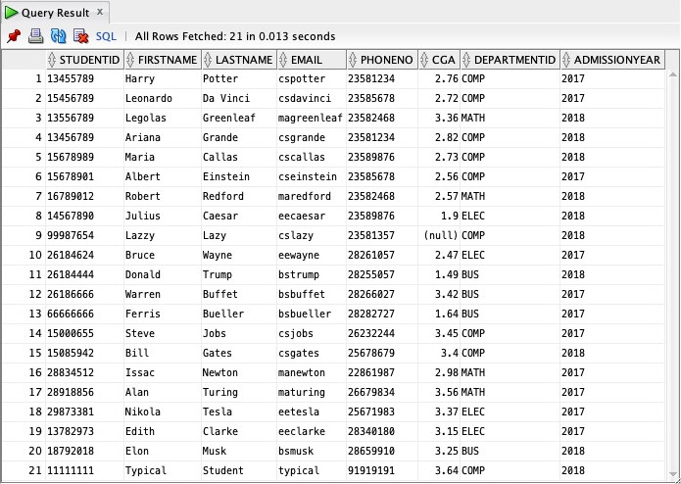

**🡨** Your record should appear somewhere in this listing.

**🡨** Original **Student** records.

Figure 1: Example **SQL Developer** Query Result tab showing **Student** records.

**tails** button on the right side of Canvas. For help, select the **Help** button at the top-right of Canvas.

# What To Save

Save your **InsertMyself.sql** script file as it will be needed in subsequent labs.

Again, you don’t need to submit the exercise, but the recommended deadline would be 23:59 at the Friday.