Launch an EC2 instance -Linux along with a web server. Then, create an EBS volume of 5 GB, attach it to an EC2 machine Linus, and take a snapshot. Finally, create an EBS volume using the taken snapshot.

Amazon Elastic Block Store (Amazon EBS) provides scalable, high-performance block storage resources that can be used with Amazon Elastic Compute Cloud (Amazon EC2) instances. With Amazon Elastic Block Store, we can create and manage the following block storage resources:

* Amazon EBS volumes — These are storage volumes that we attach to Amazon EC2 instances. After we attach a volume to an instance, we can use it in the same way we would use a local hard drive attached to a computer, for example to store files or to install applications.
* Amazon EBS snapshots — These are point-in-time backups of Amazon EBS volumes that persist independently from the volume itself. We can create snapshots to back up the data on your Amazon EBS volumes. We can then restore new volumes from those snapshots at any time.

Steps to create EBS-Volume:

1. Choose Create volume.
2. For Volume type, choose the type of volume to create. General Purpose SSD gp3 is the default selection.
3. For Size, enter the size of the volume, in 5 GB.
4. For IOPS, enter the maximum number of input/output operations per second (IOPS) that the volume should provide.
5. For Throughput, enter the throughput that the volume should provide, in MB/s.
6. For Availability Zone, choose the Availability Zone in which to create the volume. A volume can be attached only to an instance that is in the same Availability Zone.
7. For Snapshot ID, keep the default value
8. Set the encryption status for the volume.
9. For Snapshot ID, select the snapshot from which to create the volume.
10. For creating volumes from snapshot, create new volumes from those snapshots at any time.

Apache Webserver running on Remote Linux machine:

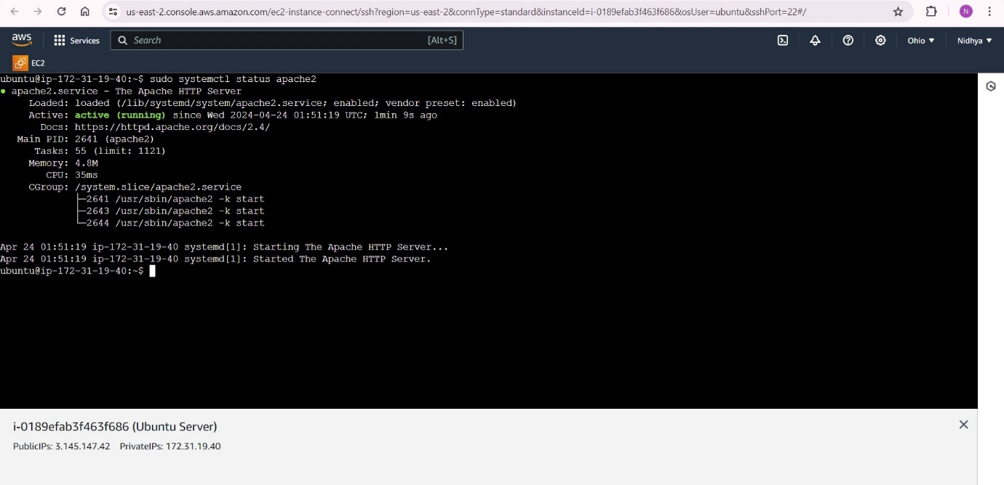

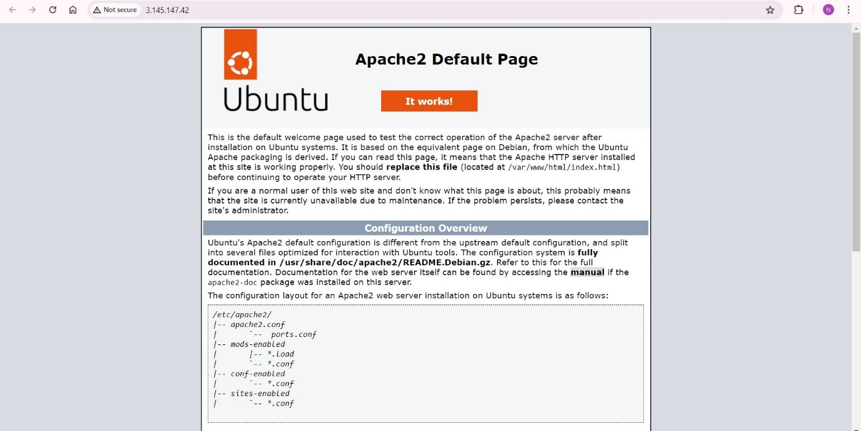

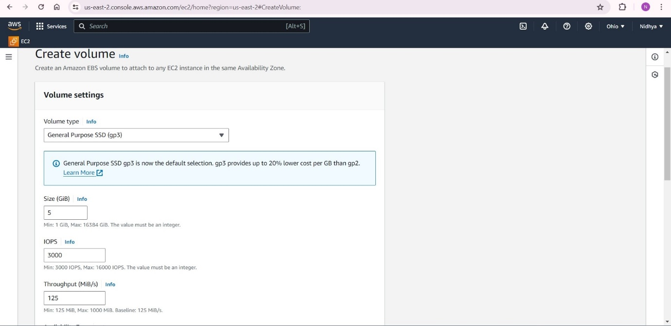

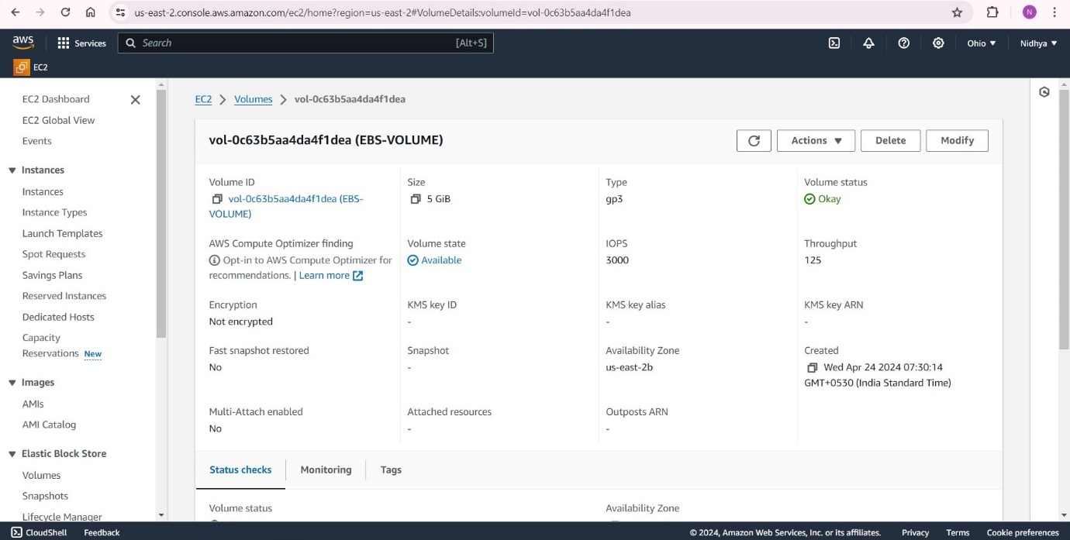

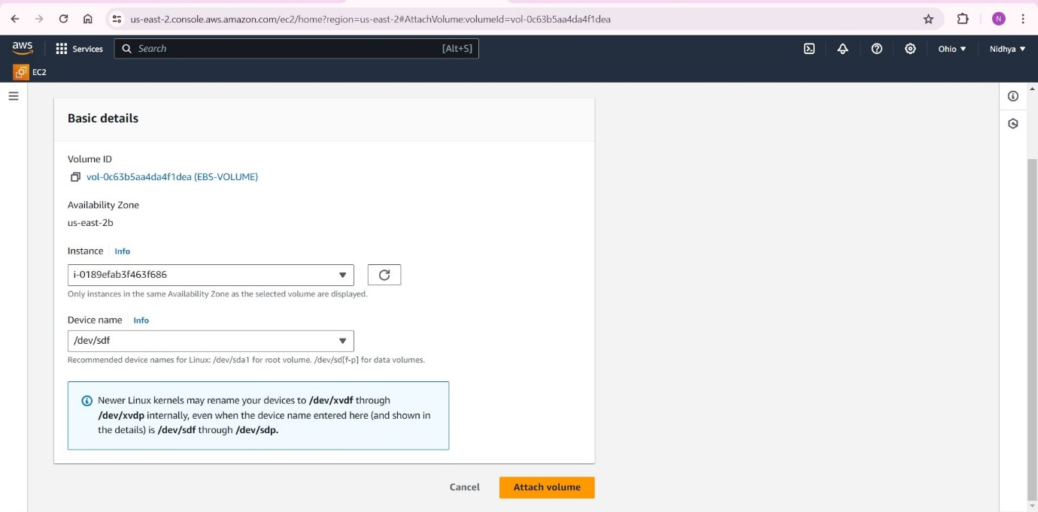

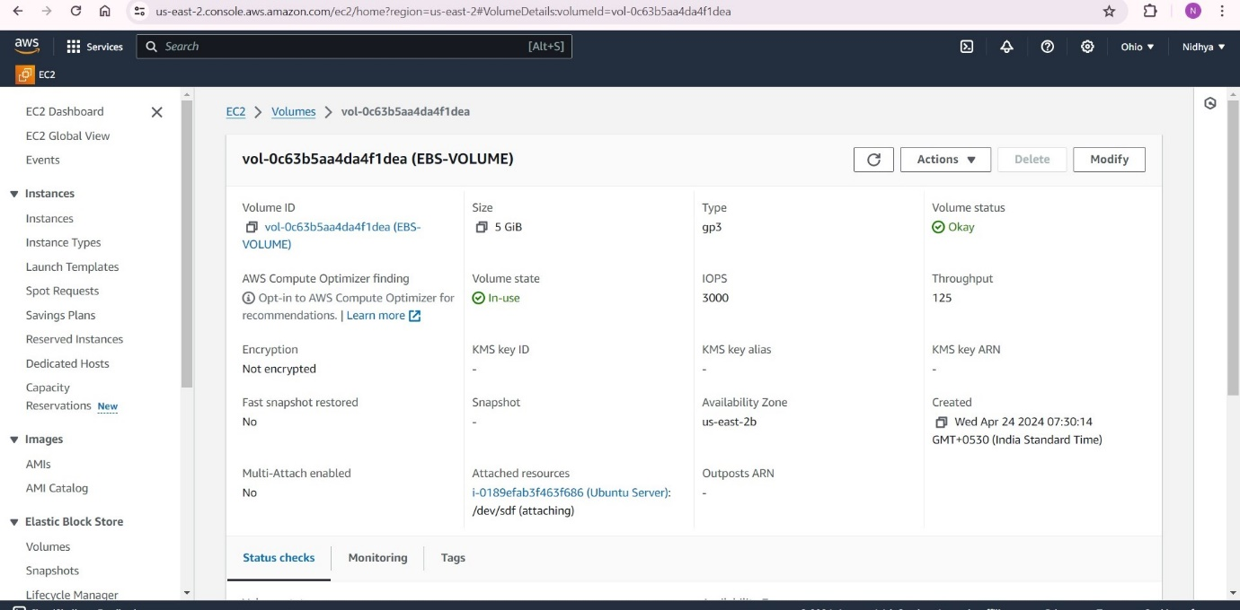

Now we have to mount the file system on your EC2 instance.

The 'lsblk' stands for 'list block devices', and as the name suggests, it is used to list out all block devices in a tree-like format.

This powerful command can help us gather comprehensive information about each block device connected to our Linux system, including the disk partitions and their respective sizes.

In Linux, fstab it is part of the util-linux package. The fstab file typically lists all available disk partitions and other types of file systems.

