Launch an EC2 instance -Windows along with a web server. Then, create an EBS volume of 5 GB, attach it to an EC2 machine Windows, and take a snapshot. Finally, create an EBS volume using the taken snapshot.

Apache Webserver running on Remote Windows machine:

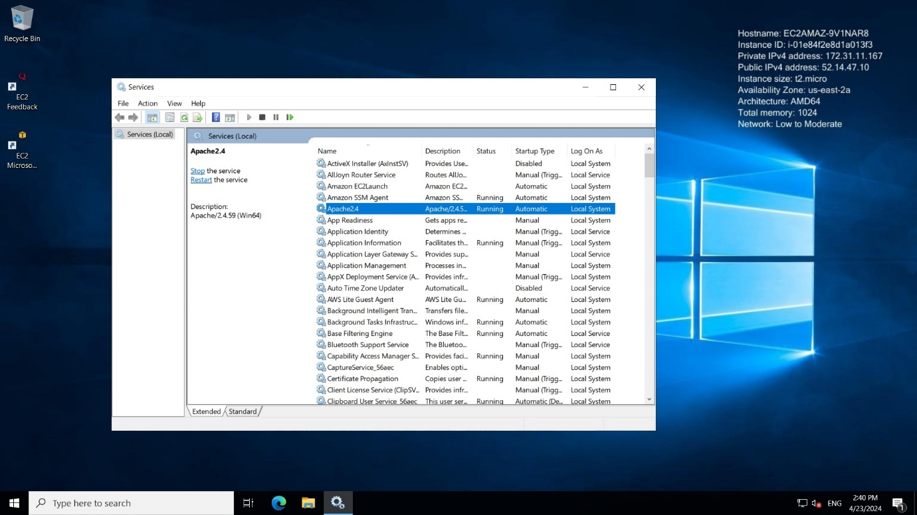

Output on Remote windows machine:

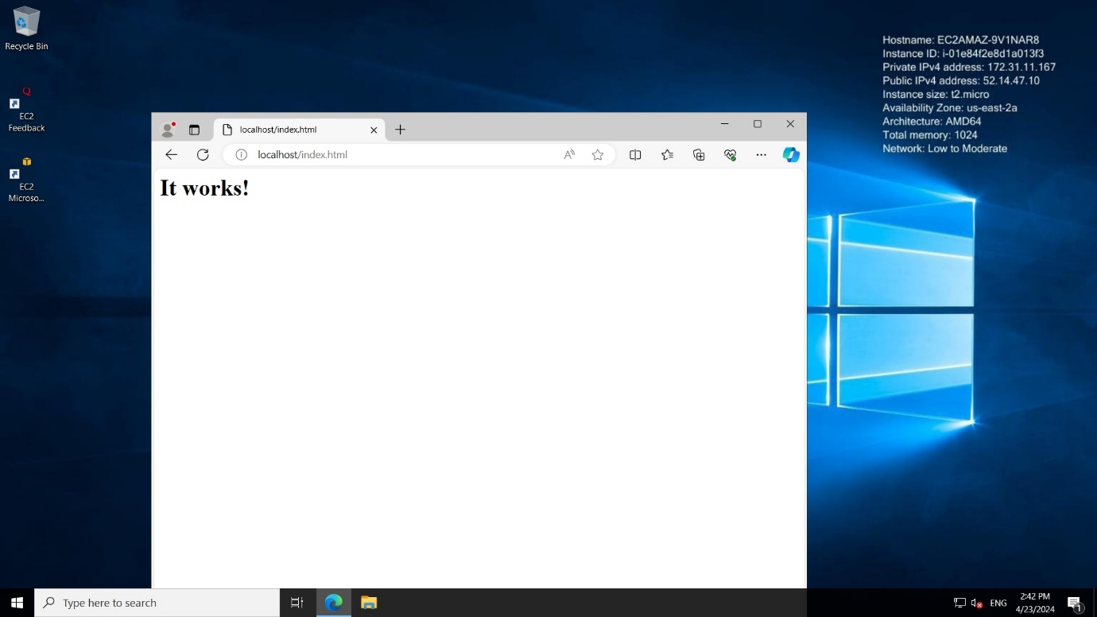

Creating volume of size 5 gb in EC2 instance:

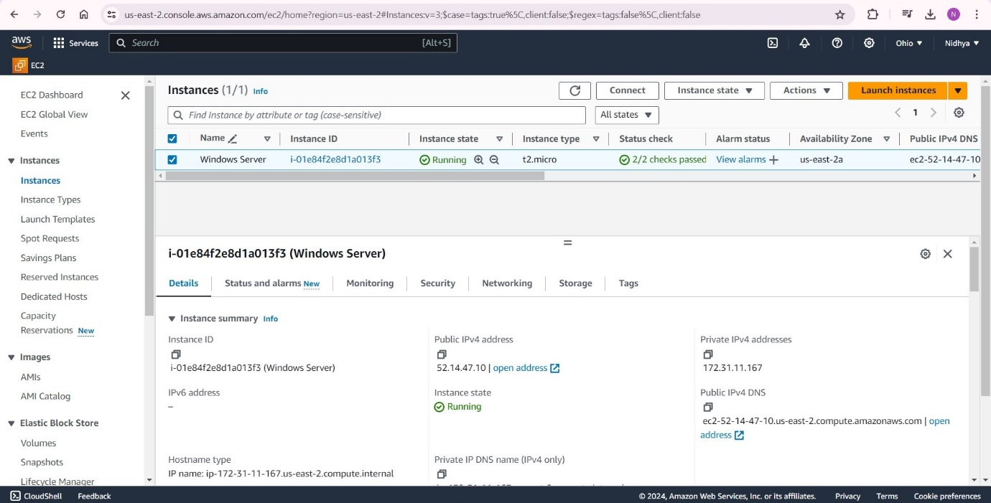

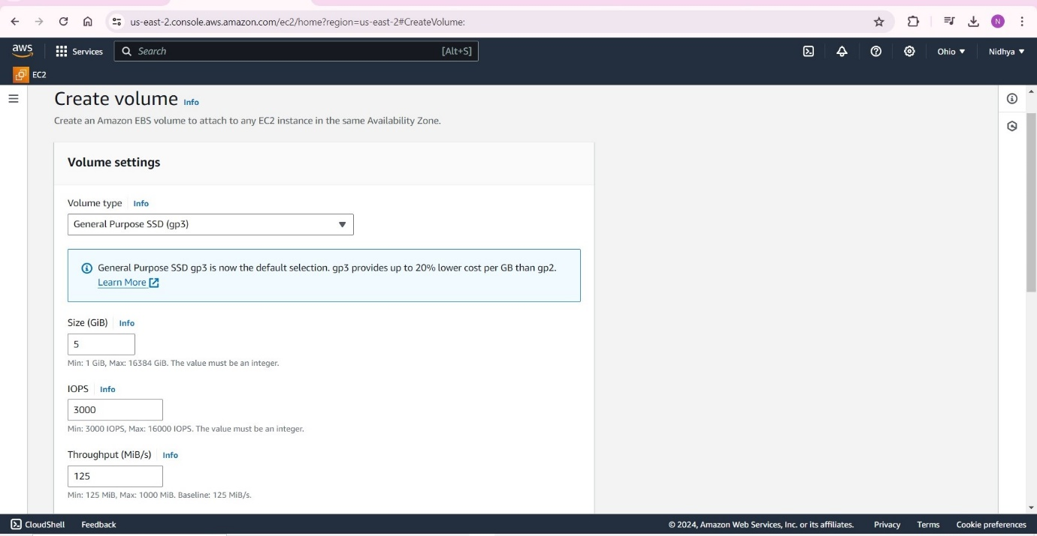

* An Amazon EBS volume is a durable, block-level storage device that we can attach to our instances.
* EBS volumes are flexible.
* For current-generation volumes attached to current-generation instance types, we can dynamically increase size, modify the provisioned IOPS (Input Output Per Second) capacity.
* IOPS is the standard measure of I/O operations per second on a storage device. It includes both read and write operations.

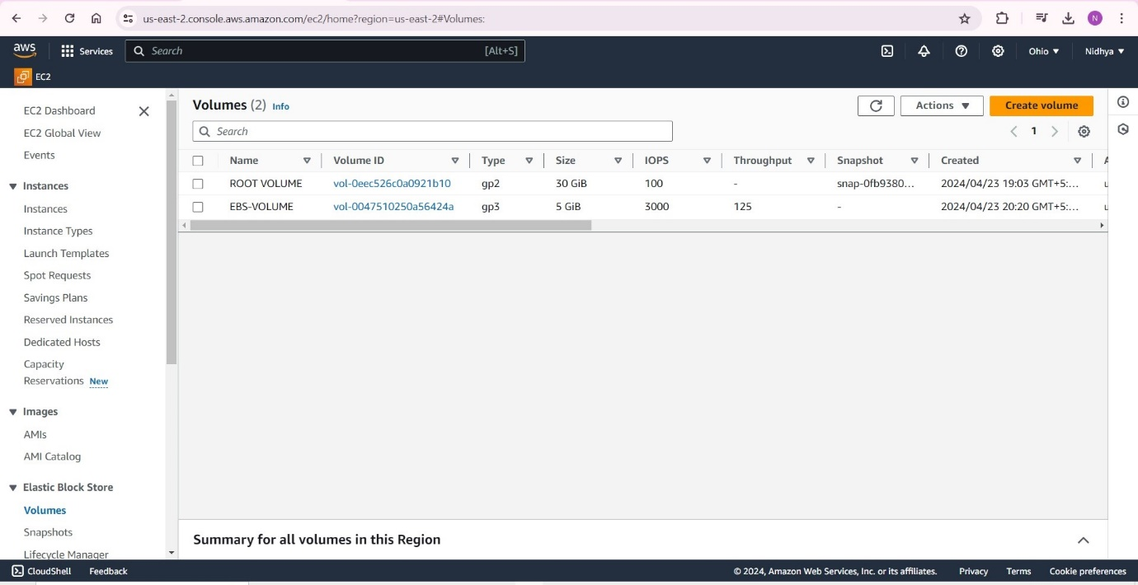

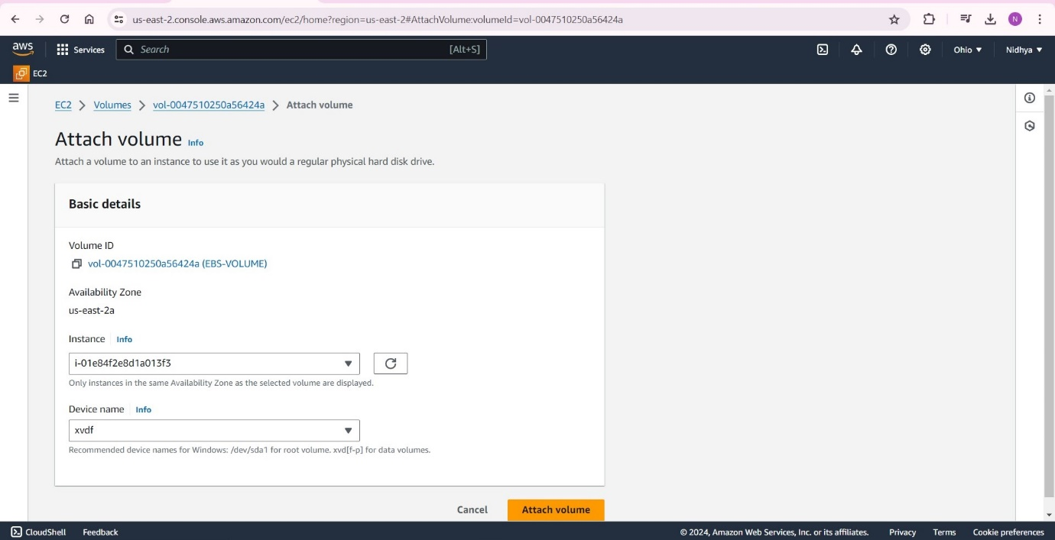

Benefits of using EBS volumes:

* [Data availability](https://docs.aws.amazon.com/ebs/latest/userguide/ebs-volumes.html#availability-benefit)
* [Data persistence](https://docs.aws.amazon.com/ebs/latest/userguide/ebs-volumes.html#persistence-benefit)
* [Data encryption](https://docs.aws.amazon.com/ebs/latest/userguide/ebs-volumes.html#encryption-benefit)
* [Data security](https://docs.aws.amazon.com/ebs/latest/userguide/ebs-volumes.html#security-benefit)
* [Snapshots](https://docs.aws.amazon.com/ebs/latest/userguide/ebs-volumes.html#backup-benefit)
* [Flexibility](https://docs.aws.amazon.com/ebs/latest/userguide/ebs-volumes.html#flexibility-benefit)

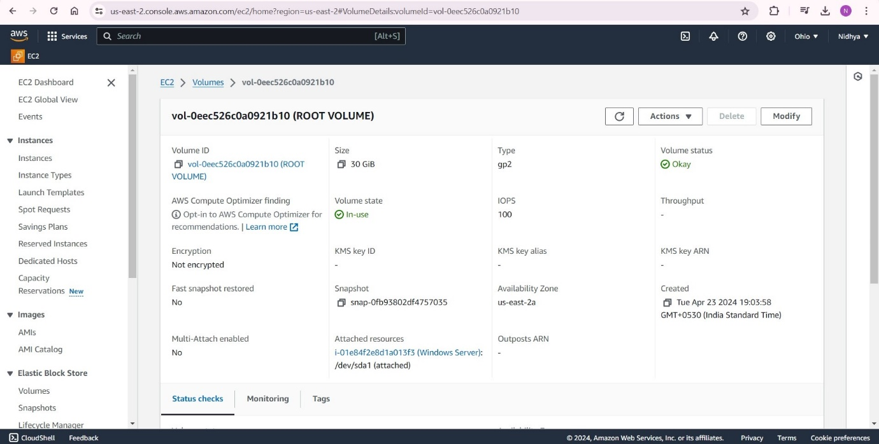

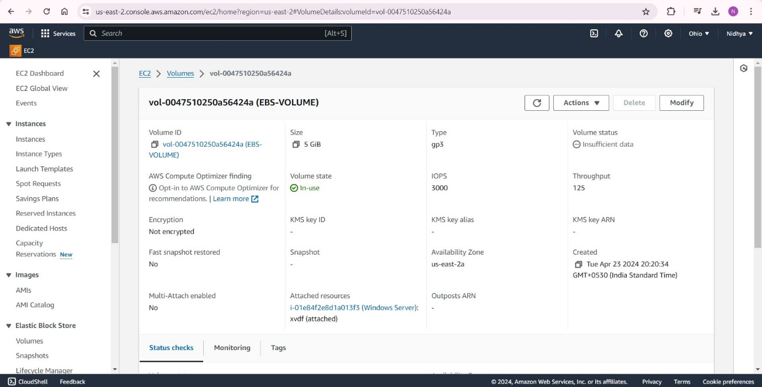

Snapshots:

* Amazon EBS provides the ability to create snapshots (backups) of any EBS volume and write a copy of the data in the volume to Amazon S3, where it is stored redundantly in multiple Availability Zones.
* As we continue to write data to a volume, we can periodically create a snapshot of the volume to use as a baseline for new volumes.
* These snapshots can be used to create multiple new EBS volumes or move volumes across Availability Zones.
* Snapshots of encrypted EBS volumes are automatically encrypted.

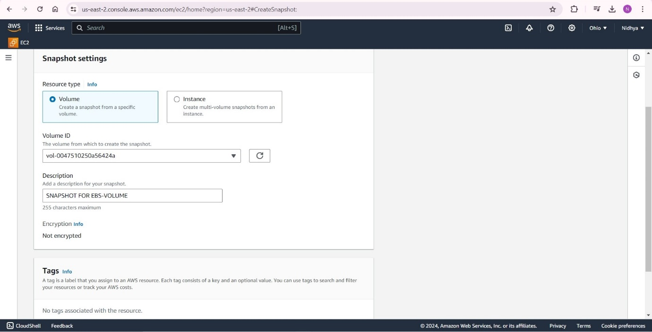

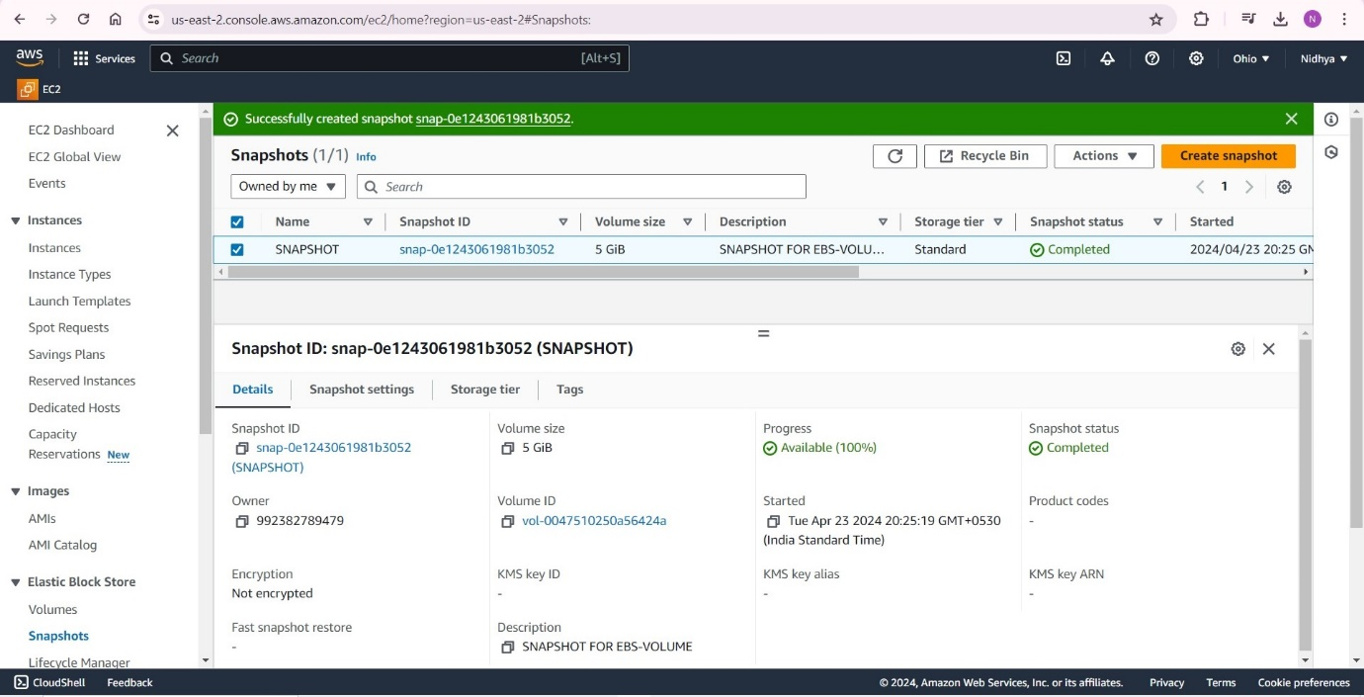

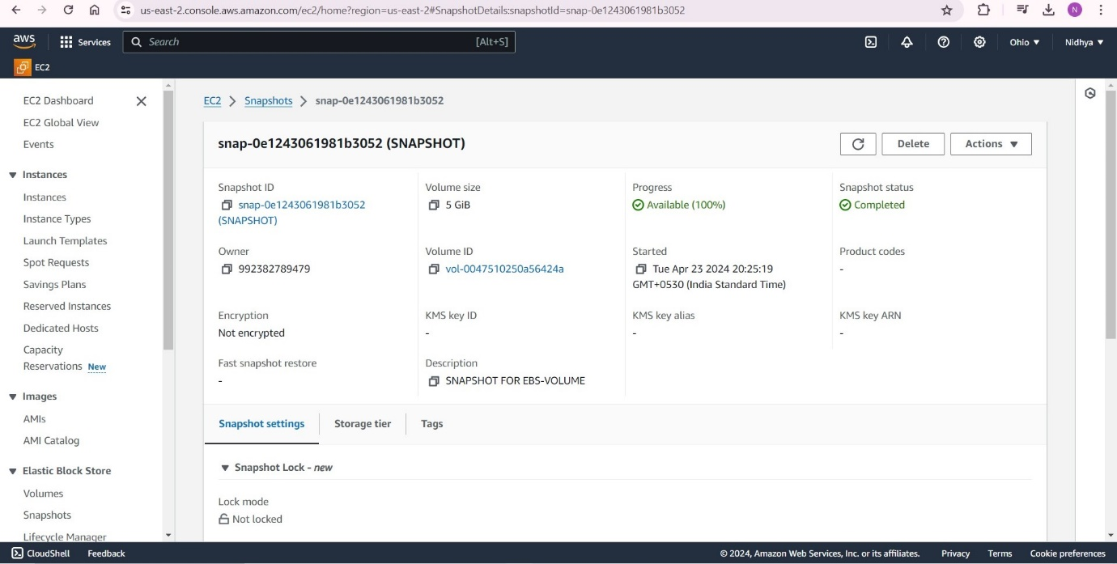

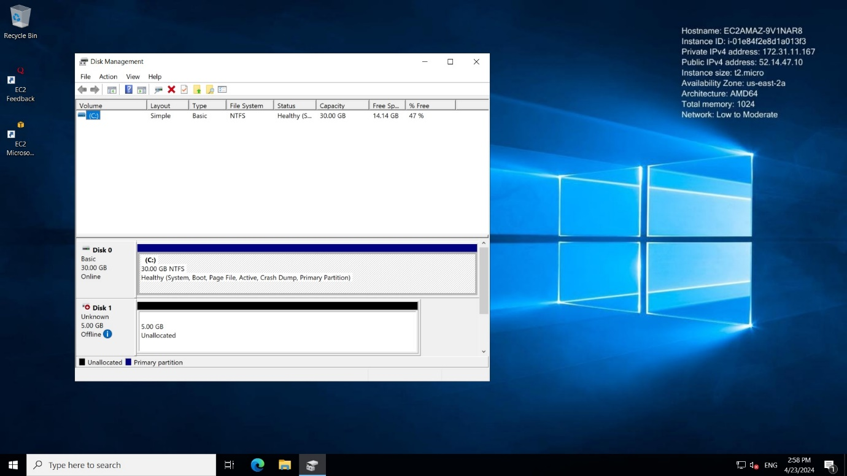

As we can see in the above screen the Volume is Unallocated, which means we are not able to use this volume, we need to make the volume disk online and format it by the filesystem.

We need to select your “Partition Style” MBR (Master Boot Record)

The Master Boot Record (MBR) is the information in the first sector of a hard disk.

It identifies how and where the system's operating system (OS) is located in order to be booted (loaded) into the computer's main storage or random access memory (RAM).

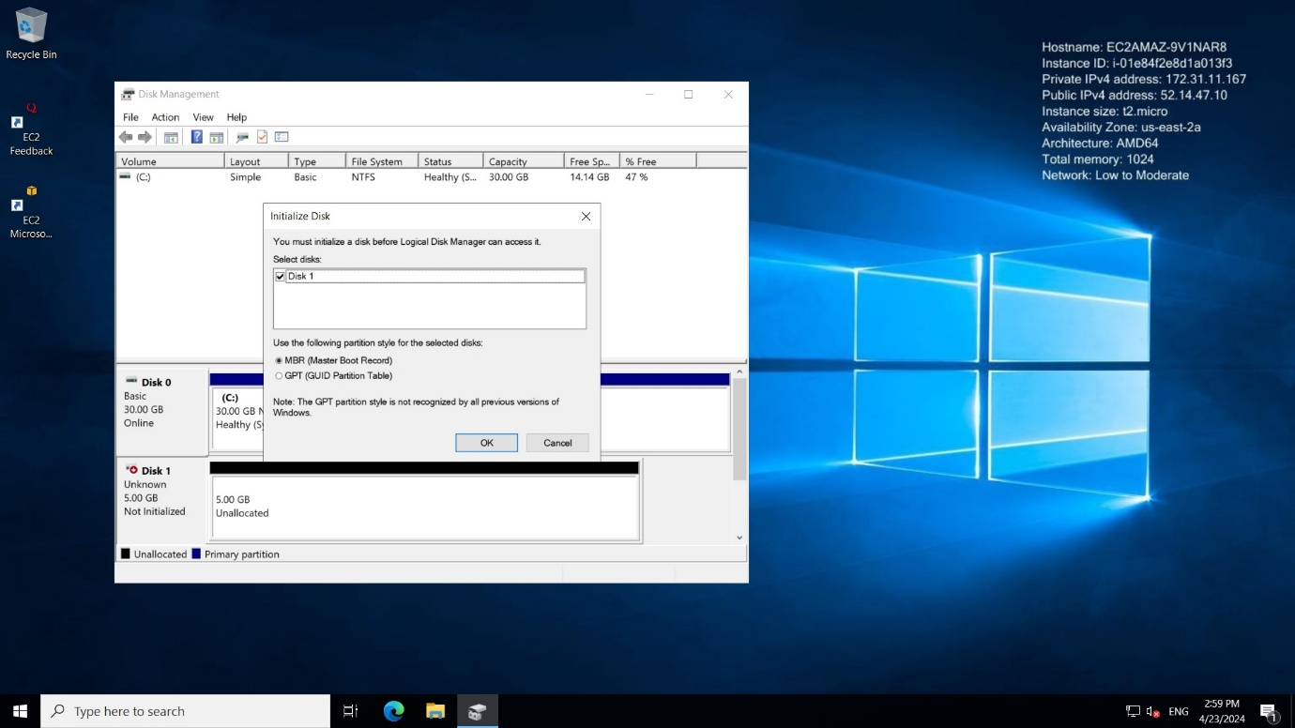

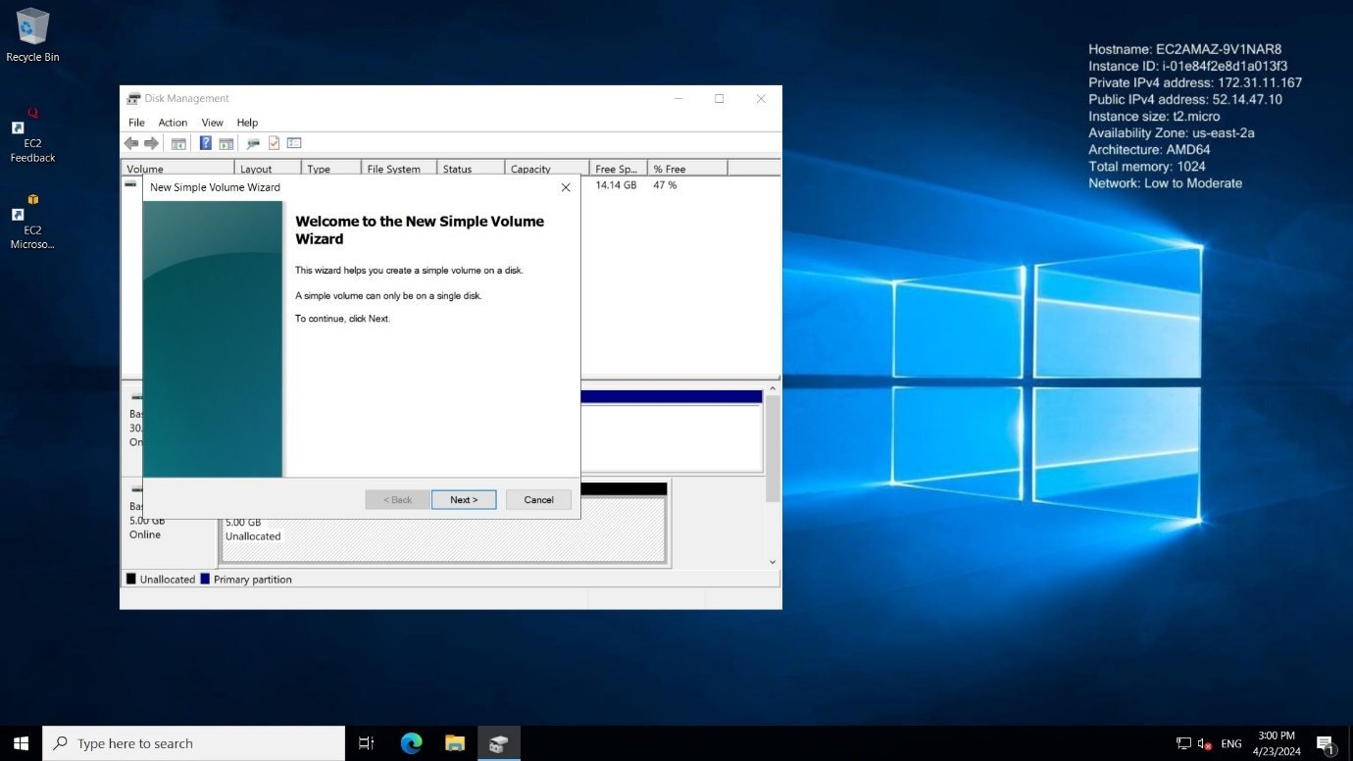

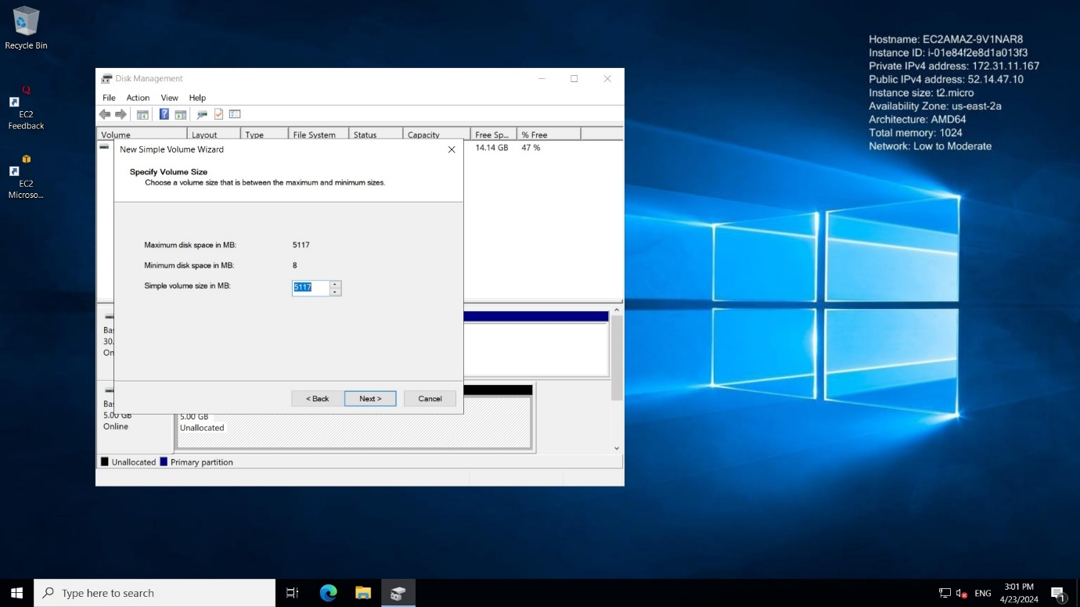

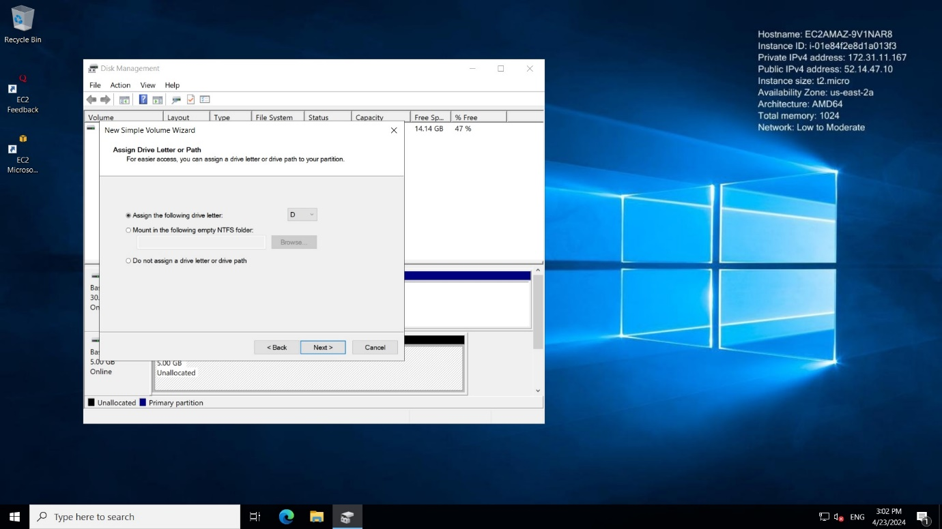

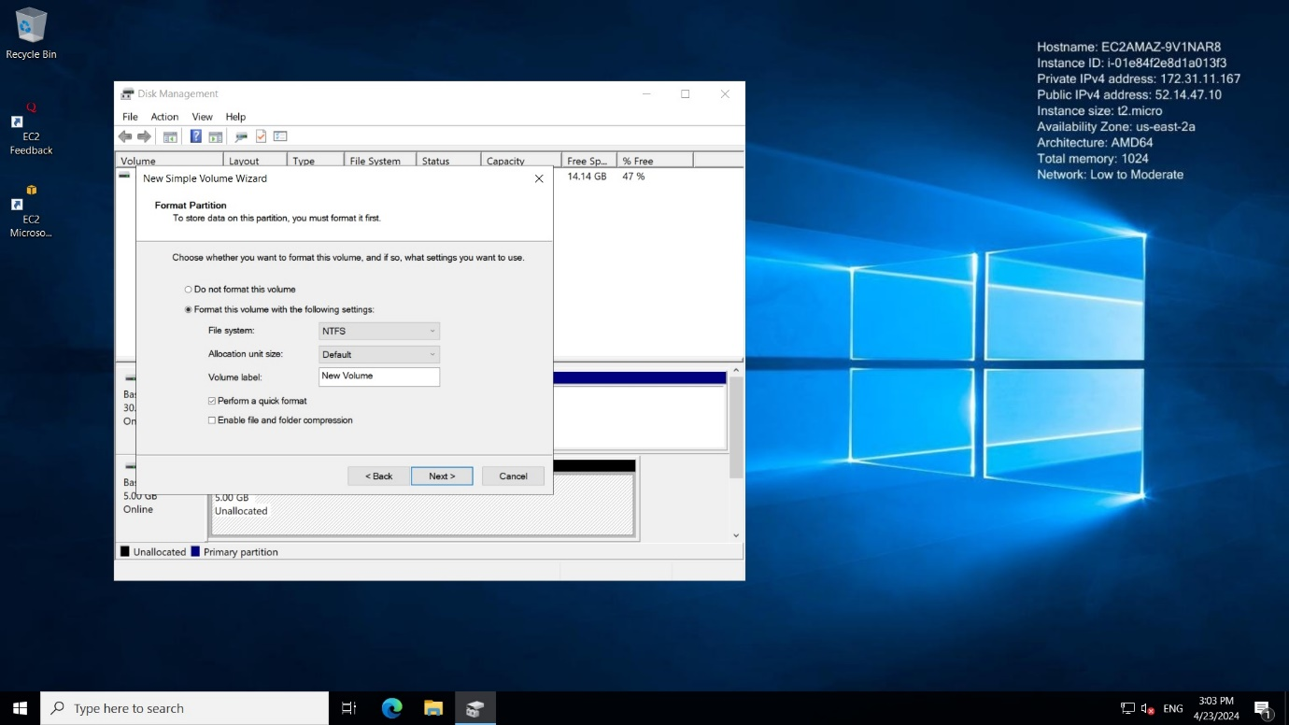

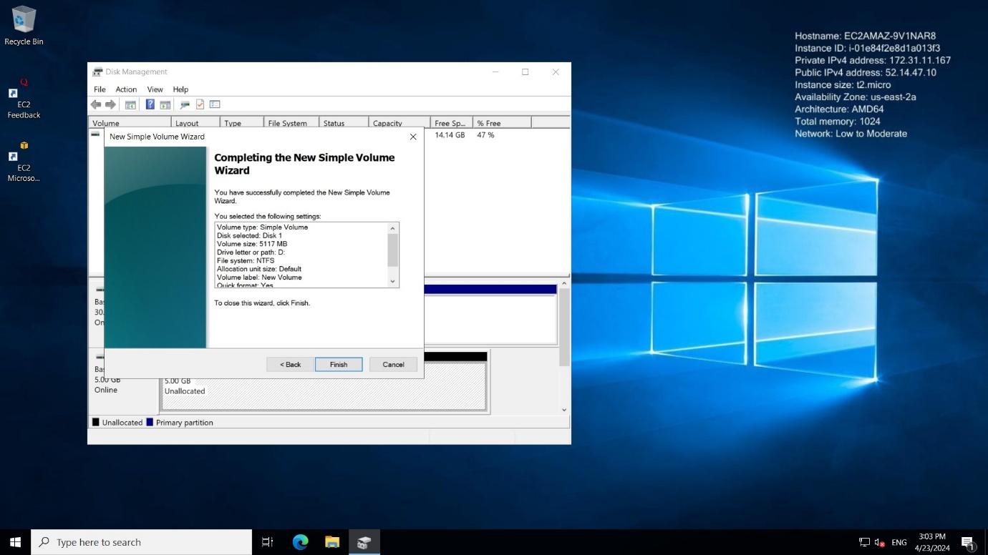

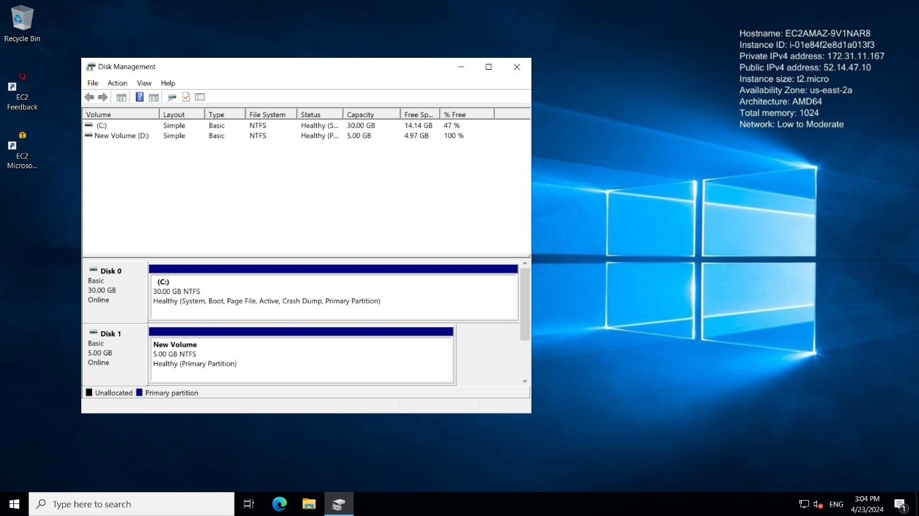

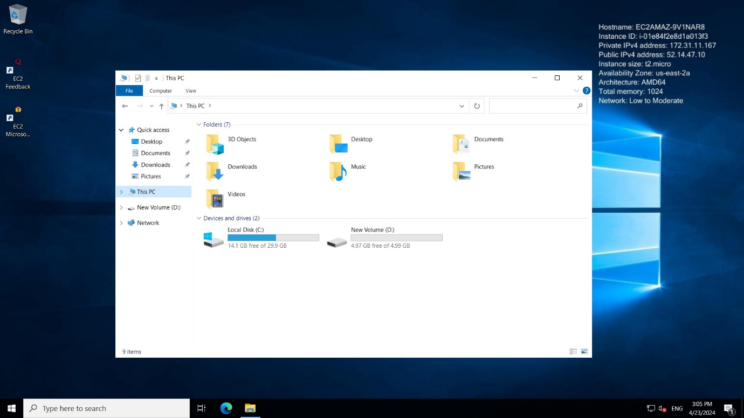

As we can see in the above image the Volume is attached and formatted successfully.

Finally, we can create an EBS volume using the taken snapshot.

Then we can able to attach EBS-volume to the single or multiple instances.

