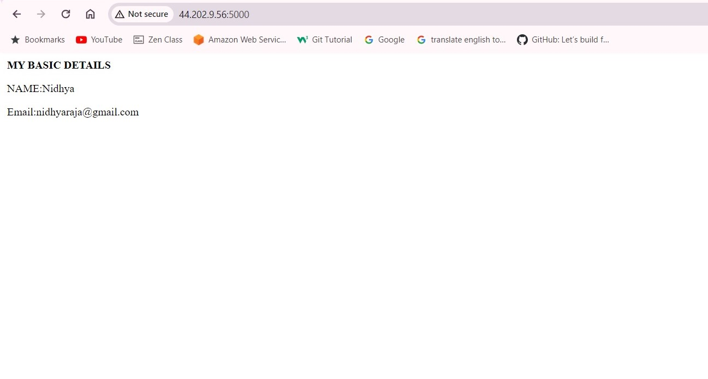

Commands

Kdml;zxmf;z

Vn;zmvz