Get me IP address of particular domain (guvi.in)

By using ping command , we get IP address of particular domain

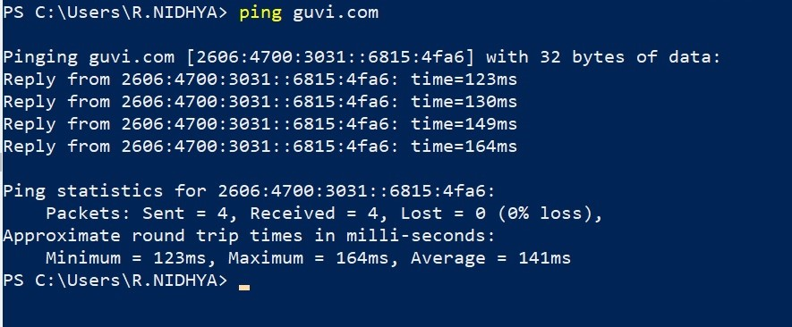

How do I find my CPU/memory usage of my server?

Top command or htop command

It provides real-time information about system performance, including CPU and memory utilization.

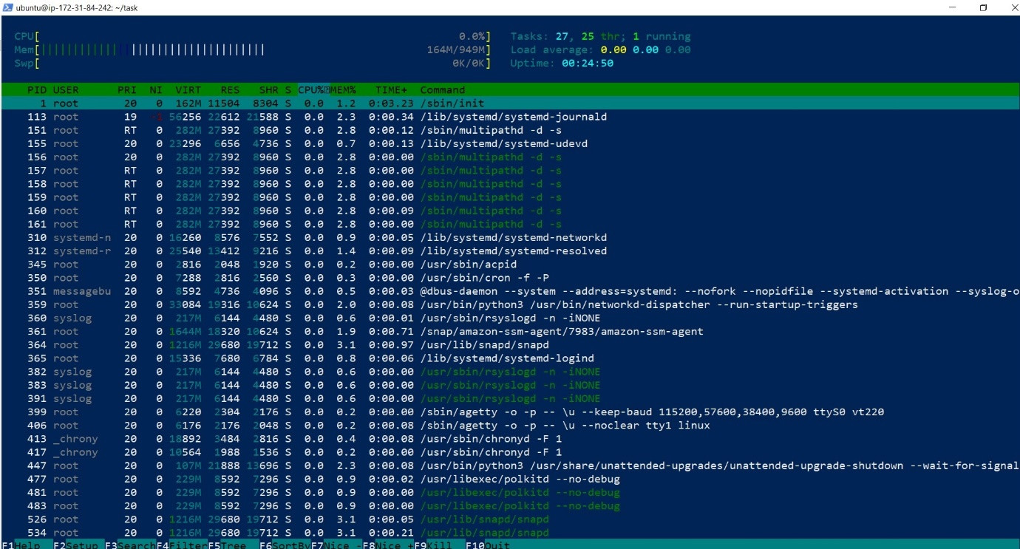

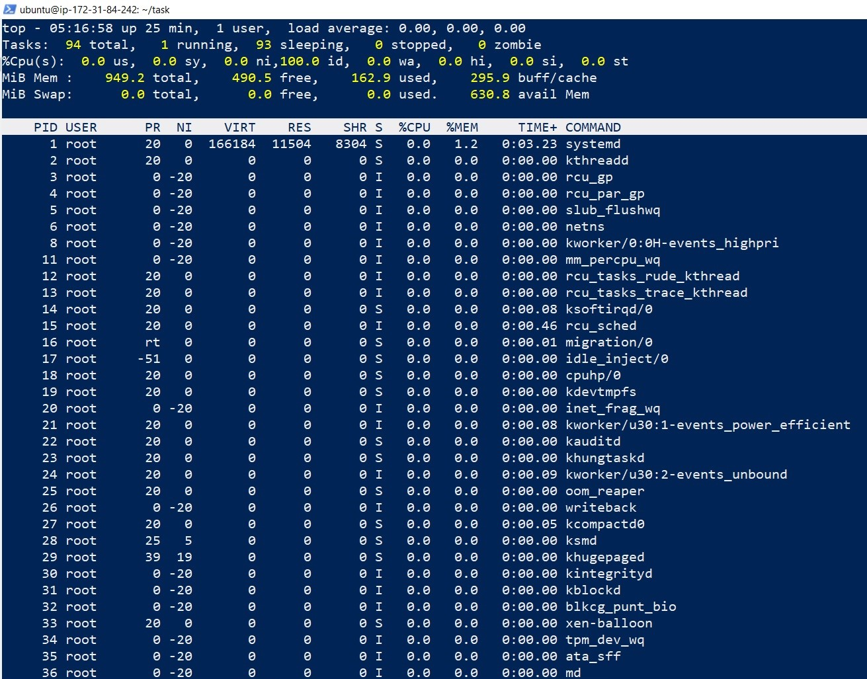

Test the connectivity between 2 nodes?

* The ping command is a utility used to check the availability of a network resource.
* It sends packets of data to a specific IP address and measures the time it takes for the packets to be returned, indicating the latency or delay in the network.
* The ping command will send a series of packets to the target device and display the results on the screen.
* If the target device is reachable and responsive, the ping command will display a series of "Reply" messages with the time it took for the packets to be returned.
* If the target device is unreachable or not responding, the ping command will display an error message indicating the reason for the failure.
* Ping yahoo.com

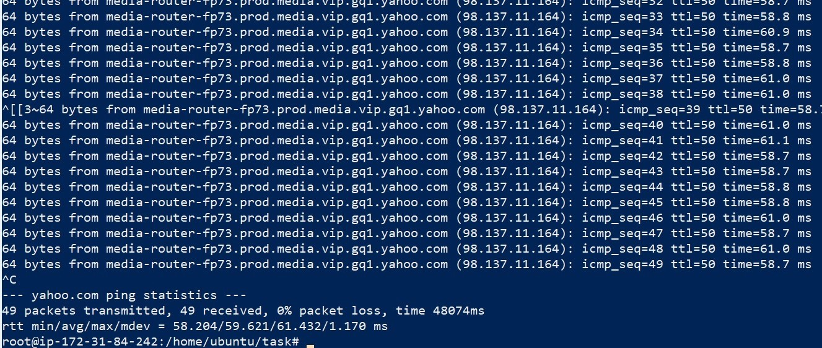

I have deployed an application in guvi.com:9000, and logs shows my app is running, but I’m unable to view the page. Check whether my port is open or not ?

telnet command or netstat command