* Crear un repositorio

* Agregar un README

* Agregar un gitignore para C#

Ilustración 1. Template de gitignore para C#

* Crear una rama que tenga por el nombre de “development”

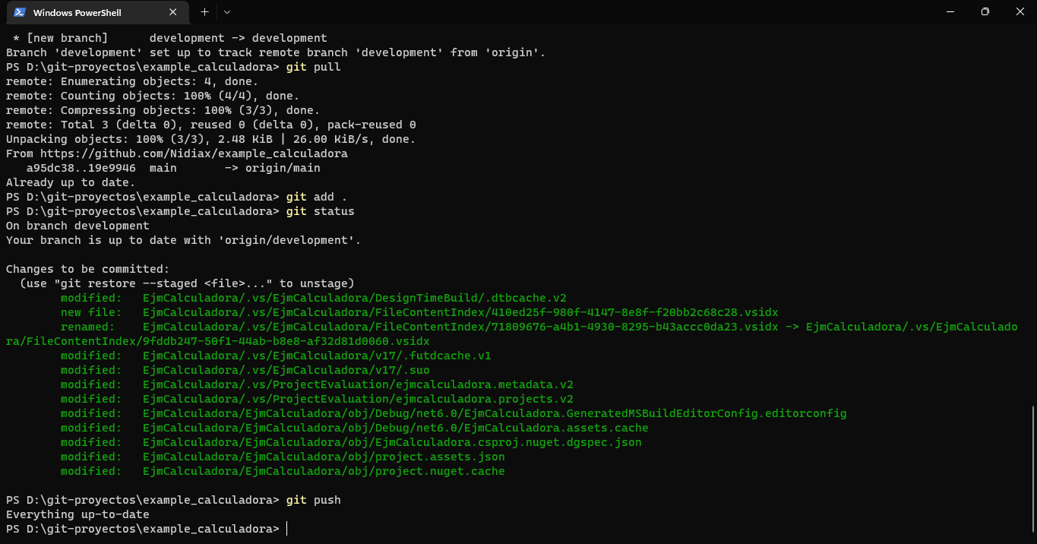

* Subir el ejercicio de calculadora en la rama development

