**Method**

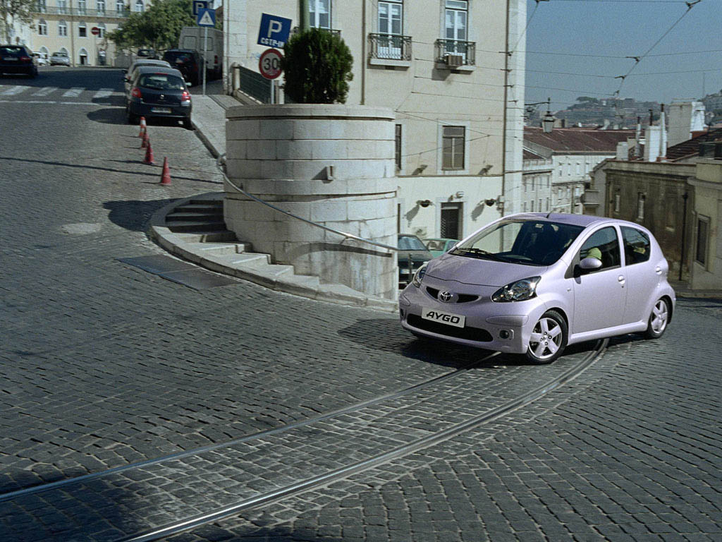

First of all selected the original background layer and then I have made a copy or duplicate of this layer. Then in the duplicate layer I named it as car paint I converted it in to mask mode. In mask mode I started painting the car with brush and at last I painted the whole car. In this way I made the selection of my whole car in mask mode. After that I removed the mask mode and now I can see my selections. Then I click on the layers button on top of the Photoshop window and I have chosen to create new layer hue or color layer in which I selected the color which I liked and then I have chosen the car in the background which helped me to change the color of car. After that I saved it as jpg image and inserted it in to MS Word. From MSWord document I converted it into PDF document with my method of whole procedure.

BR,

Jalal Syed Naveed