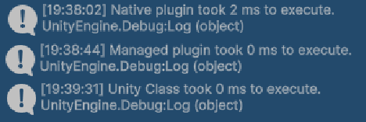
I have no idea why the Native plugin is showing as taking 2 ms and the others show as taking 0ms. I had tried multiple different ways to show the correct expected timing but failed each time. Perhaps something in the scripts will make it apparent as to why it was not working. As for why the expected result is the real result, I would assume it is because C++ is a lower level computer language and as such takes less time to be translated into machine readable code. Because of this reduction in time, the code is ran faster.

