

TRIBHUVAN UNIVERSITY
INSTITUTE OF ENGINEERING
PULCHOWK CAMPUS

A Progress Report
On

Comparative Study of Fine-Tuning, Retrieval-Augmented Generation, and Hybrid Models for Code Completion in Enterprise Repositories

Submitted by:
Nidwija Bhatta
081MSCSK010

Submitted to:
DEPARTMENT OF ELECTRONICS AND COMPUTER ENGINEERING
LALITPUR, NEPAL
(August 20, 2026)
TRIBHUVAN UNIVERSITY

ACKNOWLEDGEMENT
I would like to express my sincere gratitude to the Department of Electronics and Computer Engineering, IOE, Pulchowk Campus, for providing me with the opportunity and academic environment to undertake this thesis as part of the requirements for the Master of Science in Computer Systems and Knowledge Engineering (MSCSK).
I am deeply grateful to my thesis supervisor, Prof. Dr. Subarna Shakya Sir, for his valuable guidance, encouragement, and constructive feedback throughout the progress of this research. His support and insights have been instrumental in refining the research direction and improving the work presented in this progress report.
I would also like to thank the faculty members and staff of the department for their support and for providing an academic environment that encourages research, learning, and exploration of emerging areas of technology.
Finally, I am grateful to my family and everyone who has supported and encouraged me throughout the course of this research. Their continued support has been a constant source of motivation as I work towards completing this thesis.

Nidwija Bhatta
081MSCSK010

1. Introduction

1.1 Background
Artificial intelligence has progressed rapidly in recent years and now plays an increasingly central role in software engineering practice. Among the most visible developments is the use of large language models and large code models for code generation and code completion. These systems can suggest code snippets, complete partially written functions, and support developers across a wide range of programming activities, with the potential to reduce development time and improve productivity during implementation and maintenance.
Despite this progress, most existing code models are developed and evaluated on general-purpose or open-source code, which does not fully reflect the complexity of real-world, enterprise-style software projects. Developers in such environments typically work within large repositories composed of multiple modules, shared libraries, internal APIs, organization-specific naming conventions, and extensive cross-file dependencies. In these settings, a correct completion frequently depends on information that resides elsewhere in the repository rather than solely on the content of the file currently being edited.
Two major techniques have emerged to address this gap. Retrieval-augmented generation (RAG) retrieves relevant code snippets or repository context from other files and supplies them to the model at inference time, allowing the model to draw on external project knowledge without modifying its parameters (Gao et al., 2023). Fine-tuning instead adapts a pre-trained code model's parameters using project-specific or domain-specific examples, enabling it to internalize the style, conventions, and recurring patterns of a target project. This thesis studies both strategies and their combination for repository-level code completion.

1.2 Significance of the Study
In large and complex software repositories, effective code completion requires more than general programming knowledge. A model may need to understand project-specific functions, internal APIs, naming conventions, and relationships between files and components. Since this information is often distributed across the repository, relying only on the content of the file being edited may result in incomplete or incorrect suggestions. Approaches such as retrieval-augmented generation and fine-tuning address this limitation in different ways. RAG provides the model with relevant repository context at inference time, while fine-tuning adapts the model to patterns and conventions present in the target codebase.
The significance of this study lies in evaluating these approaches under the same experimental conditions rather than considering them independently. The comparison of RAG-only, fine-tuning-only, and hybrid approaches can provide a clearer understanding of when each method is effective and what Trade-offs are introduced when they are combined. In addition to code-completion accuracy, the study considers retrieval quality, latency, computational requirements, and the ability to make use of cross-file and internal-API information. These factors are important when considering the practical use of such systems in large software projects, where a method that improves accuracy may also introduce additional computation, latency, or dependency on repository context.
The study therefore aims to provide an empirical basis for understanding the practical strengths and limitations of repository-aware code completion approaches. The findings can help identify whether combining retrieval with model adaptation provides meaningful benefits over using either technique independently, particularly under the resource constraints and repository-level requirements considered in this research.

2. Problem Statement
Repository-level code completion remains challenging because the information required to generate an accurate and project-consistent completion may be distributed across multiple files, internal APIs, and project-specific code patterns. Retrieval-augmented generation (RAG) can provide relevant repository context dynamically during inference, while fine-tuning can adapt a code language model to project-specific patterns, but both approaches have limitations. RAG depends on the quality of retrieved context, whereas fine-tuning does not dynamically incorporate changes in the repository. Although existing studies have investigated retrieval and fine-tuning individually and in combination, there is a need for a controlled comparison of RAG-only, fine-tuning-only, and hybrid approaches for repository-level code completion, considering both completion performance and practical computational requirements. This study therefore investigates how these approaches compare in their use of cross-file and project-specific information, their code-completion performance, and their computational trade-offs.

3. Objectives

3.1 Generic Objective
To design and evaluate a comparative framework for repository-level code completion using retrieval-augmented generation, fine-tuning, and a hybrid approach that combines both techniques in enterprise-style software repositories.

3.2 Specific Objectives
- To study and prepare suitable benchmark datasets and approaches for repository-level and cross-file code completion, with a focus on retrieval-augmented generation and fine-tuning.
- To implement and compare RAG-only, fine-tuning-only, and hybrid RAG with fine-tuning approaches under consistent experimental conditions, and determine whether the hybrid approach improves code-completion performance.
- To evaluate and analyze the three approaches in terms of code-completion performance, repository context utilization, computational efficiency, and practical trade-offs.

4. Literature Review
Repository-level code completion has received increasing attention because realistic software development tasks often require information that is distributed across multiple files rather than contained within the file being edited. Unlike conventional in-file completion, repository-level completion requires a model to understand relationships among files, shared utilities, APIs, and project-specific coding patterns. Liu et al. (2023), through the RepoBench benchmark, address this problem by evaluating retrieval, code completion, and the combination of both in repository-level settings. Similarly, Ding et al. (2023) introduce CrossCodeEval to evaluate cross-file code completion across multiple programming languages. These benchmarks demonstrate the importance of repository context and provide a basis for evaluating systems that need to use information beyond the current file.
One of the important approaches for addressing this limitation is Retrieval-Augmented Generation (RAG), where relevant information is retrieved from an external source and provided to a language model during inference. Gao et al. (2023) describe RAG as a general approach in which retrieved information is incorporated into the model's input without modifying the underlying model parameters. For source code, this allows a completion system to access project-specific information dynamically from the repository rather than relying entirely on knowledge learned during pre-training. This is particularly useful for repositories that change over time, since newly added or modified code can potentially be retrieved without retraining the model.
A key reference for retrieval-based repository-level code completion is RepoCoder by Zhang et al. (2023). RepoCoder combines a similarity-based retriever with a pre-trained code language model in an iterative retrieval-generation process. Instead of relying only on the code surrounding the completion point, the system retrieves relevant information from other files in the repository and uses that information to improve the generated completion. Zhang et al. report that RepoCoder consistently improves over an in-file completion baseline and also outperforms a conventional retrieval-augmented code completion approach. The work is particularly relevant to this thesis because it establishes a practical retrieval-based framework for repository-level completion and demonstrates that information distributed across a repository can improve code completion performance.
The importance of repository retrieval is further highlighted by recent work on project-specific internal APIs. Deng et al. (2025) investigate project-specific code completion in cases where the information required for a completion depends on internal APIs that may not be explicitly visible through imports or the surrounding code. Their findings indicate that completion becomes substantially more difficult when this information is unavailable to the model. This supports the use of retrieval mechanisms that can locate relevant information elsewhere in the repository and is particularly relevant to the present study, which considers the ability of different approaches to utilize cross-file and internal-API information.
While retrieval provides access to repository information at inference time, fine-tuning provides a different form of adaptation by modifying the model's behavior through project-specific or domain-specific examples. Fine-tuning can allow a model to learn recurring patterns, naming conventions, coding styles, and other characteristics of a target project. However, the knowledge learned through fine-tuning is dependent on the training data and therefore does not automatically reflect changes made to the repository after training. This creates a fundamental difference between retrieval and fine-tuning: retrieval provides dynamically accessible repository information, whereas fine-tuning allows project-specific patterns to become part of the model's learned behavior.
Dettmers et al. (2023) introduced QLoRA, a parameter-efficient fine-tuning method that combines low-rank adaptation with quantized model weights. QLoRA keeps the base model weights in 4-bit precision while training low-rank adapters, substantially reducing the memory requirements associated with model adaptation. This makes parameter-efficient fine-tuning more practical when computational resources are limited. QLoRA is particularly relevant to this thesis because it is the fine-tuning method selected for adapting the Qwen2.5-Coder-1.5B base model. The use of QLoRA allows the study to investigate model adaptation without requiring the computational resources associated with conventional full-parameter fine-tuning.
The differences between retrieval and fine-tuning have led to increasing interest in directly comparing the two approaches. Balaguer et al. (2024) conduct a comparative case study of RAG and fine-tuning in the agriculture domain and examine the trade-offs associated with each approach. Their findings indicate that neither approach is universally superior, suggesting that the effectiveness of RAG and fine-tuning depends on the characteristics of the task and the information being used. Although this study is outside software engineering, it provides evidence that the choice between retrieval and fine-tuning should be evaluated empirically rather than assuming that one approach will consistently outperform the other.
More closely related to the present research, Wang et al. (2025) conduct an industrial comparison of RAG-based and fine-tuning-based large code models for code completion. Their study reports that retrieval can outperform fine-tuning alone under certain conditions, while combining retrieval and fine-tuning tends to produce stronger overall results. This work provides direct motivation for investigating a hybrid approach in the context of code completion. However, the findings also reinforce the need to examine the approaches under controlled experimental conditions, since the relative benefit of retrieval, fine-tuning, or their combination can depend on the characteristics of the task and the available repository information.
Another relevant direction is RAFT (Retrieval-Augmented Fine-Tuning), proposed by Zhang et al. (2024). Rather than treating retrieved information simply as additional context appended to a prompt, RAFT adapts the language model specifically to make more effective use of retrieved information. This demonstrates that retrieval and fine-tuning do not necessarily have to be treated as independent techniques. Fine-tuning can instead be used to improve how a model interprets and utilizes retrieved information. This direction is relevant to the hybrid approach considered in this thesis, although the present study focuses on a direct comparison between RAG-only, fine-tuning-only, and hybrid configurations for repository-level code completion.
Taken together, the existing literature establishes that repository-level code completion remains a challenging problem because relevant information is often distributed across files and may include project-specific APIs, conventions, and dependencies. Retrieval-based methods such as RepoCoder demonstrate that dynamically providing repository context can improve completion, while fine-tuning approaches such as QLoRA provide a way to adapt a model to project-specific patterns with reduced computational requirements. Comparative studies further suggest that neither retrieval nor fine-tuning should be assumed to be universally superior, and recent work on hybrid approaches indicates that combining the two may provide additional benefits.

4.5 Research Gap
Prior Work | Method | Key Limitation | Addressed by This Study
RepoCoder (Zhang et al., 2023) | Retrieval (RAG) | Relies on retrieval quality and does not provide model-level adaptation to project-specific patterns. | Compares retrieval with fine-tuning and a hybrid approach under the same experimental conditions.
Project fine-tuned LCMs | Fine-tuning | Knowledge learned during training is static and does not directly incorporate newly added repository code. | Evaluates fine-tuning alongside dynamic repository retrieval.
RAFT (Zhang et al., 2024) | RAG-aware fine-tuning | Focuses on adapting language models for RAG settings rather than directly comparing standalone and hybrid approaches for repository-level code completion. | Evaluates RAG-only, fine-tuning-only, and hybrid approaches for repository-level completion.
Balaguer et al. (2024) | RAG vs. fine-tuning | Domain-specific comparison outside software repository-level code completion. | Extends the comparison to repository-level code completion using code-specific benchmarks.
Wang et al. (2025) | RAG vs. fine-tuning | Industrial comparison provides evidence for the benefits of combining approaches but does not fully address the controlled repository-level comparison considered here | Provides a controlled comparison of the three approaches using a common base model, datasets, and evaluation framework.
This Study | Hybrid RAG + Fine-Tuning | Systematically compares the three approaches for repository-level code completion and analyzes both performance and practical trade-offs. | Evaluates completion accuracy, retrieval quality, cross-file and internal-API utilization, latency, and memory requirements.

5. Methodology Overview
The study follows an experiment-driven methodology to design, implement, and compare three approaches for repository-level code completion: RAG-only, fine-tuning-only, and a hybrid approach combining retrieval with fine-tuning. The overall workflow consists of dataset preparation, repository preprocessing, retrieval and indexing, model adaptation, system integration, and comparative evaluation. The same base model and evaluation conditions are used across the three approaches to make the comparison as consistent as possible.
The overall system workflow is shown in Figure 1. The figure illustrates the relationship between repository preprocessing, retrieval, model adaptation, code completion, and evaluation across the three systems.

5.1 System Overview
Before describing each system, it is useful to clarify what a code completion in this study consists of. Given an incomplete code fragment such as:
def calculate_total(items):
total = 0
for item in items:
# cursor is here
a system is expected to propose the missing code, for example:
total += item.price * item.quantity
return total
Each system below produces this kind of completion differently: without adaptation for the RAG-only system, through adaptation without retrieval for the fine-tuning-only system, and through a combination of both for the hybrid system.
The study evaluates the following three systems:
System A: RAG-only:
The RAG-only system uses the pre-trained base model without parameter adaptation. Source repositories are first divided into manageable chunks and converted into vector representations using a code-specific embedding model. These embeddings are stored in a FAISS index to support similarity-based retrieval. Given a code-completion task, the system retrieves the most relevant repository chunks and provides them as additional context to the base model. The model then generates the completion using the current code together with the retrieved repository information.
System B: Fine-Tuning Only:
The fine-tuning-only system adapts the same base model using project-specific code-completion examples. QLoRA is used as the parameter-efficient fine-tuning method to reduce the computational and memory requirements of model adaptation. Unlike the RAG-only system, this approach does not retrieve additional repository context during inference. The adapted model generates completions based on the input context and the patterns learned during fine-tuning.
System C: Hybrid RAG and Fine-Tuning
The hybrid system combines the two approaches. The base model is first adapted using QLoRA, after which relevant repository context is retrieved at inference time and provided to the fine-tuned model. This allows the system to use both project-specific patterns learned during training and repository information retrieved dynamically during completion. The hybrid system represents the primary approach being investigated in this study.
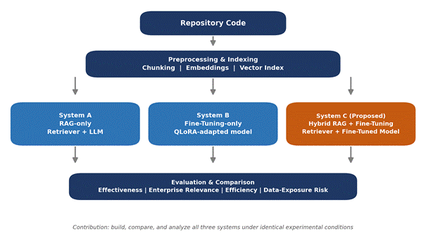
The motivation for testing this combination is that retrieval and fine-tuning address different limitations. Retrieval supplies dynamic, up-to-date repository information that a fine-tuned model cannot access on its own. Fine-tuning teaches the model repository-specific conventions that are not always retrievable as a single snippet.
Implementing the hybrid system therefore consists of three steps. First, the base model is fine-tuned as described in Section 5.3. Second, the retrieval index is built over the repository as described in Section 5.2. Third, both are combined at inference time: relevant chunks are retrieved for a given query, formatted into the same structured prompt used by the RAG-only system, and passed to the fine-tuned model instead of the frozen base model, as shown in Figure 1.
Figure 1. End-to-end system workflow showing the RAG-only, Fine-Tuning-only, and Hybrid pipelines

5.2 Dataset Preparation and Repository Processing
The study uses RepoBench and CrossCodeEval as benchmark datasets for repository-level and cross-file code completion. The datasets are processed into a common format suitable for training, validation, testing, retrieval, and evaluation.
For repository retrieval, source files are divided into overlapping chunks. The current implementation uses a default chunk size of 256 lines with a 32-line overlap. Each chunk is associated with metadata including its file path, starting line, ending line, and detected programming language. The overlap is used to reduce the loss of relevant context at chunk boundaries.
The processed repository chunks are converted into vector embeddings using microsoft/unixcoder-base. The resulting embeddings are stored in a FAISS IndexFlatIP index using normalized vectors for similarity-based retrieval. The retrieval component returns a configurable number of top-ranked chunks for each completion query.
Unlike a typical supervised learning setup where a dataset is split once into training and testing partitions, RepoBench and CrossCodeEval are used here for several distinct purposes, as shown in Figure 2. Both datasets are first converted into a common format and combined before being split, by repository, into training, validation, and test partitions, so that a repository used for fine-tuning is never also used for testing. The repository content is also indexed separately to build the retrieval component used by the RAG-only and hybrid systems. In other words, the same underlying data serves both as fine-tuning material and as the retrieval knowledge base, rather than a single conventional train and test split.
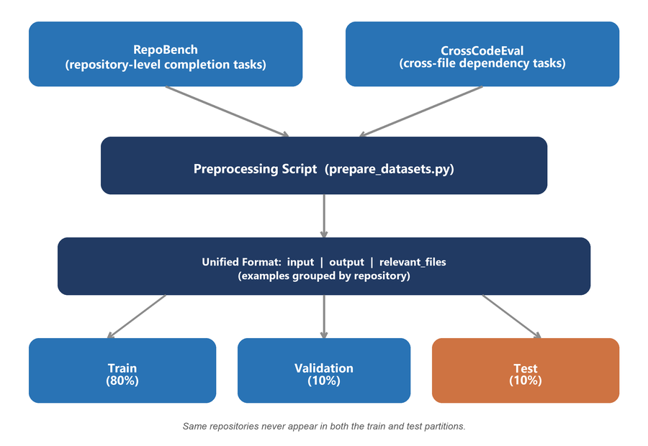
RepoBench and CrossCodeEval were selected specifically because they already provide repository-level and cross-file context and, in the case of CrossCodeEval, ground-truth relevant-file annotations needed to evaluate retrieval quality. This information would not be available in a dataset of isolated code snippets. If an additional dataset is introduced later, it will be passed through the same preprocessing script, which will extend the training data, the retrieval index, and, if desired, the test set, without requiring any change to the three systems themselves.
Figure 2. Data preparation pipeline showing conversion of RepoBench and CrossCodeEval into the unified training, validation, and test format

5.3 Model and Fine-Tuning Configuration
Qwen2.5-Coder-1.5B is used as the common base model for all three systems. The use of the same base model allows the comparison to focus on the effect of retrieval and model adaptation rather than differences between model architectures.
For the fine-tuning stage, QLoRA is applied to the base model using 4-bit NF4 quantization. The adaptation is performed on the attention projection layers while the base model weights remain quantized. This reduces the memory requirements of fine-tuning and allows the experiments to be conducted within the available computational resources.
For the RAG-based systems, the retrieved repository context and the current code context are formatted into a structured prompt before being provided to the model. The same prompt construction approach is used for the RAG-only and hybrid systems to maintain consistency between the two retrieval-based configurations.
It is worth clarifying that fine-tuning in this study does not mean training a model from scratch. It means adapting the existing pretrained Qwen2.5-Coder-1.5B model to the patterns, naming conventions, and internal APIs of a specific repository, using QLoRA as described above.
Fine-tuning and retrieval-augmented generation are not directly comparable in terms of speed, because they operate at different stages. Fine-tuning is a one-time, offline training cost paid before the system is used, while retrieval happens at inference time for every completion request. As a result, a fine-tuned model responds faster at inference time but must be retrained if the repository changes significantly, whereas a retrieval-based system reflects repository changes immediately at the cost of extra retrieval latency per request. The hybrid system pays the fine-tuning cost once and still performs retrieval at inference time. This is expected to be slower per completion than the fine-tuning-only system, but should provide access to more current repository information.

5.4 Experimental Comparison
The three systems are evaluated using the same benchmark tasks and evaluation framework. The comparison considers both code-completion quality and the ability of the retrieval-based systems to identify relevant repository information.
Code-completion performance is evaluated using exact match, edit similarity, identifier accuracy, and CodeBLEU. Retrieval performance is evaluated using precision at k, recall at k, and mean reciprocal rank based on the relevant-file information available in the benchmark data.
CodeBLEU is included because it captures syntactic and semantic correctness beyond a literal token match. This matters because two completions can be functionally equivalent while differing in variable names or formatting. Reporting completion quality, retrieval quality, and efficiency together, rather than completion quality alone, shows not only which system produces better completions but also what that improvement costs in retrieval effort and computational resources.
In addition to output quality, the study measures practical system requirements, including inference latency and memory usage. These measurements are used to examine the trade-offs between the three approaches and determine whether improvements in completion performance are associated with additional computational requirements.

5.5 Comparative Analysis
The final analysis compares the three systems across completion quality, retrieval effectiveness, repository context utilization, and computational requirements. The results are used to answer the research questions and identify the conditions under which RAG, fine-tuning, or their combination is more suitable for repository-level code completion.
Particular attention is given to whether the hybrid system provides measurable improvements over the standalone approaches and whether those improvements justify the additional retrieval and model-adaptation requirements. The analysis also considers the ability of each system to make effective use of cross-file information and project-specific internal APIs.

6. Progress Update
This section presents the progress made since the proposal defense and summarizes the work completed, the remaining implementation tasks, and the revised project timeline. The progress is reported according to the methodology and system design described in the preceding sections.

6.1 Work Completed So Far
The following activities have been completed during the current reporting period:
- Project setup: The project repository has been structured with the required source modules and configuration files. The configs/config.yaml file is used as the central configuration file for managing system parameters and hyperparameters.
- Dependency installation: The required software dependencies have been compiled into requirements.txt and installed successfully. These include PyTorch, Transformers, PEFT, BitsAndBytes, FAISS, Sentence Transformers, Evaluate, Levenshtein, and PSUtil.
- Dataset selection: RepoBench and CrossCodeEval were selected as the benchmark datasets for this study. CrossCodeEval provides cross-file code completion tasks across multiple programming languages and includes repository relationship information relevant to evaluating cross-file context. The corresponding download and preprocessing scripts are described under Additional Implementation Progress below.
- Repository chunking: The repository chunking pipeline has been implemented and tested. Source repositories are divided into overlapping, line-based chunks using a default chunk size of 256 lines and an overlap of 32 lines. Each chunk is associated with metadata including the file path, starting line, ending line, and detected programming language. The overlap is used to reduce the loss of relevant context at chunk boundaries.

Additional Implementation Progress
In addition to the components described above, several supporting modules required for the complete experimental pipeline have also been implemented. These include:
- Embedding generation and vector storage: Embeddings are generated using microsoft/unixcoder-base and stored in a FAISS index. The indexing module also supports saving and loading the generated index for reuse.
- Retrieval module: A configurable retriever has been implemented to return the top-k most relevant repository chunks for a given query.
- Prompt construction: A structured prompt-building module has been implemented to combine the retrieved repository context with the current file context before it is provided to the code completion model.
- Fine-tuning pipeline: The data loader and QLoRA training script have been implemented and are ready to run once the dataset preprocessing stage has produced the required training data.
- Hybrid pipeline: The hybrid system has been implemented to combine repository retrieval with the fine-tuned model during inference.
- Evaluation module: An evaluation module has been implemented to measure exact match, edit similarity, identifier accuracy, CodeBLEU, retrieval precision, recall, and mean reciprocal rank. The module also includes latency and memory tracking for comparing the computational requirements of the three systems
- Dataset acquisition automation: Download scripts have been implemented for both benchmark datasets: RepoBench is retrieved directly from the Hugging Face Hub (tianyang/repobench_python_v1.1), and CrossCodeEval is retrieved from a community-hosted mirror, since the official release requires a manual request to the dataset authors.
- Dataset preprocessing pipeline: A preprocessing script has been implemented to convert both datasets into a single unified format consisting of the input context, the target completion, and the ground-truth relevant files. Examples are grouped by repository before being split into training, validation, and test sets in an 80/10/10 ratio, which prevents any one repository from appearing in both the training and test data.
- Retrieval evaluation wiring: The comparative evaluation script has been updated to automatically collect the file paths returned by the retriever and match them against the ground-truth relevant files produced during preprocessing, so precision at k, recall at k, and mean reciprocal rank can be computed without manual intervention.
- Hybrid pipeline review: The hybrid inference pipeline was reviewed in detail. The import statement previously flagged as missing was found to already be present and correctly implemented, so this item is resolved and required no code change.

Each of the components listed above, the repository chunking pipeline, the embedding and vector storage module, the retriever, the prompt construction module, the QLoRA fine-tuning pipeline, the hybrid inference pipeline, the dataset download and preprocessing scripts, and the evaluation module, was designed and implemented specifically for this comparative study rather than produced automatically by an existing tool. The work remaining, described in Section 6.2, involves executing these components to produce new empirical results, which will then be compared directly against the published baselines summarized in the prior-work comparison in Section 4.5.
Figure 3. Project directory structure, showing the src/ module layout and configs/config.yaml
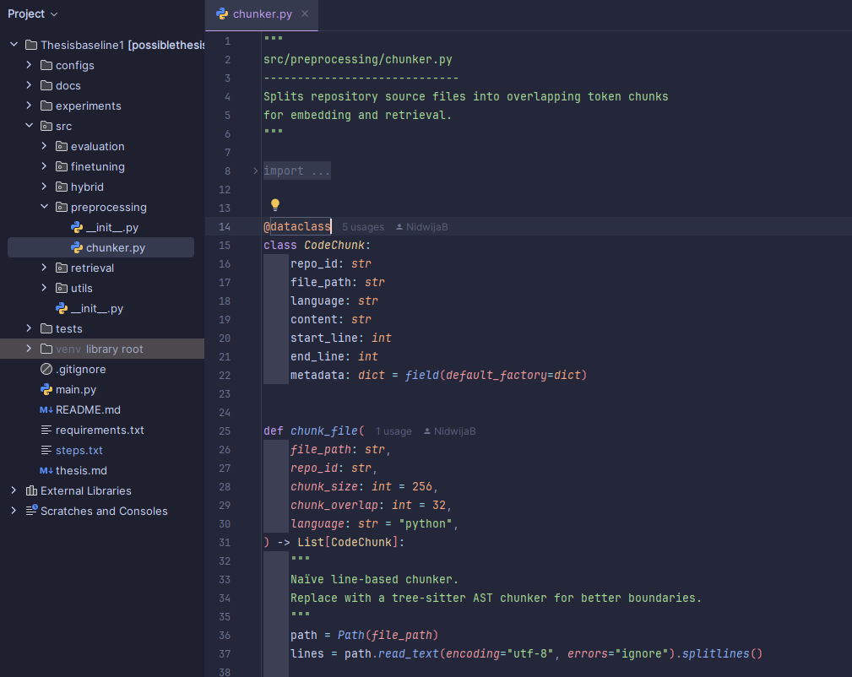
Code Snippet 4. Excerpt from src/preprocessing/chunker.py showing the chunk size and overlap configuration

6.2 Work Remaining
The following activities remain before the complete experimental evaluation can be conducted:
- Dataset execution: Run the newly implemented download and preprocessing scripts to retrieve RepoBench and CrossCodeEval and produce the processed training, validation, and test splits. The scripts themselves are implemented and ready to run; this step remains because it requires actually downloading and processing the full datasets.
- Fine-tuning: Execute the QLoRA fine-tuning stage using the processed training data for the fine-tuning-only and hybrid systems.
- Retrieval index construction: Generate the FAISS index from the prepared repository data for the RAG-only and hybrid systems.
- Comparative experiments: Run all three systems and collect completion quality, retrieval performance, latency, and memory measurements for analysis, and compare them against the published baselines in the prior-work comparison in Section 4.5, including a comparison graph plotting this study's metrics alongside the corresponding figures reported by RepoCoder, RAFT, and the RAG-versus-fine-tuning studies cited in Section 4, to make explicit how the findings relate to and differ from the existing literature.
- Optional extensions: If time permits, conduct an embedding-model ablation study and investigate syntax-aware, AST-based repository chunking.

6.3 Updated Timeline
Project setup, dependency installation, and the implementation of the core system modules, including chunking, embedding and retrieval, QLoRA fine-tuning, the hybrid pipeline, and the evaluation framework, are already complete. Because of this, the remaining work is mostly execution rather than implementation, and has been reorganized into a compressed schedule of approximately three to four months, with an additional one-month contingency period if required.
The revised timeline prioritizes downloading and preprocessing the datasets first, since this step blocks fine-tuning, retrieval indexing, and the full comparative evaluation. The subsequent stages focus on running fine-tuning, building the retrieval index, pilot testing the already-implemented hybrid pipeline, and carrying out the final comparative experiments. The contingency period is reserved for incorporating supervisor feedback, addressing unforeseen delays, and completing final formatting and submission requirements.
Timeframe | Planned Activity | Status
Month 1 | Project setup, dependency installation, and implementation of the core system modules: repository chunking, embedding and retrieval, QLoRA fine-tuning, the hybrid pipeline, and the evaluation framework | Completed
Month 2 | Download RepoBench and CrossCodeEval, run the preprocessing script to produce train, validation, and test splits, and build the FAISS retrieval index | Remaining
Month 3 | Run QLoRA fine-tuning for the fine-tuning-only and hybrid systems, and pilot test the already-implemented hybrid pipeline end to end | Remaining
Month 4 | Run the full comparative experiments across all three systems, analyze results against published baselines, and draft and finalize the thesis | Remaining
Month 5 (contingency) | Buffer for incorporating supervisor feedback, addressing delays, and finalizing formatting and submission, used only if needed | Optional

7. Challenges and Risks
A few implementation and scope risks are being tracked actively.
- Dataset download and preprocessing time: The download and preprocessing scripts are now implemented, so the remaining risk is execution time and disk space when running them against the full RepoBench and CrossCodeEval datasets, which is scheduled for the next reporting period.
- Retrieval evaluation depends on dataset quality: Precision at k, recall at k, and mean reciprocal rank are now computed automatically from the relevant-file information produced during preprocessing. The main residual risk is that the CrossCodeEval mirror used for this study may label relevant files slightly differently from the official release, so the extracted ground truth will be spot-checked before the final comparative experiments.
- Computational resources: The available GPU memory limits the size and configuration of the models that can be used. QLoRA and 4-bit inference are therefore used to keep the experiments feasible within the available resources.
- Benchmark limitations: RepoBench and CrossCodeEval are public benchmarks and may not fully represent the scale and conventions of proprietary enterprise repositories. Therefore, the results will be interpreted as evidence under enterprise-style conditions rather than as a direct representation of performance on any specific organization's codebase.

References
Balaguer, A., Benara, V., Cunha, R. L. de F., Estevão Filho, R. de M., Hendry, T., Holstein, D., Marsman, J., Mecklenburg, N., Malvar, S., Nunes, L. O., Padilha, R., Sharp, M., Silva, B., Sharma, S., Aski, V., & Chandra, R. (2024). RAG vs fine-tuning: Pipelines, tradeoffs, and a case study on agriculture [Preprint]. arXiv. https://arxiv.org/abs/2401.08406
Deng, L., Ren, X., Ni, C., Liang, M., Lo, D., & Liu, Z. (2025). Enhancing project-specific code completion by inferring internal API information [Preprint]. arXiv. https://arxiv.org/abs/2507.20888
Dettmers, T., Pagnoni, A., Holtzman, A., & Zettlemoyer, L. (2023). QLoRA: Efficient finetuning of quantized LLMs [Conference paper]. Advances in Neural Information Processing Systems (NeurIPS). https://arxiv.org/abs/2305.14314
Ding, Y., Wang, Z., Ahmad, W. U., Ding, H., Tan, M., Jain, N., Ramanathan, M. K., Nallapati, R., Bhatia, P., Roth, D., & Xiang, B. (2023). CrossCodeEval: A diverse and multilingual benchmark for cross-file code completion [Conference paper]. Advances in Neural Information Processing Systems (NeurIPS) Datasets and Benchmarks. https://arxiv.org/abs/2310.11248
Gao, Y., Xiong, Y., Gao, X., Jia, K., Pan, J., Bi, Y., Dai, Y., Sun, J., Wang, H., & Wang, H. (2023). Retrieval-augmented generation for large language models: A survey [Preprint]. arXiv. https://arxiv.org/abs/2312.10997
Liu, T., Xu, C., & McAuley, J. (2023). RepoBench: Benchmarking repository-level code auto-completion systems [Conference paper]. International Conference on Learning Representations (ICLR). https://arxiv.org/abs/2306.03091
Wang, C., Yang, Z., Gao, S., Gao, C., Peng, T., Huang, H., Deng, Y., & Lyu, M. (2025). RAG or fine-tuning? A comparative study on LCMs-based code completion in industry [Conference paper]. Proceedings of the 33rd ACM International Conference on the Foundations of Software Engineering Companion (FSE Companion '25). https://arxiv.org/abs/2505.15179
Zhang, F., Chen, B., Zhang, Y., Keung, J., Liu, J., Zan, D., Mao, Y., Lou, J.-G., & Chen, W. (2023). RepoCoder: Repository-level code completion through iterative retrieval and generation [Conference paper]. Proceedings of the 2023 Conference on Empirical Methods in Natural Language Processing (EMNLP). https://arxiv.org/abs/2303.12570
Zhang, T., Patil, S. G., Jain, N., Shen, S., Zaharia, M., Stoica, I., & Gonzalez, J. E. (2024). RAFT: Adapting language model to domain-specific RAG [Preprint]. arXiv. https://arxiv.org/abs/2403.10131

