SSN COLLEGE OF ENGINEERING DEPARTMENT OF COMPUTER SCIENCE AND ENGINEERING

UCS1711 - Mobile Application Development Lab Exercise – 09 Alarm Clock Application

**Name :** Mahesh Bharadwaj K

**Reg** : 185001089

**Date** : 28/10/2021

**AIM:**

Develop an alarm clock application for scheduling the task. The application should start an activity to set a new alarm or timer that reminds the user by alerting at the scheduled time. It should also have the option for snooze and stop the alarm.

**CODE:**

**Activity_main.xml:**

<?xml version="1.0" encoding="utf-8"?>

<RelativeLayout xmlns:android="<http://schemas.android.com/apk/res/android>"

xmlns:app="<http://schemas.android.com/apk/res-auto>"

xmlns:tools="<http://schemas.android.com/tools>"

android:layout_width="match_parent"

android:layout_height="match_parent"

tools:context=".MainActivity">

<TextView

android:id="@+id/alText"

android:layout_width="wrap_content"

android:layout_height="wrap_content"

android:layout_centerHorizontal="true"

android:layout_marginTop="20dp"

android:text="ALARM CLOCK"

app:layout_constraintBottom_toBottomOf="parent"

app:layout_constraintLeft_toLeftOf="parent"

app:layout_constraintRight_toRightOf="parent"

app:layout_constraintTop_toTopOf="parent" />

<TextClock

android:id="@+id/currTime"

android:layout_width="wrap_content"

android:layout_height="wrap_content"

**android:layout_marginTop="20dp"**

android:layout_centerHorizontal="true"

android:layout_below="@id/alText"

**/>**

<TimePicker

android:layout_width="wrap_content"

android:layout_height="wrap_content"

android:layout_centerHorizontal="true"

android:layout_below="@+id/cancel"

android:layout_marginTop="30dp"

android:id="@+id/timePicker"

android:visibility="gone"

**/>**

<TextView

android:layout_width="wrap_content"

android:layout_height="wrap_content"

android:layout_below="@id/cancel"

android:id="@+id/text"

android:text=""

android:layout_centerHorizontal="true"

**/>**

<androidx.appcompat.widget.AppCompatButton

android:id="@+id/button"

android:layout_width="wrap_content"

android:layout_height="wrap_content"

android:layout_below="@id/currTime"

android:layout_centerHorizontal="true"

android:layout_marginTop="10dp"

android:text="SET ALARM" />

<androidx.appcompat.widget.AppCompatButton

android:id="@+id/cancel"

android:layout_width="wrap_content"

android:layout_height="wrap_content"

android:layout_below="@id/button"

android:layout_centerHorizontal="true"

android:layout_marginTop="10dp"

android:text="CANCEL" />

**<Button**

android:id="@+id/snooze"

android:layout_width="wrap_content"

android:layout_height="wrap_content"

android:layout_marginTop="150dp"

android:layout_marginLeft="30dp"

android:visibility="gone"

android:text="Snooze" />

</RelativeLayout>

# MainActivity.java

package com.example.alarm_clock;

import android.app.TimePickerDialog; import android.media.Ringtone; import android.media.RingtoneManager; import android.os.Build;

import android.os.Bundle; import android.os.Handler; import android.os.Looper; import android.provider.Settings; import android.util.Log;

import android.view.View; import android.widget.Button; import android.widget.TextClock; import android.widget.TextView; import android.widget.TimePicker;

import androidx.annotation.RequiresApi;

import androidx.appcompat.app.AppCompatActivity; import java.util.Calendar;

import java.util.Timer; import java.util.TimerTask;

import java.util.concurrent.atomic.AtomicInteger; public class MainActivity extends AppCompatActivity {

TimePicker alarmtime;

TextClock currtime;

TextView t;

Button setAlarm,cancel,snz;

@Override

protected void onCreate(Bundle savedInstanceState) {

super.onCreate(savedInstanceState);

**setContentView(R.layout.*activity_main*);**

**currtime = findViewById(R.id.*currTime*);**

**setAlarm = findViewById(R.id.*button*);**

**alarmtime = findViewById(R.id.*timePicker*);**

**cancel = findViewById(R.id.*cancel*);**

t = findViewById(R.id.*text*);

**snz= findViewById(R.id.*snooze*);**

final AtomicInteger value = new AtomicInteger(0);

final AtomicInteger stop = new AtomicInteger(0);

final Timer timer = new Timer();

**final Ringtone r = RingtoneManager.*getRingtone*(getApplicationContext(),RingtoneManager.*getDefault Uri*(RingtoneManager.*TYPE_ALARM*));**

setAlarm.setOnClickListener(new View.OnClickListener() {

@Override

**public void onClick(View view) {**

**alarmtime.setVisibility(View.*VISIBLE*);**

stop.getAndSet(0);

timer.scheduleAtFixedRate(new TimerTask() {

@RequiresApi(api = Build.VERSION_CODES.*M*)

@Override

public void run() {

Log.*i*("here1",currtime.getText().toString());

Log.*i*("here2",AlarmTime());

if(currtime.getText().toString().equals(AlarmTime())&&stop.get()==0){

Log.*i*("here3","Works"); r.play();

runOnUiThread(new Runnable() { @Override

public void run() { t.setText("ALARM IS RINGING");

**snz.setVisibility(View.*VISIBLE*);**

}

});

}

else{

runOnUiThread(new Runnable() { @Override

public void run() { t.setText("");

**snz.setVisibility(View.*INVISIBLE*);**

}

});

r.stop();

}

}

},0,1000); //you want the delay to be zero because the task should be immediate and you want to check each second

}

});

cancel.setOnClickListener(new View.OnClickListener() { @Override

public void onClick(View view) { stop.getAndSet(1);

}

});

snz.setOnClickListener(new View.OnClickListener() {

@RequiresApi(api = Build.VERSION_CODES.*M*)

@Override

public void onClick(View v) {

Integer alarmMin = alarmtime.getMinute();

alarmtime.setMinute(alarmMin+5);

**}**

**});**

**}**

@RequiresApi(api = Build.VERSION_CODES.*M*)

public String AlarmTime(){

Integer alarmHour = alarmtime.getHour();

Integer alarmMin = alarmtime.getMinute();

String alarm_time,end="AM",min,hr;

if (alarmHour>=12){

end = "PM";

if (alarmHour!=12)

alarmHour-=12;

**}**

if (alarmMin<10)

**min = "0"+String.*valueOf*(alarmMin);**

**else{**

**min = String.*valueOf*(alarmMin);**

**}**

if (alarmHour==0)

hr="12";

**else{**

**hr = String.*valueOf*(alarmHour);**

**}**

alarm_time = hr+":"+min+" "+end;

return alarm_time;

**}**

}

# OUTPUT:

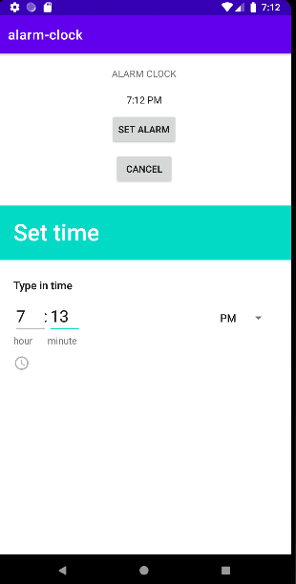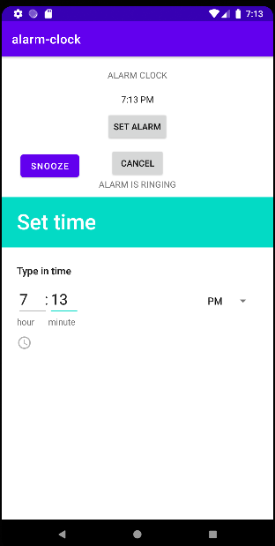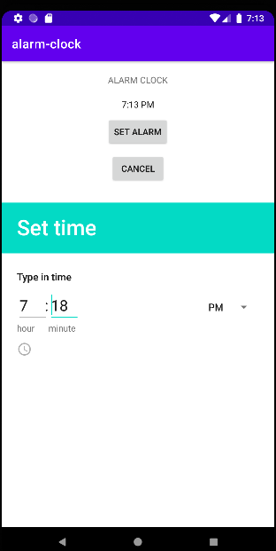

**Result:**

Thus an android app for displaying web pages in an android app was designed and implemented.