SSN COLLEGE OF ENGINEERING DEPARTMENT OF COMPUTER SCIENCE AND ENGINEERING

UCS1711 - Mobile Application Development Lab Exercise – 11 Menu Driven Application

**Name :** Mahesh Bharadwaj K

**Reg** : 185001089

**Date** : 28/10/2021

**AIM:**

Develop a Menu driven App that displays the option menu that contains 3 menu-items. When each menu-item is clicked, the description about the items should be displayed

**CODE:**

**Activity_main.xml:**

<?xml version="1.0" encoding="utf-8"?>

<androidx.constraintlayout.widget.ConstraintLayout

xmlns:android="<http://schemas.android.com/apk/res/android>"

xmlns:app="<http://schemas.android.com/apk/res-auto>"

xmlns:tools="<http://schemas.android.com/tools>"

android:layout_width="match_parent"

android:layout_height="match_parent"

tools:context=".MainActivity">

<!--Create a TextInputLayout and choose the style,

for now we are choosing the OutlinedBox ExposedDropdownMenu -->

<com.google.android.material.textfield.TextInputLayout

android:id="@+id/textInputLayout"

style="@style/Widget.MaterialComponents.TextInputLayout.OutlinedBox.ExposedDro pdownMenu"

android:layout_width="match_parent"

android:layout_height="wrap_content"

android:layout_margin="20dp"

app:layout_constraintLeft_toLeftOf="parent"

app:layout_constraintRight_toRightOf="parent"

app:layout_constraintTop_toTopOf="parent">

<!-- Inside text input layout add

an auto complete text view

and make its input type to none-->

<AutoCompleteTextView

android:id="@+id/autoCompleteTextView"

android:layout_width="match_parent"

android:layout_height="match_parent"

android:layout_weight="1"

android:inputType="none"

android:text="Choose Menu item" />

</com.google.android.material.textfield.TextInputLayout>

<TextView

android:id="@+id/textView2"

android:layout_width="365dp"

android:layout_height="373dp"

android:layout_marginStart="21dp"

android:layout_marginLeft="21dp"

android:layout_marginTop="156dp"

android:layout_marginEnd="27dp"

android:layout_marginRight="27dp"

android:fontFamily="monospace"

android:textAppearance="@style/TextAppearance.AppCompat.Large"

android:textSize="22sp"

android:textStyle="bold"

app:layout_constraintEnd_toEndOf="parent"

app:layout_constraintHorizontal_bias="0.0"

app:layout_constraintStart_toStartOf="parent"

app:layout_constraintTop_toBottomOf="@+id/textInputLayout" />

</androidx.constraintlayout.widget.ConstraintLayout>

# MainActivity.java:

package com.example.menu;

import androidx.appcompat.app.AppCompatActivity; import android.content.Context;

import android.os.Bundle; import android.view.View;

import android.widget.AdapterView; import android.widget.ArrayAdapter;

import android.widget.AutoCompleteTextView; import android.widget.Button;

import android.widget.TextView;

public class MainActivity extends AppCompatActivity {

@Override

protected void onCreate(Bundle savedInstanceState) {

super.onCreate(savedInstanceState);

**setContentView(R.layout.*activity_main*);**

**AutoCompleteTextView simpleview = (AutoCompleteTextView)findViewById(R.id.*autoCompleteTextView*);**

TextView disp = (TextView)findViewById(R.id.*textView2*);

simpleview.setOnItemClickListener(new AdapterView.OnItemClickListener()

{

@Override

public void onItemClick (AdapterView<?> parent, View view, int position, long id) {

String item = parent.getItemAtPosition(position).toString();

System.*out*.println(item);

if(item.equals("Java"))

**{**

disp.setText("Java is a high-level, class-based, object-oriented programming language first released by Sun Microsystems in 1995.\n\nThe latest version of Java is Java 17 or JDK 17 released on September, 14th 2021.");

**}**

else if(item.equals("CPP"))

**{**

disp.setText("C++ is a general-purpose programming language created by Bjarne Stroustrup as an extension of the C programming language.\n\nThe latest version is C++20 published in December 2020");

**}**

else if(item.equals("Python"))

**{**

disp.setText("Python is an interpreted high-level

general-purpose programming language.\n\nIts design philosophy emphasizes code readability with its use of significant indentation.\n\nPython 3.9.0 is the current version released in October 2020 ");

**}**

**}**

**});**

**String arr[] = getResources().getStringArray(R.array.*programming_languages*);**

ArrayAdapter<String> arrayAdapter = new ArrayAdapter<String>(this,

**R.layout.*dropdown_item*, arr);**

simpleview.setAdapter(arrayAdapter);

**}**

}

# OUTPUT:

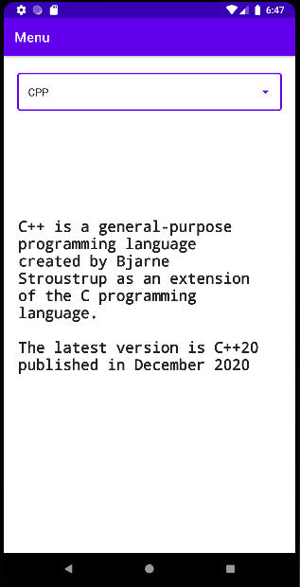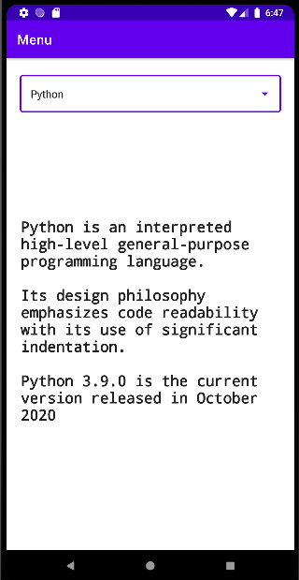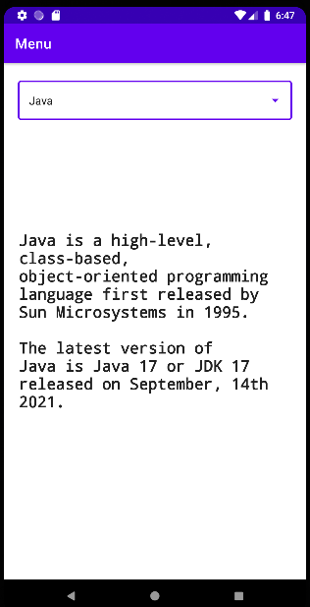

**Result:**

Thus an android app for menu driven application was designed and implemented.