Niel Angelo D. Reyes

A4 Flowgorithm Excercises Discussion

**1st. Adding Two Numbers**

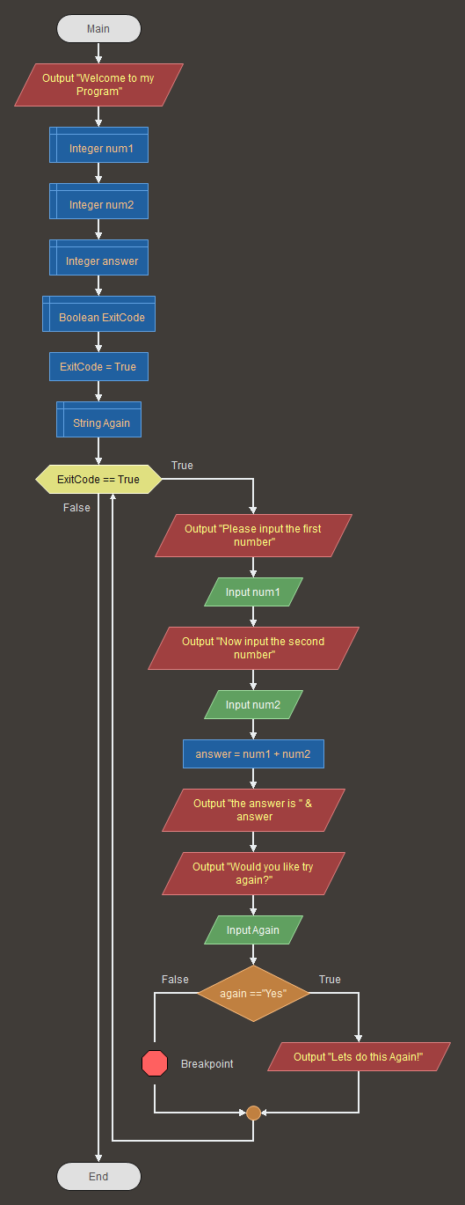

**2nd Getting the Area of Circle using Radius and Diameter**

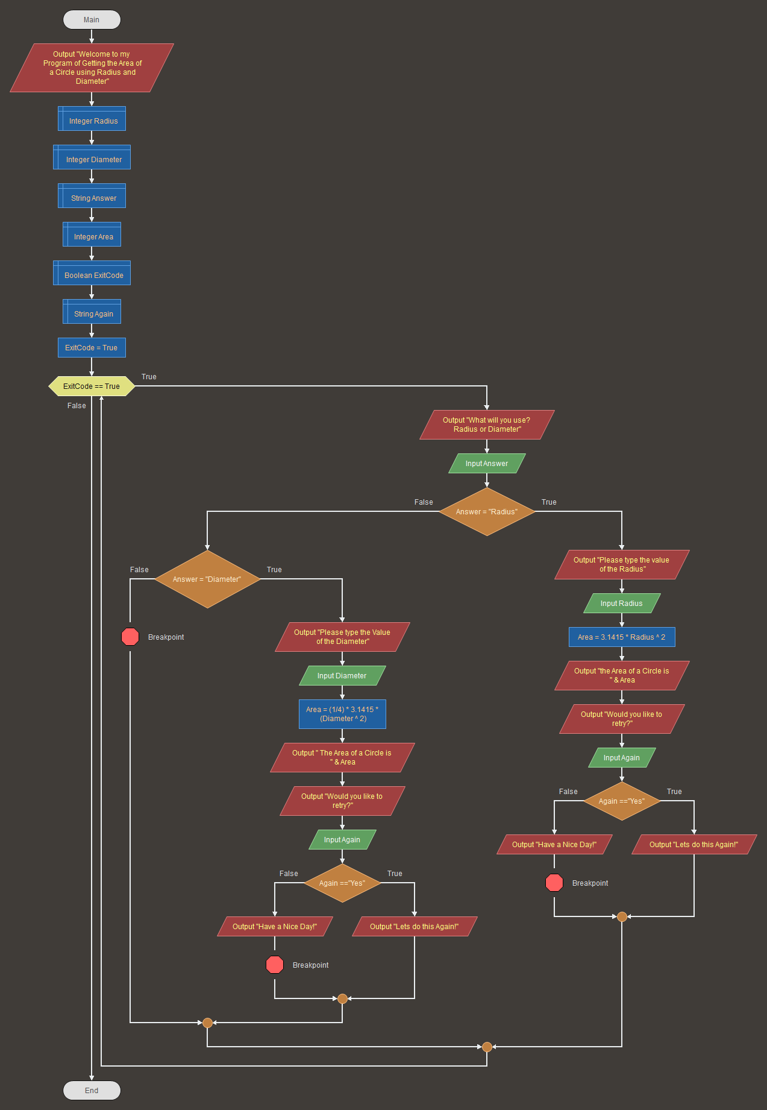

**3rd Odd and Even Number Identifier**

