Bug # 1: The etsy.com website allows weak passwords

This could be seen as an enhancement. Etsy customers may reject the idea of a having to have a special character in their password.

Steps to duplicate.

* Select the Sign In button to launch the sign in pop-up dialog.
* In the Sign In pop-up dialog, select the **Register** button to open the **Create your account** dialog.
* In the Email address field enter a email address. It does not have to be a real one but it will have to follow the email format (e.g. [JohnDoe@test.com](mailto:JohnDoe@test.com))
* Type in a name in the First name field.
* In the Password field type in Password1
* Select the Register button.

Result: A new user will be created with that weak password

Expected result: The password policy should at least a special character such as !,@,#,$,%

Bug # 2: The Edge browser has the view password feature, the Chrome browser does not.

Steps to duplicate.

* In the Edge browser select the Sign In button to launch the sign in pop-up dialog.
* In the Sign In pop-up dialog, type in a email address in the Email address field.
* In the Password field, start typing a password. Notice that the view password icon is displayed. Graphical user interface

  Description automatically generated
* Switch to the Chrome Browser.
* In the Chrome browser select the Sign In button to launch the sign in pop-up dialog.
* In the Sign In pop-up dialog, type in a email address in the Email address field.
* In the Password field, start typing a password.

Result: The view password icon is not displayed.

Expected result: We should be consistent across browsers. Chrome is by far the most popular browser on the market. Therefore, it should have the same features as Edge. This also applies to the Firefox browser on windows.

Bug # 3 The customer can log in with a incorrect password 20 times before they get locked out.

Steps to duplicate:

* Select the Sign In button to launch the sign in pop-up dialog.
* In the Sign In pop-up dialog, type in a email address in the Email address field.
* In the Password field, type in a incorrect password.
* Select Sign-in 20 times.

Result: An error message is displayed but it doesn’t tell the user that they used they have been logged out. The error doesn’t tell the user that they have been locked out. See attached screenshot.

Expected Result: The message should say that the customer’s account has been locked out. Not only that, the entering the wrong password should have locked the account long before 20 attempts. Here is the error in the Console log from Dev Tools <https://www.etsy.com/api/v3/ajax/bespoke/member/neu/specs/Join_Neu_Controller> which is a 429 error, which means that Too Many Requests. I think that this is a clumsy way to handle login security. The browser is not unusable for a significant amount of time.

Bug # 4. The Etsy website does not have an automatic logout feature.

I remained logged in overnight. I was still logged in when I got on my computer at noon.

Steps to duplicate:

* Log into the Etsy.com website.
* Wait 8 hours.

Result: The customer will still be logged in.

Expected Result. For security purposes, the customer should be automatically logged out after a relatively short period of time.

Bug #5 The cart on the first tab does not automatically update with the correct number of items.

Steps to duplicate:

* Select an item to purchase.
* The item’s page opens in a new tab.
* Add the item to the cart.
* Switch back to the first tab.

Result: The cart o the first tab shows as empty.

Expected result: The cart should automatically update.

Bug# 6. Why do we open a new tab whenever we select an item to purchase?

This is a workflow issue. It doesn’t seem all that efficient to open a new tab whenever you select an item to purchase. Each tab has its own cart as well. If you want purchase multiple items, you will clutter up your browser with new tabs. That can also eat up a computer’s resources.

Steps to duplicate:

1. Select an item to purchase.

Result: The item’s page is displayed in a new tab.

Expected result: The main window should switch to the page of the item the customer wants to buy.

Bug #7. If the browser is in a bad state, such as duplicating Bug #3, if you open a new tab or a new browser session, the user will get an generic error that does not tell them that they are locked out.

Steps to duplicate.

Try to sign in 20 times with an incorrect password.

Open a new tab or browser session or even a different browser and a different customer ID.

Attempt to log in.

Result: The user gets a generic error that offers to explanation as to what is wrong. See attached screenshot for example.

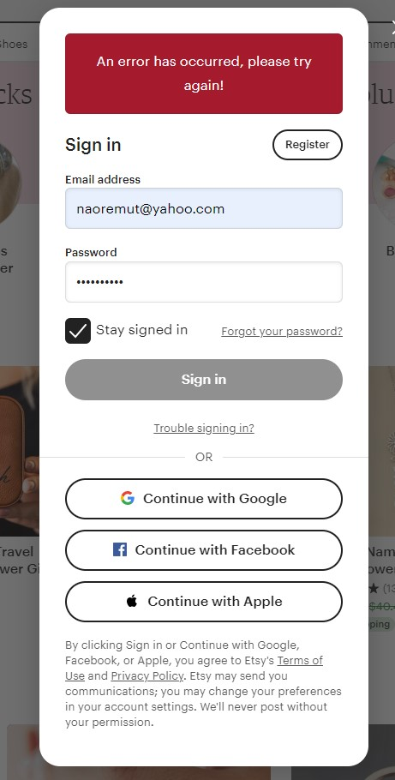

Expected result: The customer should be informed that they are locked out. If the login security module is made more robust, then this wouldn’t be an issue. It probably has the same root cause as Bug #3.

Bug #8 A ERR_BLOCKED_BY_CLIENT error is being generated whenever the Etsy page is opened.

Steps to duplicate:

* Open the etsy.com web site with the Chrome Dev tools open.

There is an error in the console. n&&j.setAttribute('nonce',n.nonce||n.getAttribute('nonce'));f.parentNode.insertBefore(j,f);

I did some research and found that there may be a solution to this script error. <https://trailblazer.salesforce.com/issues_view?id=a1p4V000001Jil7QAC&title=generated-nonce-is-not-supported-by-google-tag-manager>

Specially, this workaround:

**Workaround**  
As a workaround, You can use the nonce aware version of google tag manager: [https://developers.google.com/tag-manager/web/csp](https://trailblazer.salesforce.com/servlet/servlet.ExternalRedirect?url=https%3A%2F%2Fdevelopers.google.com%2Ftag-manager%2Fweb%2Fcsp)  
and explicitly set nonce='{SERVER-GENERATED-NONCE}' to nonce=''  
  
Please note, with the workaround in place, the script error in the builder will still exists. But on previewing the community ( 'preview as' either as an Authenticated User or as a Guest User), the console will render as expected and the GTM console window is shown at the bottom of the screen.

See attached screenshot for full example.

