# Assignment 1.

## Creating a repository (1.1)

I created a new repository on GitHub for the assignment, and I called it Git_Project_Nben. Then I created a new folder on my desktop with the same name minus the creator tag. That is all the preparation done.

## Creating the local repository (1.2)

I opened the folder I created and opened git bash. The command to “pull” the online repository to the local machine is “git pull {link}” so I entered mine.



This created a new folder in the “Git_Project” folder.



Note that this file is empty besides the .git file.

## Creating and pulling a file (1.3)

For the assignment we had to create a new text file via the GitHub website directly into the repository. So, I created a file called “test.txt”.

Next to pull the file to the local repository the command “git pull” is used. But before you use the command make sure you have git bash opened in the local repository folder. (in my case Git_Project_Nben). You can recognize it by it having the same name as your online repository.

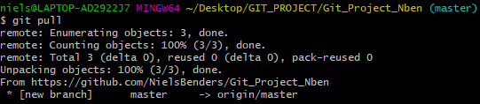

This pulled the “test.txt” file to the local repository.

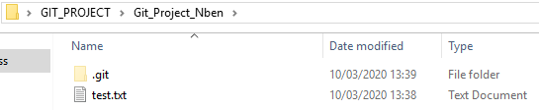

## Creating and committing a file (1.4)

Next we had to create a file and commit it to the online repository. I created a new text file in the repository folder and named it “test2.txt” for convenience. To commit a file you first need to select it, and the command for that is “git add {filename.extention}”. So in my case it was “git add test2.txt”.



To check what you have added you can use the “git status” this will tell you what has been changed.

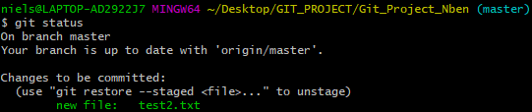

Since I added test2.txt it shows there is a new file.

Next you use the command “git commit” this is the fist step towards actually uploading or updating files.



Once this command has been entered a big chunk of text appears.

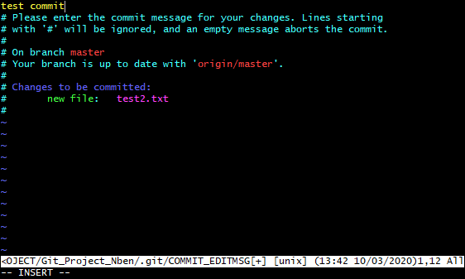

The yellow “test commit” is the comment I added. When this screen opens it is empty. You MUST add a comment, otherwise it will cancel the commit. You do this by pressing insert first. Once you are done with the comment you can press the Escape button and type “:wq” in the bottom. This will close the screen and bring you back to the main Git Bash terminal. If you are confused by this step, you have to do this since it is a Linux based program.

The last thing you need to do now is use the command “git push” this will finalize the commit and upload the files to the online repository.

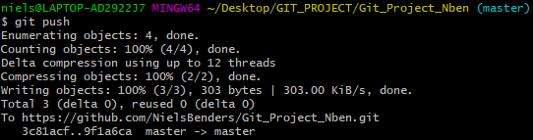

Now the file can be found on the GitHub website.

