Universal Simulator:
Plugins Tutorial

Niels Holst
Aarhus University
Dept. of Integrated Pest Management

6 November 2009
Table of contents
0 Introduction 3
1 Installation of programming tools 4
1.1 Download and install 4
1.2 Check installation 4
1.3 Providing general access to libraries 5
1.4 Create development folder 6
2 My first program 7
2.1 Setting up a programming project 7
2.2 The project folder 9
2.3 The project file 10
2.4 The main file 10
2.5 The MainWindow class 10
2.6 Version 1: A blank window 11
2.7 Version 2: With a button 12
3 My first program that does something 14
3.1 Desperate means 14
3.2 Adding a class 14
3.3 Dusting off the defaults 16
3.4 Showing calculator in main window 16
3.5 Adding widgets to calculator 17
3.6 Making connections 20
3.7 Declaring, defining and calling functions 22
3.8 Calculations, loops and whatnot 22
3.9 Real calculations 24
3.9.1 Exercise 1 24
3.9.2 Exercise 2 25
3.9.3 Exercise 3 25
4 Preparing for Universal Simulator development 26
4.1 Installing Boost C++ libraries 26
4.2 Installing UniSim C++ code 26
4.3 Setting system environment variable 28
4.4 Setting up the UniSim session in Qt Creator 29

Introduction
Universal Simulator can be used as-is when downloaded from www.weedml.org. But if you want to add models of your own making, you must know how to program such models and pack them in a plugin that Universal Simulator can read. This is what this tutorial is for. You will also need a standard reference book on the C++ programming language.
▪

Installation of programming tools

Download and install
Before we can begin programming we need to install an IDE (Integrated Development Environment) that will help us write C++ code and compile it into machine code that is executable on your platform. The IDE chosen for this tutorial is Qt Creator. It is available for most common platforms: Linux (e.g. Ubuntu), Mac OS and MS Windows. This tutorial assumes you are working on MS Windows but the instructions should be valid for the other platforms as well.
Download the Qt Creator installation file from
http://qt.nokia.com/downloads
Select the LGPL/Free version and then click ‘Download Qt SDK’ for your platform, e.g. Windows. SDK stands for ‘Software Development Kit’.
On Windows the downloaded file is called
qt-sdk-win-opensource-2009.03.1.exe
The numbers in the end designate the version. New versions are released twice per year or so. If you download a new version to update one you have already got, it will be a good idea to uninstall the older one from your machine first (just to keep things tidy and avoid confusing yourself later on).
Now, run the downloaded file, accepting all default suggestions.

Check installation
To check that the installation went OK, try to start Qt Creator. You should be greeted with this welcoming screen:
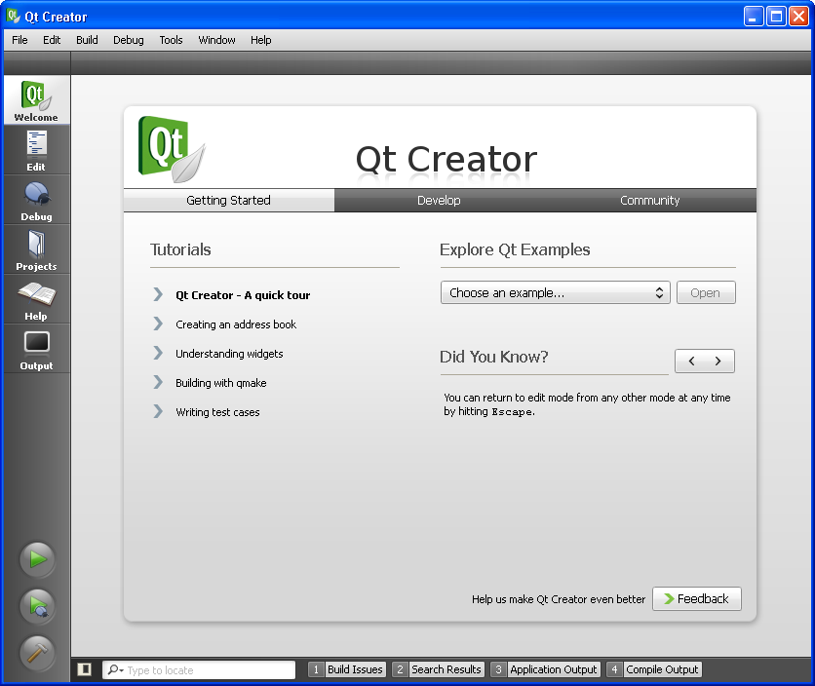
For now we wont check if it is actually working but notice the five buttons on the left. The contents of the main area change, according to which of these buttons is pushed. Try it!

Providing general access to libraries
In the next chapter you will write your first C++ program. This will be compiled into an executable file with '.exe' extension.
If your Windows Explorer is set to hide file types (=extensions), now is time to change that. As a programmer you need to be able to see the full names of files, including the extension.
But your executable file does not work in isolation. It needs access to standard library files (with '.dll' extension) that contains common functionality. The libraries needed by your programs all reside in the ‘bin’ subfolder of the Qt SDK that you just downloaded:
C:\Qt\2009.03\bin
Go find it (or a similar one, if you downloaded another version than ‘2009.03’) and check that the folder does hold a lot of .dll files.
We need to make this folder generally accessible. Super-users would say that we should put this folder on the system path.
To do this, right-click on My Computer, for example in Windows Explorer, and chose ‘Properties’ from the pop-up menu.
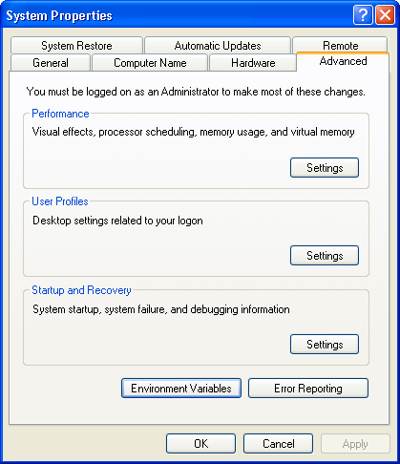

Pick the ‘Advanced’ tab. Then push the ‘Environment Variables’ button.

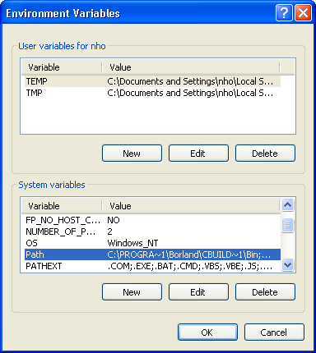
Double-click the ‘Path’ system variable and append the name of the Qt folder at then end (notice that the entries are separated by semicolons):
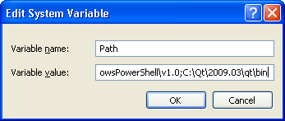
Push ‘OK’ here and in all preceeding windows, and you are done.

Create development folder
Before we get too engulfed in programming now is a good time to decide where all our program code will go. I strongly suggest that it all goes into subfolders of one common folder. To follow that advice, create a folder, e.g. ‘dev’ or ‘qdev’, and place it close to the root, e.g. ‘c:\dev’. Now you are ready to begin programming.
▪

My first program

Setting up a programming project
Start Qt Creator and choose File|New. From the available options chosse the ‘Qt4 Gui Application’:
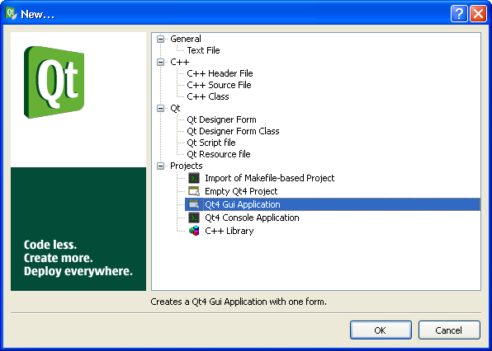
This means we are going to write a program that has a Graphical User Interface (GUI), i.e. an interface with windows, menus, buttons, etc.
The words ‘program’ and ‘application’ are synonymous.
Next, enter a name for your program. Why not, ‘hello’?
As we just agreed (right?), all code should be embraced by one common folder so select that for ‘Create in’:
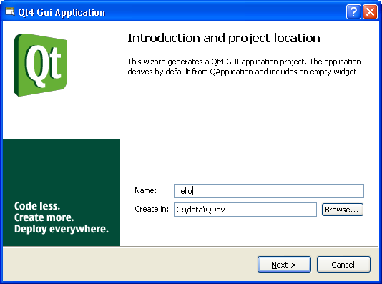
There exist a whole range of Qt modules in. We will just be using the two standard ones, so we just accept this:
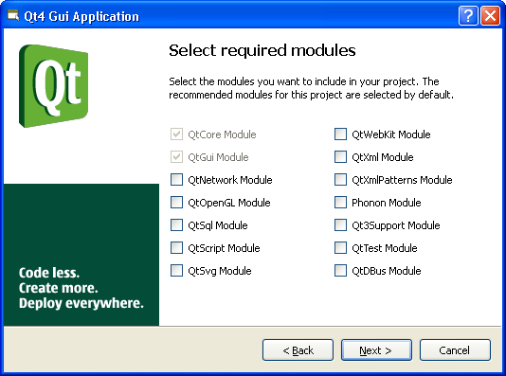
In the next step, we uncheck the ‘Generate form’ box:
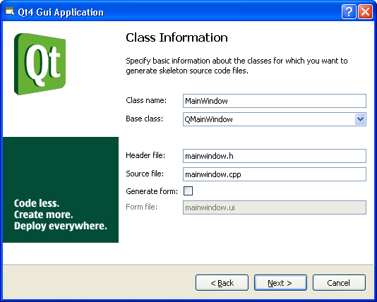
If you use forms then you compose your GUI by painting menus, buttons, etc. onto the screen. If you do not, you must compose the GUI directly in C++ code. Since we are aiming at developing Universal Simulator plugins, which do not have a GUI, we will not deal with the complexities of forms and GUI design in this tutorial. Hence, uncheck that box if you did not already.
Accept all defaults in the following, and Qt Creator will show you this screen, eagerly waiting for you to enter some fancy C++ code:
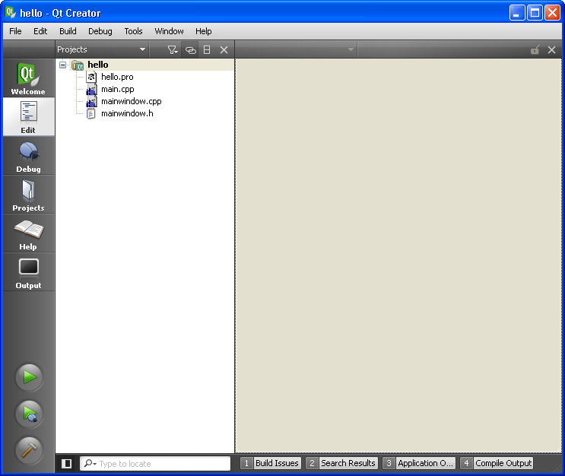

The project folder
But let us first inspect the outcome so far. Right..., four files were created for us. You can see them above in Qt Creator but you really ought to go check with Explorer that, yes, in fact these four files and nothing more were created.
But hey, wait, note that a subfolder was also created for us to avoid this programming project and future ones being mixed up. Quite naturally the name of that folder is the same as the program we are going to make, namely ‘hello’.
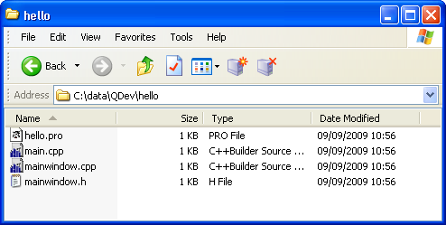
OK. So, we got these folders in the example:
- C:\data\QDev
– the development folder (yours will likely be named differently)
- hello
- the project folder
As time goes you will have more project folders, all located in the development folder.
Inside the project folder there will be one project (.pro) file. It contains a list of all the files needed to build the final program plus a few instructions on how to build it.

The project file
Double-click the project file in Qt Creator to show it in the editor window.
In hello.pro:
TARGET = hello
TEMPLATE = app
SOURCES += main.cpp\
mainwindow.cpp
HEADERS += mainwindow.h
TARGET is the name of the resulting program. TEMPLATE tells what we are building (an application in this case). SOURCES are the C++ source files and HEADERS the C++ header files that contain all the code. Notice that the source and header files indeed are those present in the project folder together with the project file. A trailing backslash just means that the line continues on the next line.

The main file
Your final program will consist of data and functions. When it is executed the machine needs to know where to start. By convention the starting point is a function called ‘main’ which in itself usually does very little.
In main.cpp
#include <QtGui/QApplication>
#include "mainwindow.h"
int main(int argc, char *argv[])
{
QApplication a(argc, argv);
MainWindow w;
w.show();
return a.exec();
}
What this does is essentially to create an object ‘w’ of the ‘MainWindow’ class and then show it. Do not care about what the ‘a’ object is all about. So what is ‘MainWindow’? We find it in the header file included in line 2 above.

The MainWindow class
The main window is the window that shows up when the program starts.
In mainwindow.h:
#ifndef MAINWINDOW_H
#define MAINWINDOW_H
#include <QtGui/QMainWindow>
class MainWindow : public QMainWindow
{
Q_OBJECT
public:
MainWindow(QWidget *parent = 0);
~MainWindow();
};
#endif // MAINWINDOW_H
This is a declaration of a class containing two functions: a constructor and a destructor. Now it is maybe time to consult your C++ reference book to read more about declarations, classes, constructors and destructors.
You put the ‘Q_OBJECT’ instruction in a class declaration, if the class is derived from ‘QObject’. In this case it is not obvious; ‘MainWindow’ is derived from ‘QMainWindow’ but that one again is actually derived from ‘QObject’. To make things simple someone at some point decided that all classes derived from ‘QObject’ should begin with a ‘Q’. And that is how it is.
The source code for the main window decides how the main window looks. We have been given a blank window to start with.

In mainwindow.cpp:
#include "mainwindow.h"
MainWindow::MainWindow(QWidget *parent)
: QMainWindow(parent)
{
}
MainWindow::~MainWindow()
{
}
Neither constructor nor destructor does a a thing, except that the constructor calls the constructor of its base class ‘QMainWindow’ (as a well-behaved class is supposed to do).

Version 1: A blank window
Version 1 of our program will just show the blank main window. To make the hello program we ‘build’ it. Choose ‘Build|Build project’ on the menu. Watch the little progress indicator in the left panel. First it is grey then, when done, it will turn either green (success!) or red (there were errors in your code).
When you get the green light, open Explorer and see what has happened to your project folder:
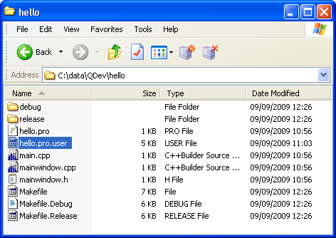
The ‘build’ created two sub-folders (‘debug’ and ‘release’), one .user file and three ‘MakeFile’ files.
The first thing to notice is that you can always safely delete these files, because they will anyway be re-created next time you build your project.
Next, we’ll ignore most of this technical stuff and concentrate on the ‘debug’ folder:
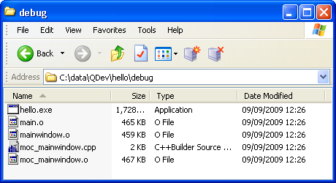
Here, you see some intermediate files (.o and .cpp) and, yes!, your very program. Try to double-click it and verify that it runs. Just an empty window, right, but it is all yours.
In case your program did not run, you must check that you did all the steps in section 1.3 correctly.
You do not need to go to Explorer to run your program. You can also do it directly from Qt Creator by pushing the green triangle in the left pane.

Version 2: With a button
Until now you did not enter any code. Let’s write code to put a button in that empty main window.
In the header file, we declare that we will use a button.
In mainwindow.h:
#ifndef MAINWINDOW_H
#define MAINWINDOW_H
#include <QtGui/QMainWindow>
class QPushButton;
class MainWindow : public QMainWindow
{
Q_OBJECT
public:
MainWindow(QWidget *parent = 0);
~MainWindow();
private:
QPushButton *button;
};
#endif // MAINWINDOW_H
In the source file, we write the code to create the button inside the main window.
In mainwindow.cpp:
#include <QtGui>
#include "mainwindow.h"
MainWindow::MainWindow(QWidget *parent)
: QMainWindow(parent)
{
button = new QPushButton("Push me!", this);
setCentralWidget(button);
}
MainWindow::~MainWindow()
{
}
To see if it works, build the program and run it. Your window now contains one huge button. Feel free to click it. Nothing happens. Why? Because you, the programmer, did not tell it what to do. We’ll see to that in the next chapter.
If you made an error entering the code above, Qt Creator will give you the red bar and show a little window with ‘Build issues’. You can click on them one by one, and the editor will jump to the corresponding line in the code where the error was detected.
If you made no errors then make one (e.g. delete the apostrophe closing the ‘push me’ text) and build, just so that you see the red bar. You are going to see this thousands of times, so better be prepared.
▪

My first program that does something
In this chapter we continue working with the ‘hello’ project.

Desperate means
Sometimes you keep getting the red bar with incomprehensible error messages. Of course, most times it will be because you have made a coding error but cannot see it, but it could also be that Qt Creator got confused somehow.
To make sure Qt Creator got it right, first you can try the menu option Build|Rebuild rather than the usual Build|Build. A rebuild will compile all of your code whereas a build will only compile the code that changed since your last build. For large projects that makes a big difference in build time.
On one occasion (doing this exercise) I had to leave Qt Creator and start it again before it would rebuild my project.
However, these problems are not so common and will disappear with future versions of Qt Creator, as the users report their problems and they are solved.

Adding a class
To make our program do something we will add a new class to it called ‘Calculator’.
First make sure your project is open in Qt Creator (if so you can see it in the Projects pane on the left). Then select File|New... and choose ‘C++ Class’:
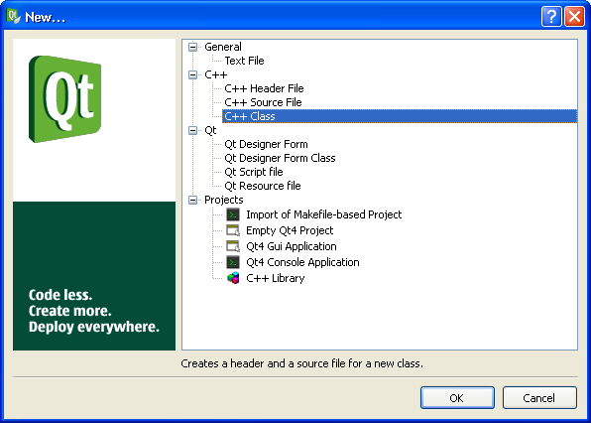

Enter the class name and base class:
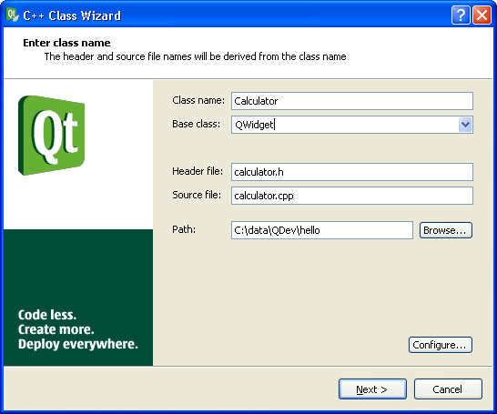
A ‘QWidget’ is a class that presents something on the screen.
Accept the next screen which offers you to add two new files to your project: a header file (calculator.h) and a source file (calculator.cpp):
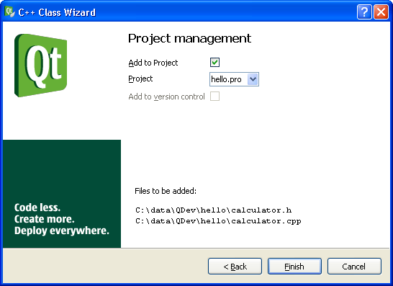

Dusting off the defaults
The two files created for us are nearly ready for a first run but let’s just tweak them a bit.
In file calculator.h:
#ifndef CALCULATOR_H
#define CALCULATOR_H
#include <QWidget>
class Calculator : public QWidget
{
Q_OBJECT
public:
Calculator(QWidget *parent = 0);
};
#endif // CALCULATOR_H
Add the ‘Q_OBJECT‘ line as shown. This gives the class some magic capabilities that you need not think about right now.
Add an argument to the constructor which facilitates this widget being the child of another. The ‘= 0’ means that the argument is optional.

In file calculator.cpp:
#include "calculator.h"
Calculator::Calculator(QWidget *parent)
: QWidget(parent)
{
}
Add the argument to the constructor and make the constructor forward it to its base class. – Hmm, maybe it is time to look up what a base class is?

Showing calculator in main window
In the main window we throw out the button an instead show our fancy new calculator widget.
In mainwindow.h:
#ifndef MAINWINDOW_H
#define MAINWINDOW_H
#include <QtGui/QMainWindow>
class Calculator;
class MainWindow : public QMainWindow
{
Q_OBJECT

public:
MainWindow(QWidget *parent = 0);
~MainWindow();
private:
Calculator *calculator;
};
#endif // MAINWINDOW_H
That was simple, replacing the declaration of button with calculator.

In mainwindow.cpp:
#include <QtGui>
#include "mainwindow.h"
#include "calculator.h"

MainWindow::MainWindow(QWidget *parent)
: QMainWindow(parent)
{
calculator = new Calculator(this);
setCentralWidget(calculator);
}

MainWindow::~MainWindow()
{
}
Quite straightforward as well. Notice that we had to include the header file. Otherwise the type ‘Calculator’ would be undefined in this file.
Now rebuild (yes, rebuilding is a good idea upon addind a new class to your project). You will again be rewarded by a blank screen. Now it is a calculator widget. The user cannot see it but you know it.

Adding widgets to calculator
I suggest the calculator should have five widgets: one for input, one for output and three buttons to calculate, clear output and exit the program.
OK. Let’s put the output on the left side and on the right have the input and buttons in a nice stack. To layout widgets in Qt Creator you use so-called QLayout objects. Here I will show you by example how they work.
Hint: You can use the F4 key to swap between the header and the source file in the editor.
In calculator.h:
#ifndef CALCULATOR_H
#define CALCULATOR_H
#include <QWidget>
class QBoxLayout;
class QLineEdit;
class QPushButton;
class QTextEdit;

class Calculator : public QWidget
{
Q_OBJECT
public:
Calculator(QWidget *parent = 0);
private:
// methods
QBoxLayout* createInputLayout();
QBoxLayout* createOutputLayout();
// data
QLineEdit *edit;
QPushButton *calculateButton, *clearButton, *exitButton;
QTextEdit *text;
};
#endif // CALCULATOR_H
So, here we declared two functions that both return a pointer to a QBoxLayout object and five variables that are all pointers to widget objects of types QLineEdit, QPushButton and QTextEdit. – You may want to read about classes vs. objects at this time and also about pointers.
All the Q.. classes in Qt Creator can be found in its help section. Push the book icon in the left pane and under the ‘API Reference’ heading, click ‘Main classes’. In the alphabetical table try to find QLineEdit, click it and scroll down to its ‘Detailed Description’. You may be surprised to find that it is, in fact, quite easy to grasp the explanation.
OK. Back to the source file (click the Edit button on the left) where we will cause all the pointers to objects declared in the header file actually to point to such objects.
In calculator.cpp:
#include <QtGui>
#include "calculator.h"
Calculator::Calculator(QWidget *parent)
: QWidget(parent)
{
QHBoxLayout *layout = new QHBoxLayout(this);
layout->addLayout(createOutputLayout());
layout->addLayout(createInputLayout());
}

QBoxLayout* Calculator::createOutputLayout() {
QHBoxLayout *layout = new QHBoxLayout;
layout->addWidget(text = new QTextEdit(this));
return layout;
}
QBoxLayout* Calculator::createInputLayout() {
QVBoxLayout *layout = new QVBoxLayout;
layout->addWidget(edit = new QLineEdit(this));
layout->addWidget(calculateButton =
new QPushButton("Calculate", this));
layout->addWidget(clearButton = new QPushButton("Clear",
this));
layout->addWidget(exitButton = new QPushButton("Exit", this));
layout->addStretch();
return layout;
}
All those ‘new’ instructions cause objects to be created. The layouts put things together either horizontally (QHBoxLayout) or vertically (QVBoxLayout).
If you wonder about the ‘’addStretch()’, you can try it with and without that line.
Now, build your code, run your program and enjoy your creation:
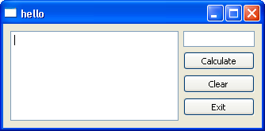

Making connections
To activate those buttons we must connect the signal, that is issued when they are clicked, to a function that should then be called. These functions are called ‘slot’ functions.
We will create three slot functions, one for each button. In our first version we will not write any code for the ‘Calculate’ button. This is typical for programming: All we want to do is to calculate but we have to write all this other user-interface code first. When we come to Universal Simulator plugins you will be relieved from that, since all user-interface code has already been written for you.
In calculate.h:
#ifndef CALCULATOR_H
#define CALCULATOR_H
#include <QWidget>
class QBoxLayout;
class QLineEdit;
class QPushButton;
class QTextEdit;
class Calculator : public QWidget
{
Q_OBJECT
public:
Calculator(QWidget *parent = 0);
private slots:
void doCalculate();
void doClear();
void doExit();
private:
// methods
QBoxLayout* createInputLayout();
QBoxLayout* createOutputLayout();
void makeConnections();
// data
QLineEdit *edit;
QPushButton *calculateButton, *clearButton, *exitButton;
QTextEdit *text;
};
#endif // CALCULATOR_H
In the source we add definitions for the four new function functions we just declared in the header file.
In calculate.cpp (only additions shown):
void Calculator::makeConnections() {
connect(calculateButton, SIGNAL(clicked()),
this, SLOT(doCalculate()));
connect(clearButton, SIGNAL(clicked()),
this, SLOT(doClear()));
connect(exitButton, SIGNAL(clicked()),
this, SLOT(doExit()));
}

void Calculator::doCalculate() {
}

void Calculator::doClear() {
text->clear();
}

void Calculator::doExit() {
QObject *p = parent();
QMainWindow *mainWindow = dynamic_cast<QMainWindow*>(p);
mainWindow->close();
}
In makeConnections the click signal of the three buttons are connected to the three functions below it.
In doClear the text widget is told to clear itself.
In doExit we have to tell the main window that it should close. But where is it? We need a pointer to main window. Thinking back we realize that a Calculator is a child of the MainWindow object. This line in the MainWindow constructor (mainwindow.cpp) established that parent-child relationship:
calculator = new Calculator(this);
So, in doExit we call for the parent using the parent() function. Now, we hold a pointer to the parent in variable ‘p’. But p is not a QMainWindow but a mere QObject, the most basic of all the Q... classes.
Time to throw in some C++ trickery: We ‘cast’ p to the desired class and thus obtain the mainWindow pointer which is of the QMainWindow class and by which we can finally close the main window. – You may want to check ‘dynamic_cast’ in your C++ book. For our Universal Simulator models later on, we will also sometimes need to cast one type of model to another.
Now build and run your program. Do the buttons work? Why not?

Declaring, defining and calling functions
If you followed my instructions above, your buttons do not work. If you have had previous experience with programming, maybe you noticed my oversigt and fixed it on the way.
The problem is with makeConnections(). We declared it in the header file and defined it in the source file. We built the program so the code is OK and ready to run, however, your computer never actually got around to makeConnections(). Why? Because you never told it so.
You put a functions to use by calling (also called ‘invoking’) it. Let us fix that and call the function from the constructor.
In calculator.cpp:
Calculator::Calculator(QWidget *parent)
: QWidget(parent)
{
QHBoxLayout *layout = new QHBoxLayout(this);
layout->addLayout(createOutputLayout());
layout->addLayout(createInputLayout());
makeConnections();
}
Build again. Now you buttons work. Well, at least two of them. Enter some text in the big field on the left, click the Clear button, and the text magically disappears! Now, let’s turn to the Calculate bit.

Calculations, loops and whatnot
At this point, we have all the calculating power of your computer right at our hands. But let us approach this in baby steps. First of all: Can your computer count?
To find out we only need to change the doCalculate function in the source code. If we use any new classes we must remember to include the header file of those classes.
In calculate.cpp (showing additions):
#include <QtGui>
#include <QTextStream>
#include "calculator.h"

void Calculator::doCalculate() {
// Get user input
int n = edit->text().toInt();
// Collect output
QString outString;
QTextStream outStream(&outString);
for (int i = 0; i < n; ++i) {
outStream << i;
}
// Show output
text->insertPlainText(outString);
}
First we ask the edit widget about the text it holds. This we convert to an integer number.
Then we set up two objects to hold the output: a string and a stream. What we put into the stream ends up in the string. It is much more convenient to put output into a stream than into a string directly, which is why we use the stream here.
In the for-loop (confused? look up for-loops in your C++ book), numbers are put into the stream one by one.
In the last statement, everything that went into the stream is shown on the text widget.
Run this program and inspect the exciting output.
After that, replace the for-loop with these different versions. Run each version and again inspect the output and see if you can understand, what is going on.
Version 1 (original):
for (int i = 0; i < n; ++i) {
outStream << i;
}

Version 2:
for (int i = 0; i < n; ++i) {
outStream << i << “ “;
}

Version 3:
for (int i = 0; i < n; ++i) {
outStream << i << “\n“;
}

Version 4:
for (int i = 0; i < n; ++i) {
outStream << i << “ “ << 2*i << “\n“;
}

Version 5:
int i = n;
int count = 0;
while (i != 1) {
++count;
if (i%2 == 0)
i /= 2;
else
i = 3*i +1;
outStream << count << " " << i << "\n";
}

For that last one you may want to read up on while-loops, if-statements and the %- operator.

Real calculations
Your final exercise is to take doCalculate through these next logical steps (well, I think they are logical; there certainly was something interesting going on in that version 5).
These three exercises will take you anywhere from 10 minutes to several days, depending on your programming experience.

Exercise 1
The eager student tried to enter numbers from 1 to 10 and took notes of the final count for each:
1 0
2 1
3 7
4 2
5 5
6 8
7 16
8 3
9 19
10 6
Hmm, the student would like to continue this up to 100, or why not 1000, and analyze the data. But that would be so tedious. Luckily, you are a programmer so you solve this easily. You simply change the code a bit.
Now the number entered (call it N) results in count being calculated not just once but for all n = 1, 2, ..., N. So if e.g. 10 is entered for N, the output in the text window should be that shown above.
Hint: Put the while-loop inside a for-loop.

Exercise 2
Hmm.. I wonder what the maximum count is for n up to 10,000?
Why don’t you just change your program a bit and let it show just one number:
The biggest count for n up to 10000 is ___

Exercise 3
InHitchhiker’s Guide to the Universe the answer to anything and everything is 42 (didn’t read it yet? oops, I am sorry I gave it away).
Could there be a connection here? Which values of n result in a count of 42?
▪

Preparing for Universal Simulator development
You can download and install a working Universal Simulator application from www.weedml.org. But you want to become a UniSimDeveloper and for that you need the C++ code that makes up the application and plug-ins, and even some more bits and pieces.

Installing Boost C++ libraries
The Boost libraries contain general facilities that were left out of the C++ language itself, for instance, a lot of mathematical functions. Universal Simulator uses Boost, so as a first step we install that.
Go to www.boost.org and find the download page. Pick a file format that you know how to unpack. The file to download should have a name like ‘boost_1_40_0.zip’:
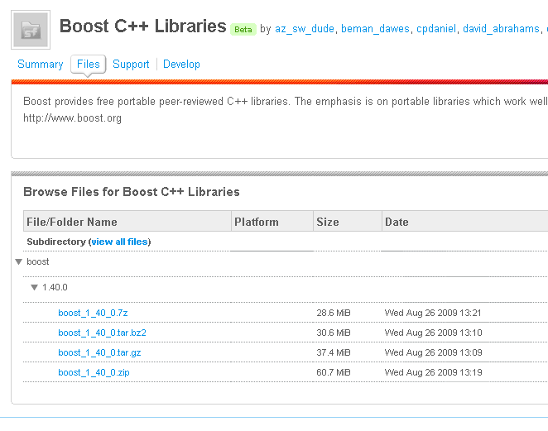
After downloading unpack the file somewhere. I put mine in ‘C:\Program Files\boost_1_35_0’ (see, I have got an older version).

Installing UniSim C++ code
This step is similar to the previous. Download the file ‘unisim.zip’ from www.weedml.org/weedml/download.html. This time unpack it, not just anywhere, but into your development folder, e.g. ‘c:\dev\unisim’.
If you incidentally got it a level too deep (i.e. ‘c:\dev\unisim\unisim’) fix it right away to avoid future confusion. If you inspect what’s inside the ‘unisim’ folder (or ‘UniSim’, it makes no difference) , you should see this nice tree:
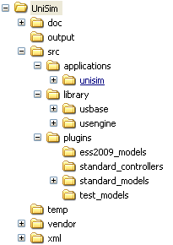

The sub-folders of UniSim have these contents:
- doc
– documentation, including this document, various notes and thoughts; just ignore this folder
- output
– initially empty, this is where various output from the UniSim application should end
- src
– C++ source code
  - applications
    - unisim
– source code for the UniSim application
  - library
    - usbase
– source code the UniSim base library (advanced note: usbase is not compiled into a separate library)
    - usengine
- source code for the UniSim engine library (advanced note: as above)
  - plugins
– each sub-folder contains one plugin; this is where you will eventually put the source code for your own plugins
    - ess2009_models
– the plugin used for the teaching at the ENDURE Summer School 2009 in Volterra, Italy
    - standard_controllers
– plugin with standard controllers providing basic integration control, such as fixed number of iterations
    - standard_models
– plugin models for calendar, weather, etc.
    - test_models
– plugin used for testing only
    - additional pluging...
  - output
– initially empty, this is where temporary files generated by the UniSim application should end
  - vendor
– third party libraries (all open source) go here
  - xml
– models and prototypes (used to create new plugins) are placed here; initially a few sample files are included
That was quite a lot, perhaps even more than you would like to get for free, but most of it can remain untouched by you. In fact, the only change, you will be making to all this, is to add a sub-folder to the plugins folder to contain the C++ code for every plugin you make. In addition, the output, temp and xml folders will fill up with a few files as you make progress.

Setting system environment variable
To tell Qt Creator where you put things, you must set a few environment variables of your system. On Windows right-click ‘My Computer’ and choose ‘Properties’. Pick the ‘Advanced’ tab:
Push the ‘Environment Variables’ button:
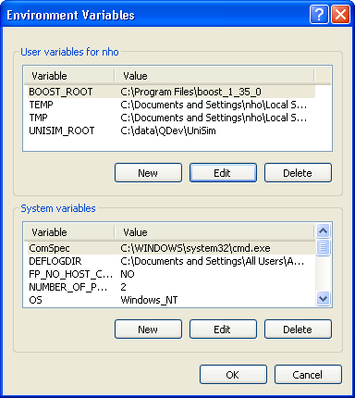
First add two new items to the top pane:
Click “New” to add ‘BOOST_ROOT’ and set it to the folder of to your Boost folder.
Click “New” again to add ‘UNISIM_ROOT’ and set it to the folder of your UniSim code.
Next update the path variable in the bottom pane. Scroll down to the PATH variable, click it and then push the Edit button:
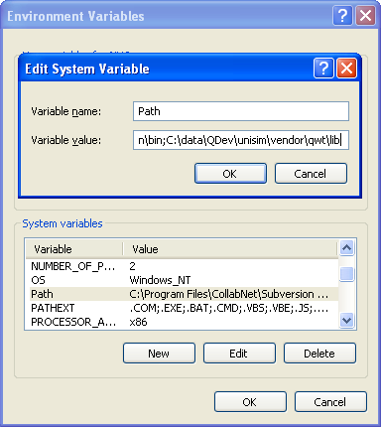
Add a semicolon to the end of the current value and then extend it with the path to the Qwt library. It is found in the unisim\vendor\qwt\lib folder but you should write the full path here, starting with the drive letter.
Qwt (qwt.sourceforge.net) is an open-source library to draw graphs. Instead of letting you download and build it, I did that for you and made it part of the UniSim package that you downloaded.
I chose not to let the UniSim application find the library (like it does with the UniSim plugin libraries). Instead your operating system (e.g. Windows) must find it. Windows looks for applications and libraries on the system path, which contains a list of folders. Above you just extended that list, so taht Windows can find the Qwt library.
You should extend the PATH variable with the path to the Qt libraries too. Otherwise, you can only execute the Universal Simulator application from within Qt Creator. With the Qt libraries in the PATH, the application can also be executed, e.g. from Windows Explorer. So, add another semicolon and a path, like c:\qt\2009.03\qt\bin. You will likely have a newer version than me.

Setting up the UniSim session in Qt Creator
Did you notice that Qt Creator remembers, how you left it? When you return to Qt Creator it starts up with the same project(s) in the left pane and the same files loaded into the editor.
The state of Qt Creator is saved in a ‘session’. What you have seen until now is just the default session but if you work on several development projects, you can save the state of each in its own session, so you can maintain the state of each. This makes life easier for you.
Now we will set up the session that you will use for all your UniSim development. First start up Qt Creator. Choose File|Session|Session Manager. Push the ‘Create New Session Button’ and type a name for this session, e.g. ‘UniSim’. Click OK and OK again.
Hmm.. You are back and nothing seems to have happened. The final step is to choose File|Session and, look!, the list of sessions have been extended with the one you just created (‘UniSim’). Choose that one. Qt Creator should now be completely blank:
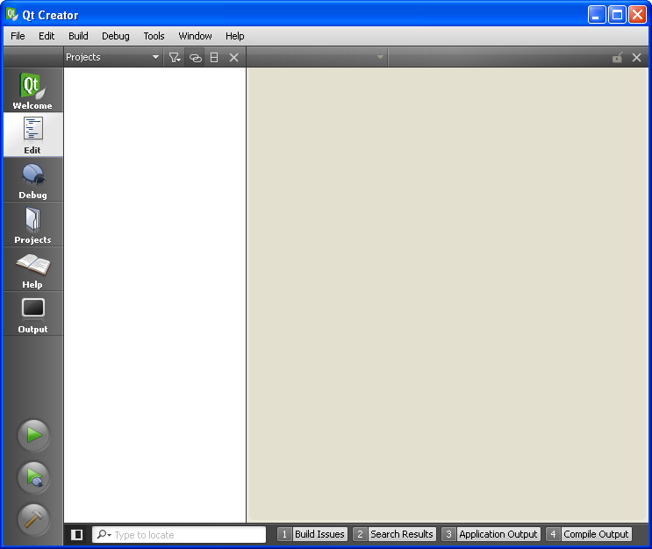
We will now fill up the left pane with the UniSim projects. There is one project for the UniSim application on one for each plugin.
Choose File|Open and select the unisim.pro file. It is found in the unisim\src\applications\unisim folder. You should now have loaded the UniSim project:
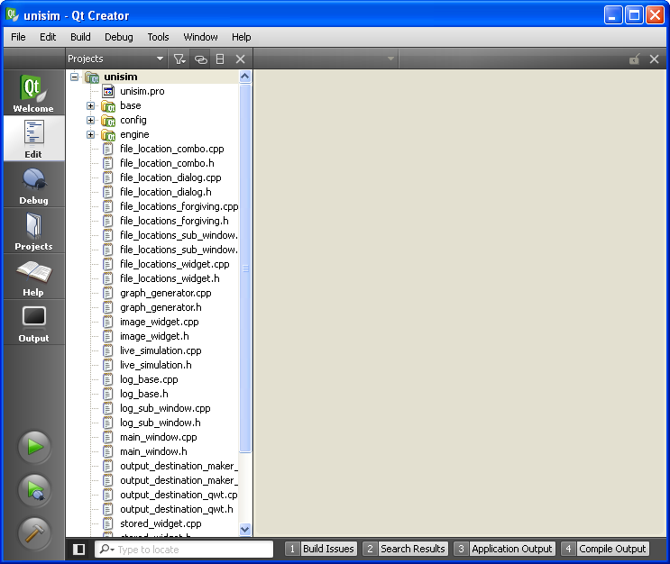
Yes, lots of files are included in that project. It is good that you do not have to look inside these (although you are welcome to). Click the small minus icon to fold the project together and get a better overview.
Choose File|Open again and load the plugin projects one by one:
ess2009_models.pro in unisim\src\plugins\ess2009_models
standard_controllers.pro in unisim\src\plugins\ standard_controllers
standard_models.pro in unisim\src\plugins\standard_models
(The test_models you do not need).
Qt Creator should now look like this:
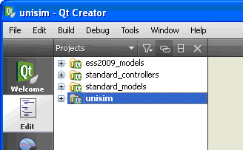
If you leave Qt Creator now and later start it again, you will be greeted with the following screen that features the new session ‘UniSim’:
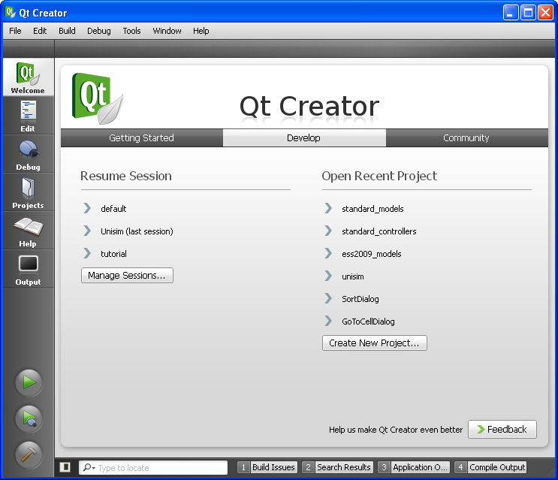
Notice the three subtle tabs in the top. This is the ‘Develop’ tab. From here you can resume any of your past sessions.
What is the difference between a session and a project? A session holds the state of Qt Creator as you left it, which includes zero, one or more projects. Sessions are stored on your computer. You cannot copy a session from one computer to another (which is why you have to put together the session yourself).
A project is a collection of files (in this tutorial, only the C++ header and source files and the project file itself, but others are possible). The project file contains a list of the files in the project together with information used by Qt Creator to build the project.

Your first UniSim build
This is the big moment when we will find out whether you followed the instructions correctly (and I wrote them completely). Start Qt Creator and pick the UniSim session from the welcoming screen (this is the last time I mention the UniSim session, you should always work in that session from now on). Qt Creator should still have four projects loaded:
Choose Build|Build All and wait a few minutes as Qt Creator digests all the code. No error messages should appear.
You can now check the results of your build. In unisim\src\applications you will find the UniSim application in the file ‘UniSimd.exe’. In unisim\src\plugins you will find a ‘.dll’ and a ‘.a’ file for each of the three plugins. The UniSim application will read these plugins when it is executed, and the models and controllers in the plugins will thus become available to the end-users of UniSim.

Your first UniSim run
You can run the UniSim application from within Qt Creator or by double-clicking the ‘UniSimd.exe’ file in Windows Explorer. It is convenient to be able to do both, so let us check that both ways work on your computer.
Qt Creator cannot guess which project you want to run, so you must tell it. Choose Build|Set Run Configuration. Place the checkmark next to the UniSim project. If it was there already there, just ecape and do nothing. Now you can push the green triangle and run the UniSim application:
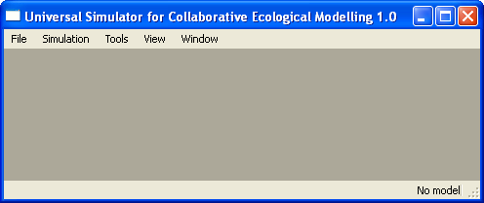
For now just close the UniSim application, switch to Windows Explorer and see if it runs as well when you click ‘UniSimd.exe’.
This is the first time the UniSim application runs, so you need to tell it where various files are located. Choose File|File locations:
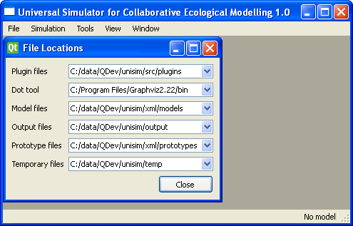
You should set up the various locations like I did above. Of course, your UniSim folder may have a different location. The dot tool is part of the Graphviz package. It is used to draw model diagrams. Follow the instructions how to install it at www.weedml.org/weedml/download.html. You may find a newer version than the 2.22 version which I have got.
Close the ‘File locations’ window. Choose File|Open. Pick the ‘7 add control.xml’ file which contains a model of an annual weed in a maize-wheat crop rotation. The previous files names ‘1...’ to ‘6’...’ build this model step by step. You should see this model diagram:
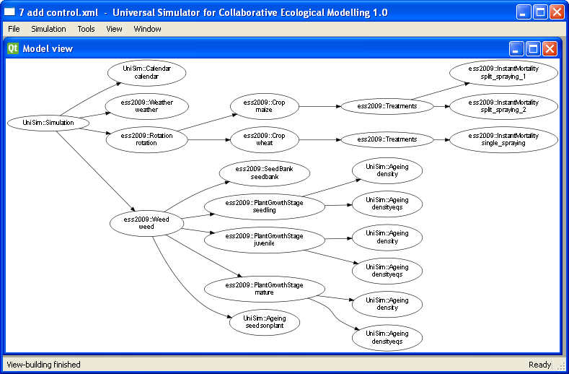
The diagram still needs some tidying up in functionality. That will be dealt with as part of refining Universal Simulator.
Fine. Now choose Simulation|Run to achieve output like this:
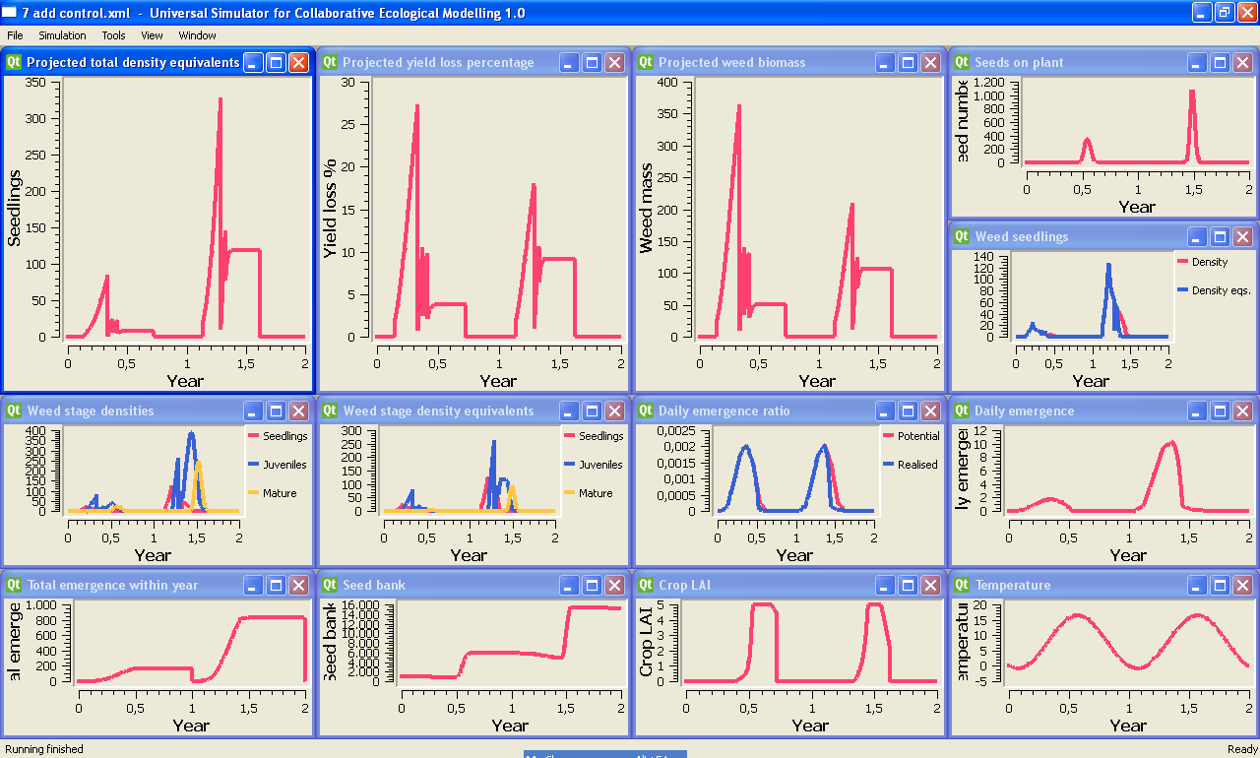
Congratulations! You have installed, built and run the Universal Simulator. You now have all the tools ready to develop your own plugins and models.
▪

