Let’s construct such a curve step by step.

1. Start with a downward-opening parabola
Take a general parabola with vertex (apex) at ((h,k)) and opening downward:
$$[ y = k - a{\left(x - h\right)}^{2}, a>0. ]$$
This ensures the “legs” point downward.

2. Choose the join point
Let the parabola be replaced (to the right) by a straight line at some point ($x = x_{0}$), where ($x_{0} > h$).
At that point:
- The function must be continuous (same value),
- The slope must match (so the join is smooth).

3. Compute the slope of the parabola
Differentiate:
$$\backslash frac\left\{dy\right\}\left\{dx\right\}= -2a(x - h)$$
At (x = x_0), the slope is:
[ m = -2a(x_0 - h). ]

4. Equation of the matching line
The line must:
- Pass through the point ((x_0, y_0)), where
[ y_0 = k - a(x_0 - h)^2, ]
- Have slope (m = -2a(x_0 - h)).
Using point–slope form:
[ y = y_0 + m(x - x_0). ]
Substitute:
[ y = k - a(x_0 - h)^2 - 2a(x_0 - h)(x - x_0). ]

5. Final piecewise function
The complete curve is:
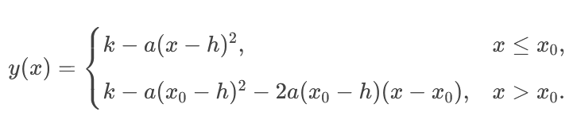

6. Key properties
- The curve is continuous at (x_0),
- The derivative is also continuous (same slope) → smooth join,
- Left side: parabola
- Right side: straight-line extension tangent to the parabola.

✅ Simplified special case (vertex at origin ( (0,0))):
Parabola: [ y = -a x^2 ]
Join at (x_0 > 0):
[ y = \begin{cases} -a x^2, & x \le x_0,\[6pt]
- a x_0^2 - 2a x_0 (x - x_0), & x > x_0. \end{cases} ]

If you want, I can plot this or express it as a single formula using step functions.

