integrate 1/(T - c*(y-C) - v*(y-V)) dy
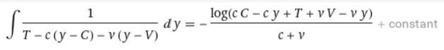

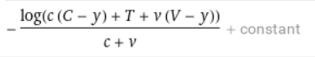

solve x = -log(c (C - y) + T + v (V - y))/(c + v) + K for y
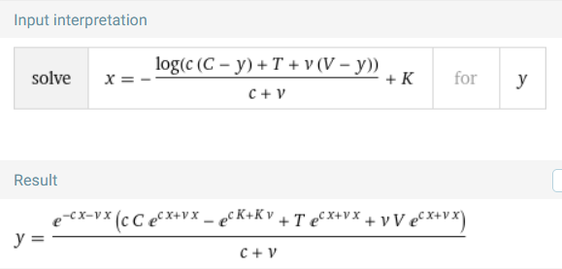
simplify y = (e^(-c x - v x) (c C e^(c x + v x) - e^(c K + K v) + T e^(c x + v x) + v V e^(c x + v x)))/(c + v), x=0
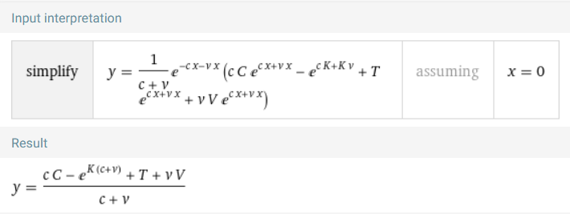
solve y = (c C - e^(Q (c + v)) + T + v V)/(c + v) for Q (K replaced by Q; did not work with K (?))
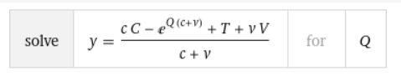
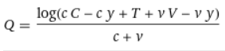

simplify y = (e^(-c x - v x) (c C e^(c x + v x) - e^(c K + K v) + T e^(c x + v x) + v V e^(c x + v x)))/(c + v), K = (log(c C - c y + T + v V - v y)/(c + v))

solve y = (e^(-c x - v x) (c C e^(c x + v x) - e^(c K + K v) + T e^(c x + v x) + v V e^(c x + v x)))/(c + v), K = log(c C - c y + T + v V - v y)/(c + v) for y

simplify y = (e^(-c x - v x) (c C e^(c x + v x) - e^((log(c C - c y + T + v V - v y)/(c + v)) (c + v)) + T e^(c x + v x) + v V e^(c x + v x)))/(c + v)
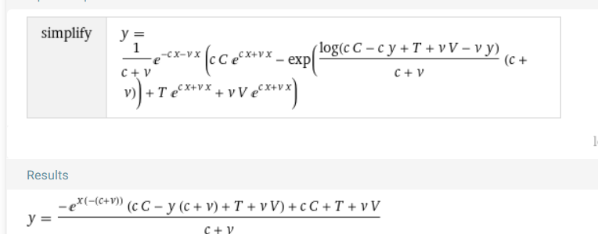

Result
y = (-e^(x (-(c + v))) (c C – y0 (c + v) + T + v V) + c C + T + v V)/(c + v)

