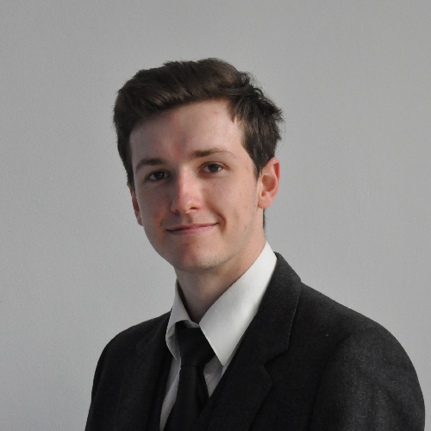

**Internship search in**

**low-level GPU programming**

**Niels   
Ouvrard**

**Objective**

4th-year Computer Engineer student with strong knowledge in C/C++.  
I am looking for a 6-month part-time internship in **low-level GPU development** starting from **September 15, 2025.**

Phone.  **+337 82 02 19 52**

Email:  
[**ouvrardniels@gmail.com**](mailto:ouvrardniels@gmail.com)

[**LinkedIn**](https://www.linkedin.com/in/niels-ouvrard-2810951ab/)

[**GitHub**](https://github.com/NielsOuvrard)

## Indienov - Embedded Development and Python (February – May 2024)

Developed a test harness and a driver in C for a "Texas Instruments LP5521" LED based on the manufacturer's documentation. Also created various production tools in Python, such as developing a class for connecting to AWS servers using canonical requests, for a unit testing software in MQTT.

Epitech Trainer (2023 – 2024, 10 months)  
Trained first and second-year students in C and C++. Delivered lessons on C libraries, project presentations, and evaluations for two groups of 60 students each.

## FrenchFounders – Frontend development (June – December 2022)

Created multiple web pages using Vue.js, integrated with the company’s backend, and migrated several pages from Vue 2 to Vue 3.

**Professional experiences**



Apple Metal API

Self-learner of **Metal 3**, using ‘Metal by Tutorials’ by Begbie C. Proficient in MSL and the **graphics pipeline**, actively expanding knowledge in areas such as compute shaders and advanced rendering techniques.

**By myself**



## Master in Computer Engineer | Epitech MarsellE

## 2021 – 2026

GPA **3.8 / 4**.

Valedictorian in the second year.  
*Grade Point Average (GPA): An index of the overall quality of a student’s work, ranging from 0 (unacceptable) to 4 (excellent)*

## Universidad Panamericana | Guadalajara, Mexico

### **June 2024 – July 2025**

Specialization in video game, microcontrollers, and mathematics (linear and geometric algebra, quaternions…).

**Formation**



**Sports:** I have been practicing rock climbing in a club since 2017.

**Cinema:**

A cinema enthusiast, I have been greatly influenced by the films of Hitchcock, Tarantino, and Kubrick.

**Interests**



**Skills**

Software development

Algorithms

Data structure

Git

…

**Languages**

C, C++, Python

Swift, MSL

Vue3, PHP, Typescript

Godot4

**Languages**

French: Native

Spanish: Very good

English: Good