
Software development,
February to May 2024
Niels
Ouvrard

Objective

Professional experience

Third-year student at Epitech, a computer science school, seeking an internship in computer development from February 1st to May 31st, 2024.

Phone :
07 82 02 19 52
Email :
niels.ouvrard@epitech.eu
Birthdate 18/07/2003
Linkedin : Niels Ouvrard

Internship at FrenchFounders Frontend (July - December 2022) :
I have been able to create numerous web pages in Vue.js, connect them to the company's backend, and migrate many pages from Vue 2 to Vue 3.
Epitech Trainer Internship (February to June 2023 and from September 2023 to January 2024) :
Our goal is to support and train students in lower years (courses, project presentations, evaluations...).



Skills :
Software development
Algorithms
Data structures
Git, GitHub
…
Languages practiced :
  
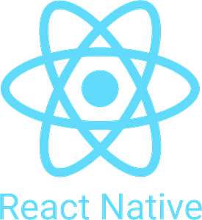
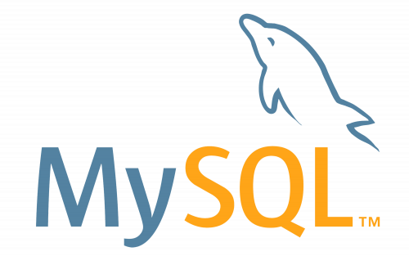

Proficiency in all operating systems.

Languages :
French : Native Language
English : B2
Spanish : B1

Formation

Sport :
I have been practicing climbing at a club since 2017.

Cinema :
As a cinema enthusiast, the works of Hitchcock, Tarantino, and Kubrick have greatly influenced me.
I am also passionate about audio-visual and have strong skills in the 'Fusion' (special effects) part of Davinci Resolve software.

Interests

Computer Expertise | Epitech

2021 – 2026
An average GPA of 3.8 / 4 at the beginning of the third year.
Top of the class for the second year
* Grade Point Average: an index of the overall quality of the student's work, ranging from 0 (unacceptable) to 4 (very good).

BACCALAUREATE | JEAN MONNET HIGH SCHOOL

2018 – 2021
With honors, (Specialization in Mathematics / Social and Economic Political Sciences / Physics - Chemistry)
Completed projects
Arcade (C++)
Creation of software for running video games (Pacman, Snake) and graphic libraries (SDL2, Ncurses, and SFML).
Antman (C)
Lossless file compression using the Huffman algorithm.
(Binary trees, linked lists)

