**Introduction:**

The positive correlation between health and wealth has been shown many times. Pollack et al. (2007)⁠ for example found 29 studies testing for the correlation between health and wealth. But as they note in the discussion of their paper, “since most of the studies identified were cross-sectional, causal inferences cannot be made” (Pollack et al., 2007, p. 263). Health and wealth could easily be endogenous. Wealth could affect health through better access to health care and better living conditions. Health could affect wealth through the ability to work and thus accumulate wealth. It could also be possible that for example time preference affects both the accumulation of wealth and health (Meer, Miller, & Rosen, 2003)⁠.

As Aittomäki, Martikainen, Laaksonen, Lahelma, and Rahkonen (2010)⁠ point out, “Wealth in particular is not directly affected by changes in labour market participation that may radically alter the current income level”. This is important “… as changes in health and illness are likely to develop over a considerable time span” (Aittomäki, Martikainen, Laaksonen, Lahelma, & Rahkonen, 2010, p. 1025)⁠. They find that wealth is highly relevant in explaining health.

The goal of this paper is to examine the causality between health and wealth in the Netherlands. This paper will try to deal with the endogeneity between health and wealth using a difference in difference analysis. The treatment group consists of home-owners and the control group consists of people who rent a house. The treatment is the financial crisis in 2008 as it affected housing prices. The change in housing prices should only affect the wealth of the home-owners and it stands to reason that it does not affect or is affected by health status of the home-owner or home-renters alike. The wealth of a person will be defined as the net worth of a person, i.e. all their assets minus their liabilities. Each person will be placed into one of two categories, i.e. healthy (1) or not healthy (0), based on their self rated health.

To try to find the causal relationship between health and wealth the data from the DNB Household Survey (DHS) from CentERdata. This survey is described as “a unique data set allowing you to study both psychological and economic aspects of financial behavior. This panel survey was launched in 1993 and comprises information on work, pensions, housing, mortgages, income, possessions, loans, health, economic and psychological concepts, and personal characteristics. We have been collecting these data from 2,000 households participating in the CentERpanel” (“DHS data access | CentERdata.nl,” n.d.). Using different waves of this dataset will allow this paper to try and find a causal relationship using the difference in difference analysis.

The paper will be structured as follows. Chapter 2 will discuss relevant literature on the subject of causality between health and wealth. Chapter 3 will describe the data used and of what the variables consists of. Chapter 4 will describe the statistical methods used. Firstly there will be explained how there will be showed that there is a correlation in the data between health and wealth. Secondly the method that will be used to test for a causal relationship will be described. Chapter 5 will present the results found by the statistical analysis and chapter 6 will discuss the results and improvements for this study.

**Related literatuur:**

In their article *Should Health Studies Measure Wealth*, Pollack et al. (2007) systematically analyze a total of 29 articles that used health as the dependent variable and wealth and at least one other socioeconomic-status variable as independent variables. Of the 29 articles analyzed, 14 used self assed health as their health variable. Most of those articles reported positive or mixed results. The other 15 articles used different variables for health such as: mortality, chronic conditions, functional status and mental health. Of the total of 29 studies, 15 found positive results, 10 found mixed results and only 4 found negative results. They conclude that there is a significant correlation between healh and wealth. Especially when the wealth variables were constructed from detailed questions instead of simpler questions (for example just a single question). It should however be noted that they only check for correlation and do not address causality.

There are however some studies that do address causality in the health wealth connection and they mostly find negative results. Meer, Miller and Rosen (2003) use a straightforward instrumental variable strategy to deal with the endogeneity. They use inheritance as the instrument as it does affect health but does not directly affect health nor is it affected by health they reason. They do find a significant correlation between health and wealth but when inheritance is used as an instrument they do not find a significant effect from wealth on health. They conclude that short run changes in wealth do not affect health. They do however note: “This finding does not rule out the possibility of a long-term impact of wealth on health” (Meer, Miller, & Rosen, 2003, p. 729)⁠. Kim and Ruhm (2012)⁠ also use inheritance as exogenous wealth shocks and also find no significant effect on health.

In a similar study, Apouey and Clark (2015)⁠ also find small or negligible effects on general health using lottery winnings and inheritance as instruments. They do however find that lottery winnings do produce better mental health but also increase smoking and social drinking. They note that “health is not a holistic concept, and we need to both be clear about what kind of health we are talking about and be ready for the possibility that different types of health behave in very different ways” (p. 536). Au and Johnston (2015)⁠ even find that wealth shocks in the form of inheritance might even increase obesity in women.

Michaud and Soest (2008)⁠ also find no causal effects of wealth on health. They use a dynamic panel data model to test for the causality. As they note in their conclusion, the data they use consists only of elderly couples. They suggest that there might be a causal effect in different age groups and that it would be interesting to see if there are differences in different countries to see if institutions have an impact on the possible causal relationship.

There are some studies that do find a significant causal effect of wealth on health. Cai (2009)⁠ focuses on health transitions instead of health status itself to avoid the endogeneity of wealth and health. She finds that wealthy people are less likely of transitioning from healthy to unhealthy compared to people in the lower end of the wealth distribution. This, she argues, is evidence that there might be a causal effect of wealth on health. She proposes four different explanations of the causal effect of wealth on health. Firstly, because the study focuses on people in Australia malnutrition might not be an issue, eating less healthy food is associated with people with less economic recourses. Secondly, people with more wealth may live in better and healthier environments. Thirdly, even in a country with universal health care system such as Australia, wealthier people might still receive more health services that less wealthy people. Finally, wealth could give people more freedom in making decisions, thus experiencing less chronic stress which leads to poor health. So there are several ways in which wealth could exert an effect on health. Testing via which effect wealth does affect health was out of the scope of the paper.

**Data**

The data consists of different (yearly) waves from the DHS. The data is collected every year by the CentERdata. The DHS consists of six questionnaires:

1. General Information on the Household  
2. Household and Work  
3. Accommodation and Mortgages  
4. Health and Income  
5. Assets and Liabilities  
6. Economic and Psychological Concepts

(“DHS data access | CentERdata.nl,” n.d.)⁠

Besides the questionnaire data, the CentERdata also provides two aggregated data files, the aggregated income data and the aggregated wealth data. This paper will only use the Healh and Income questionnaire which includes the self-rated health variable and the aggregated wealth data. The aggregated wealth data is made up from different questionnaires and consists of all the assets and liabilities someone might have.

The health variable will be a categorical variable with two options, either *healthy* or *not healthy*. The data received from the DHS has five categories for health: *poor, not so good, fair, good* and *excellent.* Persons who considered themselves to be in *poor* or *not so good* health will be places in the *not healthy* category. The persons that consider themselves to be in *fair, good* or *excellent* health will be placed in the healthy category. Self rated health is a good predictor for mortality (Idler & Benyamini, 1997)⁠ which is a good indicator for health.

To check if there is a correlation between wealth and health, a wealth variable needs to be created. For wealth this paper uses the net wealth of a person. Someone might well own a nice car and a house, but if he has a loan for the car and two mortgages on the house, he might still have a negative net wealth. To calculate the net wealth, all the assets of a person have been added together and the liabilities have been subtracted from the assets. The questionnaires are quite detailed on wealth which is important as was pointed out by Pollack et al. (2007).

The assets that could be found in the aggregated wealth data were:

* checking accounts
* employer-sponsored savings plans
* savings or deposit accounts
* deposit books
* savings certificates
* single-premium annuity insurance policies
* savings or endowment insurance policies
* growth funds
* mutual funds and/or mutual fund accounts
* bonds and/or mortgage bonds
* stocks and shares
* put options bought
* put options written
* call options bought
* call options written
* pieces of real estate, not being used for own accommodation
* value of life insurance mortgage real estate
* cars
* motorbikes
* boats
* (site-)caravans/trailers
* money lent out to family or friends
* savings or investments not mentioned before
* stocks from substantial holding
* business equity (professions)
* business equity self-employed

The liabilities consist of:

* private loans
* extended lines of credit
* outstanding debts not mentioned earlier
* finance debts
* loans from family or friends
* study loans
* credit card debts
* loans not mentioned before
* checking accounts with negative balance

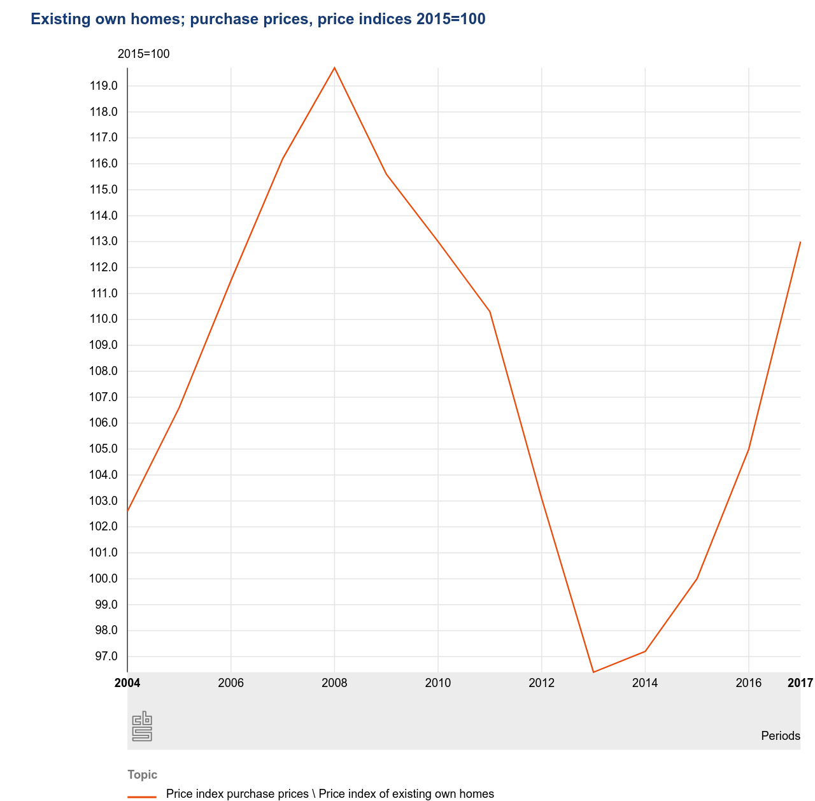  
figure 1

This paper will use the waves from 2007, 2013 and 2017. As is clearly visible in figure 1, the housing prices peaked somewhere in 2008. Because it is not clear when the data is collected it makes sense to take 2007 as the pretreatment year. 2013 is the year when the housing prices were at the lowest in the Netherlands. If wealth would cause short-term changes in health, it should be visible in 2013. So 2013 will be the first post treatment year. In 2017, the housing prices were still not as high as in 2007. Using 2017 as another after treatment year it could show us more about the mid-term effect of wealth on health.

**Methods**

First this paper will use a simple OLS regression. In this OLS regression health will be the dependent variable and wealth will be the independent variable. Health is defined as a categorical variable where someone can be either healthy, with value 1, or unhealthy, with a value of 0. Wealth is the net worth of a person as shown above.

Secondly, this paper uses a difference in difference (DD) analysis to look for a causal effect from wealth to health. A DD analysis is a quasi-experimental design with a treatment group, a control group and a treatment. A DD analysis is used to estimate the effect of a treatment by comparing the differences in the outcomes between before and after the treatment between the treatment and the control group.

The treatment group, control group and the treatment itself will be defined as follows. The treatment this paper uses is the financial crisis of 2008 in which housing prices sharply dropped as is visible in figure 1. It stands to reason that although the sharp drop in housing prices has an effect on the wealth of home-owners, it does not have a direct link to health. It can be assumed that the health of people did not directly cause, or was directly affected by health. The treatment group consists of people who own one or more houses and the control group consists of people who rent a house. Since the participants of the DHS are randomly picked, it can be assumed that the only real difference between the control and treatment group is the ownership of a house. The loss of jobs for example in the financial crisis can be assumed to have the same effect on people who own and people who do not own a house. Therefore, the sharp drop in housing prices caused by the financial can be used as a treatment which only affects the wealth of the treatment group.

The following regression model will be used:

$Health=β_{0}+β_{1}∗Time+β_{2}∗Diff+β_{3}∗Time∗Diff+ε$

Where Time is the time trend in the control group, Diff is the difference between the two groups pre-intervention and Time * Diff is the difference in change over time.

Therefore the hypotheses are:

$H_{0}:β_{3}=0$

$H_{a}:β_{3}>0$