**Forecasting energy use and energy production of NZEB row houses**

*Jefry Yehia el Bhwash1, Levy Duivenvoorden1, Cornelis Gerrit van Drunen1, Amin Mansouri2, Niels van Schaik2 and Tadeo Baldiri Salcedo Rahola1\**

1 Faculty of Technology, Innovation, and Society, The Hague University of Applied Sciences, Rotterdamseweg 137, 2628CN, Delft, The Netherlands  
2 Faculty of IT & Design, The Hague University of Applied Sciences, Stamkartplein 40, 2521 EP, Den Haag, The Netherlands

**Abstract**

**One of the main problems of Net Zero Emission Buildings (NZEB) is that the energy being delivered to the electricity grid, produced by the PV solar panels, is irregular. Therefore putting a lot of strain on the current grid infrastructure during hours of high solar irradiance. One solution to reduce the strain on the grid infrastructures is to add energy storage capacity to the Net Zero Energy Buildings and store or deliver the energy at the time that is most economically advantageous. Given the fact that the hourly energy prices are defined one day in advance, an energy consumption and production prediction will allow to define the most optimal control strategy for the energy storage system. The goal of this paper is to predict the energy production and consumption of one such NZEB house 1 day in advance with an hourly resolution. The data used is the smart meter data and solar inverter data from 12 NZEB households in Zoetermeer (Zuid-Holland, the Netherlands). Former research such as that from (Liu, et al., 2019) indicate that there are multiple machine learning models that could be valuable in the effort of predicting the hourly energy consumption of a NZEB. Besides that there are multiple research papers recommending the use of LSTM (Jana, Ghosh, & Sanyal), (Kim & Cho, 2019), (Khovalyg & Heidari, 2020), (al A. H., 2020). The following models were applied in this research; MVLR, SVR, MLP and LSTM. The SVR works best for predicting production with** a **MAE of 0.14 kWh, MSE of 0.05 kWh2 and a R2 of 0.50. And the MVLR works best for predicting the consumption with a MAE of 0.41 kWh, a MSE of 0.34 kWh2 and a MAPE of 93.29 %. However after inspection of the distributions it can be concluded that the LSTM shows the best performance on both the consumption and the production compared to the other models. All of the models applied in this research did not recognize the peaks in the data, therefore it can be recommended to make a model for predicting peaks in the data.**

# **I**ntroduction

The European Commission has set the ambitious goal of reducing the impact of global warming with the Paris agreement (United Nations Climate Change). The Netherlands has released their Nationally Determined Contributions (NDC) in November 2019, in which the plans for the coming 30 years are presented. The Netherlands has set the goal of reducing the CO2 emission, relative to 1990, with 49% by 2030 and with 80 to 95% by 2050 (Rijksoverheid). Electricity makes up around 26% of the CO2 emissions in the energy sector of the Netherlands. In 2015 the portion of renewable energy of the electricity consumption was circa 12%. As a result of the reduction of CO2 emissions this percentage will increase to circa 41% by 2023. One of the ways to achieve that is to create more Net Zero Emission Buildings (NZEB). These buildings are well insulated and are equipped with PV solar panels that are producing electricity. They are however still connected to the main grid to sell and buy electricity in case the energy produced is more or less than the NZEB consumes. At this point in time NZEBs in the Netherlands sell their surplus of energy to the net at a profit. In the near future this will not be as straightforward. With the increase of renewable energy production at a national level the electricity grid threatens to overload during hours of high solar irradiance, resulting in power outages or even in some cases irreversible damage to the electricity network. In order to prevent this, energy prices at hours of high energy production are dropped. In some cases even to negative numbers. The electricity market regulator defines the energy prices 1 day in advance. Therefore it would be most profitable if it would be possible to predict the energy production and consumption of a NZEB 1 day in advance, in order to maximise the profit of the customers by selling the energy at hours of low energy traffic. Former research indicates that such predictions of energy production and consumption can very well be done through the use of machine learning and neural network prediction models. Studies such as that from (Liu, et al., 2019) state that the machine learning approach is promising but the difficulty lies in determining what model to apply in order to gain the best result. Several studies, among which (Jana, Ghosh, & Sanyal), (Kim & Cho, 2019), (Khovalyg & Heidari, 2020), (al A. H., 2020), have shown LSTM to hold great promise in the effort of predicting energy consumption of residential facilities. The complication to neural network models such as LSTM is however the 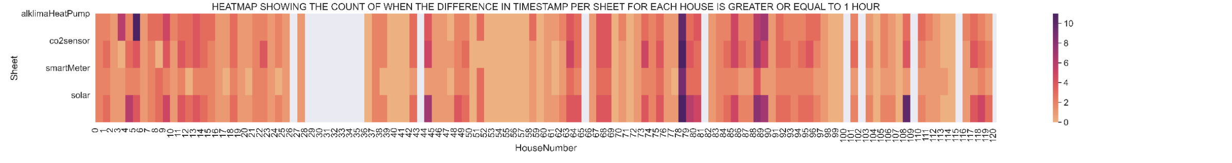determination of the hyperparameters in order to gain optimal performance. In order to gain insight into the capabilities of both machine learning as well as neural network models when it comes to the prediction of energy production and consumption of a NZEB, this research conducts the performances of 2 machine learning models and 2 neural networks for both the prediction of energy production and consumption. To be more specific, of SVR (Support Vector Regression), MVLR (Multi Variate Linear Regression), MLP (Multi-Layer Perceptron) and LSTM (Long Short Term Memory). The data used in this research consists of the energy monitoring of 120 identical NZEB households located in Zoetermeer (Zuid Holland, the Netherlands).

# Methodology

Figure 1: Heatmap indicating the amount of timestamp differences greater or equal to 1 hour per NZEB. The white spaces indicate NZEBs that were not usable due to more than 1000 timestamp gaps greater or equal to 1 h.

## Data

### Data collection

The data used consists of the historical data from the smart meter and the solar panel Inverter. The data from one such NZEB is transmitted to data servers via a communication module. The data consist of 2 data storages, one for the smart meter and the other for the solar panel inverter. The data is recorded with a 5 minute interval.

Besides the energy monitoring data, weather data is also used. The weather data was received from a nearby weather station located in Voorschoten (within 15km radius from Zoetermeer) gathered by the royal Dutch meteorological institute (Koninklijk Nederlands Meteologisch Instituut, 2019). From this data the feature Global Sun Irradiance was extracted, which defines the intensity of sunlight on 1 hour resolution. Only the solar irradiance data of the past day is used as an input for the models, since only the solar irradiance of the previous day(s) is available.

### Data pre-processing

The data recording interval of five minutes is inconsistent for all 120 houses, this is most likely due to communication issues between the monitoring communication module and the data servers. To make the period of time between 2 records more consistent the data is resampled to a 1 hour resolution. However some NZEB datasets still contained large timestamp gaps, which makes it unsuitable to make predictions with. To indicate which NZEB datasets contain the least amount of missing data a heatmap shows the most potential. After having a look at the data, a heatmap is made. This heatmap is shown in figure 1. The best houses were chosen with the help of the heatmap. In total, 12 of the houses with the least amount of gaps were selected, and used to train the models on. For both the prediction of energy production and consumption.

In order to obtain the energy consumption of the NZEB a calculation is made. The smart meter data registers the netto amount of energy, therefore the solar had to be taken into account. The total formula is shown in formula (1).

|  |  |
| --- | --- |
|  | (1) |

Where is the electricity entering the NZEB from the electricity grid, the electricity entering the NZEB from the solar panels, the electricity leaving the NZEB to the grid.

An inconsistency that occurred was at the calculation of the energy consumption of a NZEB. Although the equation would theoretically not permit a negative outcome, a negative energy consumption was still found in less than 1% of the data. Due to the insignificant amount of data it takes up this negative data was flattened to 0.

## Featured models

### MVLR

The multivariate linear regression (MVLR) is the most simple machine learning model of the chosen models. This model looks at the linear relations between multiple input features. Then when all the coefficients are known a prediction can be made (Liu, et al., 2019).

Because of the relation between the input variables and the output, the output is of a higher dimension. So the output is not a (linear) line.

### SVR

According to the literature the Support Vector Regression, SVR for short, is a simple machine learning model with good results (Liu, et al., 2019). The SVR is based on the SVM (Support Vector Machine) that is mostly used for classification (Liu, et al., 2019).

The SVR looks in the given data at hyperplanes to predict the next value. The SVR is insensitive to outliers due to its nature. It tries to find an clear distinction between the input and the desired output. Due to the insensitivity to outliers the SVR chooses its own dataset. So the SVR might find the general pattern, but high variance in the data is a problem for it.

The SVR can be tuned to make more distinction between the outliers and output.

### MLP

A multi-layer perceptron (MLP) is the most basic form of an neural network. The basic concept is as follows, an input layer consist of all the input features for the model. Then the hidden nodes will process this data in such a manner that the output will be the target. This process is repeated many times, every time is called an epoch. After each epoch the backpropagation will be calculated, afterwards this backpropagation is used to update the hidden nodes (al A. H., 2020).

During the literature study it was noted that an MLP of two hidden layers works optimally (al A. H., 2020). A Huber loss (SmoothL1Loss) was used for the model to optimize on.

|  |  |  |  |  |
| --- | --- | --- | --- | --- |
| tolerance | - | 1 | - | - |
| C-value | - | 1.0 | - | - |
| Number of layers | - | - | 2 | 1 |
| Number of neurons in each layer | - | - | 128 | 100 |
| amount of epochs trained for | - | - | 100 | 100 |
| Learning rate schedular used (y/n) | - | - | y | y |
| Reset schedular after N epochs | - | - | 100 | 100 |
| Batchsize | - | - | 64 | 64 |
| window size | - | - | 1 | 7 |
| learning rate | - | - | 3 | 1 |
| Model | **MVLR** | **SVR** | **NN (MLP)** | **LSTM** |

### LSTM

A Long Short-Term Memory (LSTM) is a more complex neural network. The LSTM is a form of recurrent neural network (RNN). This means that is learns from sequences of data. The

LSTM combines the RNN with a kind of memory, called the cell state and hidden state. Thus this is a MLP with remembering neural network (Liu, et al., 2019).

The input data is restructured in such a way (a three dimensional tensor) that it is compatible with the LSTM. Then the data is fed into the LSTM with an output layer size of a hundred nodes. The model tries to predict only 1 value, so a linear layer after the LSTM combines all outputs into one prediction.

After every epoch the LSTM and the MLP are trained, a backpropagation[1] through the layers was done and the model was updated according to the parameters.

## Evaluation Metrics

In order to evaluate the performance of the models and to be able to compare them with each other a range of metrics must be selected. 4 Evaluation metrics have been chosen. All show a different insight into the performance. Below are all of the 4 evaluation metrics used to evaluate each of the models performance.

The Mean Absolute Error, for short MAE, is the most basic form of errors. This measures the average between the absolute difference between the target and the model output. The lower the value the better. The MAE is the most relatable to the data, due to the same dimensions of input and evaluation metric. Formula 2a shows the calculation.

|  |  |
| --- | --- |
|  | [2a] |

Table 1: Relevant hyper parameters chosen per model.

Wherein is the expected outcome (target), is the value that the model predicts and is the amount of datapoints in or series.

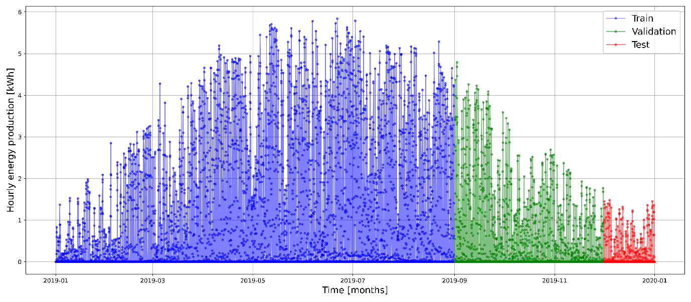The Mean Squared Error (MSE) is the most widely adopted evaluation metric (al K. X., 2019). The value incorporates both the variance and the bias. The lower the value the

Figure 2: The solar energy production over the course of a whole year (2019) from one of the NZEBs split up in 3 parts; blue: training data (8 months), green: validation data (3 months), red: testing data (1 month).

better the model is. Formula 2b shows how the value is calculated.

|  |  |
| --- | --- |
|  | [2b] |

The mean absolute percentage error (MAPE) is the mean absolute error represented as a percentage. It can be interpreted very intuitively due to the percentage. When the predictions, , has small numbers this metric can be rather large. If the outcome is higher than 100% it can be decided to not use it. The lower the percentage the better. Formula 2c shows the calculation.

|  |  |
| --- | --- |
|  | [2c] |

The R2 (pronounce R-squared) error represents the amount of relation between the variance of the actual value and the predicted value. Usually the value that comes out of the equation is between 0 and 1. A score of 1 is the best score possible, due to the lowest amount of variance between the actual value and the predicted value. Formula 2d shows the calculation for the metric.

|  |  |
| --- | --- |
|  | [2d] |

Where is the average value of all the predicted values .

## Forecasting methods

Predicting energy consumption of a NZEB requires a completely different approach as to predicting energy production. Energy production is more periodic compared to the more jittery data of energy consumption. The initial approach was to create 2 models, 1 for energy production and 1 for energy consumption. First the energy production will be discussed.

It is common for machine learning models to require scaling of the data. When data is scaled it will approach normally distributed data (scikitlearn, 2021). This was done on the input data for every model used during this research.

A neural network requires a loss-function to optimize for, the LSTM and MLP used the Huber loss as their loss function (PyTorch, 2021).







### Energy Production

When it comes to the prediction of the hourly amount of solar energy produced of the next day by the NZEB, each of the models described earlier were implemented separately. Generally machine learning models, such as SVR, MVLR and MLP, cannot look back into their timeseries dataset like the LSTM can by remembering it. Therefore these need a different way to look back into their data for comparable results. Therefore 2 datasets were created, one for each model type, displayed in Table 2. The main difference being that the one for SVR, MVLR and MLP contains the energy production of 24 hours ago till 168 hours ago.

Table 2: The various features used and splitting method applied, for both the energy production datasets of the SVR, MVLR, MLP models and the LSTM.

|  |  |  |
| --- | --- | --- |
| Datasets | | |
|  | **SVR, MVLR and MLP:** | **LSTM:** |
| Features | * History Energy production   24 hours till 168 hours in the past   * The mean energy production of the previous day and the previous week * Hour of the prediction, one-hot encoded * Global irradiance of 24 hours in the past | * History Energy production   24 hours till 168 hours in the past   * Hour of the prediction * Global irradiance of 24 hours in the past |
| Splitting method | Train: 2019-01 : 2019-08  Validate: 2019-09 : 2019-11  Test: 2019-12 | |

Representing a comparable way in which the window of the LSTM looks over the data.

What distinguishes energy production greatly from energy consumption is that energy production at first glance looks significantly more periodic (Figure 2) than energy consumption.

### Energy Consumption

Compared to energy production, predicting the energy consumption of the NZEB requires a more thoughtful design. The same models as Energy production were used; MLP, SVR, MVLR and LSTM.

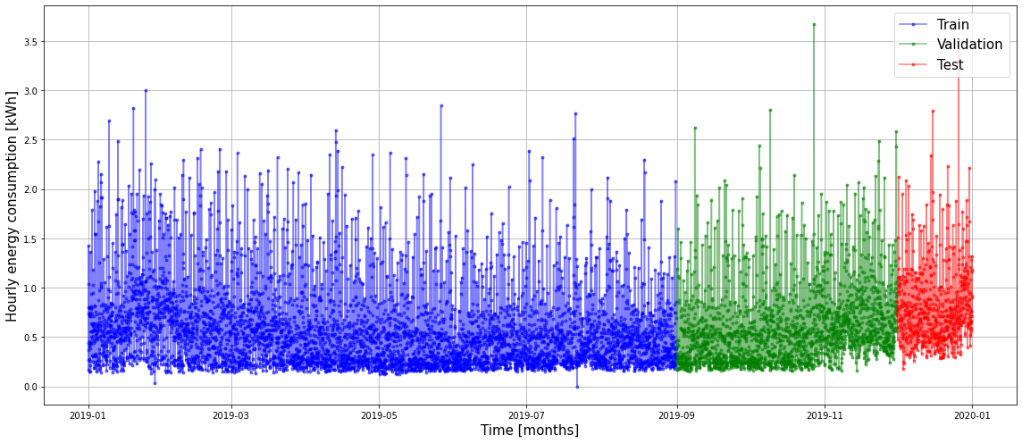The dataset being used is almost the same as production, except for a few slight changes. In Table 2 the dataset is shown. The consumption data is less periodic than the production data, see Figure 3.

Figure 3: The energy consumption over the course of a whole year (2019) from one of the NZEBs split up in 3 parts; blue: training data (8 months), green: validation data (3 months), red: testing data (1 month).

|  |  |  |
| --- | --- | --- |
| Datasets | | |
|  | **SVR, MVLR and MLP:** | **LSTM:** |
| Features | * History Energy consumption   24 hours till 168 hours in the past   * The mean energy production of the previous day and the previous week * Hour and weekday of the prediction, one-hot encoded | * History Energy consumption   24 hours till 168 hours in the past   * Hour of the prediction * Hour and weekday of the prediction |
| Splitting method | Train: 2019-01 : 2019-08  Validate: 2019-09 : 2019-11  Test: 2019-12 | |

Table 3 The various features used and splitting method applied, for both the energy consumption datasets of the SVR, MVLR, MLP models and the LSTM.

# Results

The results were determined by running the 4 models on the 12 chosen houses. After each model was run on these houses the average of the metrics MAE, MSE, MAPE and R2 was calculated and displayed in the corresponding table.

## Consumption

The results in Table 5 show that the LSTM overall outperforms the other models at predicting consumption when looking at the MAPE value only. However the MVLR seems to be outperforming the other models looking at the MAE and MSE scores. The R2 score is for all models negative, which indicates that it is currently not a good metric with which to compare the performance of the models.

|  |  |  |  |  |
| --- | --- | --- | --- | --- |
| Model | MAE [kWh] | MSE [kWh2] | MAPE [%] | R2 [-] |
| LSTM | 0.44 | 0.43 | 69.54 | -3.19 |
| MLP | 0.57 | 0.65 | 99.78 | -1.77 |
| MVLR | 0.41 | 0.34 | 93.29 | -4.09 |
| SVR | 0.65 | 0.90 | 398.45 | -5.08 |

Table 4: The MAE, MSE, MAPE and R2 value for each of the models on energy consumption, 2 decimals significant.

In Figure 5 the four models for consumption are shown in combination with the ground truth. The LSTM is closest to predicting the timing and height of the peaks, as well as the mean of the

data. The MLP seems to perform the worst out of these models, when it was the second worst according to Table 5.

## Production

The results in

Table 5 show that the SVR is performing the best overall at predicting the production. The MLP performs the worst overall.

|  |  |  |  |  |
| --- | --- | --- | --- | --- |
| Model | MAE [kWh] | MSE [(kWh)2] | MAPE [%]  () | R2  [-] |
| LSTM | 0.17 | 0.07 | 1.11 | 0.15 |
| NN | 0.50 | 0.37 | 21.15 | -1.78 |
| MVLR | 0.19 | 0.08 | 59.34 | 0.53 |
| SVR | 0.14 | 0.05 | 42.12 | 0.50 |

Table 5: The MAE, MSE, MAPE and R2 value for each of the models on energy production, 2 decimals significant

In Figure 4 the four models for production are shown in combination with the ground truth. The SVR shows the lowest percentage of negative production predictions which results in the SVR having better predictions at night than the other models. The LSTM seems to perform better at predicting the shape of the production during the day, however the LSTM predicts negative production during the night.

The MLP seems to perform the worst out of these models, which corresponds to the results of Table 5.

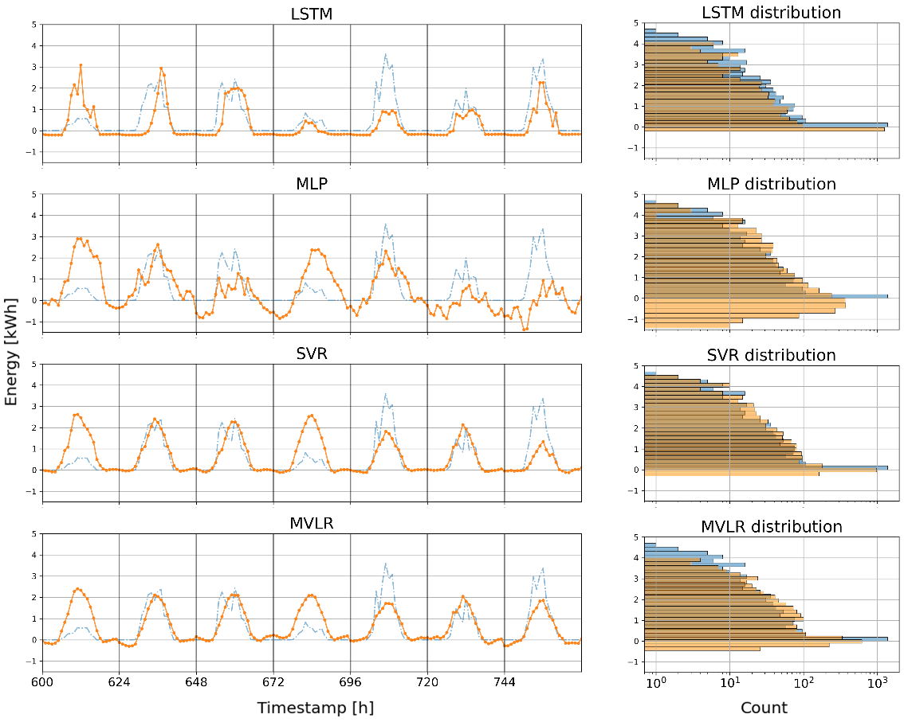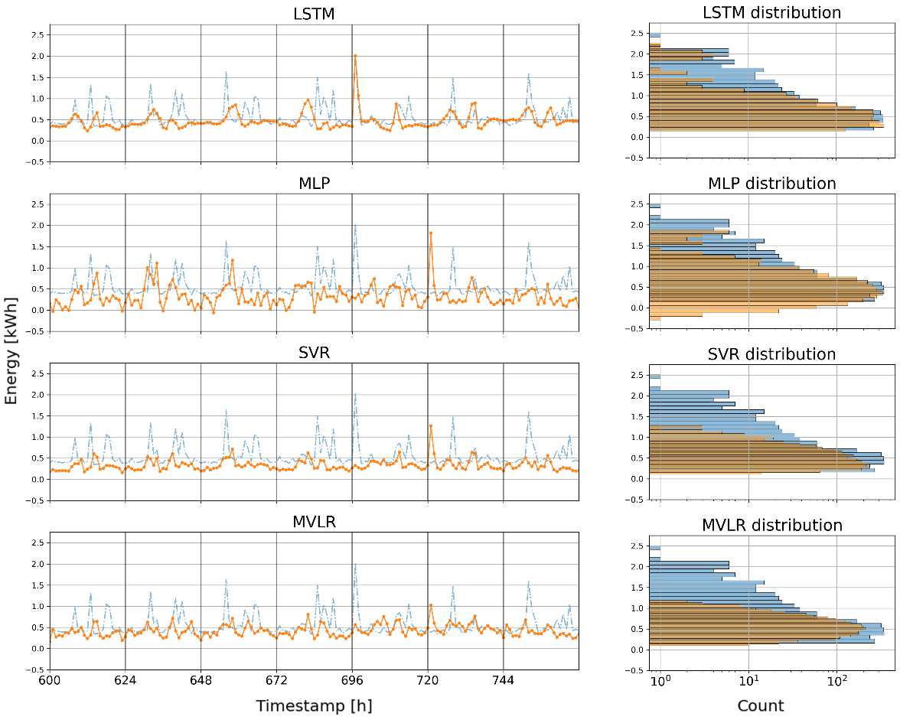

Figure 4: The output of each model fitted for energy production together with the ground truth, with next to it the corresponding distribution histogram. Blue indicates the ground truth, orange the output of the model.

Figure 5: The output of each model fitted for energy consumption together with the ground truth, with next to it the corresponding distribution histogram. Blue indicates the ground truth, orange the output of the model.

# Conclusion

All of the models were evaluated for the production of the houses. The SVR has the lowest MAE value, 0.14 kWh. However the difference between the other models on the MAE is small, around 0.05 kWh, except for the NN (MLP) with an value of 0.50 kWh. The LSTM is a close second best, with a score of 0.17 kWh. After MAE the next metric is the MSE, which is the lowest for the SVR, 0.05 kWh2. The LSTM here is a close second best. Due to the high values of the MAPE values, around trillions of percentages, will not be taken into account. The R2 value is the highest for the MVLR, 0.53 kWh, with the SVR as a close second with an value of 0.50 kWh.

The production models output distributions show that the MVLR does not predict values above 4.0 kWh very well. While the SVR does better than the MVLR it also does predict negative values which is not preferable. The NN (MLP) shows that does find an right distribution, however the evaluation metrics are worse than all other models. The LSTM does find the distribution of the data, however it does not find high values. It can be concluded that due to the non-existence of negative values in the distribution that the model differentiate between different data points unlike the rest of the models.

For predicting the consumption (energy use) the MAE is the lowest for the MVLR with an value of 0.41 kWh. Whereas the LSTM is a close second best with an value of 0.44 kWh. Also on the MSE metric the MVLR performed the best with a value of 0.34 kWh2. The LSTM performed worse with a value of 0.43 kWh2. However the MAPE is the lowest for the LSTM with an value of 69.54 %, whereas the MVLR performed worse with an value of 93.29 %. The R2 values are negative for all models which means that the variance between the models and the expected outcome has no relation. Therefore it will not be considered.

The consumption models output distributions show that the SVR and MVLR don’t perform well on values bigger than 1.2 kWh. However the distribution of the NN (MLP) and LSTM show that values bigger than 1.2 kWh can be predicted. The NN (MLP) predicts values around 1.7 kWh best, while the LSTM predicts values around 2.0 kWh best.

Literature shows that it the difficulty in predicting the production and consumption lies in finding the right model (Liu, et al., 2019). The results show that there is not 1 definitive model, which is analogous to the findings in the literature. The literature also shows that the LSTM holds the most promising results (al A. H., 2020), which also is what the findings indicate.

To conclude, for predicting production the SVR, MVLR, NN (MLP) were implemented. The SVR has the lowest MAE and MSE values. However looking at the distributions in the data it can be concluded that the SVR fits the distribution of the data well. However the model does not differentiate much between different datapoints.  
And to conclude predicting consumption, the MVLR has the lowest MSE and MAE values. However the LSTM has the lowest MAPE value, which means the lowest percental difference between the values. Therefore it can be concluded that the MVLR has the best global performance, while the LSTM has better hourly predictions than the MVLR. This is also supported by the distributions of prediction and actual values.

To sum up, the evaluation metrics show that the SVR is most suitable for predicting the production. While MVLR is most suitable for predicting consumption. However both models contain negative values, which suggests that these models do not differentiate between datapoints. While the LSTM does differentiates best between datapoints. The literature shows and the current findings indicate that the LSTM is the most promising. However more research is needed to make a sound conclusion.

# Discussion

All models will most probably benefit if the peaks in the data can be detected and predicted, or so the models output distributions show. Due to the stochastic nature of the problem it is difficult to make an sufficient prediction, therefore more research is needed to make a better model.

There is improvement possible with the LSTM, by for example adding a second layer (al A. H., 2020).

# Recommendations

While looking through the data we encountered large spikes in energy usage in somewhat consistent intervals. After looking in to these spikes we concluded that the booster was causing these spikes (figure 7). These spikes are indicated in purple. This was to kill of potential Legionella bacteria. The interval between these spike was inconsistent enough that we noted an improvement in the prediction models after we removed the peaks. This is why we suggest to set the booster on a consistent interval. This might help the models to identify the peaks in energy that the booster causes and thus could improve the model.

Figure 6: Hourly basis and its MAE

After some testing it also appeared that the interval in which the model predicts also effects the accuracy of the model (figure 6). It might be worth looking more deeply in this interval to achieve better results than the 1 hour interval that was used in this paper.

One of the problems that occurred while creating the models was inconsistent peaks and predicting these peaks. It may be worth it to see if models benefit from a separate model that predicts peaks or other means to detect these.

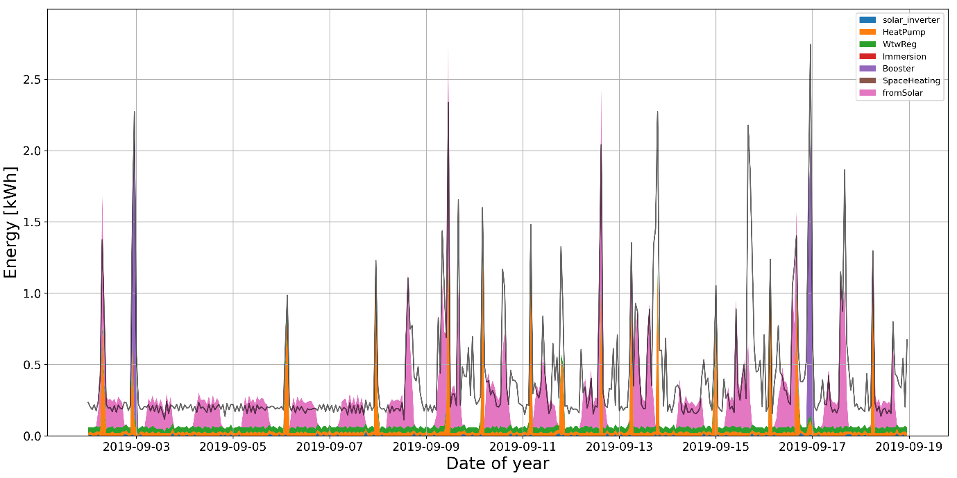

Figure 7: Energy use of house #37 categorised by appliances that use energy over a period of 3 weeks

# References

al, A. H. (2020). Short-term energy use prediction of solar-assisted water heating system: Application case of combined attention-based LSTM and time-series. *Solar Energy 207*, 626-639.

al, K. X. (2019). Short-term Time Series Data Prediction of Power Consumption Based. *IOP Conference Series: Materials Science and Engineering*, 646.

Azhar Mat Daut, M., Yusri Hassan, M., Abdullah, H., Yusri Hassan, M., Abdul Rahman, H., Pauzi Abdullah, M., & Hussin, F. (n.d.). Buildingelectrical energy consumption forecasting analysis using conventional andartificial intelligence methods: A review. *Elsevier*. Retrieved from ScienceDirect.

Fan, C., Xiao, F., & Wang, S. (n.d.). Development of prediction models for next-day building energy consumption and peak power demand using data mining techniques. *Elsevier*. Retrieved from ScienceDirect.

Jana, R., Ghosh, I., & Sanyal, M. (n.d.). A granular deep learning approach for predicting energy consumption. *Elsevier*. Retrieved from ScienceDirect.

Khan, P. W., Byun, Y.-C., Lee, S.-J., Kang, D.-H., Kang, J.-Y., & Park, H.-S. (2020). Machine Learning-Based Approach to Predict Energy Consumption of Renewable and Nonrenewable Power Sources. *Energies*. Retrieved from MDPI.

Khovalyg, D., & Heidari, A. (2020). Short-term energy use prediction of solar-assisted water heating system: Application case of combined attention-based LSTM and time-series decomposition. *Elsevier*. Retrieved from ScienceDirect.

Kim, T.-Y., & Cho, S.-B. (2019). Predicting residential energy consumption using CNN-LSTM neural networks. *Elsevier*. Retrieved from ScienceDirect.

Koninklijk Nederlands Meteologisch Instituut. (2019). Daggegevens van het weer in Nederland - download. Voorschoten, Zuid-Holland, Netherlands.

Liu, Z., Wu, D., Han, Y., Lun, L., Gao, J., Jin, G., & Cao, G. (2019). Accuracy analyses and model comparison of machine learning adopted in building energy consumption prediction. Energy Exploration & Exploitation. *Elsevier*. Retrieved from ScienceDirect.

*over ons*. (n.d.). Retrieved from factoryzero: https://factoryzero.nl/over-ons/

PyTorch. (2021). *SmoothL1Loss -- PyTorch 1.7.0 documentation*. Retrieved from pytorch.org: https://pytorch.org/docs/stable/generated/torch.nn.SmoothL1Loss.html

Rijksoverheid. (n.d.). *Energieagenda: naar een CO₂-arme energievoorziening.* Retrieved from rijksoverheid.nl: https://www.rijksoverheid.nl/documenten/rapporten/2016/12/07/ea

scikitlearn. (2021). *sklearn.preprocessing.StandardScaler -- scikit-learn 0.24.0 documentation*. Retrieved from scikit-learn.org: https://scikit-learn.org/stable/modules/generated/sklearn.preprocessing.StandardScaler.html

United Nations Climate Change. (n.d.). *The Paris Agreement.* Retrieved from UNFCCC: https://unfccc.int/process-and-meetings/the-paris-agreement/the-paris-agreement

1. A method to calculate all the gradients in a Neural Network starting from the output. Whereafter the model can be optimized.