Pathway数据库中Pathway、sub-pathway、gene、protein、compound、reaction分层分析
Reactome is cross-referenced to the NCBI Entrez Gene, Ensembl and UniProt databases, the UCSC and HapMap Genome Browsers, the KEGG Compound and ChEBI small molecule databases, PubMed, and GO.
The core unit of the Reactome data model is the reaction.
Entities (nucleic acids, proteins, complexes and small molecules) participating in reactions form a network of biological interactions and are grouped into pathways.
Examples of biological pathways in Reactome include signaling, innate and acquired immune function, transcriptional regulation, translation, apoptosis and classical intermediary metabolism.
细胞信号通路（cell signaling pathway）是细胞内参与同一生物过程的生物分子之间的相互作用或功能关系，pathway属于生物分子网络的初级形式之一，是构成复杂网络的基础，在细胞增殖、分化、代谢、调控等生命过程中起着非常重要的调控作用，因而与多种生物学功能和疾病有关，是系统生物学研究的基础。
细胞内存在诸多的pathway，绝大多数pathway之间都会通过pathway分支相互连接，从而形成复杂的pathway网络。相互连接的pathway中，一条pathway中的蛋白节点可以通过蛋白相互作用（或化学修饰）去影响其他pathway中的信号传递，这种现象称之为pathway crosstalk1.
本研究流程通过整合癌症相关的pathway之间的蛋白相互作用关系和基因芯片表达谱数据，对pathway之间crosstalk的异常以及pathway自身功能的异常进行了系统分析，为我们理解各类癌症如非小细胞肺癌、肝癌发生的分子机制提供了系统生物学依据2-4。
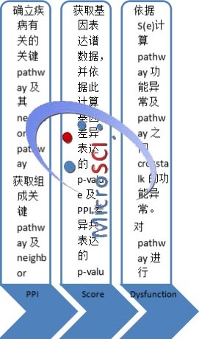
图1. Pathway crosstalk分析流程
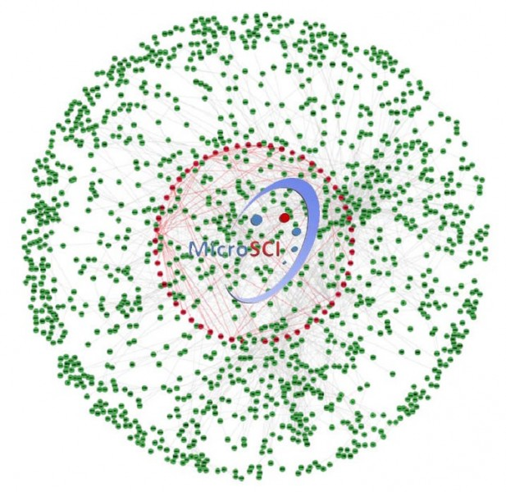
图1. Pathway 相关的PPI网络. 红色节点（边）代表关键pathway的ppi，绿色节点（灰色边）代表neighbor pathway相关的PPI.
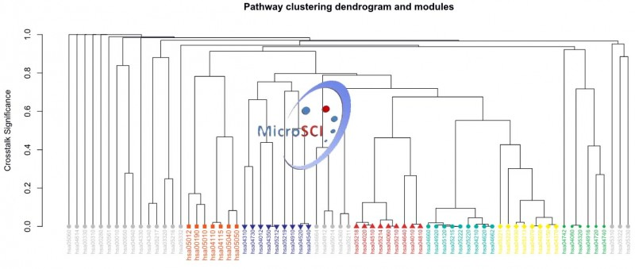
图2. Pathway层次聚类
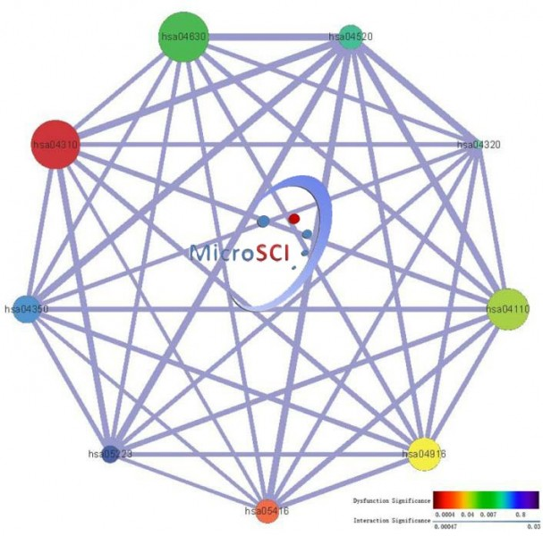
图2. 肺癌发生相关的Pathway Crosstalk，节点大小（size）代表pathway所含基因数目，节点颜色代表pathway功能异常显著性，边的粗细代表pathway之间crosstalk功能异常的显著性。
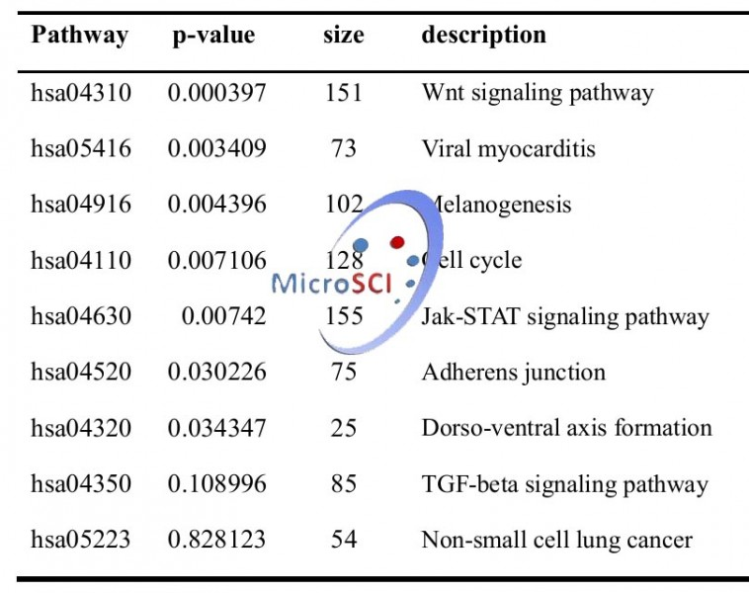
表1. 功能异常癌症相关Pathway列举
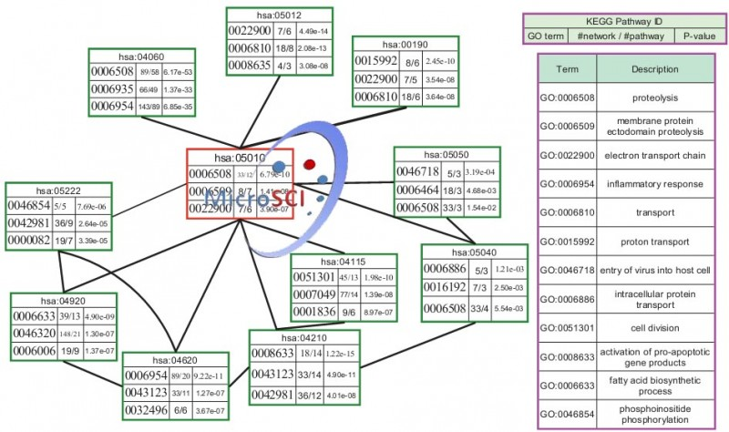
图3. Pathway GO功能富集
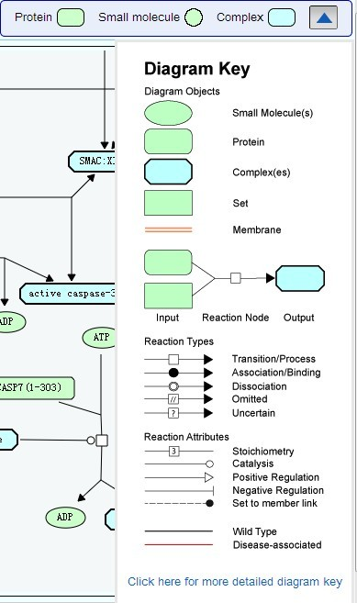
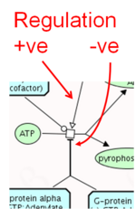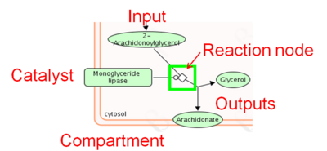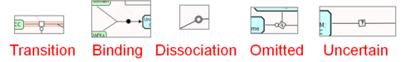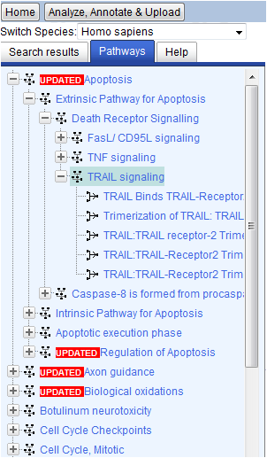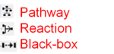

Biological pathways
Cells are constantly receiving cues from both inside and outside the body, which are prompted by such things as injury, infection, stress or even food. To react and adjust to these cues, cells send and receive signals through biological pathways. Some of the most common are involved in metabolism, the regulation of genes and the transmission of signals. While some molecules, like oxygen, can easily travel through the cell membrane, signals go through structures on the cell surface, called receptors. After interacting with a receptor, the signal travels through the cell where its message is transmitted and changed by specialized proteins or other molecules residing in the cell. Signals can be involved in chemical reactions, turning genes on or off, or even changing the shape of a cell.
Pathway Analysis
Cell behavior is regulated by a complex network of intracellular and extracellular signal transduction pathways. A major focus in biomedical research over the past ten or fifteen years has been the identification and characterization of the components that make up such signaling pathways. Researchers have focused on how these pathways are controlled, how they communicate with each other, and, most importantly, what happens when they do not function properly.
Integrate the pathway database
hiPathDB provides two different types of integration. The pathway-level integration is a simple collection of individual pathways as described in the original database. We devised a gene-centric pathway model that could reflect different properties of four databases. The entity-level integration creates a super pathway that merged all pathways by unifying redundant components. Even though the detailed molecular information such as complex formation or modification can be lost in some cases, the merged superpathway provides a unified view of current knowledge on human pathways, which is critical to understand relationships among different pathways. Another strong merit of hiPathDB is the built-in pathway visualization module to support explorative study of complex networks in an interactive fashion. The force-directed layout algorithm is optimized for almost automatic visualization of pathways
下一代测序技术（NGS）和全基因组关联研究（GWAS）产生了数以百万计的读取和数百个数据集，因此迫切需要一个更好的方法来解释和读取大量的数据过程的激活会解释药物作用下的复杂生物通路，对新的和现有的药物治疗的病人的分层研究，并且了解抗癌药物的潜在影响。目前PathGuide数据库大约有547个人类生物通路。

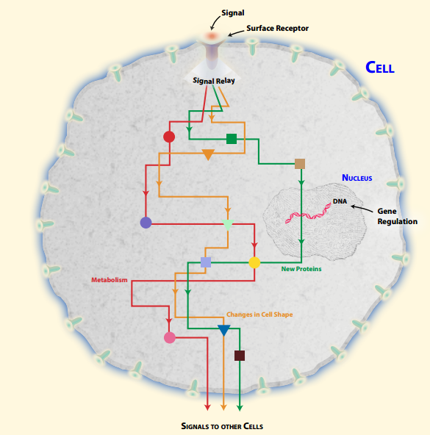

What is a biological pathway?
A biological pathway is a series of actions among molecules in a cell that leads to a certain product or a change in a cell. Such a pathway can trigger the assembly of new molecules, such as a fat or protein. Pathways can also turn genes on and off, or spur a cell to move.
How do biological pathways work?
For your body to develop properly and stay healthy, many things must work together at many different levels - from organs to cells to genes.
Cells are constantly receiving cues from both inside and outside the body, which are prompted by such things as injury, infection, stress or even food. To react and adjust to these cues, cells send and receive signals through biological pathways. The molecules that make up biological pathways interact with signals, as well as with each other, to carry out their designated tasks.
Biological pathways can act over short or long distances. For example, some cells send out signals to nearby cells to repair localized damage, such as a scratch on your knee. Other cells produce substances, such as hormones, that travel through your blood to distant target cells.
Biological pathways can also produce small or large outcomes. For example, some pathways subtly affect how the body processes drugs, while others play a major role in how a fertilized egg develops into a baby.
There are many other examples of how biological pathways help our bodies work. The pupil in your eye opens or closes in response to light. If your skin senses that the temperature is rising, your body sweats to cool you down. In fact, without biological pathways, we-and all other living creatures-could not exist.
Still, it's important to keep in mind that biological pathways do not always work properly. When something goes wrong in a pathway, the result can be a disease such as cancer or diabetes.

What are some types of biological pathways?
There are many types of biological pathways. Some of the most common are involved in metabolism, the regulation of genes and the transmission of signals.
Metabolic pathways make possible the chemical reactions that occur in our bodies. An example of a metabolic pathway is the process by which your cells break down food into energy molecules that can be stored for later use. Other metabolic pathways actually help to build molecules.
Gene regulation pathways turn genes on and off. Such action is vital because genes produce proteins, which are the key components needed to carry out nearly every task in our bodies. Proteins make up our muscles and organs, help our bodies move and defend us against germs.
Signal transduction pathways move a signal from a cell's exterior to its interior. Different cells are able to receive specific signals through structures on their surface, called receptors. After interacting with a receptor, the signal travels through the cell where its message is transmitted by specialized proteins that trigger a specific action in the cell. For example, a chemical signal from outside the cell might be turned into a protein signal inside the cell. In turn, that protein signal may be converted into a signal that prompts the cell to move.
What is a biological network?
Researchers are learning that biological pathways are far more complicated than once thought. Most pathways do not start at point A and end at point B. In fact, many pathways have no real boundaries, and they often work together to accomplish tasks. When multiple biological pathways interact with each other, it is called a biological network.
How do researchers find biological pathways?
Researchers have discovered many important biological pathways through laboratory studies of cultured cells, bacteria, fruit flies, mice and other organisms. Many of the pathways identified in these model systems are the same or have similar counterparts in humans.
Still, many biological pathways remain to be found. It will take years of research to identify and understand the complex connections among all of the molecules in all biological pathways, as well as to understand how these pathways work together.
What can biological pathways tell us about disease?
Researchers are able to learn a lot about human disease from studying biological pathways. Identifying what genes, proteins and other molecules are involved in a biological pathway can provide clues about what goes wrong when a disease strikes.
For example, researchers may compare certain biological pathways in a healthy person to the same pathways in a person with a disease to discover the roots of the disorder. Keep in mind that problems in any number of steps along a biological pathway can often lead to the same disease.
How can biological pathway information improve health?
Finding out what pathway is involved in a disease-and identifying which step of the pathway is affected in each patient-may lead to more personalized strategies for diagnosing, treating and preventing disease.
Researchers currently are using information about biological pathways to develop new and better drugs. It likely will take some time before we routinely see drugs that are specifically designed using the pathway approach. However, doctors are already beginning to use pathway information to more effectively choose and combine existing drugs.
Why are cancer researchers excited about biological pathways?
Take the case of cancer. Until recently, many had hoped that most types of cancers were driven by a single genetic error and could be treated by designing drugs to target those specific errors. Much of that hope was based on the success of imatinib (Gleevec), a drug that was specifically designed to treat a blood cancer called chronic myeloid leukemia (CML). CML occurs because of a single genetic glitch that leads to the production of a defective protein that spurs uncontrolled cell growth. Gleevec binds to that protein, stopping its activity and producing dramatic results in many CML patients.
Unfortunately, the one-target, one-drug approach has not held up for most other types of cancer. Recent projects that deciphered the genomes of cancer cells have found an array of different genetic mutations that can lead to the same cancer in different patients. Then, based on the genetic profile of their particular tumor, patients could receive the drug or drug combination that is most likely to work for them.
The complexity of the findings appears daunting. Instead of attempting to discover ways to attack one well-defined genetic enemy, researchers now faced the prospect of fighting lots of little enemies. Fortunately, this complex view can be simplified by looking at which biological pathways are disrupted by the genetic mutations. Rather than designing dozens of drugs to target dozens of mutations, drug developers could focus their attentions on just two or three biological pathways. Patients could then receive the one or two drugs most likely to work for them based on the pathways affected in their particular tumors.
You might think of it like this: Imagine a thousand people from all across the United States travelling towards the front door of a single building in Chicago. How would you keep all of these people from entering the building?
If you had limitless resources, you could hire workers to go out and stop each person as he or she drove down the highway, arrived at the train station or waited at the airport. That would be the one-target, one-drug approach.
But if you wanted to save a lot of time and money, you could just block the door to the building. That is the pathway-based strategy that many researchers are now pursuing to design drugs for cancer and other common diseases.

