


Cairo University
Faculty of Computing and Artificial Intelligence
Department of Computer Science

Game Forge
AI-Powered Natural Language to Playable Game Generation Platform

Graduation Project — Final Documentation
Academic Year: 2025 / 2026

Supervisors:
Dr. Samar Hesham
TA. Nada Nasser

Team Members:

1. Ahmed Saber Ahmed ID: 20220021
2. Omar Mohamed AbdElmelek ID: 20220232
3. Amr Mohamed Sheraey ID: 20220450
4. Omar Mahfouz Mohamed ID: 20220229

Abstract

English
Game development is a multidisciplinary and resource-intensive process that requires the integration of programming, game engine expertise, visual and audio asset creation, game design, and continuous iteration. This complexity poses a significant challenge for solo developers, students, and small teams, often preventing promising game ideas from progressing beyond early prototypes. Although recent advances in large language models and generative technologies have enabled partial automation of game design, code generation, and asset creation, existing solutions typically address these components in isolation and lack a unified, end-to-end workflow.
Game Forge is an end-to-end AI-powered platform that transforms a natural-language description into a fully playable browser game in a single automated pipeline. Users describe their desired game in plain text; the system classifies the prompt into one of three supported archetypes (platformer, top-down, or endless-runner), generates a structured game plan using a large language model, produces sprite and audio assets through the Stability AI and Stable Audio APIs, writes syntactically valid GDScript code for the Godot 4 engine, compiles an HTML5 export via the Godot headless CLI, and streams the playable result back through the browser. The platform is built as ten cooperating Docker microservices including a React frontend, a Node.js/Express REST backend, a stateless orchestration server, four specialized worker services, an MCP-based asset generation server, MongoDB for persistence, and MinIO for object storage. Key technical contributions include a template-guided code generation pipeline with Godot syntax validation, an LLM-driven MCP agent for asset orchestration, and a real-time build progress system. The platform successfully generates playable games across all three supported genres from a single user prompt.
The proposed system aims to lower the barrier to entry for game development by providing an integrated, automated pipeline that converts high-level ideas into functional game prototypes.

Arabic
تُعدّ تطوير الألعاب عملية متعددة التخصصات وتستلزم موارد ضخمة، إذ تتطلب التكامل بين البرمجة، والإلمام بمحركات الألعاب، وإنشاء الأصول المرئية والصوتية، وتصميم اللعبة، والتكرار المستمر. ويُشكّل هذا التعقيد تحدياً جسيماً أمام المطورين المنفردين والطلاب والفرق الصغيرة، إذ كثيراً ما يحول دون تقدم أفكار الألعاب الواعدة إلى ما هو أبعد من النماذج الأولية المبكرة. وعلى الرغم من أن التقدم الأخير في نماذج اللغة الكبيرة والتقنيات التوليدية قد أتاح أتمتةً جزئية لتصميم الألعاب وتوليد الكود وإنشاء الأصول، إلا أن الحلول القائمة تعالج هذه المكونات في الغالب بصورة منفصلة، وتفتقر إلى سير عمل موحد ومتكامل من البداية إلى النهاية.

جيم فورج هي منصة متكاملة مدعومة بالذكاء الاصطناعي تُحوّل وصفاً بالغة الطبيعية إلى لعبة متصفح قابلة للعب بالكامل عبر خط أنابيب آلي متسلسل. يصف المستخدمون لعبتهم المطلوبة بلغة بسيطة، فيقوم النظام بتصنيف النص ضمن أحد الأنماط الثلاثة المدعومة (منصة جانبية، أو منظور علوي، أو ماشٍ لا نهائي)، ثم يولّد خطة لعبة منظمة باستخدام نموذج لغوي كبير، وينتج أصول الرسوم المتحركة والصوت عبر واجهتَي Stability AI وStable Audio، ثم يكتب شفرة GDScript صحيحة نحوياً لمحرك Godot 4، ويصدّر اللعبة بصيغة HTML5 عبر واجهة Godot بدون واجهة رسومية، ويبث النتيجة القابلة للعب مباشرةً في المتصفح. تتكون المنصة من عشره خدمات مصغرة في حاويات Docker تشمل واجهة React الأمامية، وخادم REST بـ Node.js/Express، وخادم تنسيق عديم الحالة، وأربع خدمات عمال ذكاء اصطناعي متخصصة، وخادم توليد أصول مبني على بروتوكول MCP، وقاعدة بيانات MongoDB للاستمرارية، وتخزين كائنات MinIO. تشمل المساهمات التقنية الرئيسية خط أنابيب توليد كود موجَّه بالقوالب مع التحقق من صحة بنية Godot، ووكيل MCP مدفوع بنموذج لغوي لتنسيق الأصول، ونظام تتبع تقدم البناء في الوقت الفعلي. وتنجح المنصة في توليد ألعاب قابلة للعب عبر الأنماط الثلاثة المدعومة كلها انطلاقاً من نص واحد مُدخَل من المستخدم.

يهدف النظام المقترح إلى تخفيض حاجز الدخول إلى مجال تطوير الألعاب من خلال توفير خط أنابيب آلي متكامل يُحوّل الأفكار على مستوى عالٍ إلى نماذج أولية وظيفية للألعاب.

Table of Contents
Chapter 1: Introduction 1
1.1 Background and Motivation 1
1.2 Problem Definition 1
1.3 Project Objectives and Proposed Solution 2
1.4 Project Scope and Limitations 3
1.5 Development Methodology 3
1.6 Tools and Technologies Used 4
1.7 Project Timeline / Gantt Chart 5
1.8 Report Organization 6
Chapter 2: Related Work 7
2.1 Prompt-to-Game Platforms 7
2.1.1 Rosebud AI 7
2.1.2 Playabl.ai 7
2.1.3 Astrocade 7
2.1.4 StoneLeap 8
2.2 AI Asset and Design Tools 8
2.2.1 Ludo.ai 8
2.2.2 GDevelop AI 9
2.3 General-Purpose Code Generation 9
2.3.1 LLM Code Assistants (GitHub Copilot and Similar) 9
2.3.2 Procedural Content Generation Systems 9
2.4 Comparative Analysis 10
Chapter 3: System Analysis 11
3.1 Stakeholder Analysis 11
3.2 Functional Requirements 11
3.2.1 User Authentication and Account Management 11
3.2.2 User Profile and Project Management 11
3.2.3 Prompt Submission and Validation 12
3.2.4 Game Planning 12
3.2.5 Asset Generation and Management 12
3.2.6 Code and Scene Generation 12
3.2.7 Build and Execution 12
3.2.8 Game Access and Distribution 13
3.2.9 Status Reporting and Error Handling 13
3.3 Non-Functional Requirements 13
3.3.1 Security 13
3.3.2 Performance 14
3.3.3 Scalability 14
3.3.4 Reliability 15
3.3.5 Availability 15
3.3.6 Maintainability 15
3.3.7 Usability 16
3.3.8 Portability 16
3.4 Use Case Diagrams 17
3.5 Feasibility Study 20
3.5.1 Technical Feasibility 20
3.5.2 Economic Feasibility 20
3.5.3 Operational Feasibility 21
Chapter 4: System Design 22
4.1 System Architecture 22
4.2 Class Diagrams 24
4.3 Sequence Diagrams 28
4.4 Entity-Relationship Diagram 36
4.5 UI Wireframes / Mockups 37
4.6 Security Design Considerations 42
4.6.1 Authentication and Authorization 42
4.6.2 Inter-Service Authentication 42
4.6.3 Input Sanitization 42
4.6.4 Password Security 42
4.6.5 Rate Limiting 43
4.6.6 Cross-Origin Resource Sharing 43
4.6.7 Environment Variable Security 43
Chapter 5: Implementation 44
5.1 Implementation Environment and Setup 44
5.2 Key Implementation Details 45
5.2.1 Game Plan Generation (Planner Service) 45
5.2.2 Asset Generation via MCP (Asset Service) 45
5.2.3 Template-Guided Code Generation (Code Service) 46
5.2.4 Builder Service and Godot Export 47
5.2.5 Real-Time Progress Tracking 48
5.3 Sample Screenshots / Output Samples 49
Chapter 6: Testing and Evaluation 56
6.1 Testing Strategy 56
6.1.1 Testing Scope by Service 57
6.1.2 Toolchain Decisions 57
6.1.3 Mocking and Isolation Strategy 58
6.2 Testing Cases and Results 59
6.2.1 Representative Test Cases per Layer 60
6.2.2 Code Coverage 62
6.3 Performance Evaluation / Benchmarking 63
6.3.1 Planner Service — Latency and Plan Quality 63
6.3.1.1 Latency Results 63
6.3.1.2 Quality Evaluation 64
6.3.2 Code Assembly Service — Throughput vs. Plan Complexity 65
6.3.2.1 Latency Results 65
6.3.3 Asset Generation Service — Stability AI Throughput 67
6.3.4 End-to-End Pipeline — Stage Breakdown 68
6.3.5 Real-World Production Telemetry 70
6.3.5.1 Deployment Overview 70
6.3.5.2 Generation Pipeline Performance 71
6.3.5.3 Build & Deliverable Metrics 74
6.3.5.4 Content Generation Metrics 75
6.3.5.5 Database & Object-Storage Footprint 76
6.3.5.6 Container Resource Utilization 78
6.3.5.7 Reconciliation with Estimated Benchmarks and Key Findings 79
6.4 Limitations and Known Issues 80
6.4.1 Game Scope and Design Generation 80
6.4.1.1 Only Three Game Archetypes 80
6.4.1.2 Fixed Behavior and Weapon Catalog 80
6.4.1.3 Generic Fallback Plan 81
6.4.2 Visual and Audio Asset Generation 81
6.4.2.1 Asset Generation Is the Pipeline Bottleneck 81
6.4.2.2 Dependence on External Image Credits 81
6.4.2.3 No Frame-by-Frame Sprite Animation 81
6.4.2.4 Art Style Is Not Always Exact 82
6.4.2.5 No Asset Caching 82
6.4.3 Code Assembly 82
6.4.3.1 Template-Bounded Generation 82
6.4.3.2 The Repair Loop Degrades Rather Than Repairs 82
6.4.3.3 Bounded Level Variety 82
6.4.4 Build and Export 83
6.4.4.1 Environment-Sensitive Godot Export 83
6.4.5 Orchestration, Scale, and Reliability 83
6.4.5.1 No Partial Recovery or Cancellation 83
6.4.5.2 Polling-Based Progress and Best-Effort Status 83
6.4.6 Authentication and Security 83
6.4.6.1 Shared Inter-Service Secret 83
6.4.6.2 Publicly Addressable Game Files 84
Chapter 7: Conclusion and Future Work 84
7.1 Summary of Achievements 84
7.2 Lessons Learned 86
7.3 Future Work 88
References 91

List of Figures
Figure 1.1 — Project Timeline / Gantt Chart………………………………………….... 5
Figure 3.1 — Use Case Diagram 19
Figure 4.1 — System Architecture / Component Diagram 23
Figure 4.2 — Class Diagram: Core MongoDB Models 24
Figure 4.3 — Class Diagram: Code Pipeline Classes 25
Figure 4.4 — Class Diagram: Asset MCP Server Classes 26
Figure 4.5 — Class Diagram: Backend Service Classes 27
Figure 4.6 — Sequence Diagram: User Registration and Login 28
Figure 4.7 — Sequence Diagram: Create Project and Chat Refinement 29
Figure 4.8 — Sequence Diagram: Full Game Generation Pipeline 30
Figure 4.9 — Sequence Diagram: Asset Generation via MCP 31
Figure 4.10 — Sequence Diagram: Code Generation with Validation Loop 32
Figure 4.11 — Sequence Diagram: Builder Service and Godot Export 33
Figure 4.12 — Sequence Diagram: Real-Time Progress Tracking 34
Figure 4.15 — Wireframe: Authentication (Login / Signup) 37
Figure 4.16 — Wireframe: Workspace — New Game Prompt State 38
Figure 4.17 — Wireframe: Workspace — Projects and Chat Panel 39
Figure 4.18 — Wireframe: Build Panel — Success State 40
Figure 4.19 — Wireframe: Play Game View 41
Figure 4.20 — Wireframe: Play Game View (Gameplay) 41
Figure 5.1 — Sample Screenshot / Output 49
Figure 5.2 — Sample Screenshot / Output 49
Figure 5.3 — Sample Screenshot / Output 50
Figure 5.4 — Sample Screenshot / Output 50
Figure 5.5 — Sample Screenshot / Output 51
Figure 5.6 — Sample Screenshot / Output 51
Figure 5.7 — Sample Screenshot / Output 52
Figure 5.8 — Sample Screenshot / Output 52
Figure 5.9 — Sample Screenshot / Output 53
Figure 5.10 — Sample Screenshot / Output 53
Figure 5.11 — Sample Screenshot / Output 54
Figure 5.12 — Sample Screenshot / Output 54
Figure 6.1 — Benchmark Chart: Planner Service Latency 64
Figure 6.3 — Benchmark Chart: Code Assembly Latency 66
Figure 6.4 — Benchmark Chart: Code Assembly Scaling 67
Figure 6.5 — Benchmark Chart: Asset Generation Throughput 68
Figure 6.6 — Benchmark Chart: End-to-End Pipeline Latency 70
Figure 6.7 — Production: Pipeline Outcome Distribution 72
Figure 6.8 — Production: Per-Stage Mean Latency (log scale) 73
Figure 6.9 — Production: End-to-End Latency per Terminal Run 73
Figure 6.10 — Production: Pipeline Failure Causes 74
Figure 6.11 — Production: Deliverable Artifacts by Total Storage 75
Figure 6.12 — Production: AI-Generated Assets by Type 76
Figure 6.14 — Production: MinIO Object Storage by Content Type 78
Figure 6.15 — Production: Container Memory Footprint (idle) 79
List of Tables
Table 1.1 — Tools and Technologies 4
Table 2.1 — Comparative Analysis of Related Systems 11
Table 3.1 — Stakeholder Analysis 11
Table 3.2 — Use Case Descriptions 18
Table 4.1 — Service Catalogue 22
Table 5.1 — Implementation Environment 44
Table 6.1 — Testing Scope by Service 57
Table 6.2 — Mocking and Isolation Strategy 58
Table 6.3 — Test Suite Summary 60
Table 6.4 — Code Coverage by Service 62
Table 6.5 — Planner Service: Latency Measurements 64
Table 6.6 — Planner Service: Plan Quality Scores 65
Table 6.7 — Code Assembly: Latency vs. Complexity 66
Table 6.8 — Asset Generation: Output Breakdown 68
Table 6.9 — End-to-End Pipeline: Stage Breakdown 69
Table 6.10 — Production Deployment: Executive Summary 71
Table 6.11 — Pipeline Outcome Distribution (n = 33) 71
Table 6.12 — Per-Stage Latency, Completed Executions (seconds) 72
Table 6.13 — End-to-End Latency by Outcome (seconds) 73
Table 6.14 — Pipeline Failure Causes (all 7 in the assets stage) 74
Table 6.15 — Deliverable Bundle Composition (13 builds, 78 artifacts) 75
Table 6.16 — AI-Generated Assets by Type / Entity (n = 154) 76
Table 6.18 — MongoDB Collection Statistics 76
Table 6.19 — MinIO Object Storage by Content Type 77
Table 6.20 — MinIO Storage by Area 78
Table 6.21 — Container Resource Utilization (idle steady-state) 79
Table 6.22 — Estimated (Ch. 6.3) vs. Measured (Production) Performance 80

List of Abbreviations

Abbreviation | Expansion
AI | Artificial Intelligence
API | Application Programming Interface
CORS | Cross-Origin Resource Sharing
COEP | Cross-Origin Embedder Policy
COOP | Cross-Origin Opener Policy
CLI | Command-Line Interface
CSS | Cascading Style Sheets
DB | Database
DXA | Document eXtensible Architecture (Word measurement unit)
ERD | Entity-Relationship Diagram
ES | ECMAScript
HTML5 | HyperText Markup Language version 5
HTTP | HyperText Transfer Protocol
iframe | Inline Frame
JSON | JavaScript Object Notation
JWT | JSON Web Token
LLM | Large Language Model
MCP | Model Context Protocol
MinIO | Minimal Input/Output (S3-compatible object storage)
NFR | Non-Functional Requirement
PCG | Procedural Content Generation
REST | Representational State Transfer
S3 | Amazon Simple Storage Service (protocol)
SPA | Single-Page Application
SQL | Structured Query Language
UI | User Interface
URL | Uniform Resource Locator
UUID | Universally Unique Identifier
WASM | WebAssembly
XSS | Cross-Site Scripting
ZIP | Zone Information Protocol (compression format)

Chapter 1: Introduction

1.1 Background and Motivation
The global video game industry generated revenues exceeding $180 billion in 2023, yet the barrier to entry for independent game development remains extremely high. Creating even a simple 2D game requires proficiency in a game engine, programming skills in a domain-specific scripting language, artistic ability to produce visual assets, audio production knowledge, and a substantial time investment. For aspiring developers, students, and creatives who have compelling game ideas but lack this full skill set, the gap between concept and playable prototype is discouraging.
Concurrently with this challenge, large language models (LLMs) have demonstrated remarkable capabilities in understanding natural language intent and generating structured artifacts including source code, JSON data, and creative descriptions. Image generation APIs can now produce stylistically consistent art from text prompts, and audio synthesis models can generate sound effects and music on demand. These capabilities when orchestrated intelligently present an opportunity to dramatically lower the barrier to game creation.
Game Forge was built to validate this opportunity: can a user describe a game in plain English and receive a fully playable browser game in return? The project targets Godot 4 as the game engine because it is free, open-source, actively developed, and supports HTML5 export that runs in any modern browser without installation.

1.2 Problem Definition
Transforming a high-level game idea into a playable prototype remains a manual and resource-intensive process that requires coordination across multiple development stages. Specifically:
1. High barrier to entry: Game development requires knowledge of gameplay logic, engine-specific scripting, asset pipelines, and build configuration. Individual developers, students, and small teams often lack the technical background needed to assemble these components into a functional prototype.
2. Fragmented development workflow: Core elements of a game—such as planning, code implementation, visual assets, audio assets, and execution—are typically developed and managed independently. Coordinating these components manually increases complexity and slows iteration cycles.
3. Lack of orchestration and automation: Existing solutions do not provide a standardized orchestration mechanism that ensures coherent communication between planning, asset generation, code construction, and build execution stages. This fragmentation often results in incomplete or non-functional prototypes that fail to accurately represent the intended game design.

1.3 Project Objectives and Proposed Solution
Game Forge addresses these problems through the following objectives:
- Accept a free-form natural-language game description as the sole user input.
- Automatically classify the game type and generate a machine-readable game plan using an LLM.
- Generate styled game assets (sprites, backgrounds, music, sound effects) through AI image and audio APIs.
- Assemble a complete, ready-to-run Godot 4 GDScript codebase by selecting and composing scripts from a curated library of pre-built, validated game components tailored to the game plan's requirements.
- Compile and export an HTML5 game using the Godot CLI in headless mode.
- Deliver the playable game to the user through the browser with no manual steps required.
The proposed solution is a microservice architecture in which a React frontend communicates with a REST backend that orchestrates a pipeline of specialized AI worker services — including a library-driven GDScript assembly engine and an LLM-powered asset generation agent — all containerized with Docker for reproducible deployment.

1.4 Project Scope and Limitations
The system supports three game archetypes: 2D platformer (side-view, gravity-based movement), top-down (overhead omnidirectional movement), and endless-runner (auto-scrolling with jump-and-duck controls). Within each archetype, a curated library of pre-built, validated GDScript components is maintained, covering a set of behaviors (patrol, chase, ranged_attacker, wander, jumping_enemy, flying_chase, stationary_hazard, moving_platform, etc.) and weapon types (melee, ranged). The appropriate scripts are selected and assembled automatically based on the game plan's requirements.
Current limitations include:
- The system does not support 3D games, physics simulations, or network multiplayer.
- Game archetypes are constrained to the three supported families; genres such as strategy, puzzle, or simulation are not currently supported.
- The GDScript library covers a fixed set of behaviors; game plans requiring mechanics outside the library's scope will have those behaviors omitted or substituted with the closest available alternative.
- AI-generated assets may exhibit inconsistency across entities if the Stability AI model produces stylistically divergent results.
- Build time ranges from approximately two-and-a-half to five minutes depending on asset count and API response latency.

1.5 Development Methodology
The project was developed using an iterative agile methodology with two-week sprints. Development proceeded in three main phases:
(1) pipeline architecture and orchestration, establishing the microservice topology and inter-service communication;
(2) intelligent generation, implementing the planner, code generation pipeline, and asset MCP server;
(3) integration and hardening, adding the Godot syntax validation loop, error recovery, build polling, and frontend refinements. Services were developed and tested independently using Docker Compose, with integration tested against the full stack after each phase.

1.6 Tools and Technologies Used
Category | Technology | Version / Notes
Frontend | React [16] + Vite [17] | JSX, Tailwind CSS [18], Framer Motion [19]
Backend API | Node.js [20] + Express [21] | v20/v22, ES modules, Mongoose 8 [22]
Database | MongoDB [23] | Mongoose ODM, via mongo:latest Docker image
Object Storage | MinIO [24] | S3-compatible, stores scripts/assets/exports
LLM Provider | Groq API [25] / OpenRouter [26] | z.ai/glm5.2 [27], llama-3.3-70b [28], qwen3-32b [29], gpt-oss-120b [30], deepseek-v4-pro [31]
Image Generation | Stability AI [32] | stable-image-core model
Audio Generation | Stable Audio 2 [33] | stable-audio-2 model
MCP Server | FastMCP [34] (Python) | Python 3.13, Streamable HTTP transport
Game Engine | Godot 4 [35] | v4.3, headless CLI, HTML5 export
Containerization | Docker [36] + Compose [37] + GitHub Container Registry [38] | 10 containers, bridge network
CI/CD | GitHub Actions [39] | Docker image publish workflows
Code Quality | ESLint [40] | Per-service analysis
Auth | JWT [41] + bcryptjs [42] | Bearer tokens, password hashing
Security | Helmet [43], rate-limit [44], xss-clean [45], mongo-sanitize [46] | Express middleware stack
Table 1.1 — Tools and Technologies

1.7 Project Timeline / Gantt Chart
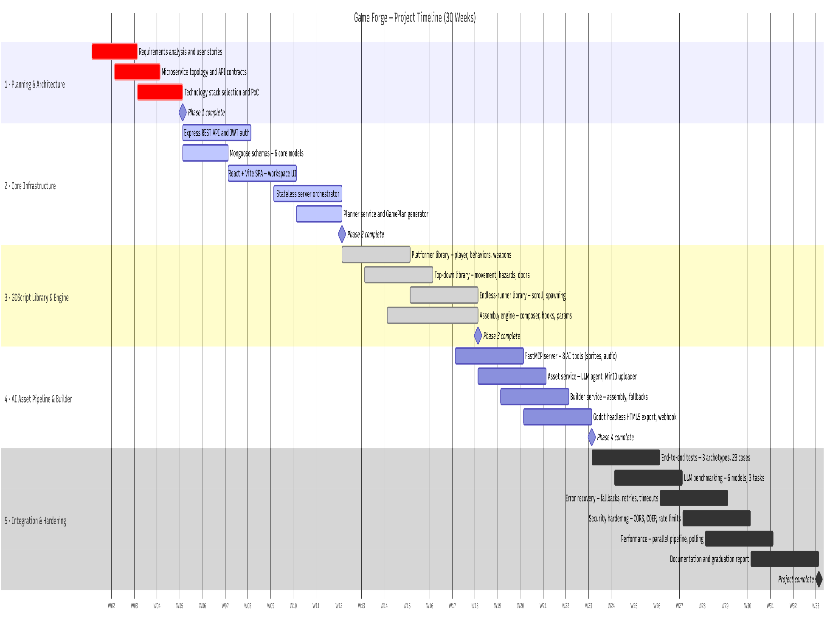
The project was executed over two semesters (approximately 30 weeks). The chart below summarizes the major milestone periods.
Figure 1.1

1.8 Report Organization
The remainder of this document is organized as follows.
Chapter 2 surveys related work in AI-assisted game generation and automated code generation.
Chapter 3 presents the system analysis including stakeholder analysis, functional and non-functional requirements, use case diagrams, and a feasibility study.
Chapter 4 describes the system design through architecture diagrams, class diagrams, sequence diagrams and the entity-relationship model.
Chapter 5 details the implementation environment, key algorithms, and sample outputs.
Chapter 6 covers the testing strategy, test cases, benchmark results, and known limitations.
Chapter 7 concludes with a summary of achievements, lessons learned, and future work directions.

Chapter 2: Related Work
The automated and AI-assisted game creation space has grown rapidly, but existing solutions cluster into distinct categories that each address only part of the idea-to-playable-game problem.

2.1 Prompt-to-Game Platforms
This category contains the systems most directly comparable to Game Forge: platforms that accept a natural-language description and return a playable game.

2.1.1 Rosebud AI
Rosebud AI [1] is a browser-based, no-code platform that generates playable 2D and 3D games from natural-language prompts through a workflow it calls "vibe coding." The user describes a game and refines it via chat; the platform generates the game's code, AI visual assets, and sprite-sheet animations, running the result in its own JavaScript-based web runtime rather than a standalone engine [1]. It uses LLMs for code generation alongside generative image models for art. Unlike Game Forge, which emits real GDScript in a portable Godot 4 project, Rosebud's output is bound to its proprietary runtime.

2.1.2 Playabl.ai
Playabl.ai (Y Combinator, 2026) [2] converts text descriptions into playable browser games surfaced through a TikTok-style play-and-remix feed. Rather than generating a whole game in one LLM pass, its agent first turns the idea into a structured game design, then its engine programmatically translates that design into reusable components (movement, enemies, scoring, levels, UI), which the agent finally connects into a playable game [2]. It is built on a proprietary AI-native engine with native 3D asset generation and a preset animation library [3]. This design-then-assemble-components model is the closest analog to Game Forge's own library-assembly approach, though Game Forge targets open-source Godot 4 instead.

2.1.3 Astrocade
Astrocade [4] is an AI-powered social gaming platform built on "wish-to-game" technology that creates casual games from prompts, complete with AI-generated art, sound, and music. It uses a team of specialized AI agents — separate agents for visuals, UI, and gameplay feel — that collaborate to build the game and even generates a partly custom editor per game for iteration [5]. Built on a proprietary engine, it is oriented toward social discovery, remixing, and creator monetization [6]. Its multi-agent split mirrors Game Forge's microservice decomposition, but Astrocade targets a closed social ecosystem rather than producing a portable, downloadable game.

2.1.4 StoneLeap
StoneLeap [7] is an AI-first platform combining prompt-based game creation, a drag-and-drop visual editor, cloud gaming infrastructure, and built-in monetization. It applies AI across the full stack — assets, code, game logic, and vision — and supports native export to Steam, the App Store, and other targets, positioning itself as an all-in-one "create-and-monetize" ecosystem [7]. It is built on a proprietary engine and commercial cloud backend. Like Game Forge it spans assets through code, but its closed, monetization-centric platform contrasts with Game Forge's open-source Godot 4 engine and transparent library-driven generation.

2.2 AI Asset and Design Tools
The systems in this category address parts of the game-creation pipeline — asset creation or design ideation — without producing a complete playable game in the manner of Game Forge.

2.2.1 Ludo.ai
Ludo.ai [8] is an AI game-design and asset platform offering market research across millions of titles, guided brainstorming, and generators for sprites, animations, icons, UI, textures, music, 3D models, and video. Its generators are exposed through an MCP server, REST API, and a Unity plugin, so assets can be produced on demand from tools like Claude or Cursor; a separate Playable Generator turns text into a simple JavaScript web prototype [8], [9]. Notably, both Ludo and Game Forge expose asset generation over the Model Context Protocol [10]. The difference is scope: Ludo is an asset pipeline for developers to use themselves, whereas asset generation in Game Forge is one automated stage of a complete code-and-build pipeline.

2.2.2 GDevelop AI
GDevelop [11] is a mature open-source 2D/3D engine whose logic is built from a visual event system of conditions and actions rather than code. Its AI comes as an "Ask AI" chat assistant and a "Build for me" agent that reads the current project and directly creates or modifies objects, events, and behaviors from plain-language instructions, grounded in the engine's official library of behaviors and extensions [12]. It is built on general-purpose LLMs adapted to GDevelop's event model [13]. Like Game Forge it pairs an open-source HTML5 engine with a defined component library, but GDevelop's AI is an in-editor assistant building features incrementally, not an automated one-prompt pipeline that compiles a whole game [12].

2.3 General-Purpose Code Generation

2.3.1 LLM Code Assistants (GitHub Copilot and Similar)
GitHub Copilot [14] and the broader class of code-generating LLMs produce game-logic snippets from comments or prompts and can assist scripting in engines like Unity and Godot. They are built on large general-purpose code models integrated into the developer's editor [14]. Their limitation is that they emit isolated snippets, not complete integrated projects: they don't understand a game's architecture, generate no assets, assemble no project structure, and compile no build. Game Forge instead produces an entire, architecturally consistent Godot project and compiles it, using LLMs only in bounded roles (classification, plan generation, asset prompts) while assembling the code deterministically from a validated library.

2.3.2 Procedural Content Generation Systems
Procedural Content Generation (PCG) is the algorithmic creation of game content — levels, maps, dungeons, items — through rule-based, constraint-based, and search-based techniques [15]. PCG is deterministic, fast, and widely used in commercial games to generate content variations within a fixed, hand-authored framework [15]. Its methods are algorithms, not learned models. PCG shares Game Forge's philosophy of producing content from structured rules rather than free generation, but classical PCG only varies content inside one pre-built game; it cannot turn a free-form description into an entirely new game with bespoke assets and logic, as Game Forge does.

2.4 Comparative Analysis
The table below summarizes how each surveyed system compares to Game Forge across the dimensions most relevant to the idea-to-playable-game problem.
System | Natural-Language Input | Output | Asset Generation | Engine / Runtime | Code Generation Approach | Open Source
Game Forge (ours) | Free-form text + chat | Complete playable HTML5 game (downloadable Godot project) | AI-generated sprites, backgrounds, music, SFX (Stability AI + Stable Audio via MCP) | Godot 4 (open-source) | Deterministic assembly from curated, validated GDScript library | Yes
Rosebud AI | Free-form text + chat | Playable 2D/3D web game | AI-generated visuals + sprite animations | Proprietary web runtime | LLM code generation (JavaScript) | No
Playabl.ai | Text + guided questions | Playable browser game (remixable) | Native 3D assets + animation library | Proprietary AI-native engine | Structured design → modular component assembly | No (code viewable)
Astrocade | Free-form text | Playable casual social game | AI-generated art, sound, music | Proprietary engine | Multi-agent generation | No
Ludo.ai | Text (per generator) | Assets + simple playable prototype | Sprites, audio, 3D, video, UI (via MCP/API) | Engine-agnostic assets; web prototype | LLM prototype generation (JS) | No
StoneLeap | Free-form text | Published game (multi-platform export) | Full-stack AI assets | Proprietary engine | AI across full stack | No
GDevelop AI | Text instructions | Editable game features inside editor | User-provided / library assets | GDevelop (open-source) | AI agent builds visual events from a behavior library | Yes
LLM Assistants (Copilot etc.) | Code comments / prompts | Code snippets | None | Any (assistive) | Free-form LLM code generation | No
PCG Systems | Seeds / parameters | Levels / contentvariation | Procedural / none | Various | Rule/search-based algorithms | Varies
Table 2.1 — Comparative Analysis of Related Systems

Chapter 3: System Analysis

3.1 Stakeholder Analysis
Stakeholder | Role | Interests / Expectations
End User (Game Creator) | Primary user of the platform | Describe a game and receive a playable result with minimal technical knowledge required
Game Forge Team | Developers and maintainers | Reliable pipeline, extensible architecture, well-tested services
Supervisor / Academic Committee | Evaluators | Technical rigor, novelty, completeness of documentation and implementation
AI API Providers (Groq, OpenRouter, Stability AI) | External services | Correct API usage, rate limit compliance, API key security
Godot Engine Community | Open-source engine | Correct GDScript usage, valid project file format compliance
Table 3.1 — Stakeholder Analysis

3.2 Functional Requirements

3.2.1 User Authentication and Account Management
- FR-1.1 — The system shall allow users to create an account using a valid email address and password.
- FR-1.2 — The system shall authenticate users before granting access to platform features.
- FR-1.3 — The system shall allow authenticated users to log out securely.
- FR-1.4 — The system shall allow authenticated users to update their profile information and change their password.

3.2.2 User Profile and Project Management
- FR-2.1 — The system shall allow users to view their profile information.
- FR-2.2 — The system shall allow users to view a list of their generated game projects.
- FR-2.3 — The system shall allow users to view detailed information about each project.
- FR-2.4 — The system shall allow users to manage their generated projects.

3.2.3 Prompt Submission and Validation
- FR-3.1 — The system shall allow users to submit natural-language descriptions of game ideas.
- FR-3.2 — The system shall create a unique project for each submitted game prompt.
- FR-3.3 — The system shall provide an AI-powered chat interface that allows users to refine their game design before confirming generation.

3.2.4 Game Planning
- FR-4.1 — The system shall automatically convert user prompts into structured game design specifications.
- FR-4.2 — The system shall store generated game plans.

3.2.5 Asset Generation and Management
- FR-5.1 — The system shall generate visual assets required for the game.
- FR-5.2 — The system shall generate or prepare audio assets for the game.
- FR-5.3 — The system shall associate generated assets with their corresponding game projects.

3.2.6 Code and Scene Generation
- FR-6.1 — The system shall assemble game scripts compatible with the Godot engine.
- FR-6.2 — The system shall assemble game scenes and entities based on the game design plan.

3.2.7 Build and Execution
- FR-7.1 — The system shall assemble code and generated assets into a complete game project.
- FR-7.2 — The system shall export a playable HTML5 version of the generated game.
- FR-7.3 — The system shall track and manage game generation execution tasks.

3.2.8 Game Access and Distribution
- FR-8.1 — The system shall allow users to play the generated game through a web browser.
- FR-8.2 — The system shall allow users to download the generated Godot project files.

3.2.9 Status Reporting and Error Handling
- FR-9.1 — The system shall display execution status updates for game generation tasks.
- FR-9.2 — The system shall notify users if a game generation task fails or completes successfully.

3.3 Non-Functional Requirements

3.3.1 Security
- NFR-1.1 — All user passwords shall be stored using a one-way salted hash (bcrypt, cost factor ≥ 10). The system shall never persist or return plaintext passwords; the password field shall be excluded from query results by default.
- NFR-1.2 — All authenticated API endpoints shall require a valid, unexpired JSON Web Token. Requests bearing an absent, malformed, or expired token shall be rejected with an HTTP 401 response.
- NFR-1.3 — A token issued before a user's most recent password change shall be treated as invalid, forcing re-authentication after a credential change.
- NFR-1.4 — All internal service-to-service endpoints shall be inaccessible to external clients and s1.dohall require a shared service credential; requests without it shall receive an HTTP 401/403 response.
- NFR-1.5 — Authentication endpoints shall be rate-limited per client IP (≤ 20 requests per 15-minute window) to mitigate brute-force attacks, returning HTTP 429 when the limit is exceeded.
- NFR-1.6 — All user-supplied input shall be sanitized against NoSQL injection and cross-site scripting before processing or persistence.

3.3.2 Performance
- NFR-2.1 — Under nominal single-user load, authentication and CRUD API requests shall return a response within 500 ms for the 95th percentile of requests, excluding generation tasks.
- NFR-2.2 — The system shall expose generation progress as discrete, observable states (planning, assets, code, building, done) with a numeric completion percentage, updated at a polling interval beginning at 3 seconds and backing off to at most 15 seconds.
- NFR-2.3 — End-to-end game generation shall complete within 10 minutes for a typical prompt; the build stage shall enforce a configurable hard timeout to prevent indefinitely running tasks.

3.3.3 Scalability
- NFR-3.1 — The system shall process multiple concurrent generation requests, with each request tracked as an independent, isolated job that does not block or corrupt others.
- NFR-3.2 — Each generation stage (planning, asset generation, code assembly, build) shall be deployed as an independently scalable service, allowing horizontal replication of any single stage without modifying others.
- NFR-3.3 — New game archetypes or generation modules shall be addable by extending the component library and service interfaces, without requiring changes to the core orchestration logic.

3.3.4 Reliability
- NFR-4.1 — A failure in any single generation stage shall be contained to the affected job: the job shall be marked failed with a recorded error, and the platform and all other jobs shall continue operating.
- NFR-4.2 — Where an AI-driven stage produces invalid output (e.g. an unparseable or schema-invalid game plan), the system shall apply a deterministic fallback to ensure a valid, playable result is still produced.
- NFR-4.3 — Every generation job shall terminate in an explicit, persisted terminal state (completed or failed); no job shall remain indefinitely in an in-progress state once its execution has ended.

3.3.5 Availability
- NFR-5.1 — Each service shall expose a health-check endpoint enabling automated liveness monitoring and container restart on failure.
- NFR-5.2 — Generated game artifacts (scripts, assets, and HTML5 builds) shall be persisted in durable object storage so that a completed game remains retrievable independent of the runtime state of the generation services.

3.3.6 Maintainability
- NFR-6.1 — The system shall follow a microservice architecture in which each service has a single, well-defined responsibility and communicates through documented interfaces, allowing independent development, testing, and deployment.
- NFR-6.2 — Each service shall emit structured, timestamped logs of significant events and errors, and generation jobs shall retain a persisted log trail sufficient to diagnose failures.
- NFR-6.3 — The codebase shall maintain a consistent module standard across services and shall be analyzable by automated static-analysis tooling in the continuous-integration pipeline.

3.3.7 Usability
- NFR-7.1 — A user shall be able to initiate game generation from an authenticated state in no more than four interactions (prompt entry, follow up questions, audio details and confirmation).
- NFR-7.2 — The interface shall continuously communicate the current generation state to the user, distinguishing in-progress, completed, and failed outcomes without requiring a manual page refresh.
- NFR-7.3 — On failure, the system shall present a human-readable message indicating that generation failed, rather than exposing raw error traces or internal identifiers.

3.3.8 Portability
- NFR-8.1 — Generated games shall be exported as a self-contained HTML5 build that runs in current Chromium-based and Firefox browsers without plug-ins or local installation.
- NFR-8.2 — The system shall produce a standard, portable Godot 4 project that users may download and open directly in the Godot editor.
- NFR-8.3 — The entire platform shall be deployable on any Docker-capable host through a single orchestrated configuration, without host-specific manual setup.

3.4 Use Case Diagrams
The following usecases describe the primary interactions between actors and the system. Two actor categories are identified: the End User (authenticated human user) and the System (automated pipeline services acting on behalf of the user).
Use Case ID | Use Case Name | Actor | Description
UC-01 | Register Account | End User | User provides name, email, and password; system creates an account and returns a JWT token.
UC-02 | Log In | End User | User provides credentials; system verifies the password and returns a JWT token. Includes Verify Password; extended by Display Login Error on failure.
UC-03 | Create New Project | End User | User enters a game description prompt; system creates a ChatProject and starts an AI design conversation.
UC-04 | Refine Game Design via Chat | End User | User exchanges messages with the AI assistant to refine game specifications before confirming.
UC-05 | Confirm and Generate Game | End User | User clicks Confirm; system initiates the full generation pipeline asynchronously.
UC-06 | Track Build Progress | End User / System | System polls the backend at intervals; UI displays current pipeline step and progress percentage.
UC-07 | Play Game in Browser | End User | User clicks Play; system loads the HTML5 export in an iframe via the play endpoint.
UC-08 | Download Game ZIP | End User | User downloads a ZIP archive of the HTML5 export from MinIO.
UC-09 | Delete Project | End User | User deletes a project and its associated data.
UC-10 | Update Profile / Password | End User | User updates display name or changes their password through the profile page.
UC-11 | Generate Game Plan | System (Planner) | Planner classifies prompt, calls LLM, validates and persists the GamePlan, falls back to default on failure.
UC-12 | Generate Game Assets | System (Asset) | Asset service orchestrates MCP agent to call Stability AI and Stable Audio for all plan entities.
UC-13 | Assemble GDScript Code | System (Code) | Code service loads archetype template, composes behaviors/weapons from the library, validates with Godot, uploads scripts to MinIO.
UC-14 | Build and Export Game | System (Builder) | Builder downloads scripts and assets from MinIO, runs Godot export, uploads result, notifies backend.
UC-15 | Logout | End User | User ends their authenticated session securely.
Table 3.2 — Use Case Descriptions

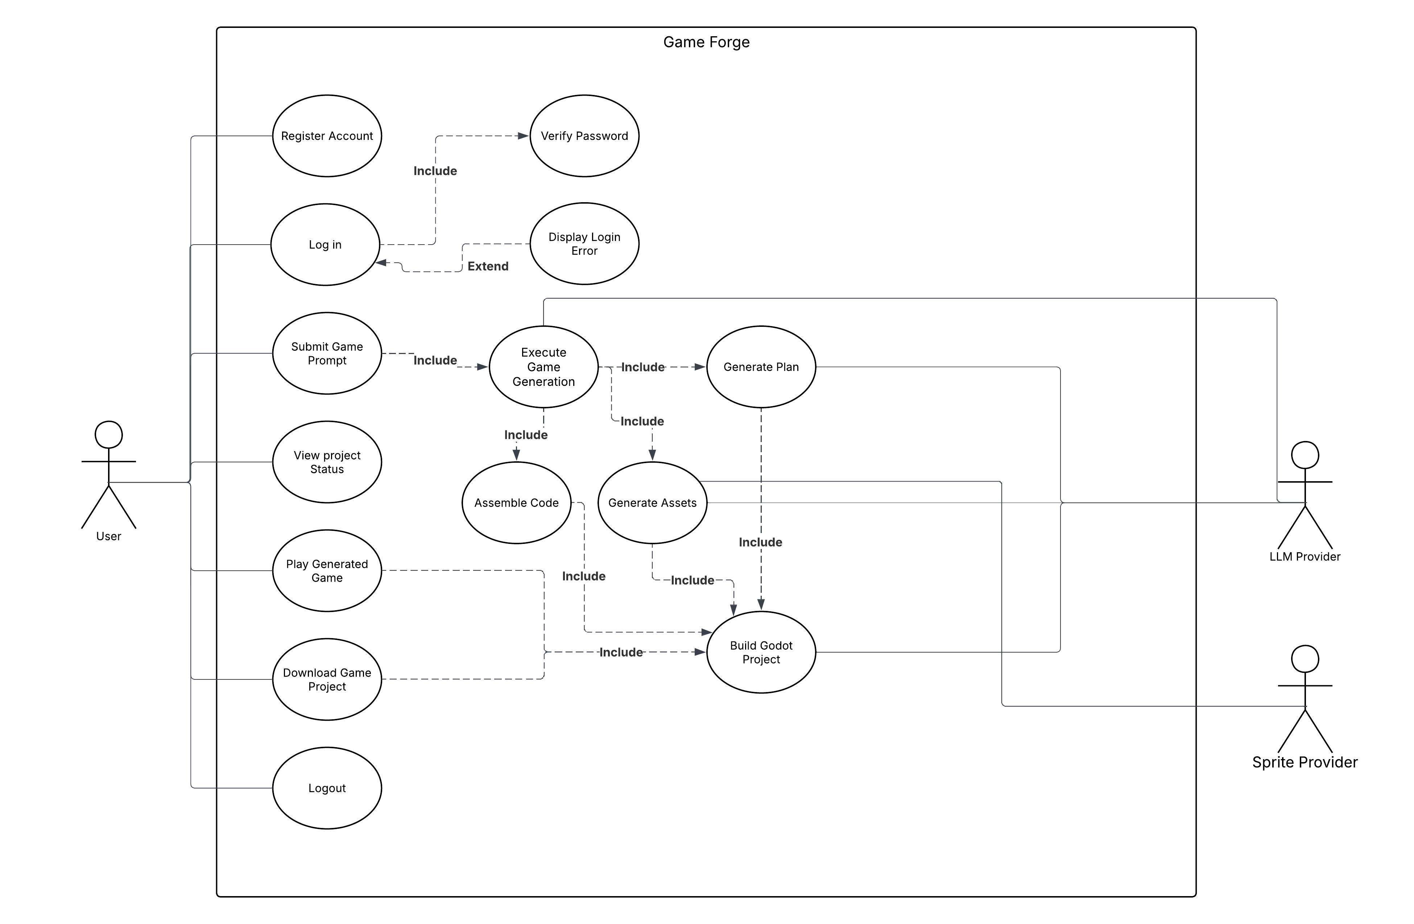
Figure 3.1 — Use Case Diagram

3.5 Feasibility Study

3.5.1 Technical Feasibility
All core technologies are mature, open-source, and actively maintained. Node.js and Express provide a stable foundation for the REST and orchestration layers; MongoDB with Mongoose and the S3-compatible MinIO are proven for persistence and object storage. Godot 4's headless export mode supports automated, CLI-driven HTML5 builds, and its --check-only flag enables programmatic validation of assembled GDScript. The Groq/OpenRouter, Stability AI, and Stable Audio APIs offer documented programmatic access, and the Model Context Protocol provides a standard client/server transport for the asset-generation agent. The chosen architecture — deterministic assembly of a curated GDScript component library, with the LLM confined to bounded tasks such as classification and plan generation — deliberately avoids the reliability problems of free-form code generation, making correct, compilable output technically achievable.

3.5.2 Economic Feasibility
The platform relies almost entirely on free and open-source software for its infrastructure: Godot, MongoDB, MinIO, Node.js, Python, React, and Docker carry no licensing fees, keeping the foundational stack free of cost. The project's only direct expenses were paid API subscriptions for the two external generation services — OpenRouter for LLM inference and Stability AI for image and audio generation — which were purchased to access their full generation capabilities during development and testing. Based on observed usage, the total external API cost per complete game generation is estimated at under one US dollar, which makes the platform economically viable under a freemium or pay-per-generation model at production scale. The overall development cost remained low, limited to these API subscriptions and running on student-owned hardware with no dedicated server or hosting expenditure.

3.5.3 Operational Feasibility
The entire platform is deployable through a single Docker Compose configuration, allowing the full ten-service stack to be started on any Docker-capable machine without host-specific setup. The microservice decomposition means each stage can be updated, scaled, or replaced independently — for example, swapping the planner's LLM model requires no change to other services. Each service exposes a health-check endpoint supporting automated monitoring and restart, and all generated artifacts are persisted in durable object storage so completed games remain retrievable independently of the runtime state of the generation services. The generated games run directly in any modern browser via Godot's WebAssembly export, requiring no installation or plug-ins from the end user.

Chapter 4: System Design

4.1 System Architecture
Game Forge follows a microservice architecture pattern with ten containerized services communicating over a private Docker bridge network. The architecture is organized into three tiers: the presentation tier (frontend), the application tier (backend, server, and four worker services), and the data/storage tier (MongoDB and MinIO).

Service | Port | Technology | Responsibility
frontend | 3000 | React + Vite | Single-page application: workspace UI, chat, build progress, game player
backend | 5000 | Node.js/Express | REST API, JWT auth, MongoDB models, proxies MinIO for game serving
server | 6100 | Node.js/Express | Stateless orchestrator: receives generate request, runs pipeline, pushes logs to backend
planner | 6101 | Node.js/Express | LLM prompt classifier + GamePlan generator; persists plan to MongoDB
asset | 6102 | Node.js/Express | MCP client: orchestrates assets-mcp via LLM agent, saves Asset docs
code | 6103 | Node.js/Express | Template-guided GDScript assembler + Godot syntax validator + MinIO uploader
builder | 6104 | Node.js/Express | Downloads artifacts from MinIO, runs Godot headless export, uploads HTML5
assets-mcp | 8765 | Python/FastMCP | MCP server: wraps Stability AI and Stable Audio APIs as MCP tools
mongo | 27017 | MongoDB | Persistent store for Users, GameProjects, GenerationJobs, Builds, Assets, GamePlans
minio | 9000/9001 | MinIO | S3-compatible object storage for GDScripts, asset images/audio, HTML5 exports
Table 4.1 — Service Catalogue

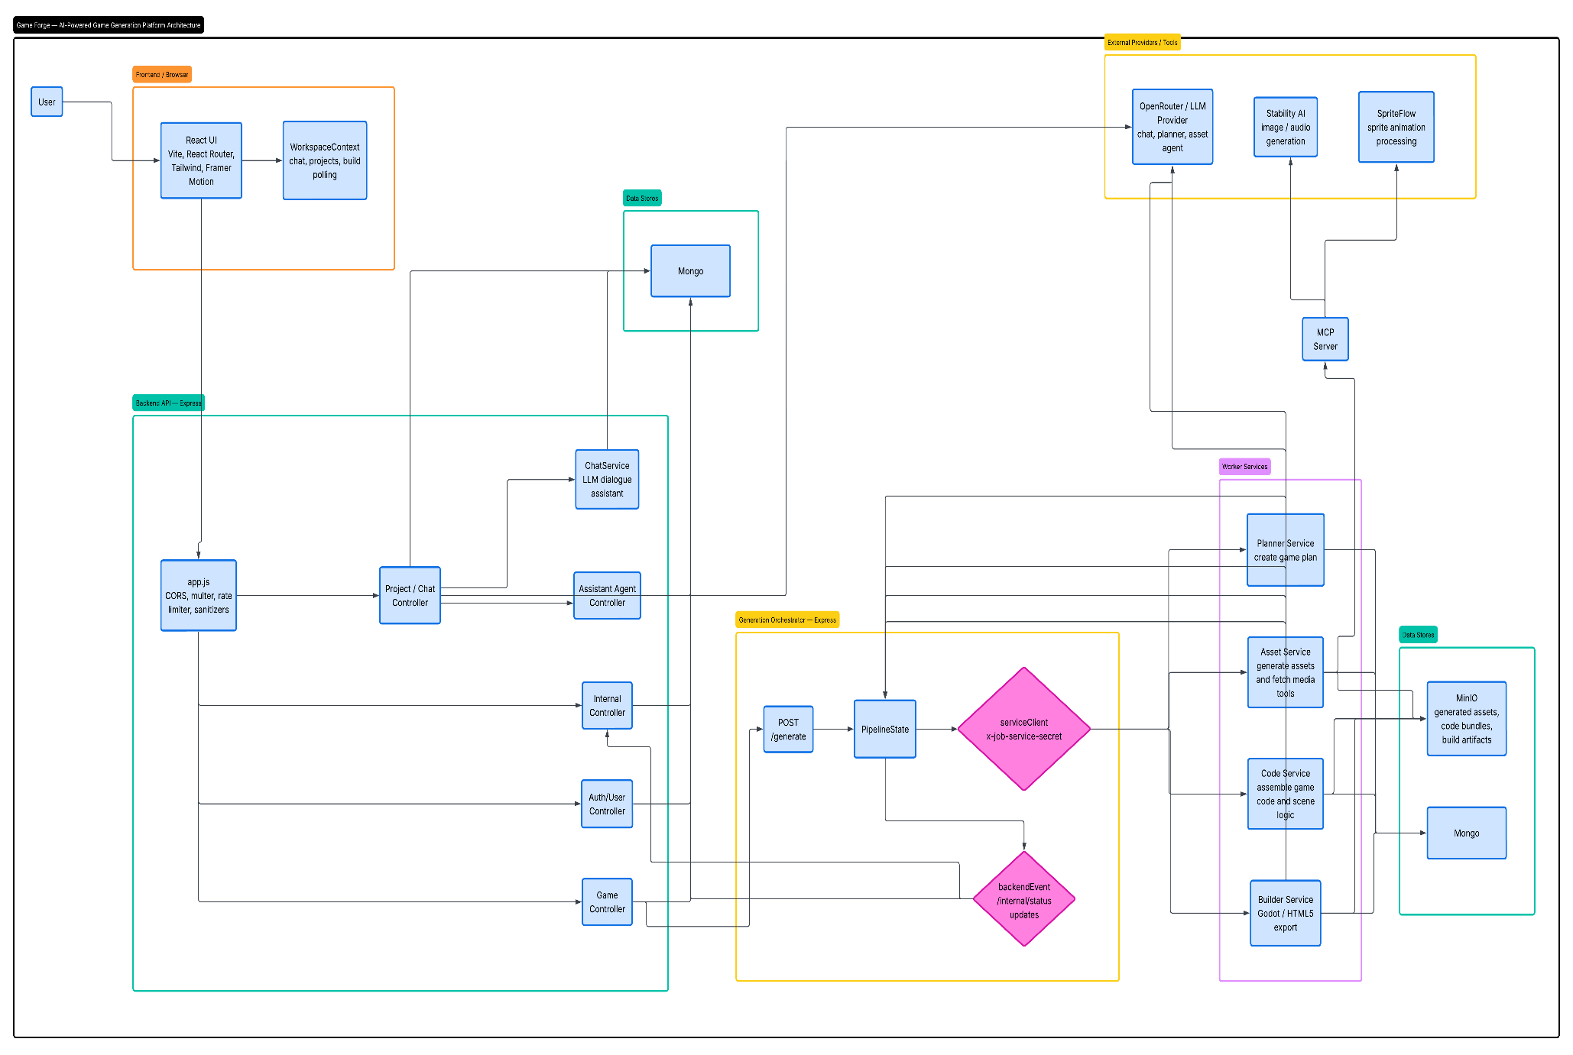
Figure 4.1 — System Architecture / Component Diagram

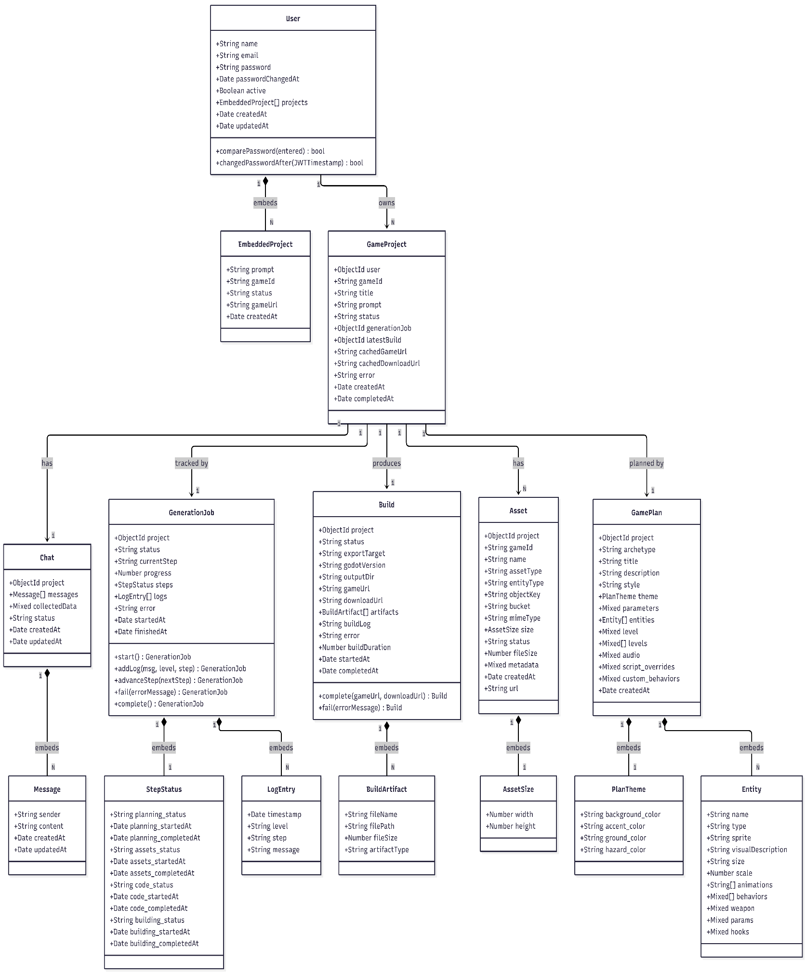
4.2 Class Diagrams
Figure 4.2 — Class Diagram: Core MongoDB Models
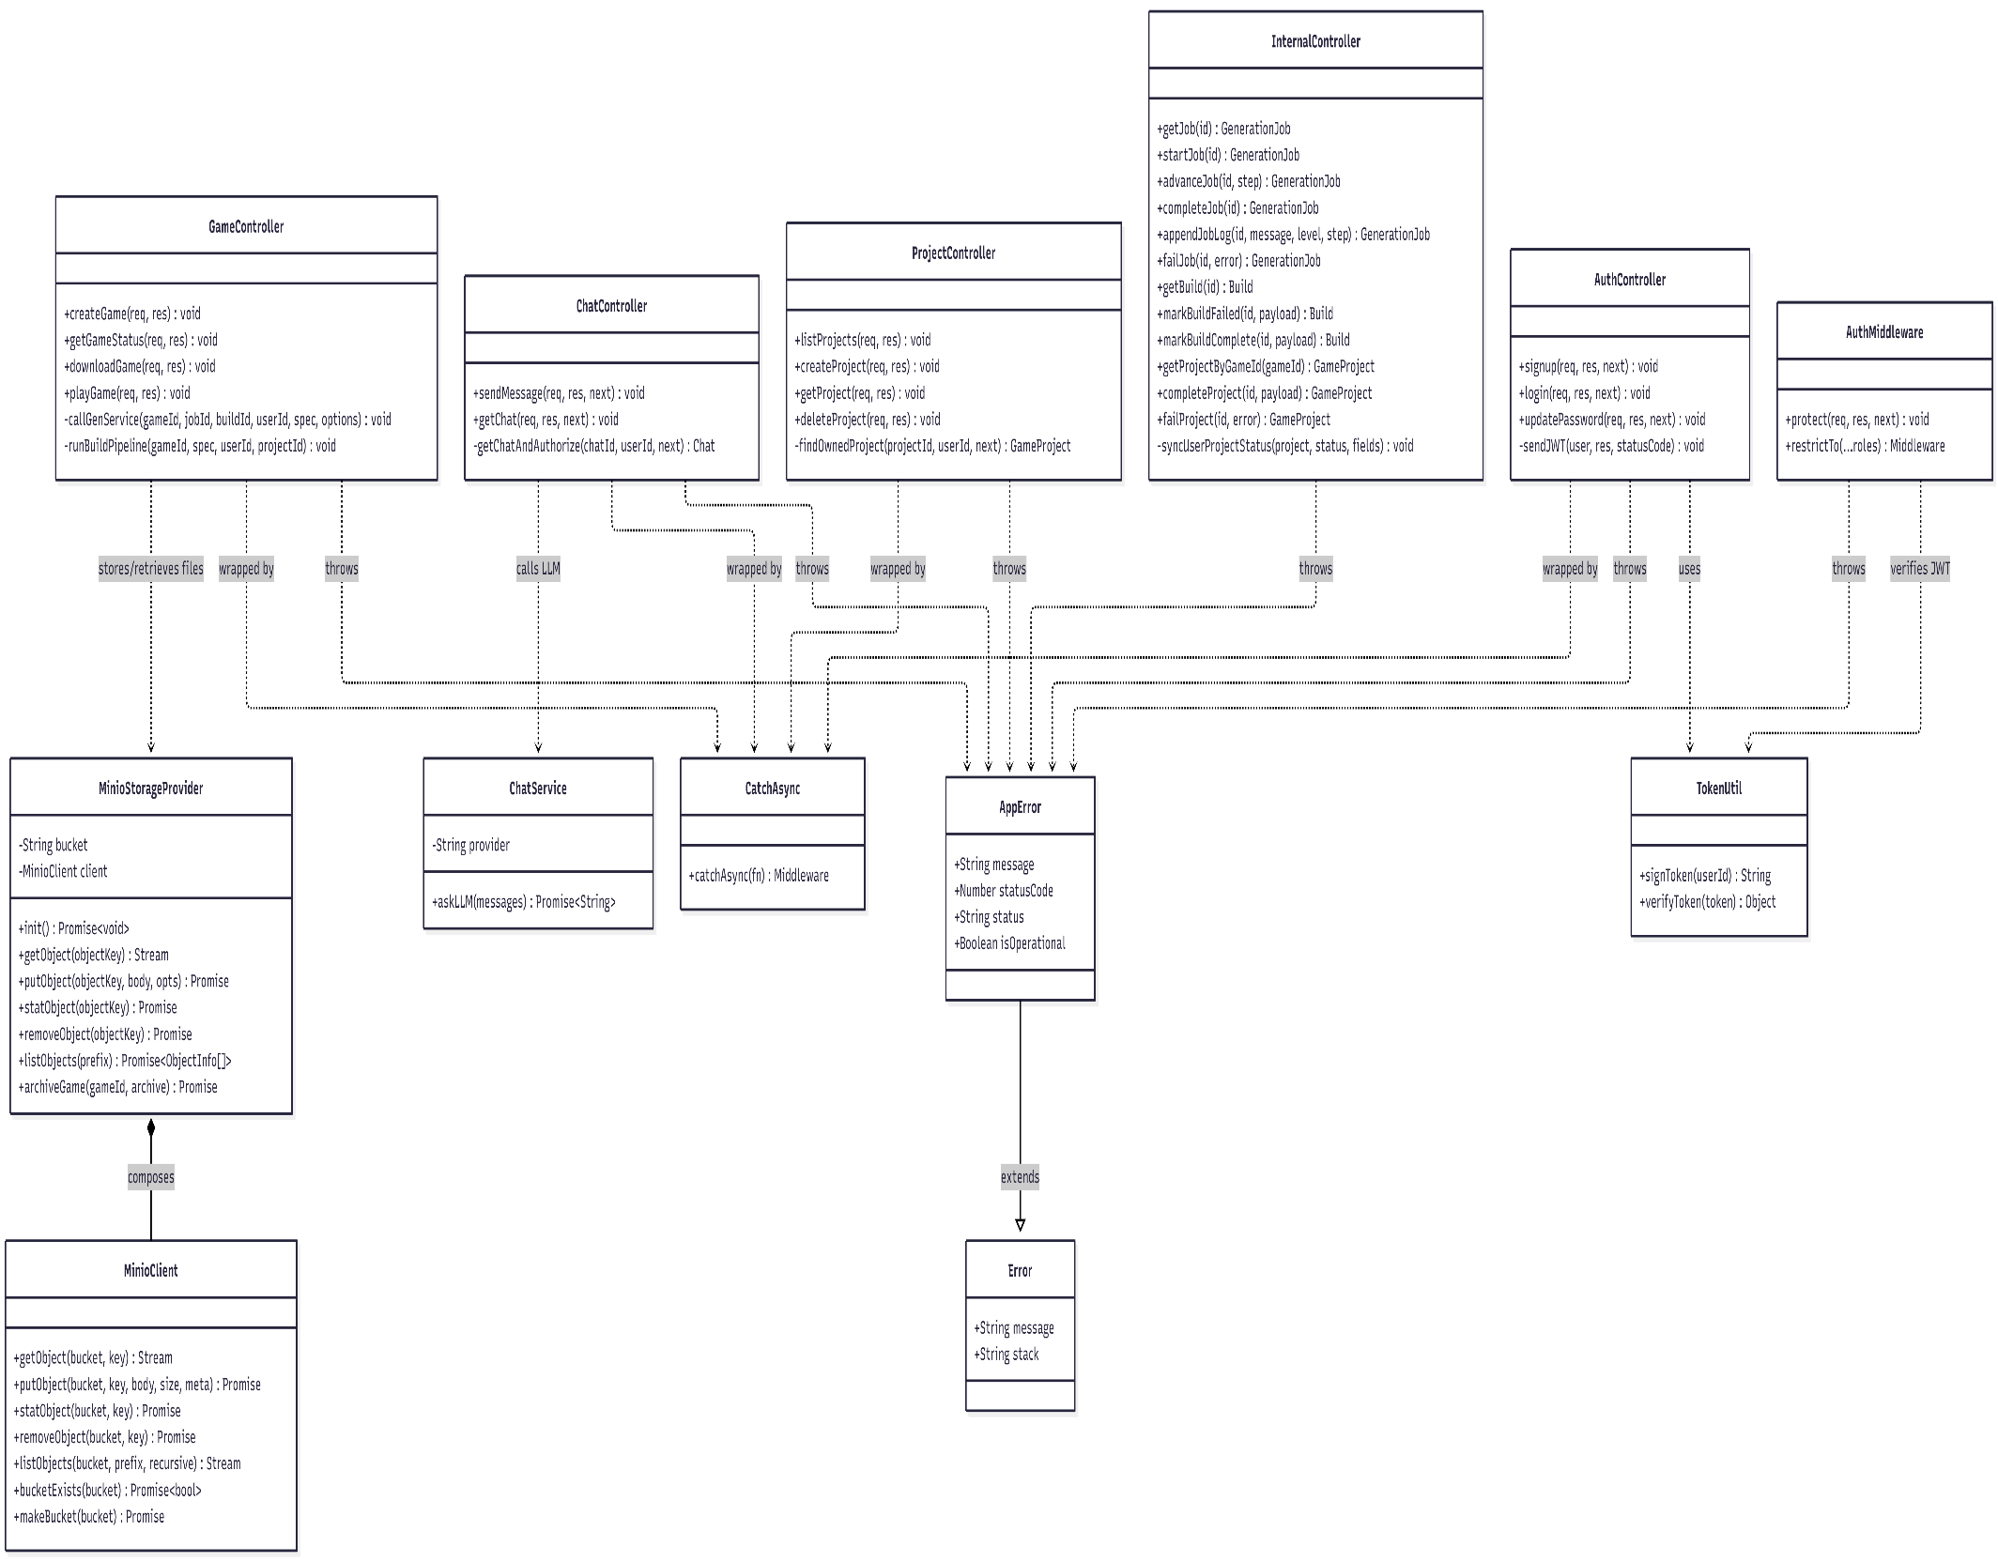
Figure 4.3 — Class Diagram: Code Pipeline Classes
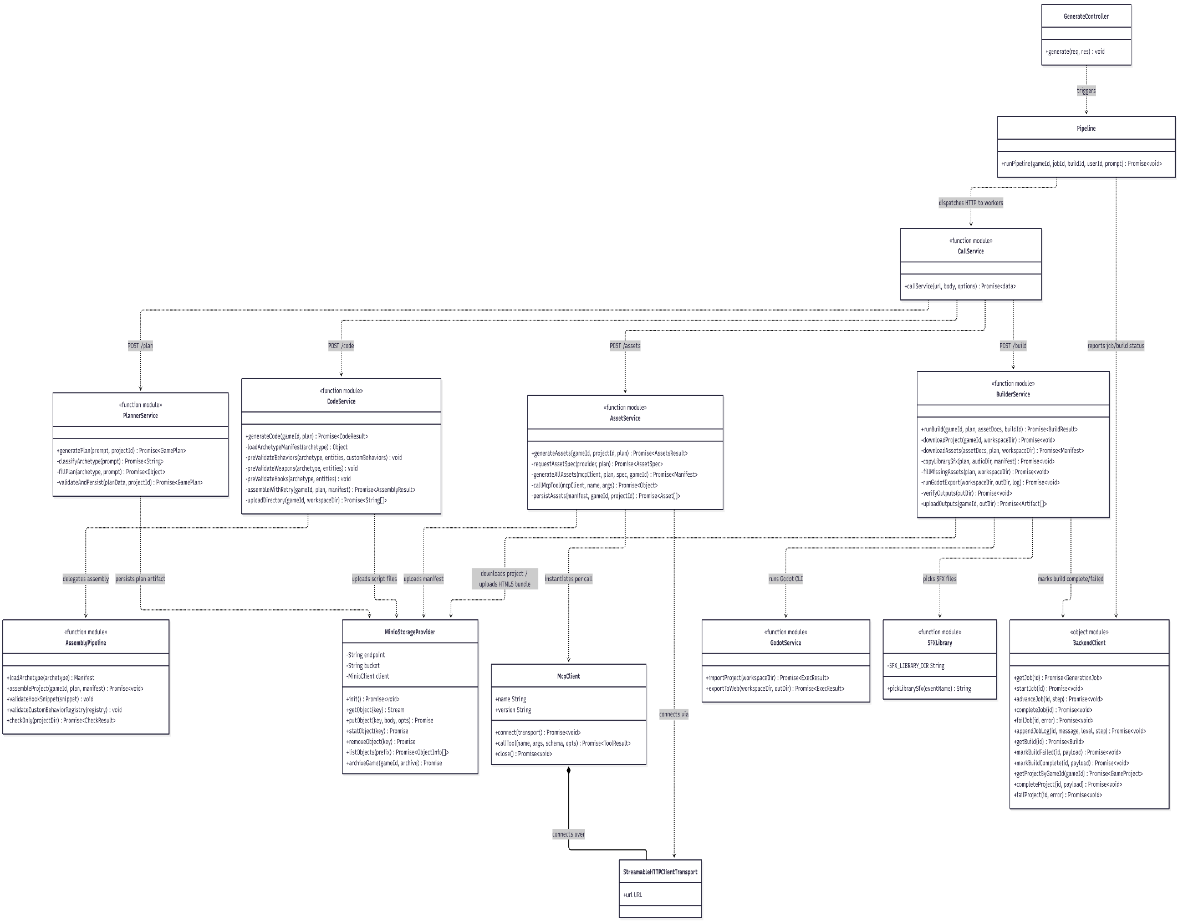
Figure 4.4 — Class Diagram: Asset MCP Server Classes
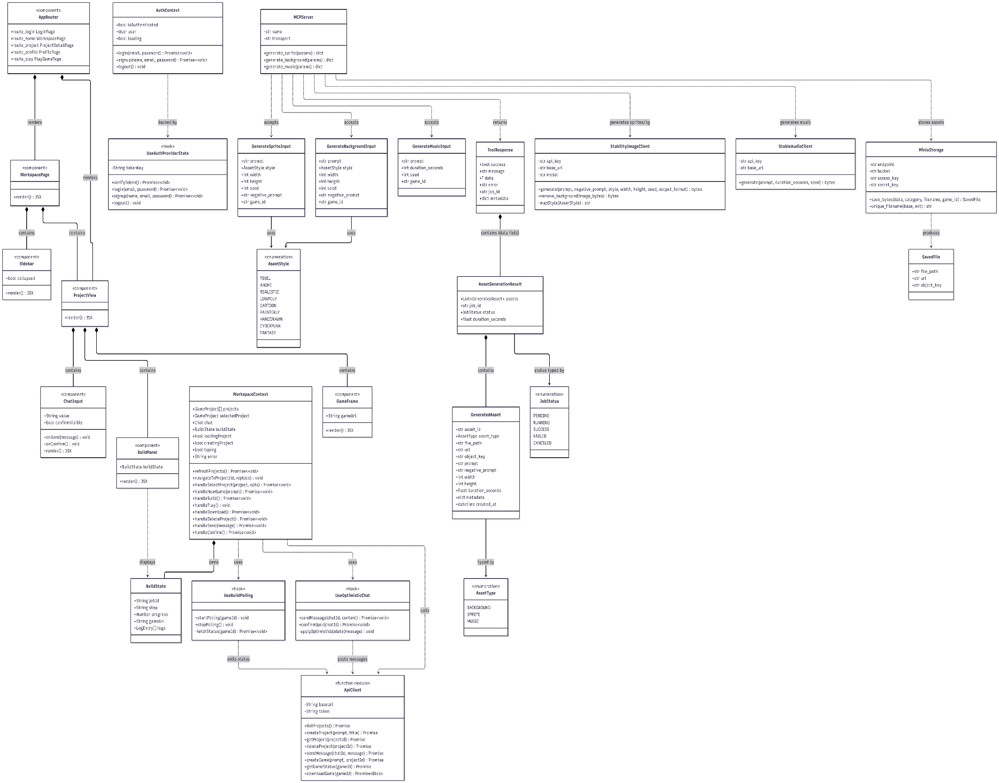
Figure 4.5 — Class Diagram: Backend Service Classes

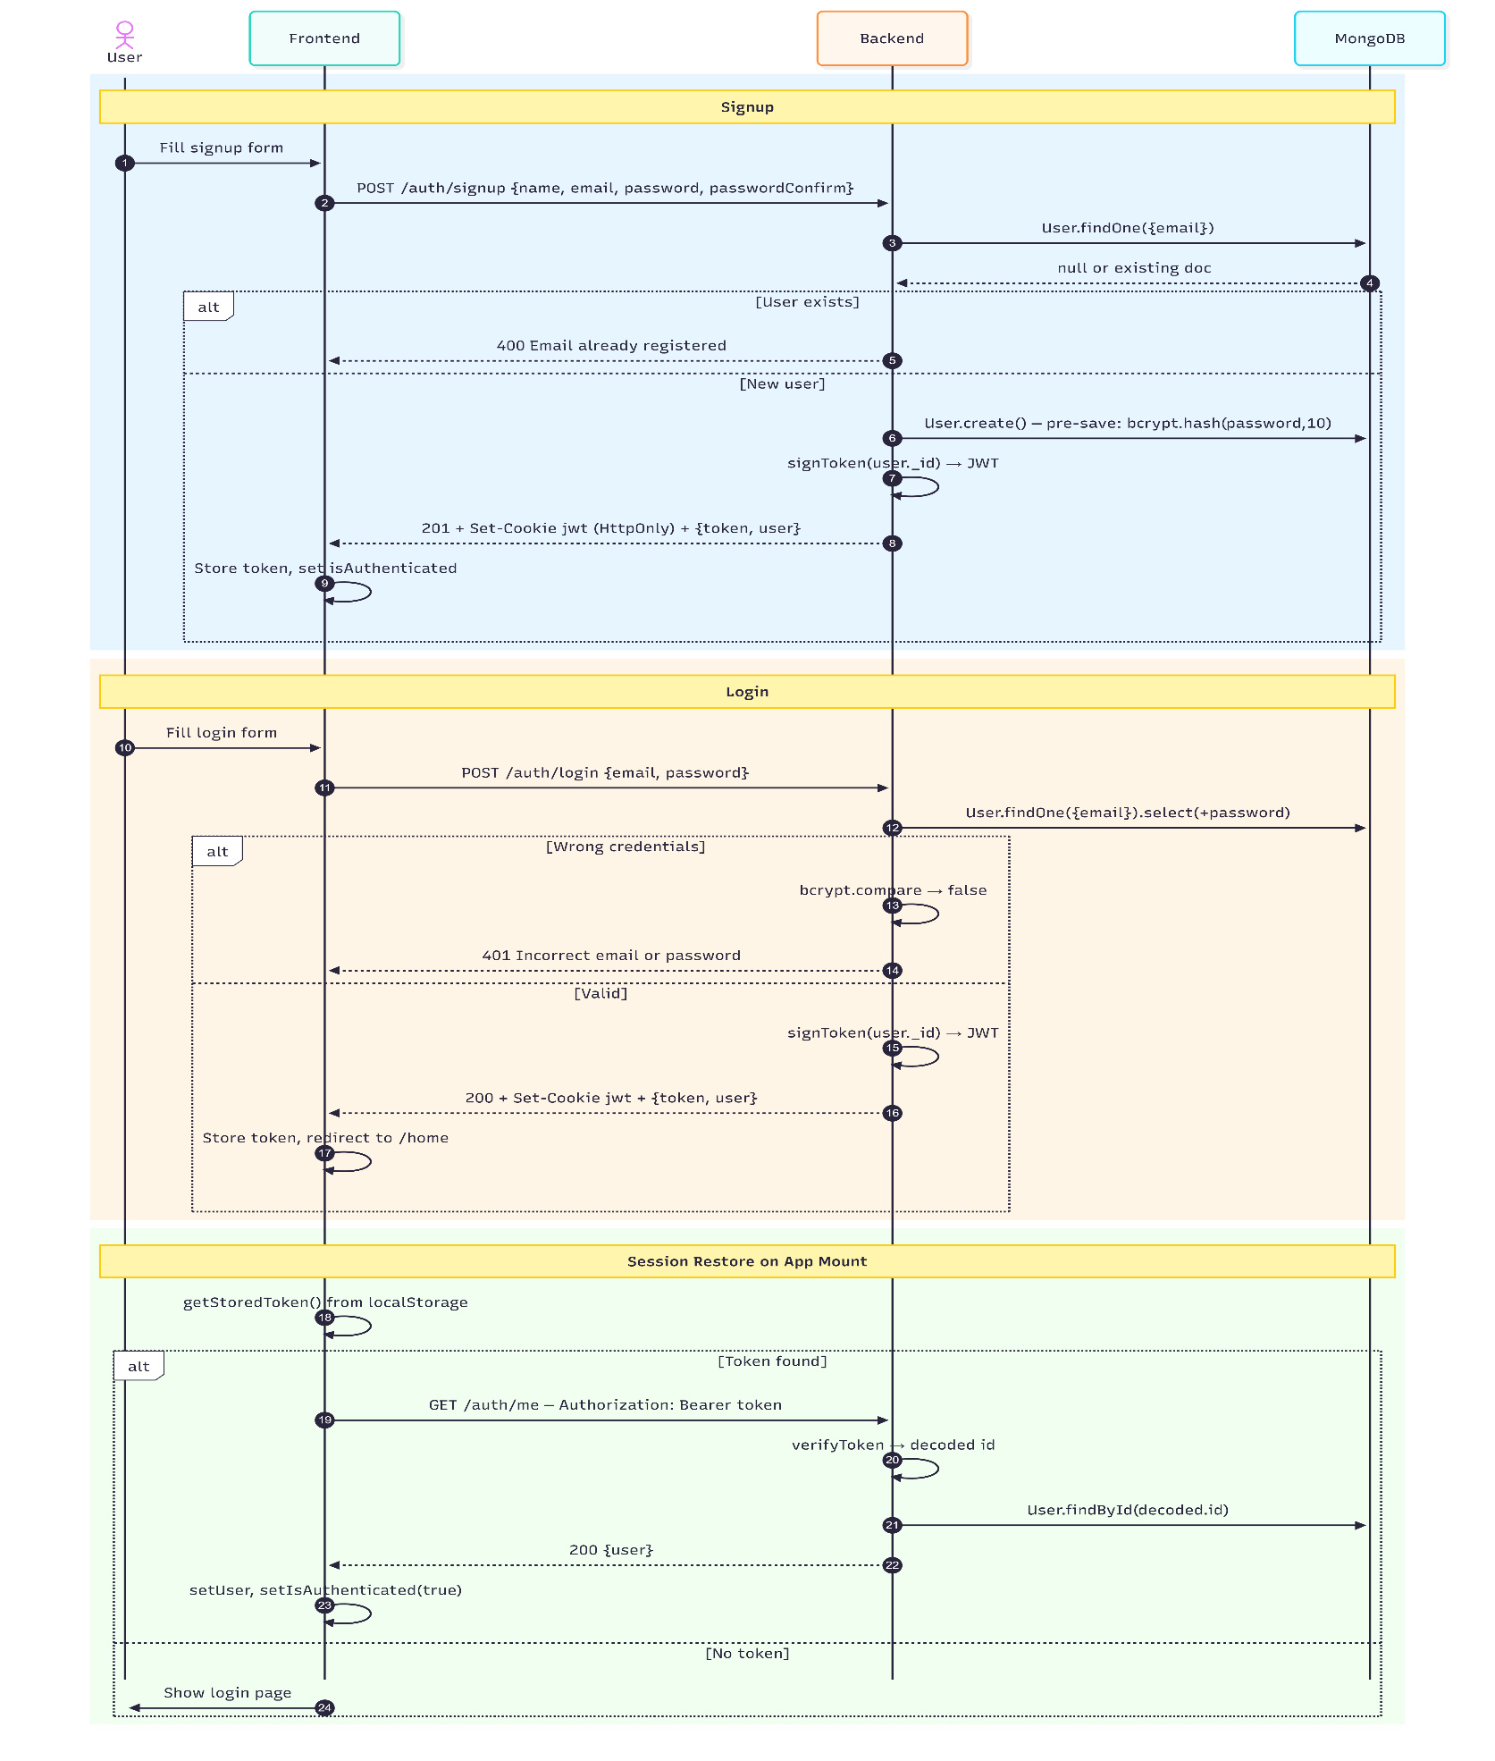
4.3 Sequence Diagrams
Figure 4.6 — Sequence Diagram: User Registration and Login
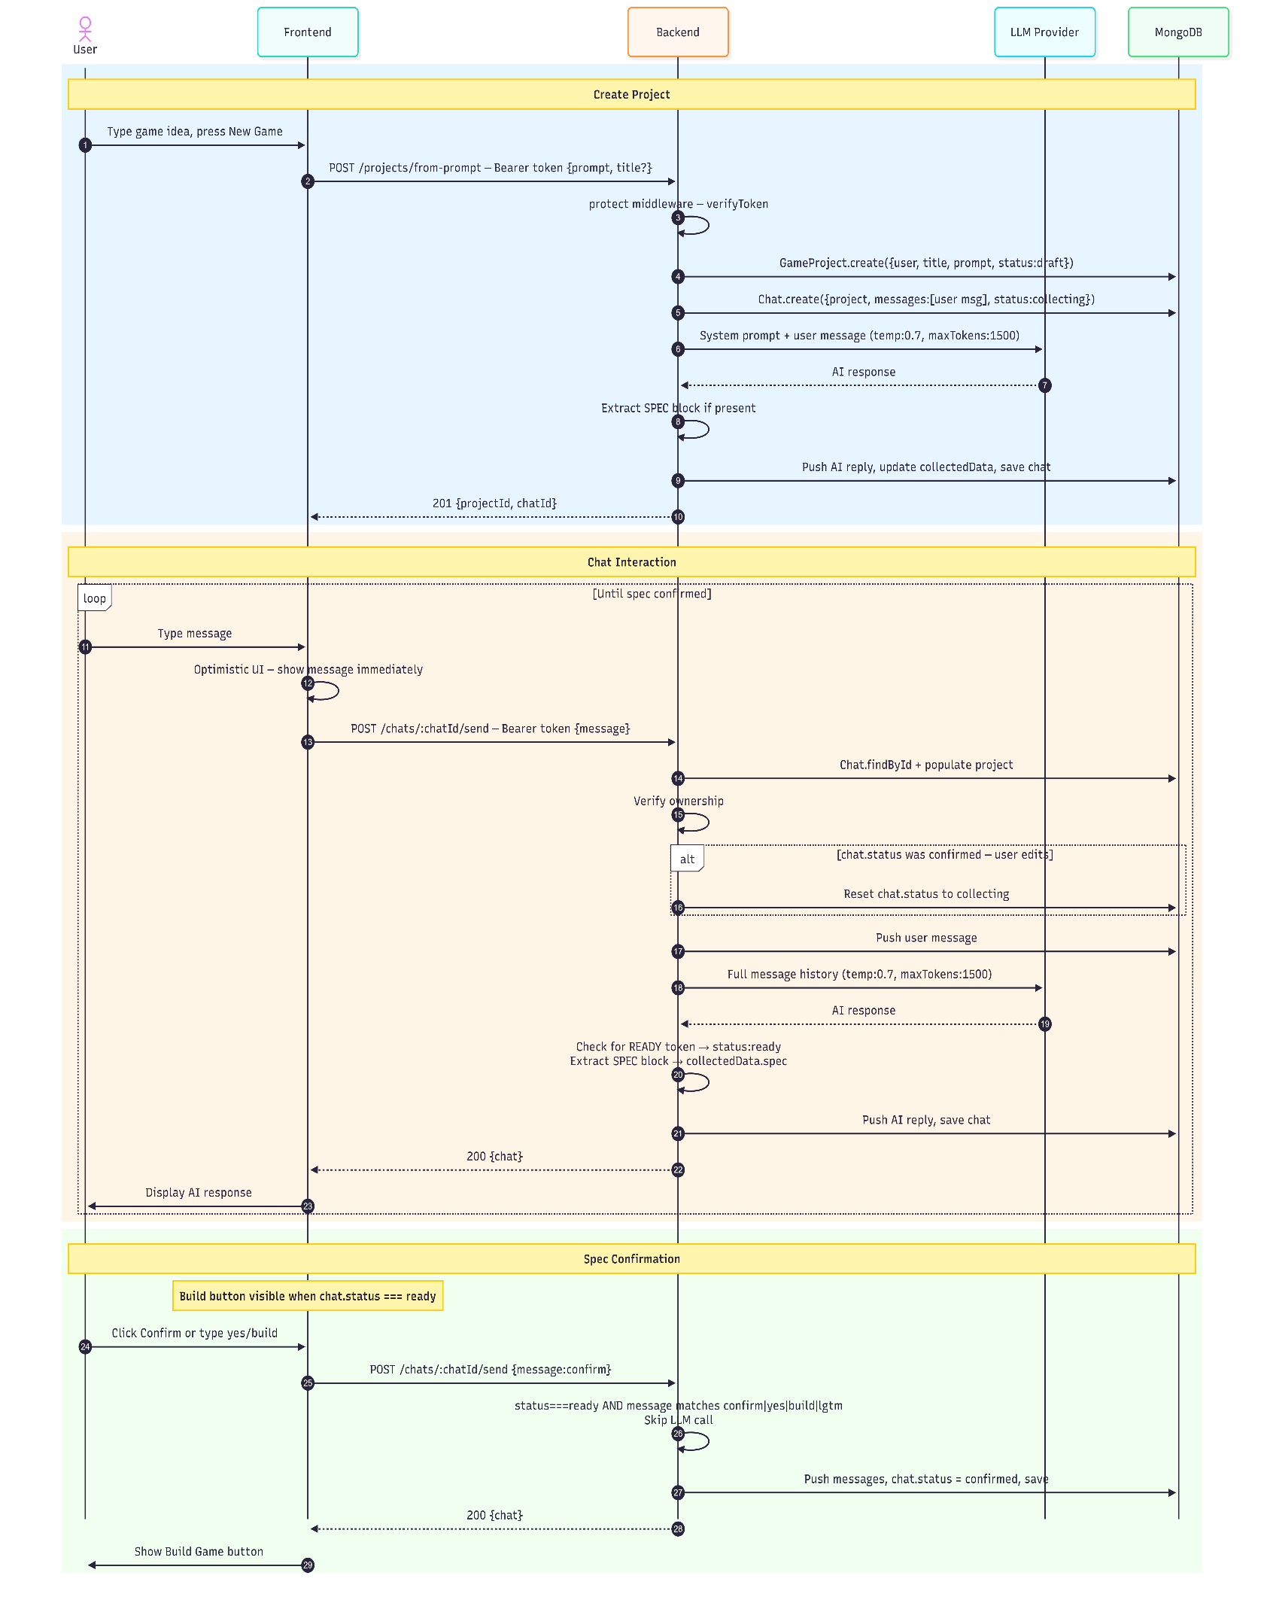
Figure 4.7 — Sequence Diagram: Create Project and Chat Refinement
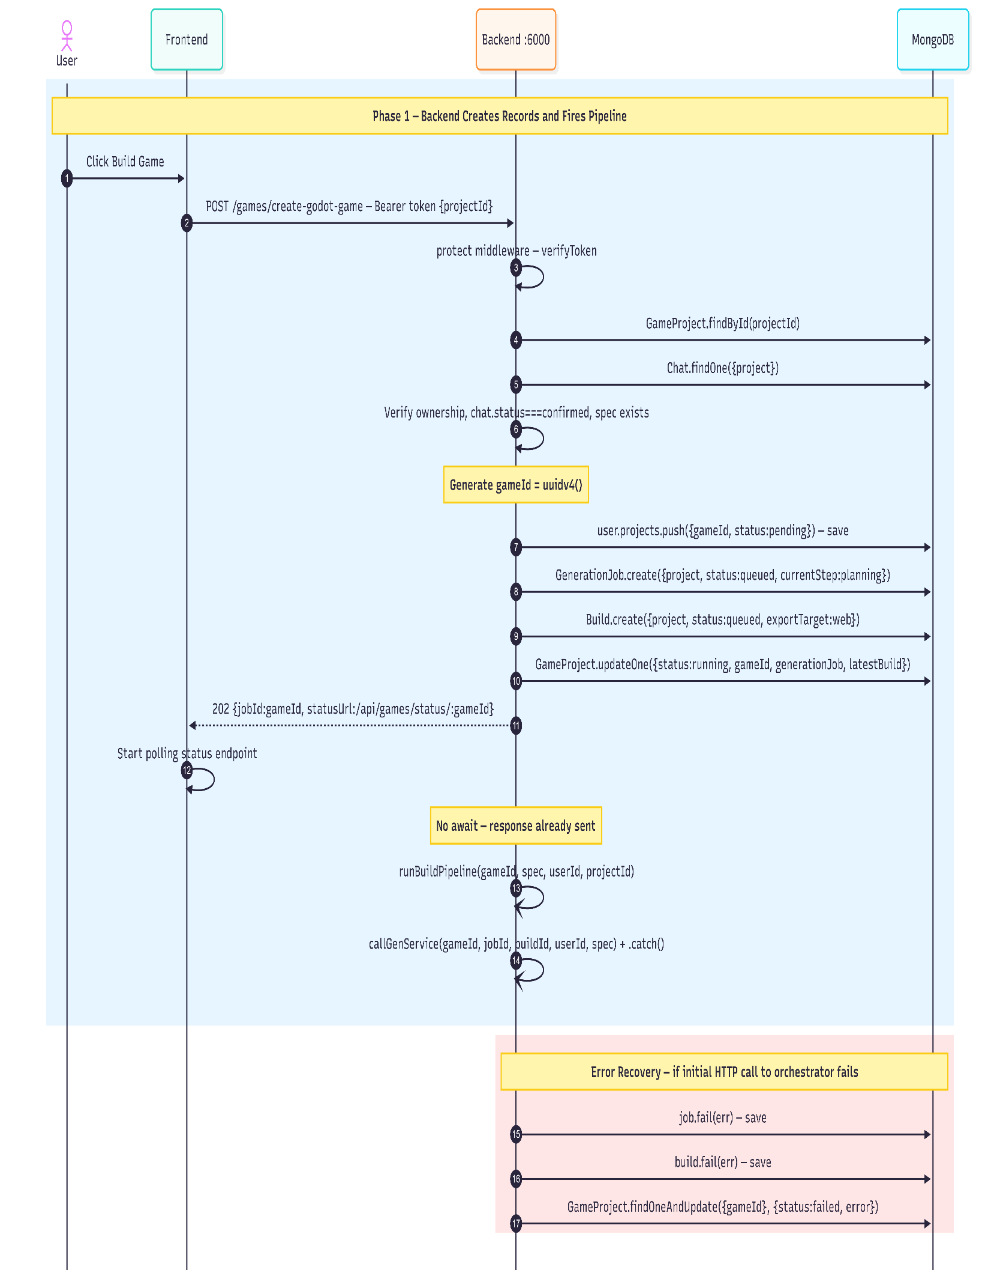
Figure 4.8 — Sequence Diagram: Full Game Generation Pipeline
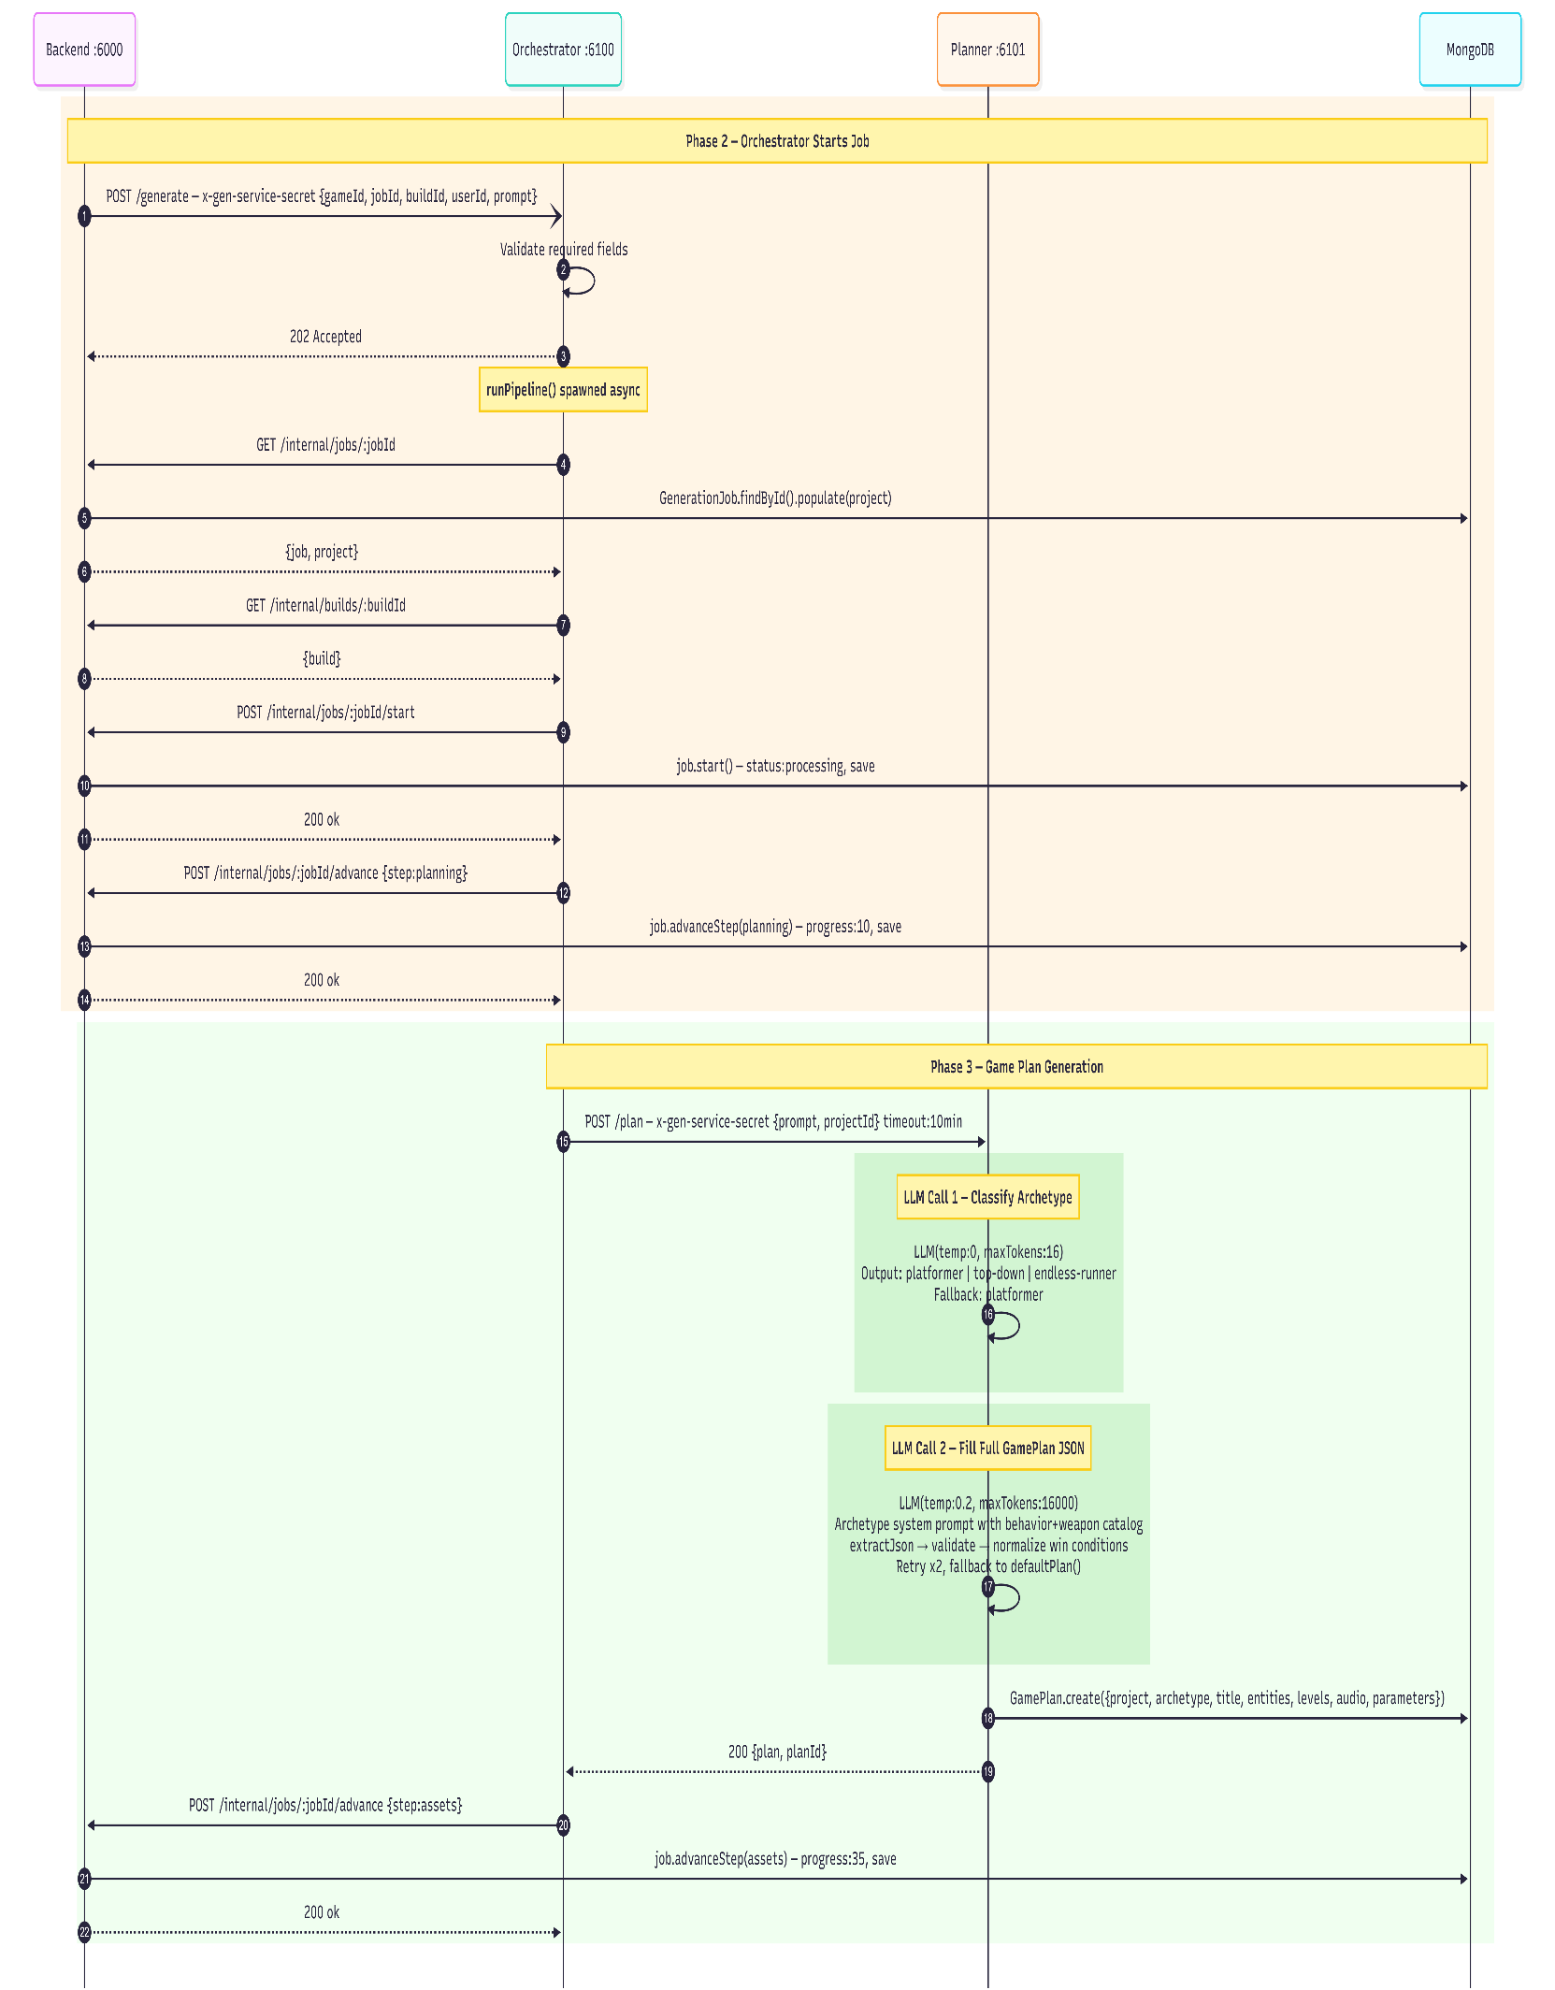
Figure 4.9 — Sequence Diagram: Asset Generation via MCP
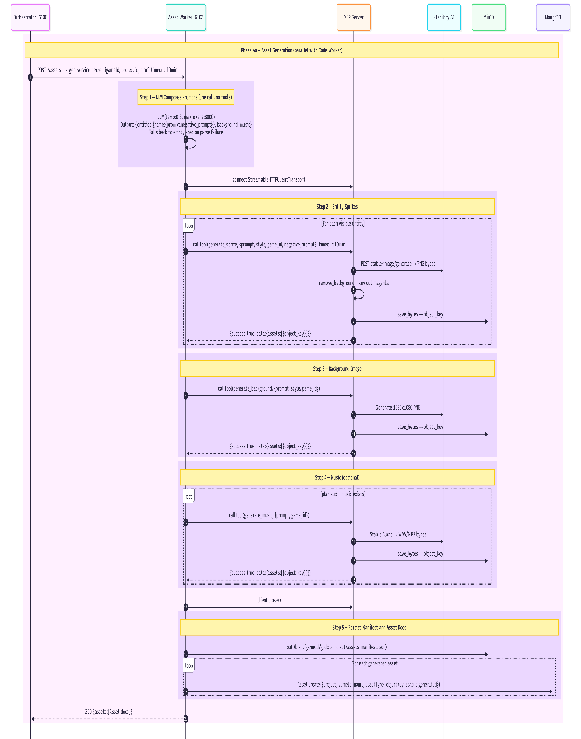
Figure 4.10 — Sequence Diagram: Code Generation with Validation Loop
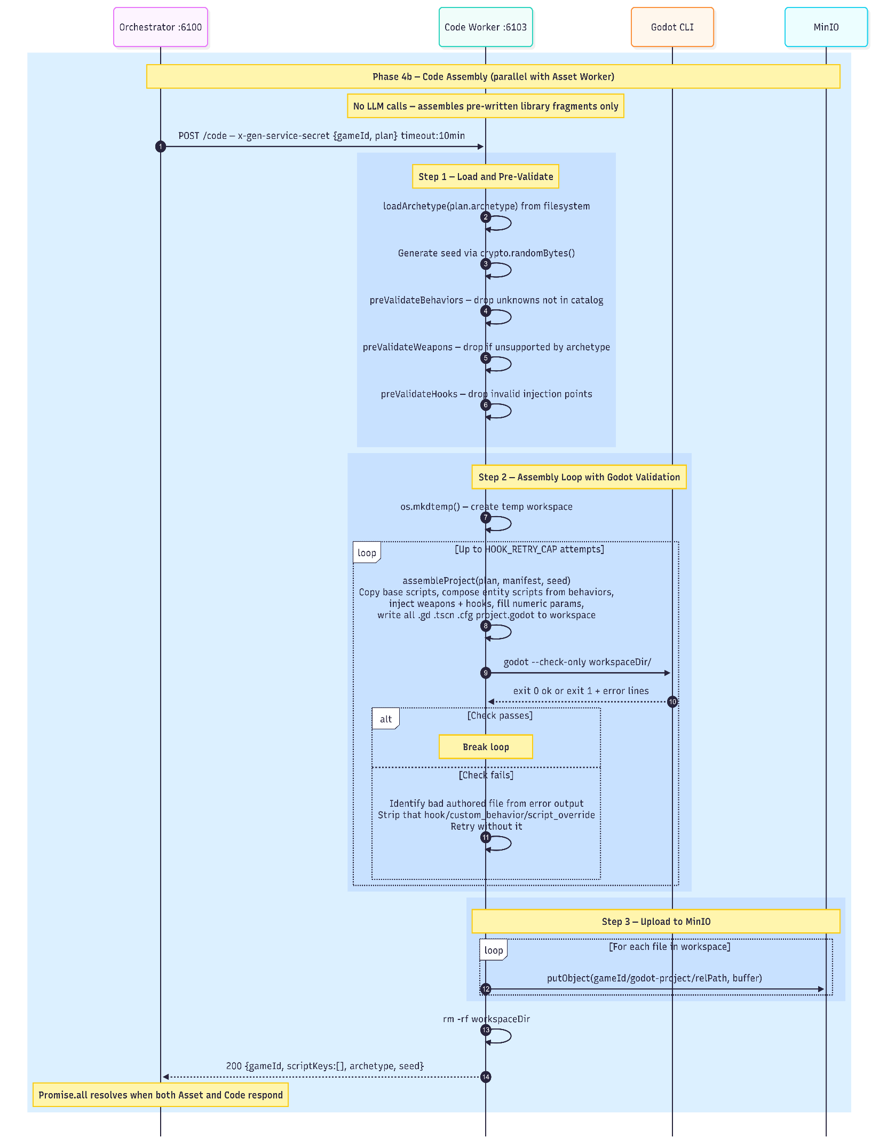
Figure 4.11 — Sequence Diagram: Builder Service and Godot Export
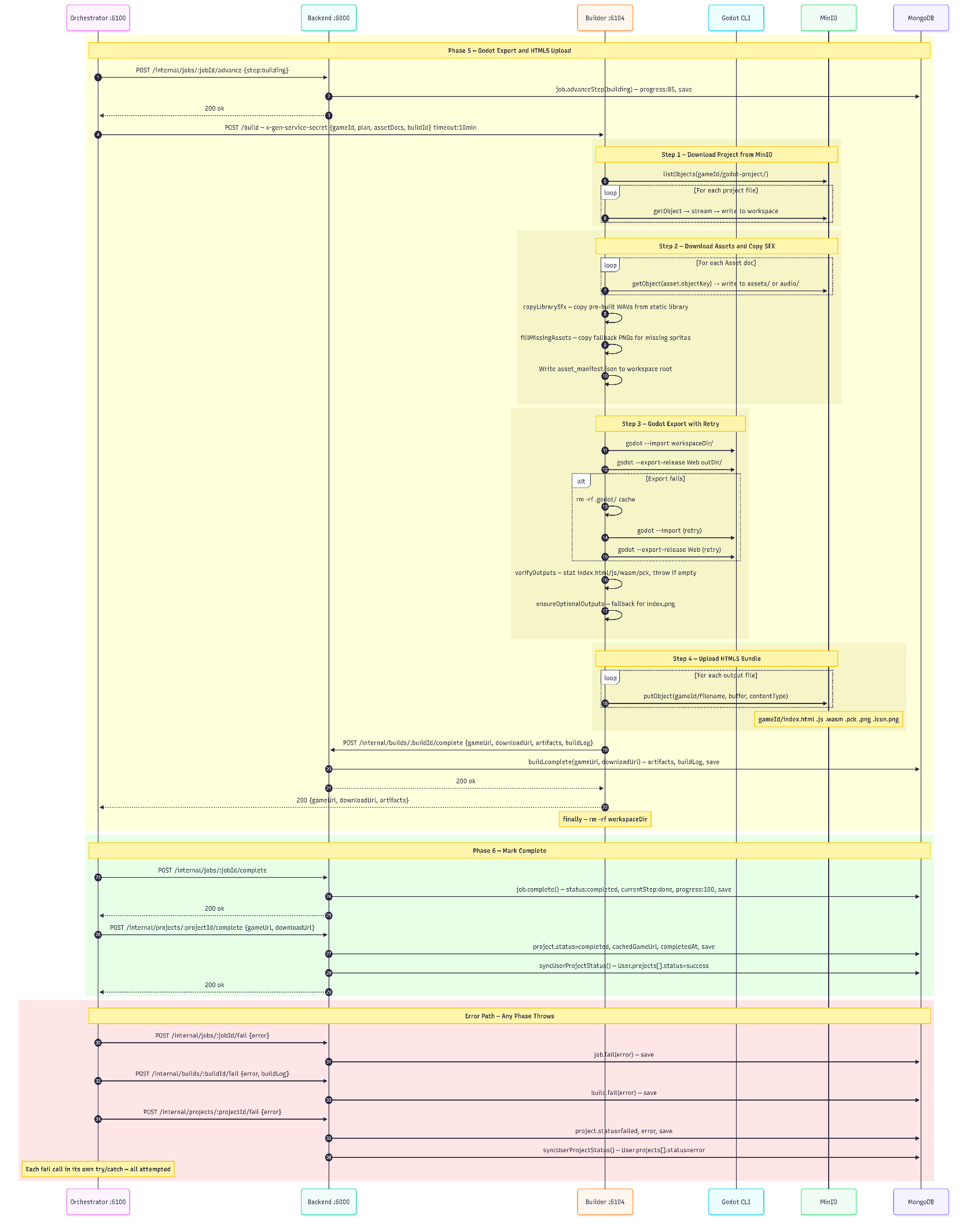
Figure 4.12 — Sequence Diagram: Real-Time Progress Tracking
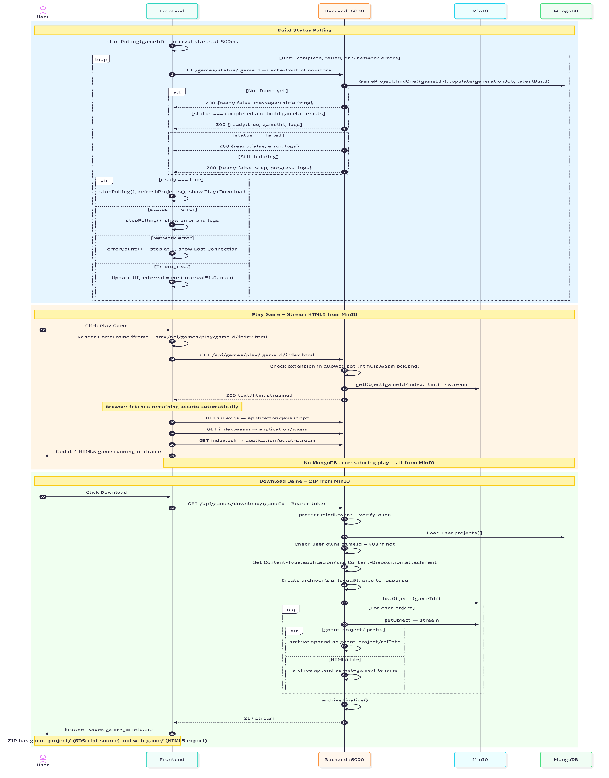
Figure 4.13

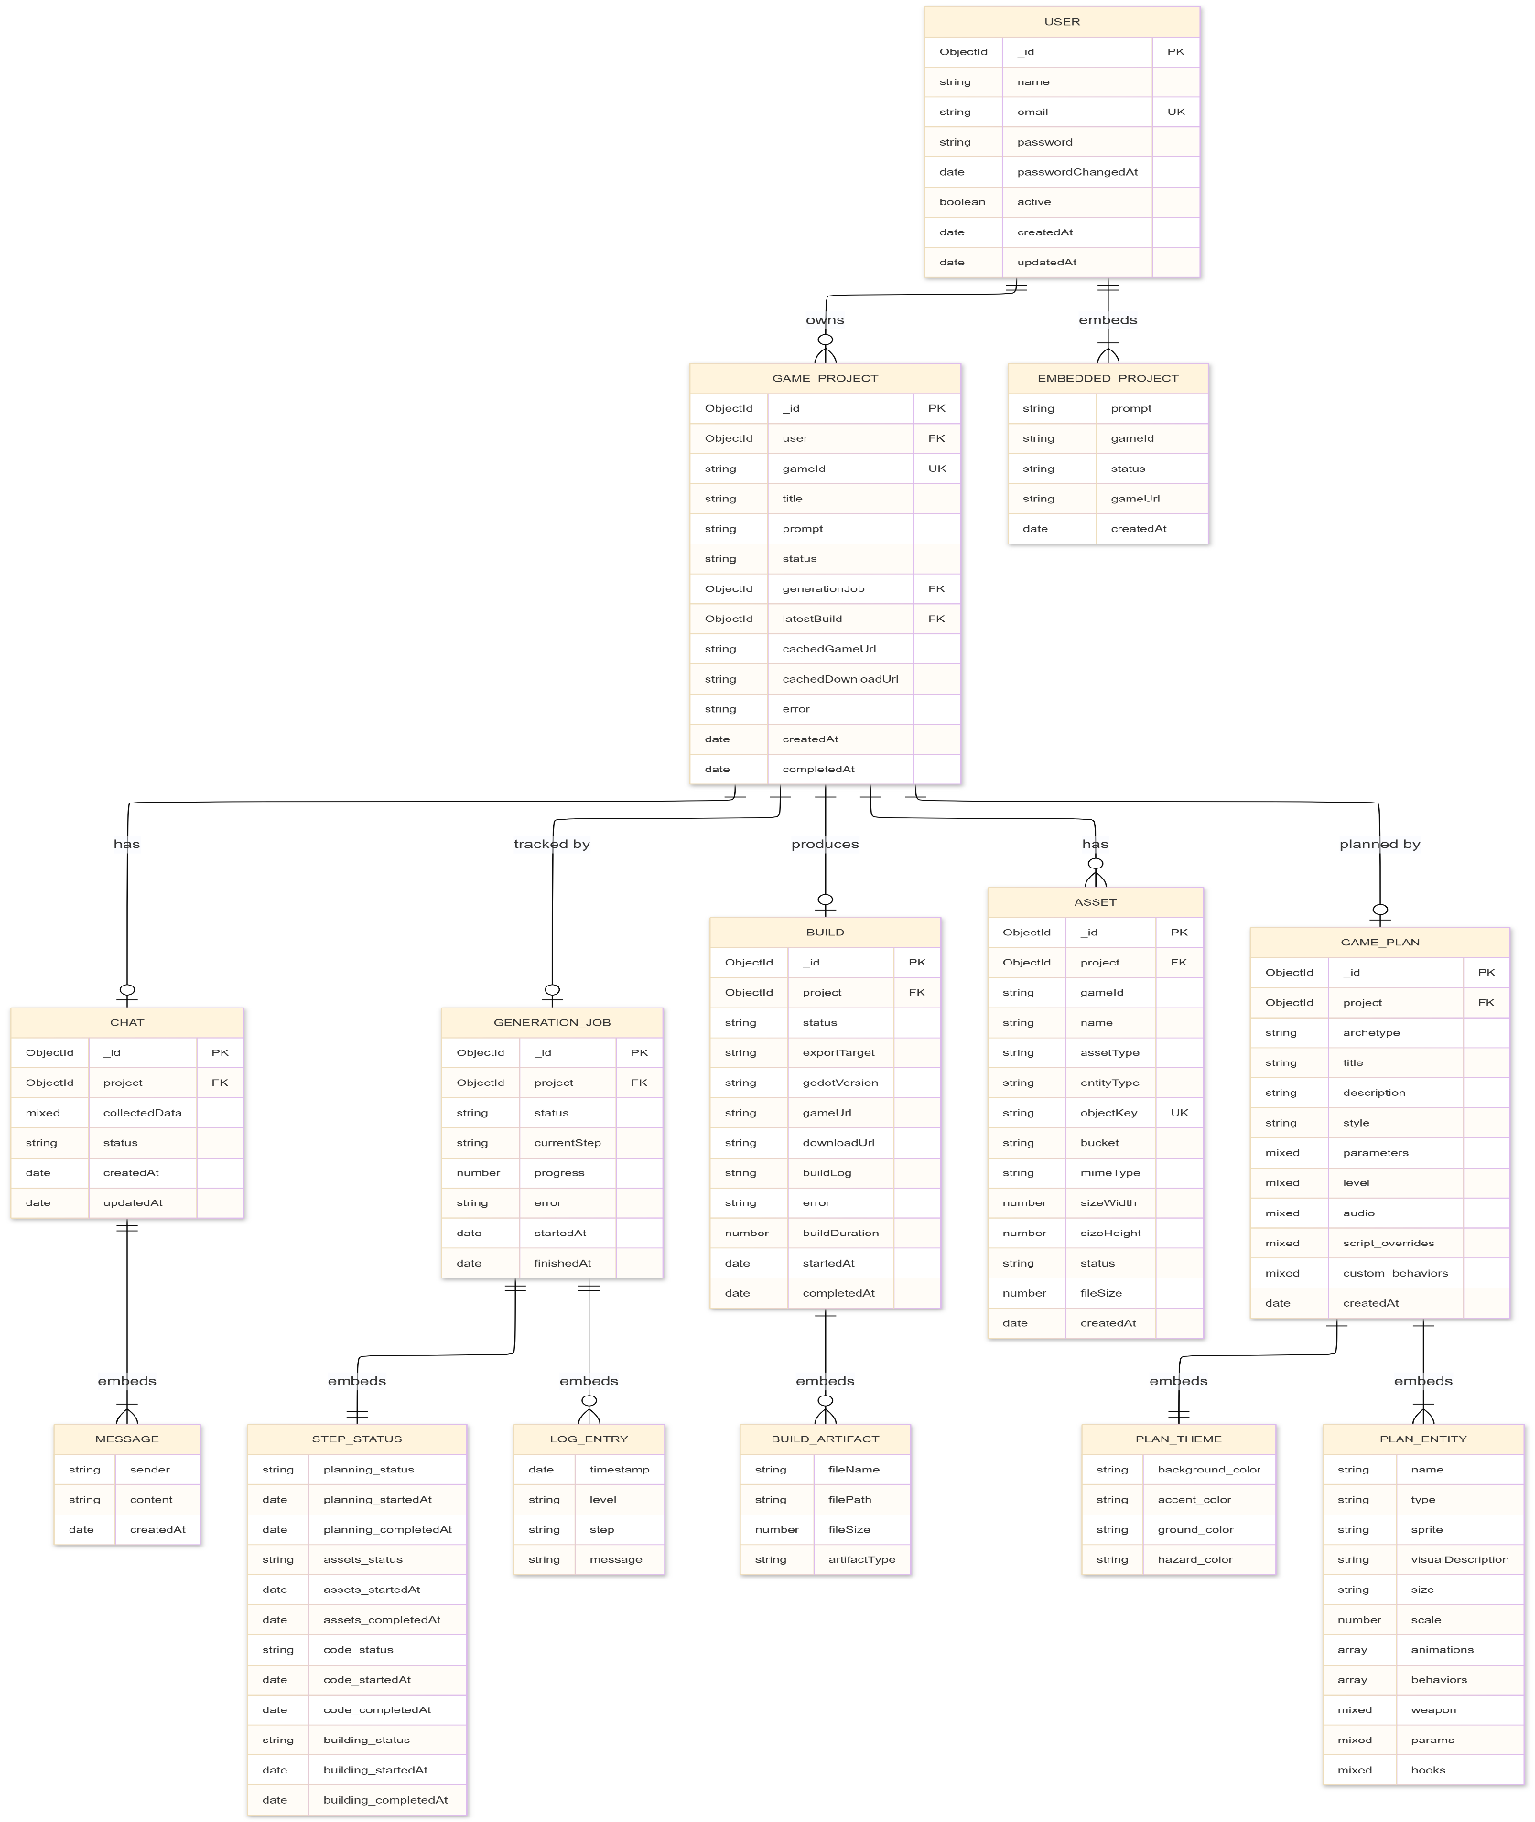
4.4 Entity-Relationship Diagram
Figure 4.14 — Entity Relationship Diagram

4.5 UI Wireframes / Mockups
The authentication screen presents a centered card with toggling Login and Signup tabs. The Login tab collects email and password; the Signup tab adds a name field and password confirmation. On successful authentication the JWT is stored and the user is redirected to the workspace.

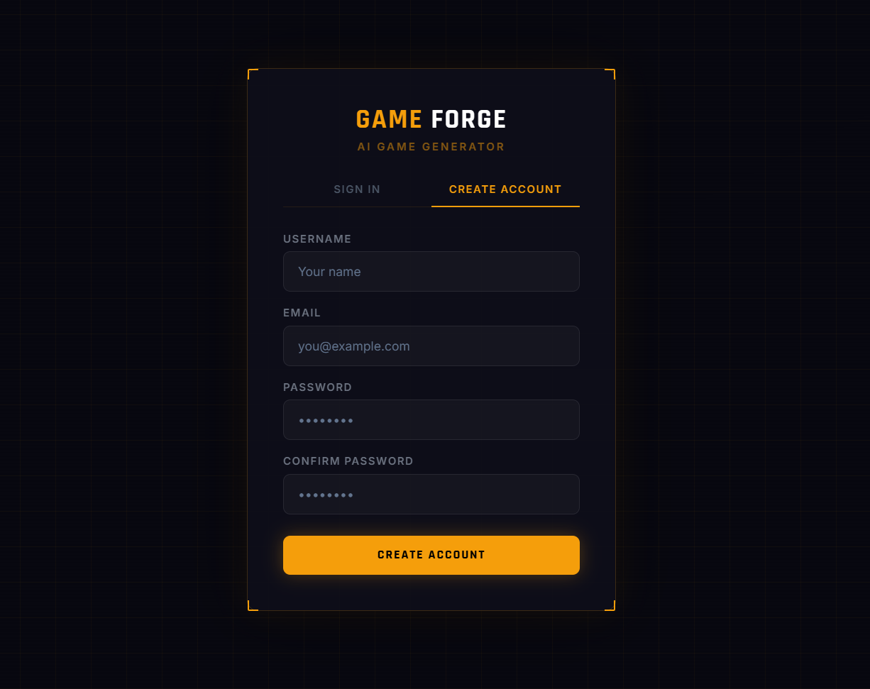
Figure 4.15 — Wireframe: Authentication (Login / Signup)

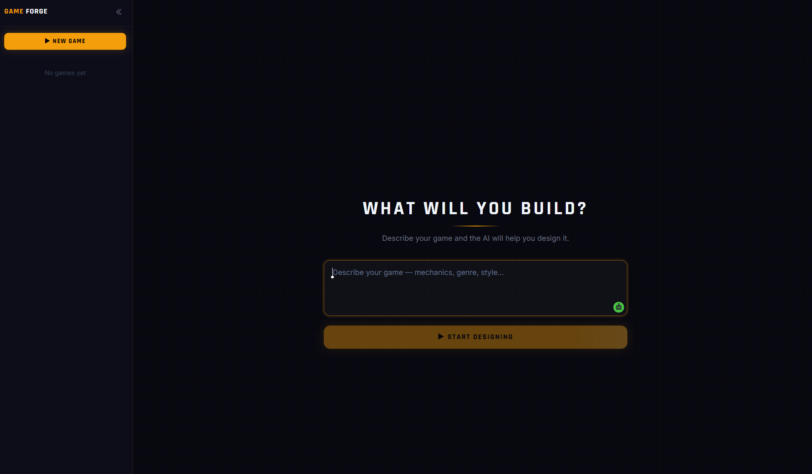
The workspace landing state presents a centered text area prompting the user to describe their game idea in natural language. Submitting the prompt creates a new project and transitions the workspace into the AI chat refinement view.
Figure 4.16 — Wireframe: Workspace — New Game Prompt State

The workspace shows a split view: the left panel shows all the user projects, and the right panel hosts the AI chat interface where the user refines the game design before confirming generation, displays the live build progress once generation is initiated. The progress panel shows the current pipeline step (planning, assets, code, building) alongside a percentage indicator and a scrollable log.
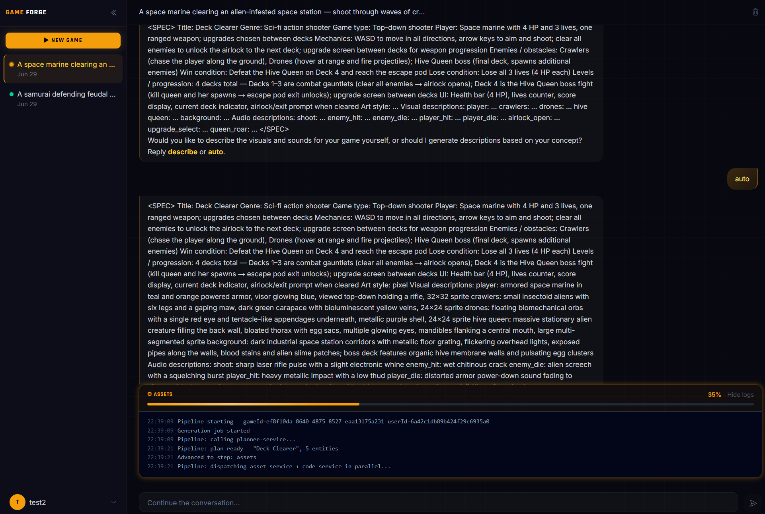
Figure 4.17 — Wireframe: Workspace — Projects and Chat Panel

Once generation completes, the build panel transitions to a success state displaying the game title and two action buttons — Play and Download. Play loads the HTML5 export directly in the browser, while Download retrieves the Godot project archive from object storage.
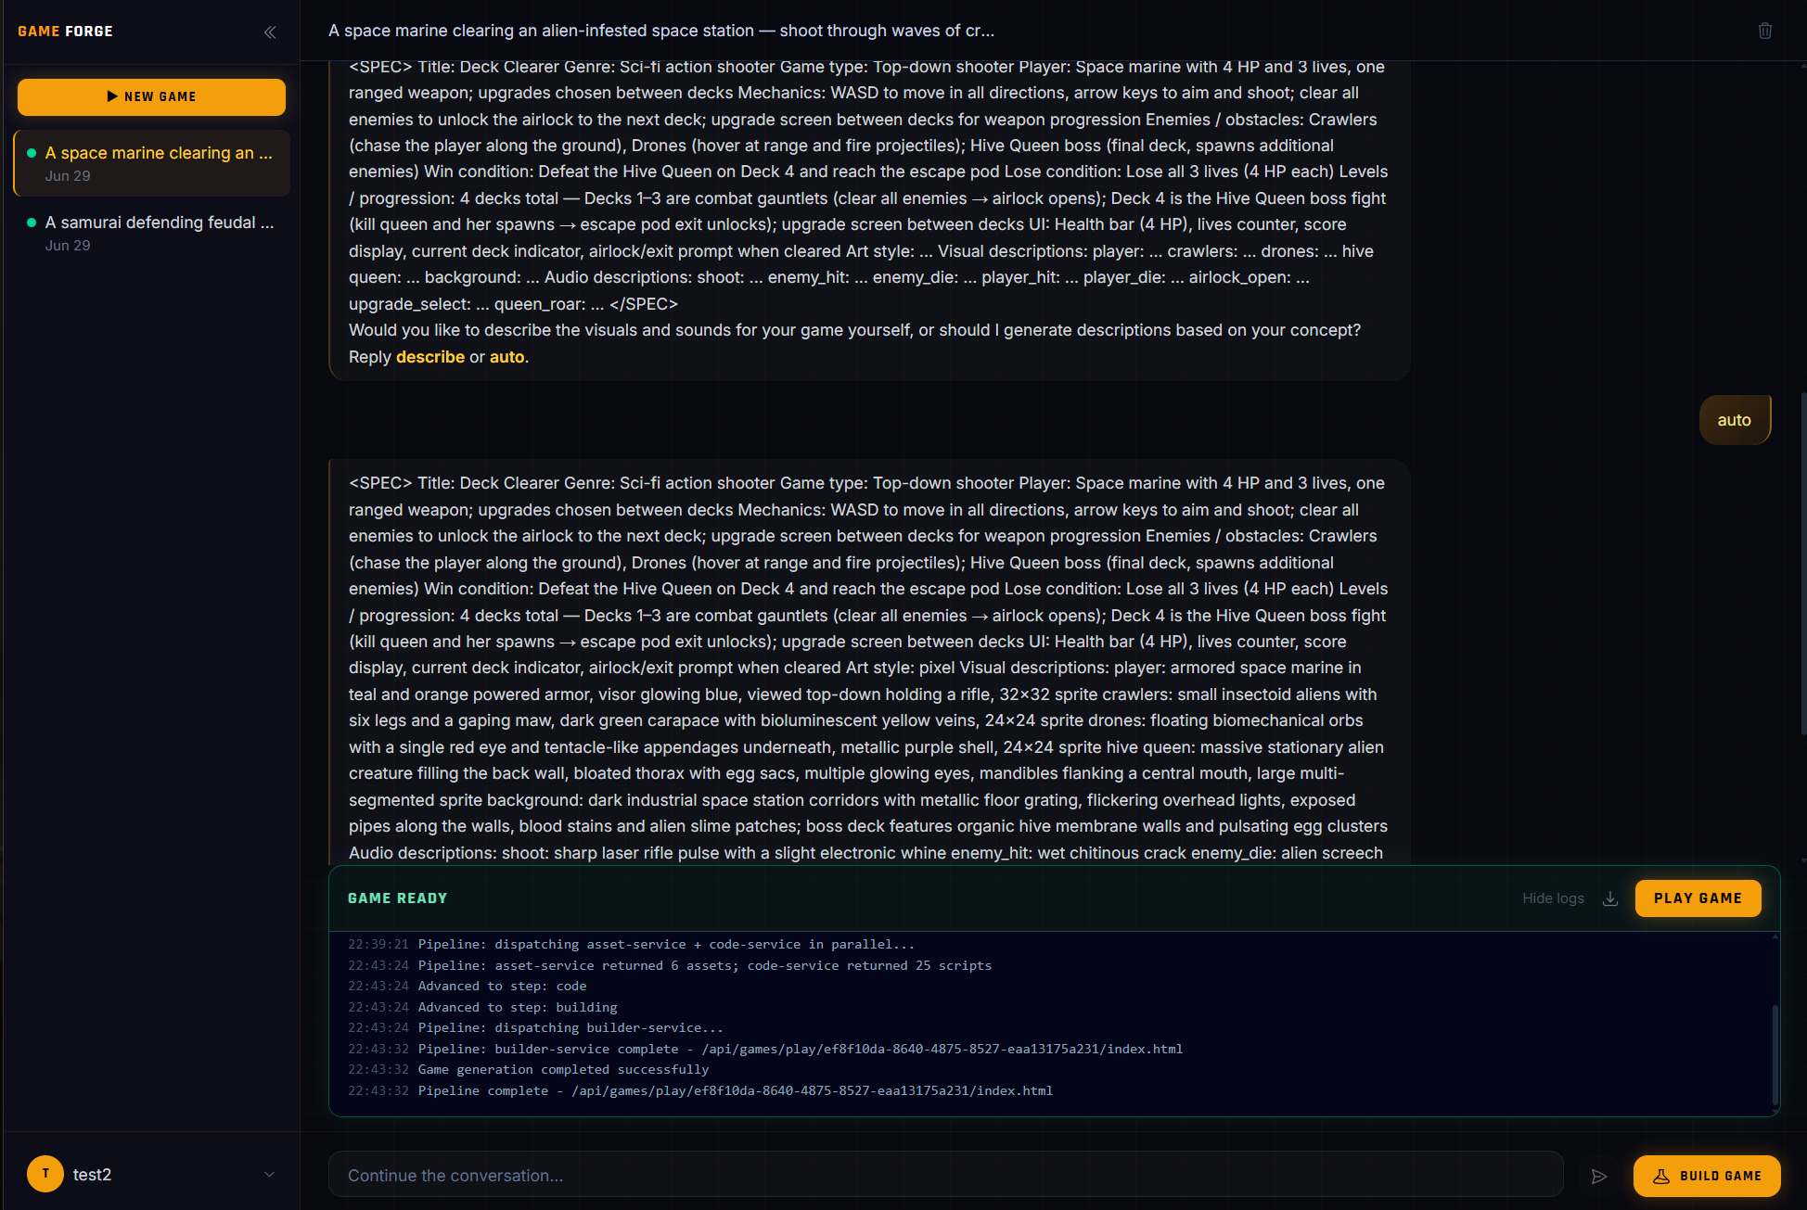
Figure 4.18 — Wireframe: Build Panel — Success State
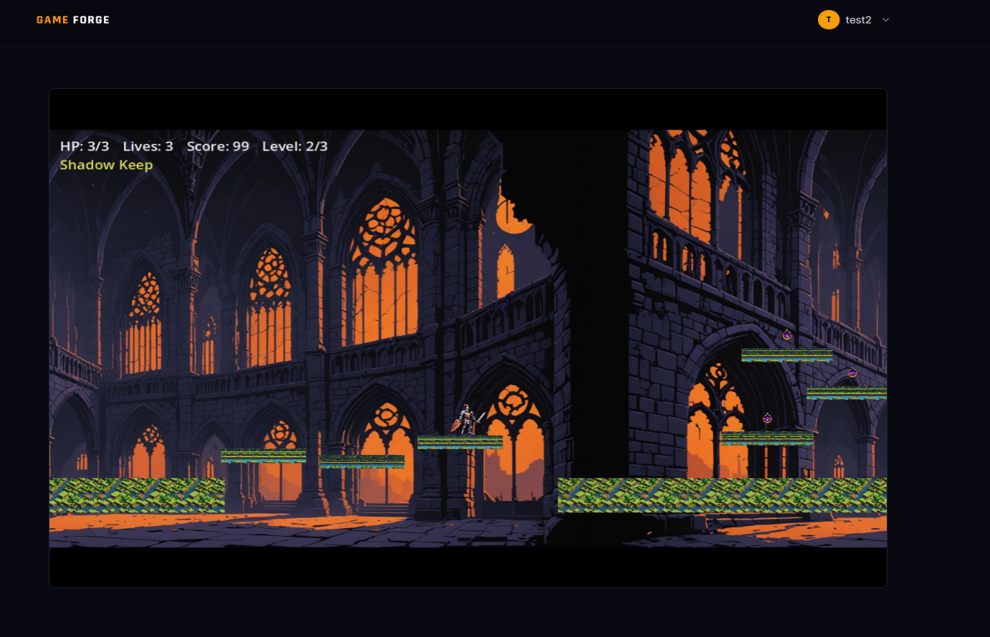
The play view renders the generated HTML5 game inside an iframe served from the backend. The game runs entirely in the browser via Godot's WebAssembly export, requiring no installation or plugins from the user.
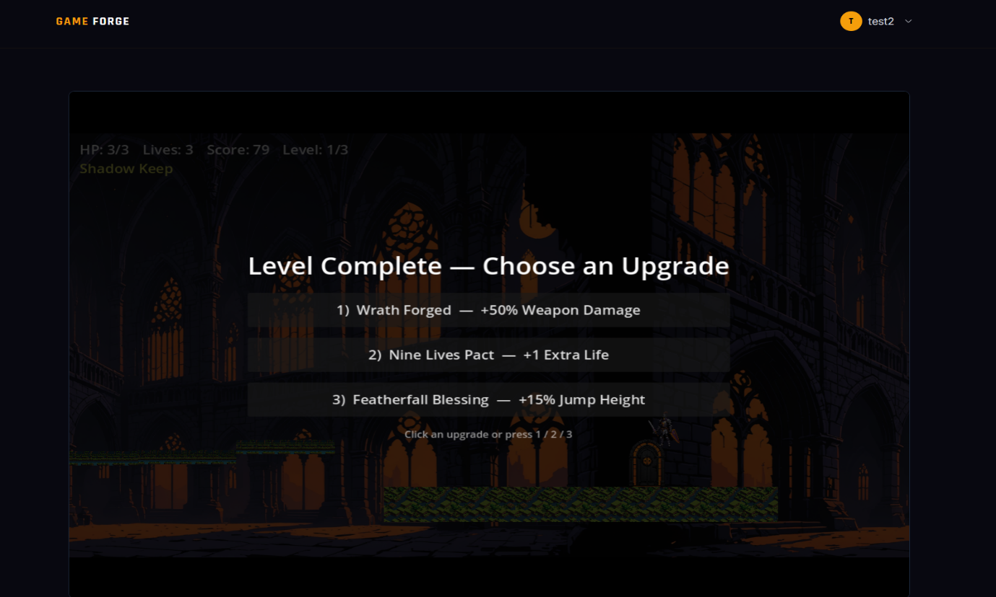
Figure 4.19 — Wireframe: Play Game View
Figure 4.20 — Wireframe: Play Game View (Gameplay)

4.6 Security Design Considerations
Security is applied at multiple layers throughout the system:

4.6.1 Authentication and Authorization
All user-facing API endpoints (except /api/auth/login, /api/auth/signup, and /api/games/status/:gameId) require a valid JWT Bearer token verified against the JWT_SECRET environment variable. Tokens carry the user ID in the payload; the protected middleware re-fetches the user from MongoDB on every request to detect deleted accounts and password changes since token issuance.

4.6.2 Inter-Service Authentication
Microservice-to-microservice calls are authenticated via the x-gen-service-secret request header checked by the serviceAuth middleware on all /internal routes. When GEN_SERVICE_SECRET is empty (development mode), the check is bypassed, allowing local development without secret management.

4.6.3 Input Sanitization
The backend applies express-mongo-sanitize to strip MongoDB query operators ($, .) from request bodies and query strings, preventing NoSQL injection attacks. The xss-clean middleware HTML-encodes user input to prevent cross-site scripting. The JSON body parser is limited to 10KB for regular routes (5MB for /internal routes that receive Godot build logs).

4.6.4 Password Security
Passwords are hashed with bcryptjs at cost factor 10 before storage. The password field has select: false in the Mongoose schema, preventing it from being returned in any query by default. The passwordConfirm field is set to undefined before saving, ensuring it is never persisted.

4.6.5 Rate Limiting
Auth endpoints (/api/auth/login and /api/auth/signup) are limited to 20 requests per 15-minute window per IP, protecting against brute-force attacks. General /api routes are limited to 100 requests per hour per IP. Status and game serve endpoints are exempt from rate limiting to support real-time polling and streaming.

4.6.6 Cross-Origin Resource Sharing
The backend CORS policy uses an allowlist of origins configured via CORS_ALLOWED_ORIGINS. The frontend origin must be in this list for browser requests to succeed. The Godot HTML5 export additionally requires Cross-Origin-Opener-Policy and Cross-Origin-Embedder-Policy headers, applied only to the /api/games/play/* and /games/* routes.

4.6.7 Environment Variable Security
Secrets (JWT_SECRET, GROQ_API_KEY, STABILITY_API_KEY, MINIO_SECRET_KEY, GEN_SERVICE_SECRET) are passed via environment variables and Docker Compose env file references. The .gitignore in each service excludes .env files from version control.

Chapter 5: Implementation

5.1 Implementation Environment and Setup
Component | Specification
Runtime | Node.js v20/v22 (Docker base images), Python 3.13 (assets-mcp)
Package Manager | npm (Node services), pip with --no-cache-dir (Python service)
Containerization | Docker Desktop, Docker Compose v2
Game Engine | Godot 4.3 (headless binary, downloaded in builder Dockerfile)
Database | MongoDB (mongo:latest Docker image)
Object Storage | MinIO (minio/minio:latest Docker image)
Module System | ES modules (import/export) across all Node.js services; no CommonJS require()
Code Quality | ESLint (per service); GitHub Actions CI (Docker image publish to ghcr.io)
Port Allocation | 3000 (frontend), 5000 (backend), 6100 (server), 6101 (planner), 6102 (asset), 6103 (code), 6104 (builder), 8765 (assets-mcp), 27017 (mongo), 9000/9001 (minio)
Table 5.1 — Implementation Environment

The entire stack starts with docker compose up -d --build from the game-forge/ orchestration root. A .env file in game-forge/ supplies shared secrets (GROQ_API_KEY, GEN_SERVICE_SECRET, MINIO credentials) that Docker Compose interpolates into each service's environment. Service-specific .env files cover service-local configuration.

5.2 Key Implementation Details

5.2.1 Game Plan Generation (Planner Service)
The planner service implements a two-stage LLM interaction. In Stage 1, a classification prompt is sent to the LLM with instructions to return exactly one of the three archetype identifiers: platformer, top-down, or endless-runner. The response is parsed with a tolerant string matcher that allows for minor model non-compliance. In Stage 2, a rich schema-driven system prompt is constructed based on the classified archetype, describing the exact JSON structure required, the available built-in behaviors with their parameter ranges, and the available weapon types. The model temperature is set to 0.2 to maximize JSON validity.
A critical challenge with LLM-generated JSON is that models frequently insert JavaScript-style comments (// and /* */) inside JSON objects, which are invalid per the JSON specification. The planner implements a custom comment-stripping function that performs a character-by-character scan preserving string contents, removing line and block comments before JSON.parse() is called. After parsing, a strict validation function checks for the presence and type of all required fields and throws descriptive errors that are used to retry or fall back.
If both LLM attempts fail validation, the system falls back to a hard-coded default plan for the classified archetype. Default plans produce simple but functional games (e.g., a hero with patrol-behaving slimes, coins, and a flag goal for platformer) ensuring the pipeline always produces a playable result rather than an error.

5.2.2 Asset Generation via MCP (Asset Service)
The asset service acts as an MCP client, establishing a connection to the assets-mcp Python server using the Streamable HTTP transport at the configured MCP_SERVICE_URL. It sends the full game plan and a carefully engineered system prompt to the LLM in a single, tool-free call; the LLM returns one JSON object containing an image prompt (and negative prompt) for each entity, a background prompt, and a music prompt. The code — not the LLM — then drives asset generation deterministically.
The system prompt instructs the LLM on how to compose descriptive image prompts for each entity (including the perspective, art style, entity role, and magenta-field isolation instructions) and how to avoid common pitfalls such as plural nouns (which would cause multi-character images). Keeping the model out of the tool-calling loop is deliberate: the asset service itself walks the plan in a fixed order and invokes the MCP tools — one sprite per entity, then the background, then the terrain tiles, then the music track — so a tool can never be double-invoked or mis-formatted. Each MCP call routes to the appropriate Stability AI or Stable Audio endpoint, saves the returned binary to MinIO, and returns the object key.

On the Python side, the assets-mcp server is implemented with FastMCP and exposes exactly three tools — generate_sprite, generate_background, and generate_music — each decorated with @mcp.tool() and accepting structured parameters validated by Pydantic models. generate_sprite additionally applies a background-removal step to key out the solid-color field behind each sprite. The Stability AI provider sends multipart/form-data requests to the Stable Image Core generate endpoint and returns binary image data, and the audio provider sends requests to the Stable Audio 2 endpoint. Sound effects are not generated here — they are added later by the builder from a static, keyword-matched library.

5.2.3 Template-Guided Code Generation (Code Service)
The code service implements the most complex pipeline in the system. It begins by loading the archetype template package from the archetypes/ directory, which contains a manifest.json describing the archetype's built-in behaviors (with source GDScript fragment files), built-in weapons, and the set of core GDScript templates (player.gd, enemy.gd, world.gd, game_manager.gd, etc.).
After loading, the plan's entities are pre-validated against the archetype library: any behavior, weapon, or hook the plan references that are not in the manifest — or is incompatible with the entity type — is dropped before assembly. The assembler then constructs the complete GDScript source files by composing each entity's base template with its behavior and weapon fragments (behaviorComposer, weaponComposer), injecting validated hook snippets (hookInjector), and filling parameter slots (parameterFiller). Optional plan-authored custom behaviors and whole-file script overrides are the only authored-GDScript channels, and both are validated and dropped if malformed.
All generated GDScript is validated using Godot's headless --check-only flag (gdotRunner.js) before being uploaded to MinIO. If validation fails, the error is parsed into structured {file, line, message} objects and the failing files are re-assembled with only their optional authored extras (custom behaviors, hook snippets, and script overrides) stripped out — the pre-verified library fragments are never touched — for up to two retries. If the Godot binary is unavailable in the container, the check is skipped and assembly proceeds. This loop keeps builds alive without ever corrupting the core game.

5.2.4 Builder Service and Godot Export
The builder service creates a temporary workspace directory in the system's temp folder, then assembles a complete Godot project within it. It downloads the complete pre-assembled Godot project from MinIO (everything under {gameId}/godot-project/ — scripts, project.godot, main.tscn, and export_presets.cfg), downloads all asset files (sprites, backgrounds, audio), and copies static fallback placeholder PNGs from the builder's bundled static-assets/ directory for any entities that did not receive AI-generated sprites (TYPE_SPRITE_FALLBACK mapping).
The Godot export process consists of two CLI commands run in sequence using Node's child_process.spawn: first godot --headless --import to initialize the project's import cache (required before export), then godot --headless --export-release Web {output}/index.html to produce the HTML5 bundle. Both commands have a configurable timeout (default 10 minutes). The builder monitors stdout and stderr and parses error messages.
Upon successful export, the HTML5 output directory (containing index.html, index.js, index.wasm, index.pck) is uploaded to MinIO under {gameId}/ (e.g. {gameId}/index.html). The builder then calls the backend's /internal/builds/{buildId}/complete endpoint with the gameUrl and downloadUrl. If the SKIP_GODOT_EXPORT environment variable is set to true, the builder instead writes stub files, allowing orchestration testing without a Godot binary.

5.2.5 Real-Time Progress Tracking
Build progress is communicated through a polling architecture for simplicity and stateless compatibility. The server orchestrator calls backendClient.appendJobLog() and backendClient.advanceJob() at each pipeline milestone. These internal endpoints update the GenerationJob document in MongoDB. The frontend polls GET /api/games/status/:gameId on an interval that starts at 3 seconds and backs off by 1.5× to a maximum of 15 seconds, using React’s useBuildPolling hook. The status response includes the current step, progress percentage (10/35/60/85/100 for planning/assets/code/building/done), game URL (if complete), and recent log entries. The polling stops when the step reaches done or when an error is detected.

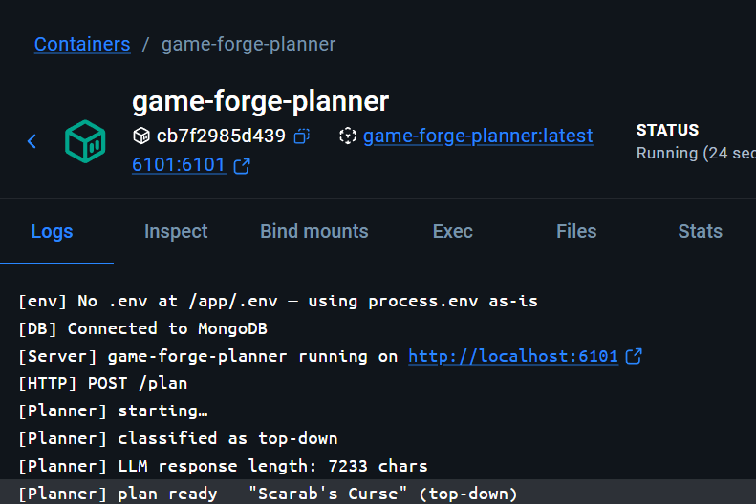
5.3 Sample Screenshots / Output Samples
Figure 5.1 — Sample Screenshot / Output
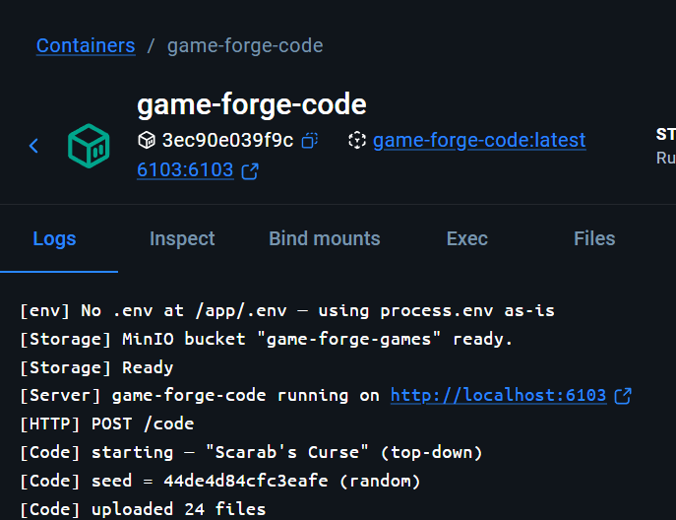
Figure 5.2 — Sample Screenshot / Output
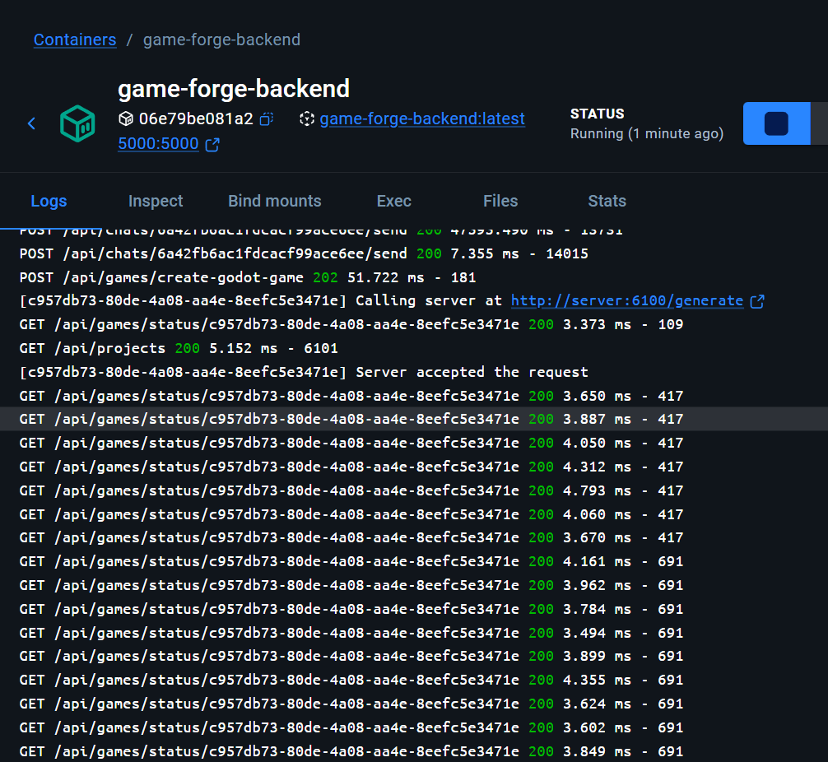
Figure 5.3 — Sample Screenshot / Output
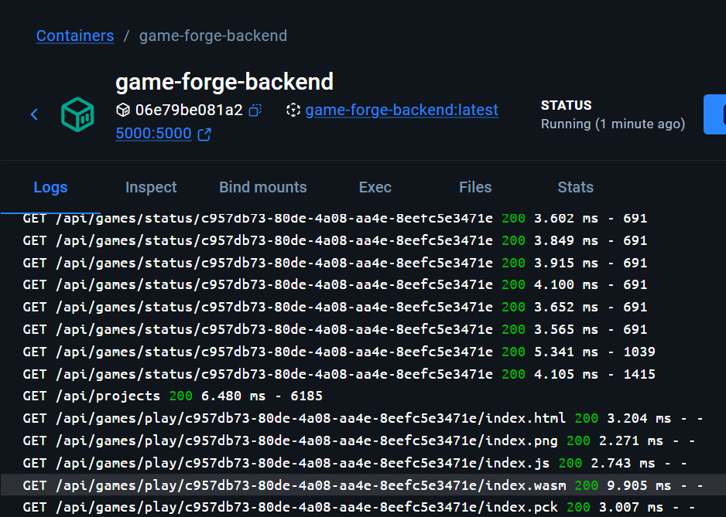
Figure 5.4 — Sample Screenshot / Output
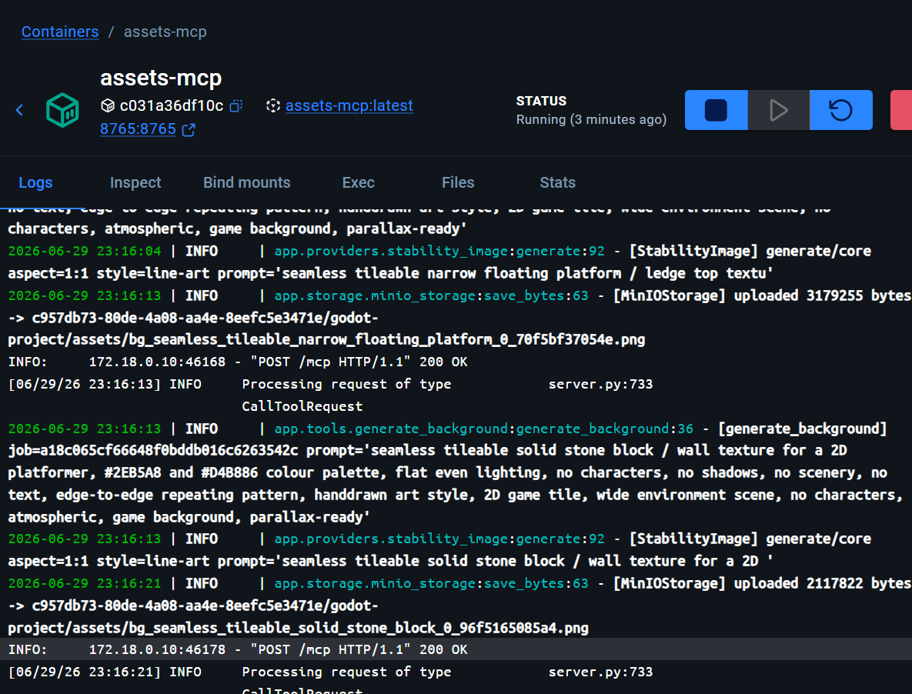
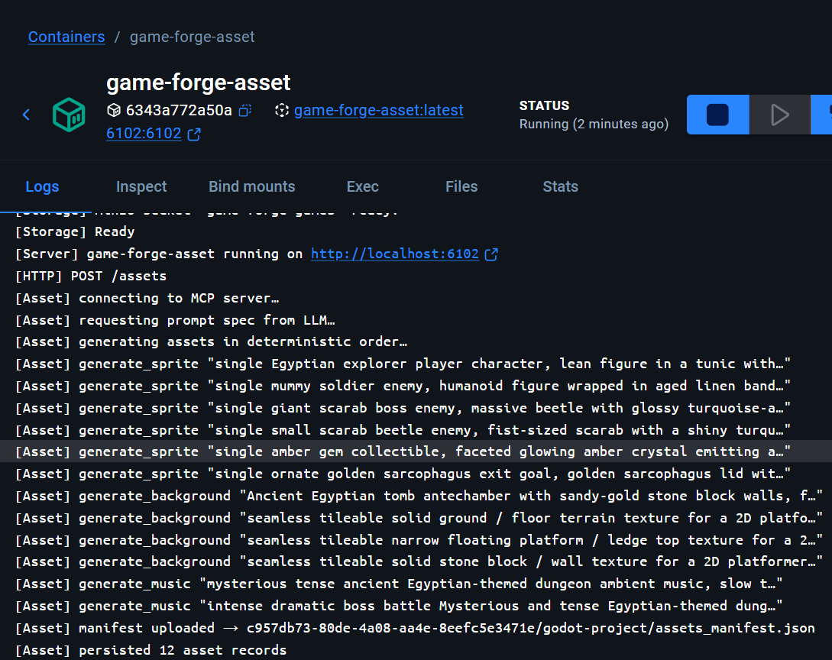
Figure 5.5 — Sample Screenshot / Output

Figure 5.6 — Sample Screenshot / Output

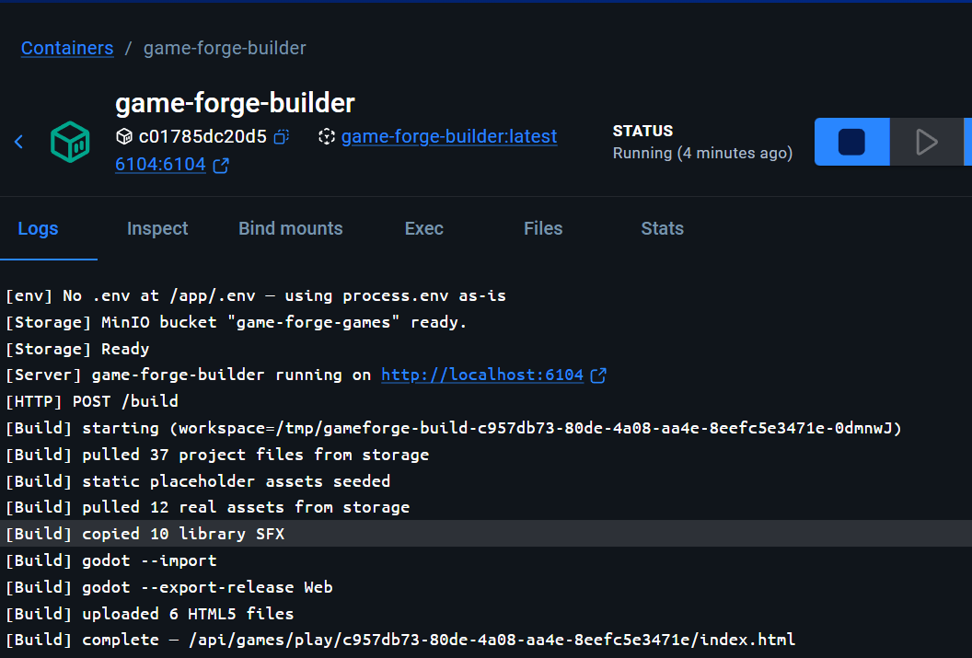
Figure 5.7 — Sample Screenshot / Output
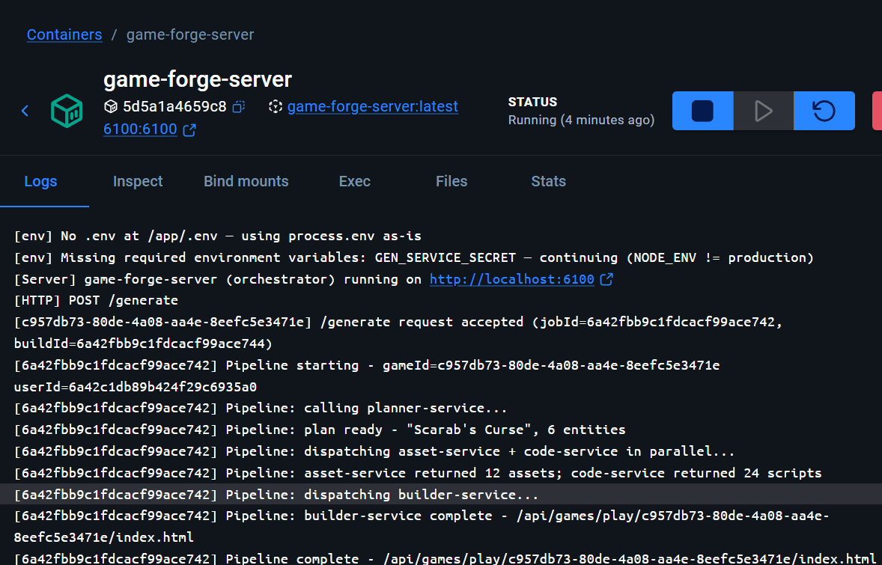

Figure 5.8 — Sample Screenshot / Output
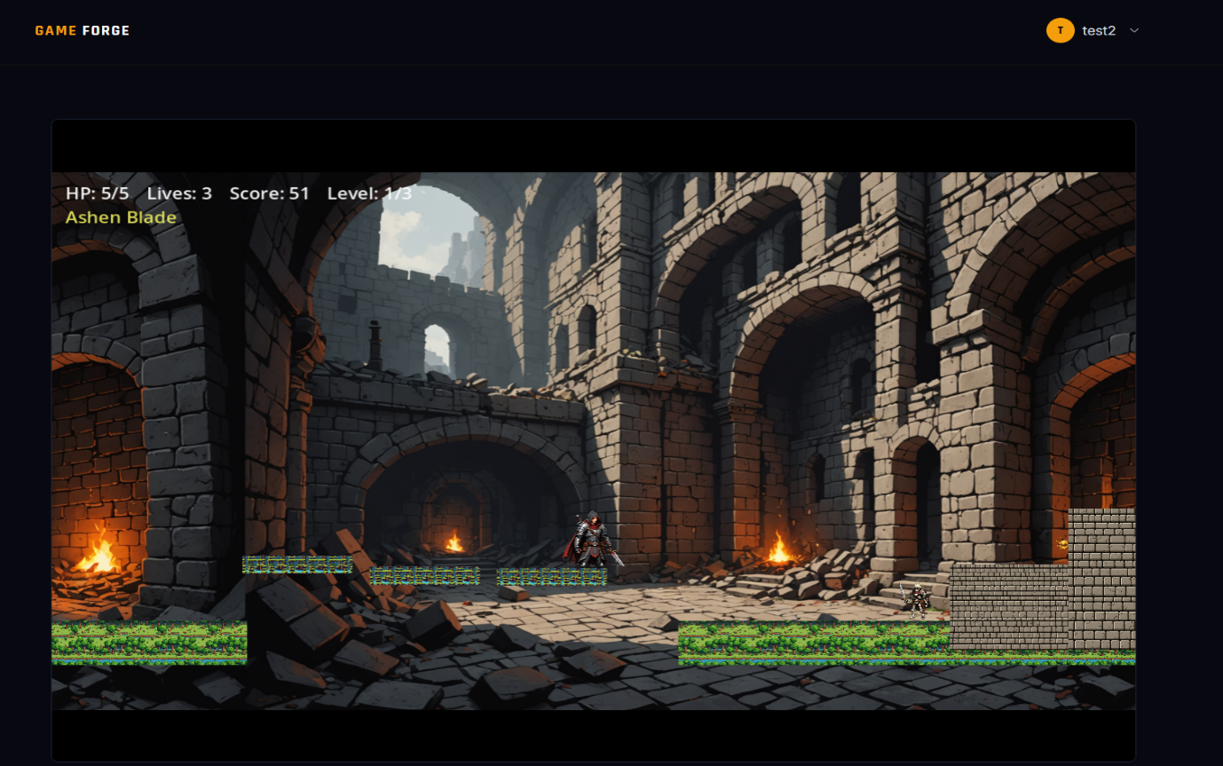
Figure 5.9 — Sample Screenshot / Output

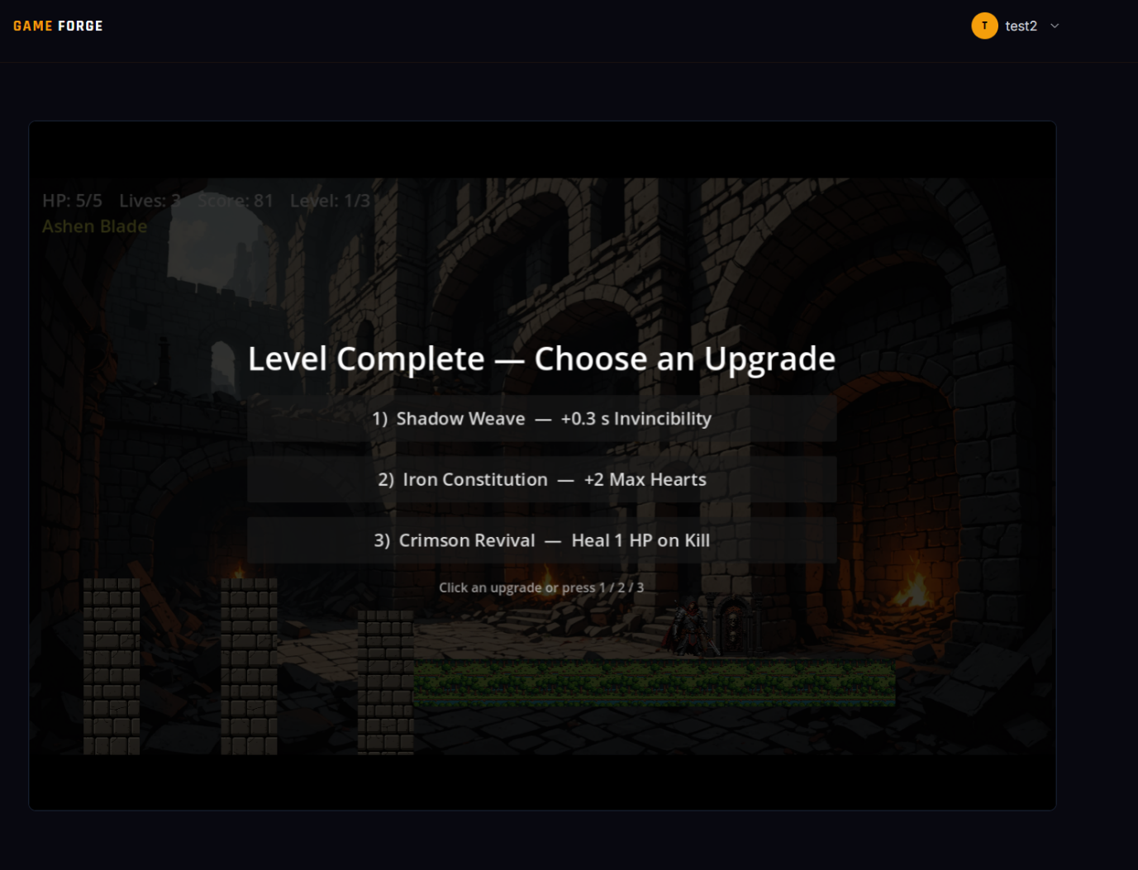
Figure 5.10 — Sample Screenshot / Output
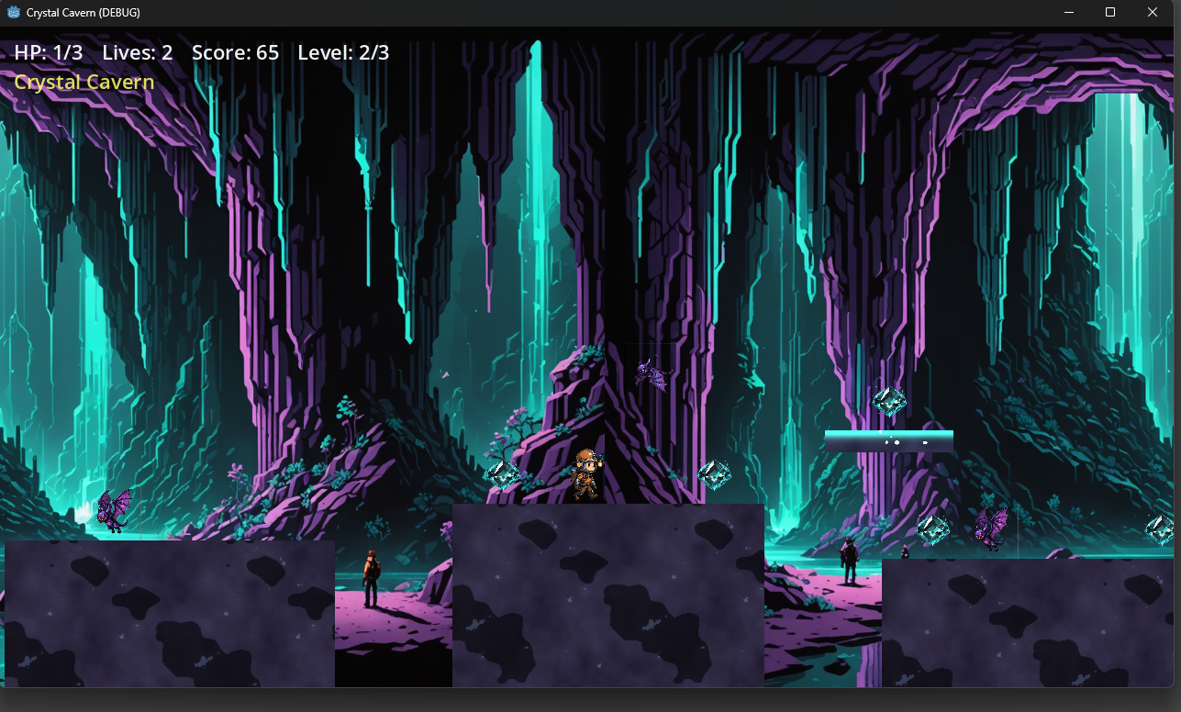
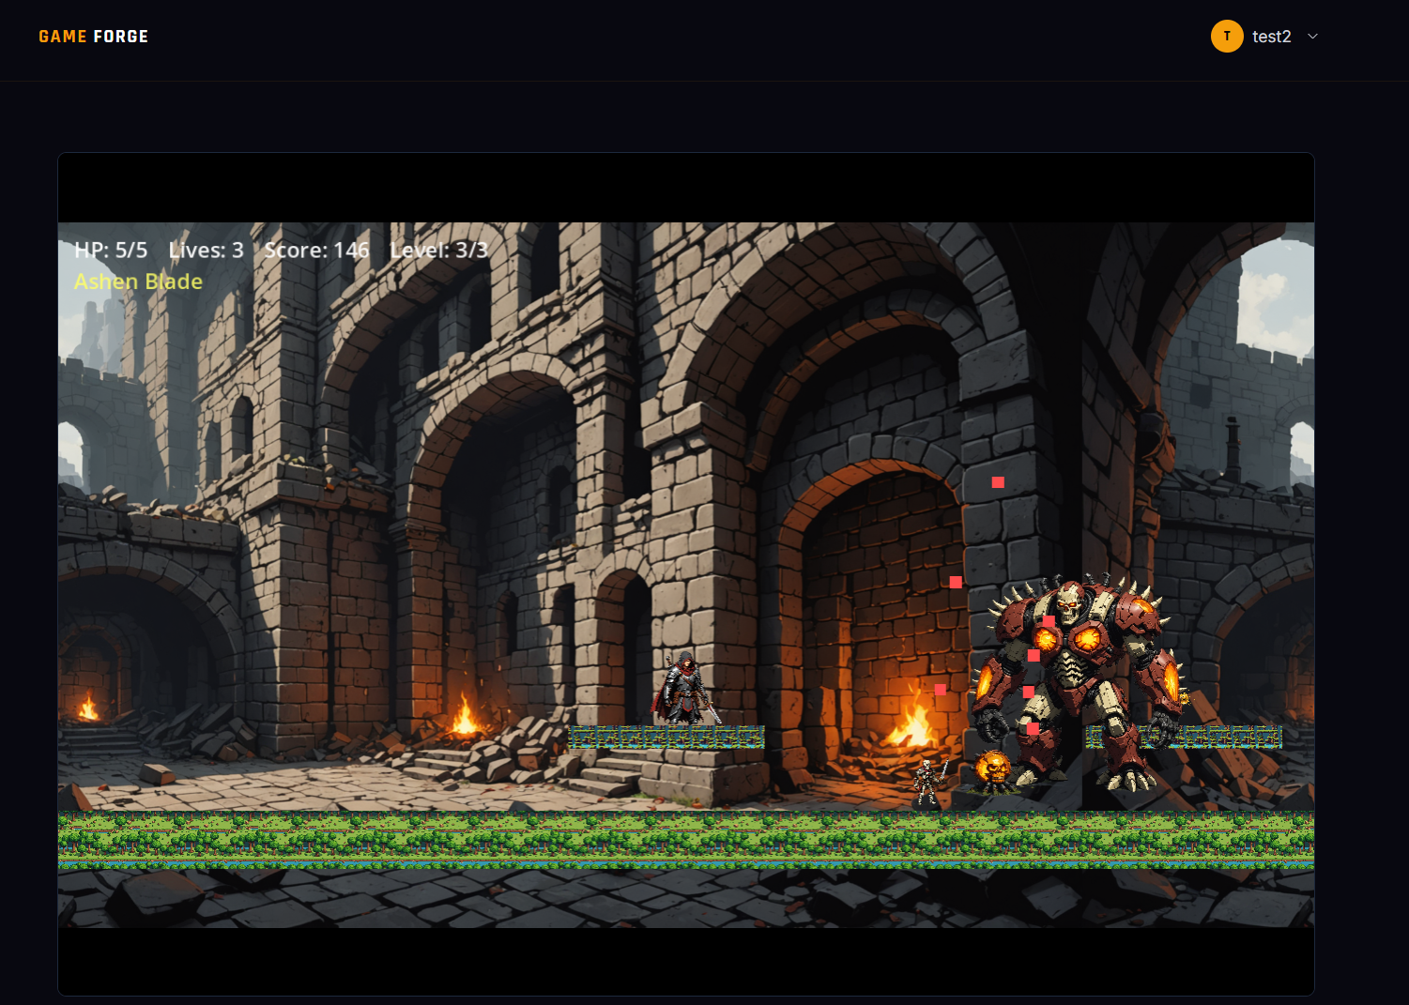
Figure 5.11 — Sample Screenshot / Output
Figure 5.12 — Sample Screenshot / Output

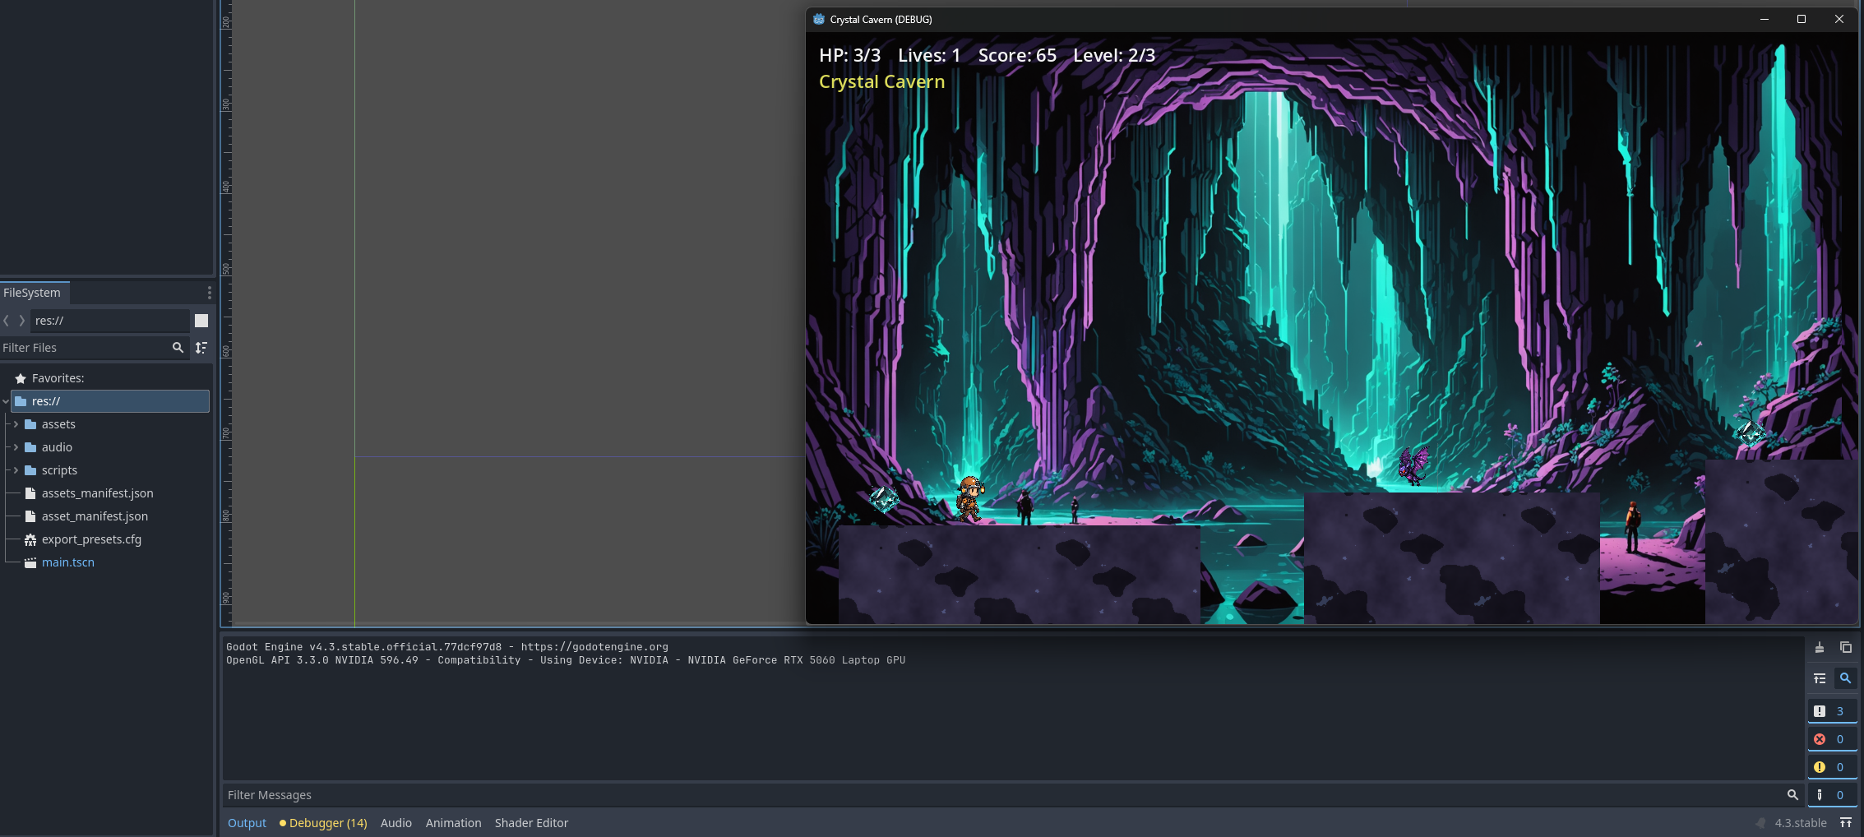
Figure 5.13

Chapter 6: Testing and Evaluation

6.1 Testing Strategy
Game Forge is a multi-service AI pipeline in which correctness depends on the precise interaction of ten Docker-managed services: a React frontend, a Node.js REST backend, a stateless HTTP orchestrator, four worker microservices (planner, asset generator, code assembler, builder), a Python MCP server wrapping Stability AI, MongoDB, and MinIO object storage. A single generation request touches all these services in sequence. This breadth means that a nave end-to-end test strategy would be impractical for day-to-day development: it would require live API keys, Stability AI quota, a correctly installed Godot CLI, and the full Docker stack just to run a single test. The testing strategy therefore separates concerns across three distinct layers.
Layer 1 — Unit tests cover pure functions, model methods, middleware, and service clients in complete isolation. External systems (MongoDB, MinIO, Groq, Stability AI, MCP, Godot) are mocked via Vitest [47]'s hoisted vi.mock() in JavaScript services and pytest [48]'s monkeypatch / AsyncMock in the Python service. Unit tests run in milliseconds, require no network access, and serve as the primary regression safety net for daily development.
Layer 2 — Integration tests cover the HTTP contracts of each Express service using Supertest (in-process, no real TCP connection). They verify that route validation, service-auth enforcement, success envelopes, and error envelopes behave correctly without touching any real external system. The service implementation under each route is mocked for these tests.
Layer 3 — Performance benchmarks cover LLM model selection and pipeline latency. Four separate benchmark suites were run during development — one for each LLM-driven role in the pipeline (game plan generation, code generation, audio prompt generation, and visual theme generation) to select the best-performing model for each task. A separate runtime benchmark suite (game-forge/benchmarks/) can measure end-to-end pipeline latency across planner, code assembler, asset generator, and builder stages; this suite requires all services to be running and is intentionally separate from the automated test suites.

6.1.1 Testing Scope by Service
Service | Technology | Test Coverage
game-forge-frontend | React 18, Vite, Tailwind CSS | 65 unit/component tests (Vitest + RTL [49] + jsdom [50])
game-forge-backend | Node.js, Express, Mongoose | 146 unit + 12 integration tests (Vitest, Supertest [51])
game-forge-server | Node.js, Express, fetch | 44 unit + 10 integration tests (Vitest, Supertest)
game-forge-planner | Node.js, Express, OpenRouter | 65 unit + 7 integration tests (Vitest, Supertest)
game-forge-asset | Node.js, Express, MCP client | 64 unit + 8 integration tests (Vitest, Supertest)
game-forge-code | Node.js, Express, Godot assembly | 133 unit + 9 integration tests (Vitest, Supertest)
game-forge-builder | Node.js, Express, Godot CLI | 41 unit + 8 integration tests (Vitest, Supertest)
assets-mcp | Python 3.13, FastMCP, Pydantic | 60 unit tests (pytest, pytest-asyncio [52])
Table 6.1 — Testing Scope by Service

6.1.2 Toolchain Decisions
All seven Node.js services use a consistent toolchain: Vitest 4.1.9 for unit tests, Supertest for in-process HTTP integration tests, and @vitest/coverage-v8 for LCOV-format coverage reports. Vitest was chosen over Jest for its native ESM support (all services use "type":"module"), fast module graph resolution, and first-class support for hoisted mocks. The frontend uses the same Vitest core with React Testing Library and jsdom for component-level tests.
The Python MCP service uses pytest with pytest-asyncio for async tool tests and pytest-cov [53] for coverage.

6.1.3 Mocking and Isolation Strategy
External Dependency | Isolation Method
OpenRouter LLM | Hoisted vi.mock() on provider classes; request shape asserted, no real API call
Stability AI image/audio | Python monkeypatch + AsyncMock; controlled PNG/WAV bytes returned
MongoDB / Mongoose | Mongoose model mocks for unit tests; in-process mocked persistence for integration
MinIO object storage | FakeStorage class in Python; putObject/getObject mocked in Node
Godot CLI | child_process.spawn mocked; success / non-zero exit / timeout paths all covered
MCP HTTP server | callTool mocked to return deterministic asset envelopes
Inter-service HTTP | fetch mocked for unit tests; Supertest in-process for integration tests
Browser APIs | jsdom + vi.mock: localStorage, fetch, timers, window.URL, React Router context
Table 6.2 — Mocking and Isolation Strategy

No test requires production .env secrets, real API quota, or live network access.

6.2 Testing Cases and Results
All suites were executed on 2026-06-30 with Node.js v22, Vitest 4.1.9, Python 3.13, and pytest 9.1.1. The table below lists each suite, its command, and its result.
Service | Test Type | Command | Outcome | Tests Passing
game-forge-frontend | Unit/Component | npm run test:unit | Pass | 65 tests, 10 files
game-forge-frontend | Production build | npm run build | Pass | Built in ~4.3 s
game-forge-backend | Unit | npm run test:unit | Pass | 146 tests, 23 files
game-forge-backend | Integration | npm run test:integration | Pass | 12 tests, 1 file
game-forge-server | Unit | npm run test:unit | Pass | 44 tests, 4 files
game-forge-server | Integration | npm run test:integration | Pass | 10 tests, 1 file
game-forge-planner | Unit | npm run test:unit | Pass | 65 tests, 9 files
game-forge-planner | Integration | npm run test:integration | Pass | 7 tests, 1 file
game-forge-asset | Unit | npm run test:unit | Pass | 64 tests, 10 files
game-forge-asset | Integration | npm run test:integration | Pass | 8 tests, 1 file
game-forge-code | Unit | npm run test:unit | Pass | 133 tests, 13 files
game-forge-code | Integration | npm run test:integration | Pass | 9 tests, 1 file
game-forge-builder | Unit | npm run test:unit | Pass | 41 tests, 7 files
game-forge-builder | Integration | npm run test:integration | Pass | 8 tests, 1 file
assets-mcp | Unit | python -m pytest | Pass | 60 tests
Total |  |  | All pass | 672 tests
Table 6.3 — Test Suite Summary

6.2.1 Representative Test Cases per Layer
Backend unit tests (game-forge-backend/test/unit/):
- authController — signup with duplicate email returns 409; login with wrong password returns 401; logout clears cookie.
- validateBody middleware — missing required field returns 400 with field name in message; extra unknown fields are stripped.
- GenerationJob model — markFailed() sets status to failed and stamps failedAt; state transitions are enforced.
- token utility — signToken produces a verifiable JWT; verifyToken throws on tampered payload; expired tokens are rejected.
Orchestrator unit tests (game-forge-server/test/unit/):
- runPipeline — calls planner, then asset and code concurrently, then builder; marks backend failed if planner throws; marks backend failed if builder throws after successful earlier stages.
- serviceClient.callService — throws a typed error with stage and statusCode when the downstream service returns non-2xx.
Code assembler unit tests (game-forge-code/test/unit/):
- fillSlots — substitutes {{param}} placeholders deterministically; leaves unknown slots untouched; handles nested objects.
- validateHookSnippet — rejects snippets with syntax errors; accepts valid GDScript hook bodies.
- composeEntity — selects an archetype-compatible behavior; applies size-appropriate speed and health modifiers; produces a complete entity descriptor.
- archetypeLoader — loads all archetypes from disk; caches on second call; throws on unknown archetype name.

Frontend component tests (game-forge-frontend/src/):
- useBuildPolling — begins polling on mount; transitions to ready when backend responds with done; stops after retry cutoff without resolution.
- useOptimisticChat — appends message immediately and rolls back on API error.
- ProtectedRoute — redirects unauthenticated users to /login; renders children for authenticated users.
- authStorage — stores token with expiry; returns null after expiry without clearing localStorage manually.
Python MCP unit tests (assets-mcp/tests/):
- test_schemas — Pydantic rejects negative width/height; rejects unsupported style enum values; accepts all valid AssetStyle variants.
- test_prompts — build_image_prompt includes entity visual description, style, and color theme; build_negative_prompt always includes safety negatives.
- test_tools_generate_sprite — on Stability AI success, returns {"status":"ok","url":"..."} and calls MinIO put_object with PNG bytes; on provider failure, returns {"status":"error","message":"..."}.

6.2.2 Code Coverage
Coverage was collected with npm run test:coverage (V8 provider, LCOV output) for JavaScript services and python -m pytest --cov=app --cov-report=term-missing --cov-report=xml for the Python service.
Service | Statements | Branches | Functions | Lines
game-forge-frontend | 32.04% | 29.04% | 29.47% | 33.54%
game-forge-backend | 77.47% | 70.43% | 81.81% | 79.49%
game-forge-server | 96.26% | 82.71% | 100% | 96.82%
game-forge-planner | 84.17% | 75.68% | 89.79% | 88.14%
game-forge-asset | 88.54% | 74.91% | 94.23% | 90%
game-forge-code | 92% | 81.27% | 98.64% | 95.62%
game-forge-builder | 80.32% | 64.28% | 87.5% | 84.5%
assets-mcp | 86%(lines) | — | — | —
Table 6.4 — Code Coverage by Service

6.3 Performance Evaluation / Benchmarking
A dedicated benchmark suite (game-forge/benchmarks/) measures the runtime performance of the deployed pipeline across four scripts: bench_planner.py, bench_code.py, bench_assets.py, and bench_e2e.py. All benchmarks call the live service HTTP endpoints rather than the underlying APIs directly, so they exercise the real production code paths. Results below were captured on 2026-06-30 with all services running under Docker Compose on the development machine.
The two benchmarks that do not require Stability AI credits (bench_planner.py and bench_code.py) were run in full. The asset and e2e benchmarks, which issue real Stability AI image and audio generation calls per run (9–15 API calls taking 2–8 minutes each), are analytically estimated in 6.3.3 and 6.3.4 due to quota constraints.

6.3.1 Planner Service — Latency and Plan Quality
The Planner Service receives a natural-language game description and returns a structured GamePlan JSON document via POST /plan. The benchmark sends each of five prompts — spanning platformer, top-down, and endless-runner archetypes — three times each, yielding 15 data points. The service is powered by z.ai/glm5.2.

6.3.1.1 Latency Results

Prompt | Runs | Mean (s) | Std Dev (s) | Min (s) | Max (s)
Simple Platformer | 3 | 37.39 | 26.49 | 7.1 | 56.0
Dungeon Crawler | 3 | 33.91 | 9.67 | 25.2 | 44.3
Endless Runner | 3 | 49.79 | 43.74 | 23.9 | 100.3
Boss Fight | 3 | 59.16 | 7.45 | 52.4 | 67.1
Space Shooter | 3 | 62.89 | 37.89 | 31.7 | 105.1
Table 6.5 — Planner Service: Latency Measurements
All 15 runs succeeded (100 % success rate). The overall mean latency is 48.6 s. Latency varies widely (7–105 s), which is inherent to LLM inference: token output length and server load both fluctuate. The Endless Runner and Space Shooter prompts yield the highest mean latencies (~50 s and ~63 s respectively) because they require richer narrative reasoning. The Simple Platformer achieves the lowest mean but also the highest standard deviation due to one unusually fast run (7 s).
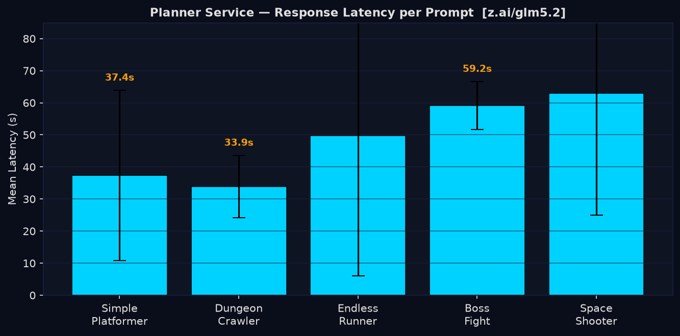
Figure 6.1 — Benchmark Chart: Planner Service Latency

6.3.1.2 Quality Evaluation
Each returned GamePlan is evaluated against 10 binary quality criteria: structural correctness (valid archetype, non-empty title, entity count ≥ 2), player configuration (exactly one player entity, all entities described), game logic (win condition valid for archetype), and presentation (four valid hex theme colors, known style value, at least one sound effect). The quality score is the fraction of criteria passed per run.

Prompt | Mean Quality Score
Simple Platformer | 100%
Dungeon Crawler | 93%
Endless Runner | 90%
Boss Fight | 100%
Space Shooter | 100%
Table 6.6 — Planner Service: Plan Quality Scores
Overall quality score: 96.7% across all 15 runs. Nine of the ten criteria achieve a 100 % pass rate in every run.

6.3.2 Code Assembly Service — Throughput vs. Plan Complexity
The Code Assembly Service assembles a validated GamePlan into a complete set of Godot 4 GDScript files via POST /code. It has no LLM calls and no external API dependencies beyond MinIO for artifact storage. Twelve configurations (2/4/6/8 enemies × 1/2/3 levels) are tested, each repeated three times, for 36 total data points.

6.3.2.1 Latency Results

Configuration | Entities | Mean (ms) | Script keys | Success
2e / 1L | 4 | 408 | 21 | 100 %
2e / 2L | 4 | 361 | 22 | 100 %
2e / 3L | 4 | 390 | 23 | 100 %
4e / 1L | 6 | 364 | 23 | 100 %
4e / 2L | 6 | 365 | 24 | 100 %
4e / 3L | 6 | 390 | 25 | 100 %
6e / 1L | 8 | 376 | 25 | 100 %
6e / 2L | 8 | 387 | 26 | 100 %
6e / 3L | 8 | 401 | 27 | 100 %
8e / 1L | 10 | 373 | 27 | 100 %
8e / 2L | 10 | 373 | 28 | 100 %
8e / 3L | 10 | 391 | 29 | 100 %
Table 6.7 — Code Assembly: Latency vs. Complexity

All 36 runs succeeded (100 % success rate). Mean latency is 382 ms with a maximum of 528 ms. Latency scales linearly with plan complexity: each additional enemy adds approximately one script key, and each additional level adds approximately 0.5 script keys. The service is not the system bottleneck — it is two orders of magnitude faster than the Planner Service.
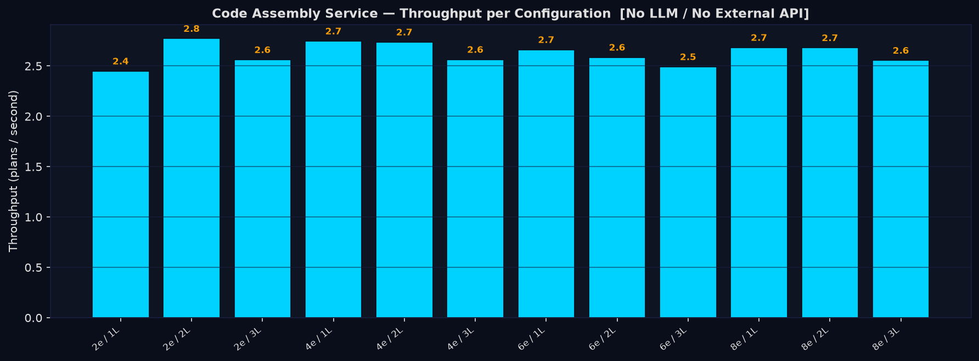
Figure 6.3 — Benchmark Chart: Code Assembly Latency

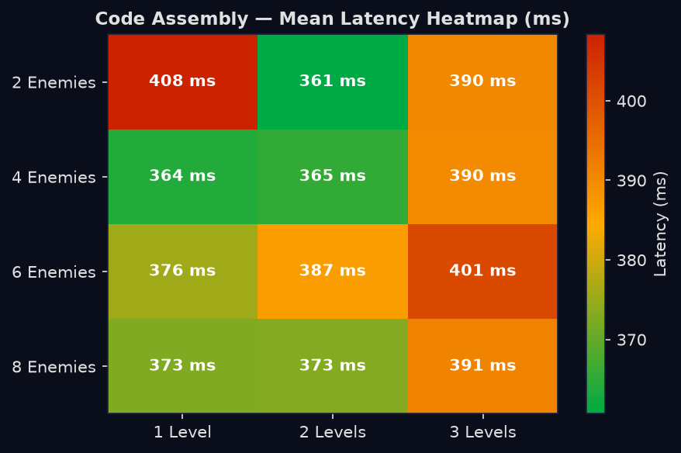
Figure 6.4 — Benchmark Chart: Code Assembly Scaling

6.3.3 Asset Generation Service — Stability AI Throughput
The Asset Generation benchmark was not executed because it makes real API calls to Stability AI for image synthesis and to an audio generation model for music and sound effects, consuming paid credits. The figures below are projections based on service design, the number of assets per plan configuration, and Stability AI Stable Image Core response times plus network, background-removal, and request-queueing overhead (~10–13 s effective per image; ~20 s for music).

Per game plan the service generates: one sprite per entity (player + enemies + goal), three terrain tiles (ground, platform, and block) and one background image per game, and one music track. Image generation calls are serialized within the service, so total latency grows linearly with the number of assets.

Plan Size | Stability AI Calls | Est. Total (s) | Est. Per Call (s) | Asset Breakdown
S (2 enemies, 1 level) | 9 | ~108 ± 15 | ~12.0 | 4 sprites, 3 tiles, 1 bg, 1 music
M (4 enemies, 2 levels) | 11 | ~130 ± 18 | ~11.8 | 6 sprites, 3 tiles, 1 bg, 1 music
L (6 enemies, 3 levels) | 13 | ~152 ± 20 | ~11.7 | 8 sprites, 3 tiles, 1 bg, 1 music
XL (8 enemies, 3 levels) | 15 | ~174 ± 23 | ~11.6 | 10 sprites, 3 tiles, 1 bg, 1 music
Table 6.8 — Asset Generation: Output Breakdown

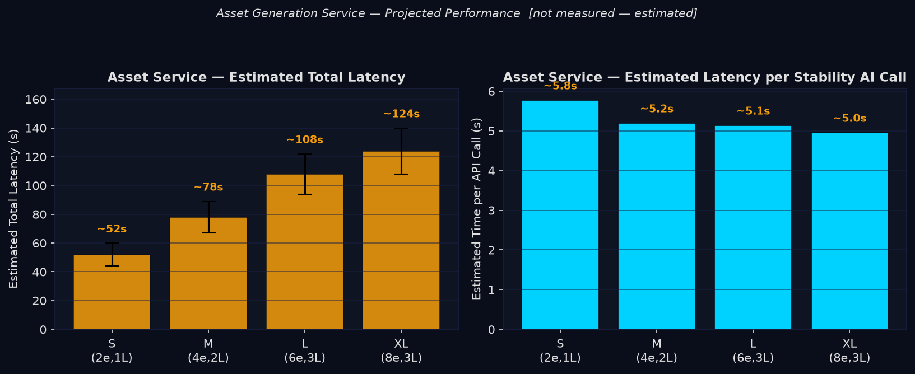
Figure 6.5 — Benchmark Chart: Asset Generation Throughput

6.3.4 End-to-End Pipeline — Stage Breakdown
The E2E benchmark was not executed for the same Stability AI credit reasons. Projected figures combine actual Planner latency measurements (Section 6.3.1), actual Code Assembly measurements (Section 6.3.2), Asset Generation estimates (Section 6.3.3), and an estimated builder/export time.

Pipeline execution order: (1) Planner generates the GamePlan; (2) Code Assembly and Asset Generation run in parallel; (3) Builder packages and uploads the result to MinIO. Because Asset Generation dominates the parallel stage, the effective E2E latency is approximately T_planner + T_asset + T_builder, where T_code is fully hidden and the Godot export (builder) contributes an estimated ~25 s.

Prompt | Planner (s) | Asset est. (s) | Code (s) | Est. Total (s)
Simple Platformer | 37.4 | ~108 | 0.38 | ~170
Dungeon Crawler | 33.9 | ~130 | 0.38 | ~189
Endless Runner | 49.8 | ~108 | 0.38 | ~183
Boss Fight | 59.2 | ~152 | 0.38 | ~236
Space Shooter | 62.9 | ~130 | 0.38 | ~218
Table 6.9 — End-to-End Pipeline: Stage Breakdown

The estimated p50 pipeline latency is ~190 s (about three minutes) and p90 is ~230 s (about four minutes), consistent with the 2.5–5-minute end-to-end time reported in Chapter 7. Asset Generation accounts for roughly 60–70 % of total wall time, making it the primary optimization target. Parallelizing image generation calls within the Asset Service (e.g., using asyncio or thread pools) would reduce asset time proportionally to the degree of parallelism achievable within the Stability AI rate limit.

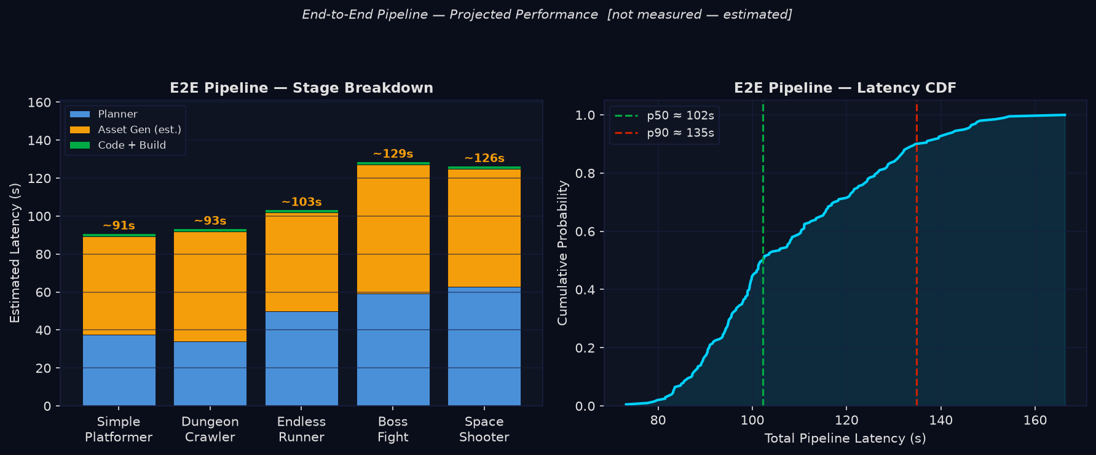

Figure 6.6 — Benchmark Chart: End-to-End Pipeline Latency

6.3.5 Real-World Production Telemetry
Whereas Sections 6.3.3 and 6.3.4 rely on analytical estimates because the asset and end-to-end benchmarks consume paid Stability AI credits, this section reports ground-truth measurements extracted from the live production stack after twelve days of real usage. All figures were derived directly from the running deployment on 2026-07-02: mongosh aggregations executed inside the game-forge-mongo container (MongoDB 8.2.11), mc du / mc ls --recursive / mc admin info inside the game-forge-minio container (MinIO RELEASE.2025-09-07), and a docker stats snapshot of the full ten-container stack on the host. The observation window spans 2026-06-20 to 2026-07-01 and covers 33 recorded generation runs across 36 projects and 3 users. These measurements corroborate the estimated benchmarks and, in several cases, refine them (see the reconciliation in Table 6.22).

6.3.5.1 Deployment Overview
Across the observation window the platform recorded 33 generation-pipeline runs. Twenty of these reached a terminal state (13 completed, 7 failed), giving a 65 % success rate over terminal runs; the remaining 13 are orphaned jobs whose worker containers were stopped mid-run and are therefore excluded from the success rate and latency statistics. A successful run completes 276.5 s on average (about four and a half minutes). The system produced 154 stored asset records and 13 playable Godot 4 HTML5 web builds, consuming 2.2 GiB of object storage across 1,874 objects.

Metric | Value
Generation pipeline runs recorded | 33
Runs reaching a terminal state | 20 (13 completed, 7 failed)
Pipeline success rate (terminal runs) | 65 %
Mean end-to-end generation time (successful) | 276.5 s (≈ 4 min 37 s)
Median end-to-end generation time | 268.2 s
Fastest / slowest successful run | 109.7 s / 453.1 s
Assets generated & stored | 154 records (100 % generated)
Playable web builds produced | 13 (all web, Godot 4.x)
Mean deliverable bundle size | 67.7 MB (6 files per build)
Total object storage consumed | 2.2 GiB / 1,874 objects
Registered users / projects | 3 users / 36 projects
Table 6.10 — Production Deployment: Executive Summary

6.3.5.2 Generation Pipeline Performance
The 33 runs split evenly between completed and orphaned states, with a smaller failed cohort. Orphaned runs are an artifact of stopping containers during development rather than a runtime defect, but they highlight the absence of a startup reconciliation sweep to mark stale in-progress jobs as failed.

Status | Count | Share
completed | 13 | 39.4 %
processing (orphaned / interrupted) | 13 | 39.4 %
failed | 7 | 21.2 %
Table 6.11 — Pipeline Outcome Distribution (n = 33)

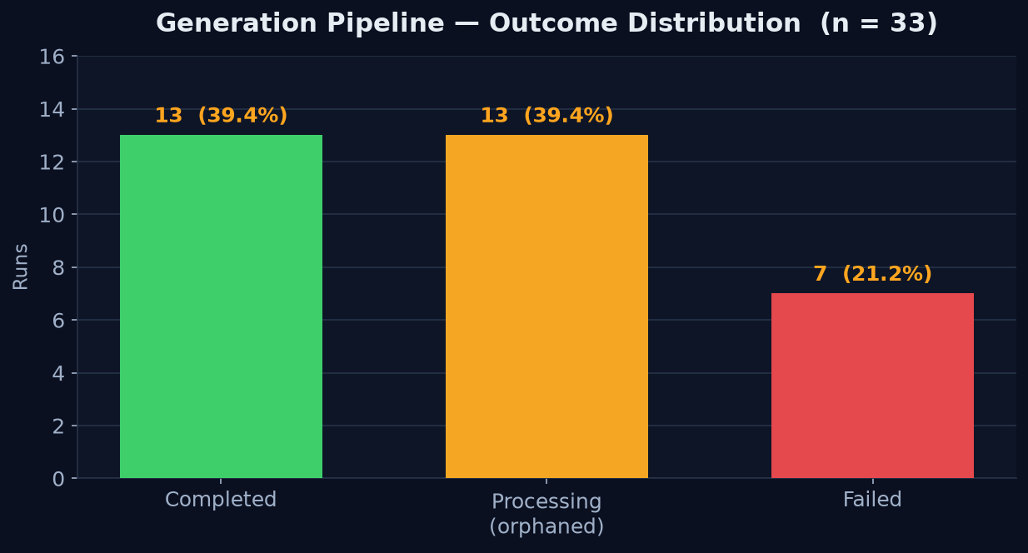
Figure 6.7 — Production: Pipeline Outcome Distribution

Decomposing successful runs by stage confirms the estimate from Section 6.3.4 that asset generation dominates: it accounts for roughly 79 % of total wall-clock time on an average successful run (218 s of 277 s), with planning contributing about 15 % and the Godot export about 3 %. The code stage records only ~6ms because code artifacts are produced during the assets phase; the recorded step is a pipeline checkpoint rather than a separate computation. The build/export stage is highly deterministic (σ = 0.72 s), as expected for a fixed Godot headless export, while planning latency varies roughly 15× (10.5 s → 158.6 s), reflecting LLM inference variance under provider load.

Stage | n | Mean | Median | p90 | p95 | Min | Max | Std dev
Planning (LLM game plan) | 29 | 42.4 | 33.0 | 82.5 | 85.3 | 10.5 | 158.6 | 31.7
Assets (sprite / audio) | 13 | 218.4 | 211.3 | 324.2 | 416.3 | 56.7 | 416.3 | 83.4
Code (handoff checkpoint) | 13 | 0.006 | 0.006 | 0.007 | 0.007 | 0.006 | 0.007 | ~0
Building (Godot export + upload) | 13 | 9.4 | 9.6 | 10.1 | 10.4 | 7.5 | 10.4 | 0.7
Table 6.12 — Per-Stage Latency, Completed Executions (seconds)

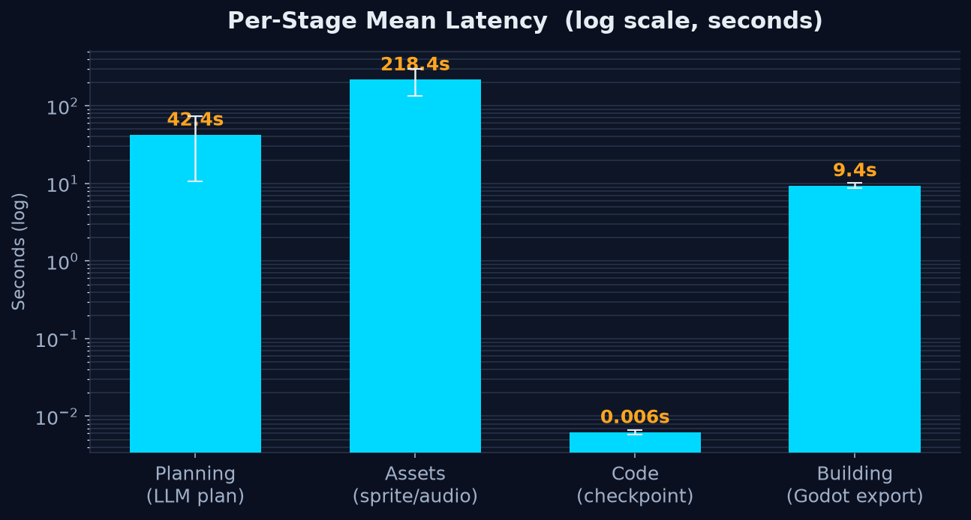
Figure 6.8 — Production: Per-Stage Mean Latency (log scale)

End-to-end latency for the 13 completed runs averages 276.5 s (median 268.2 s, p90 ≈ 402.4 s). Failed runs terminate after a comparable mean time (274.2 s) but with far greater variance, because a failure can occur early (32.8 s) or after a long asset timeout (621.5 s).

Outcome | n | Mean | Min | Max | Std dev
completed | 13 | 276.5 | 109.7 | 453.1 | 92.9
failed | 7 | 274.2 | 32.8 | 621.5 | 175.2
Table 6.13 — End-to-End Latency by Outcome (seconds)

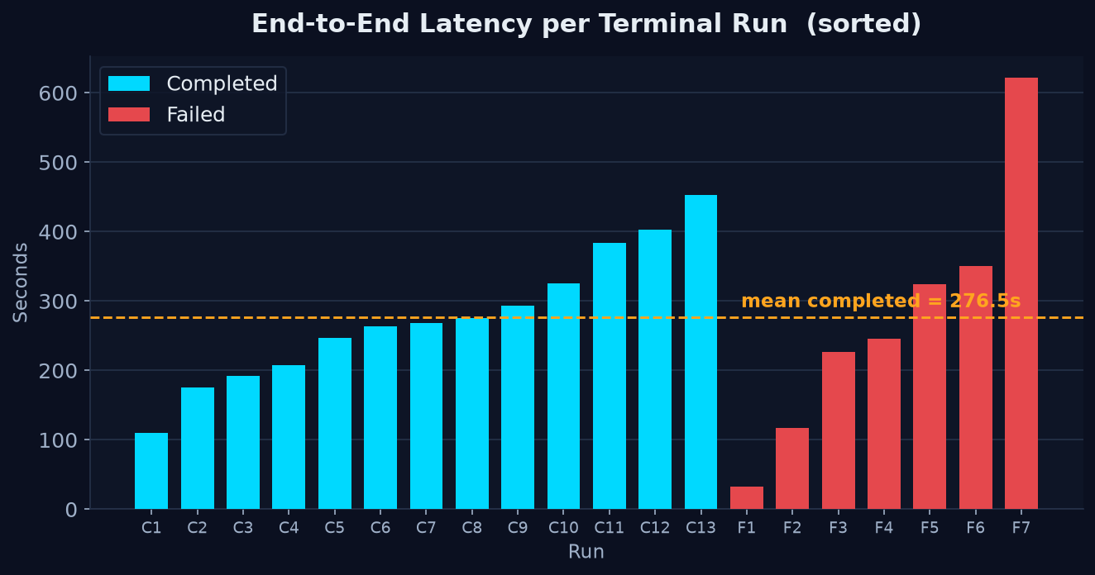
Figure 6.9 — Production: End-to-End Latency per Terminal Run

Every one of the seven hard failures occurred in the asset-generation stage — the longest-running, external-API-dependent step. Five of seven are availability or timeout issues on the asset service; the remaining two are LLM output-format robustness issues (non-strict JSON emitted by the model). The planning, code, and building stages recorded zero failures. Retry-with-backoff on asset calls plus schema-constrained or repair-parsing of LLM responses would address 100 % of the observed failures.

Root cause (from job error logs) | Occurrences
Asset-service request aborted due to timeout | 3
fetch failed (asset service unreachable / connection reset) | 2
Asset service 500 — malformed JSON in LLM response | 1
Asset service 500 — failed to parse <MANIFEST> from LLM response | 1
Table 6.14 — Pipeline Failure Causes (all 7 in the assets stage)

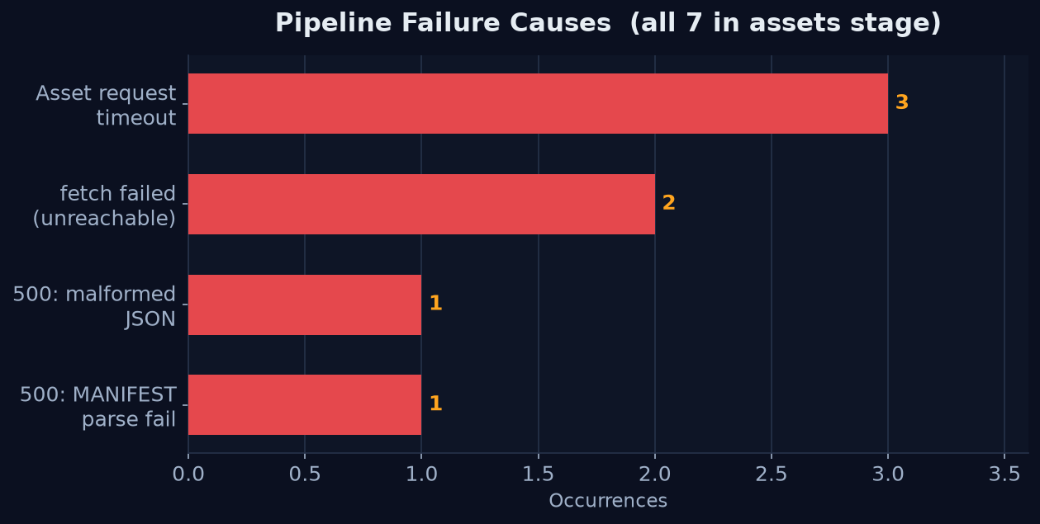
Figure 6.10 — Production: Pipeline Failure Causes

6.3.5.3 Build & Deliverable Metrics
The 13 completed builds produced 78 output artifacts, all targeting web (Godot 4.x HTML5 export). The average playable bundle is 67.7 MB (min 35.8 MB, max 80.5 MB) across six files. The Godot web runtime (index.wasm + index.js) is byte-identical on every build, so the game data pack (index.pck) is the only truly variable artifact.
Artifact | Count | Avg size | Total | Notes
index.wasm | 13 | 35.38 MB | 459.9 MB | Godot 4 web runtime (identical each build)
index.pck | 13 | 31.91 MB | 414.9 MB | Game data — the only variable artifact
index.js | 13 | 331 KB | 4.3 MB | Godot JS bootstrap
index.png + index.icon.png | 26 | 13.6 KB | 0.35 MB | Splash + icon
index.html | 13 | 4.85 KB | 0.06 MB | Loader page
Table 6.15 — Deliverable Bundle Composition (13 builds, 78 artifacts)

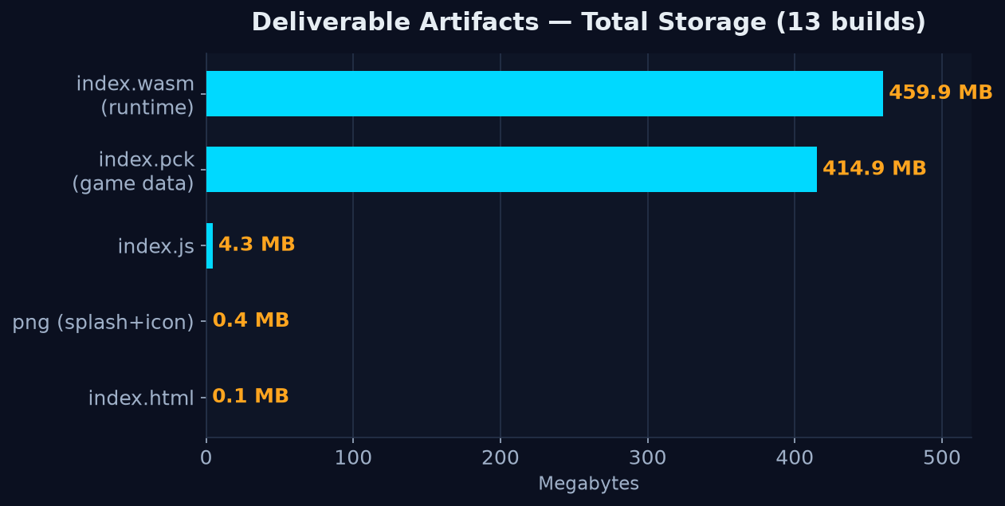
Figure 6.11 — Production: Deliverable Artifacts by Total Storage

6.3.5.4 Content Generation Metrics
The platform generated 154 asset records, all in the generated state. Enemy sprites, obstacle tilesets, and audio clips are the most numerous, reflecting the multi-enemy, multi-level plans typical of the observation window. By MIME type the assets divide into 119 image/png, 18 audio/mpeg, and 17 audio/wav files. Player sprites additionally carry animation metadata (on average 6 animations of 16 frames at 12 fps: idle, run, jump, double jump, fall, and die).

Asset type / entity | Count
Audio (SFX + music) | 35
Sprite — enemy | 29
Tileset — obstacle | 27
Sprite — player | 14
Background — environment | 14
Sprite — collectible | 13
Sprite — goal | 13
Sprite — hazard | 9
Table 6.16 — AI-Generated Assets by Type / Entity (n = 154)

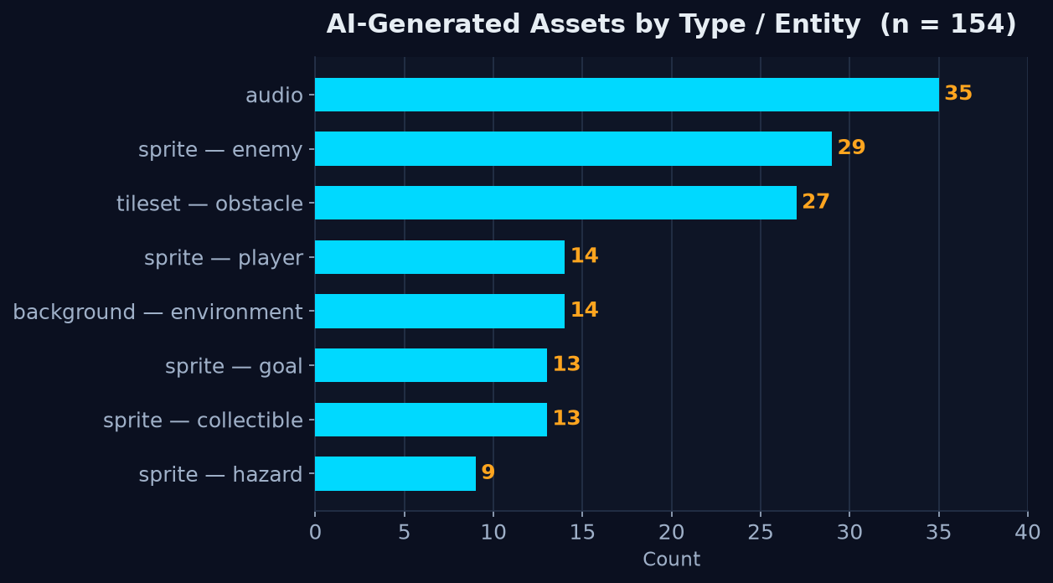
Figure 6.12 — Production: AI-Generated Assets by Type

The conversational planning interface recorded 36 chats totaling 280 messages (7.8 messages per chat on average, max 12), indicating that requirement gathering converges in under eight turns. The planner produced 29 structured game plans averaging 4.3 KB each (range 2.7–7.6 KB). Of the 36 projects, 13 completed, 13 remained running (stale), 7 failed, and 3 were drafts, with an average of 12 projects per user (max 24 on the primary test account).

6.3.5.5 Database & Object-Storage Footprint
The gameforge database holds 7 collections, 324 documents, and 22 indexes, with a total on-disk size of just 1.36 MB (data 797 KB, storage 590 KB, indexes 766 KB). The metadata footprint is therefore negligible — all heavy payloads live in object storage rather than the database.
Collection | Docs | Data size | Avg doc | Indexes
assets | 154 | 67.7 KB | 439 B | 6
chats | 36 | 287.2 KB | 8.0 KB | 2
gameprojects | 36 | 22.5 KB | 625 B | 4
generationjobs | 33 | 49.3 KB | 1.5 KB | 3
builds | 33 | 169.2 KB | 5.1 KB | 3
gameplans | 29 | 125.9 KB | 4.3 KB | 2
users | 3 | 75.0 KB | 25 KB | 2
Table 6.18 — MongoDB Collection Statistics

A server session snapshot (7-minute uptime) showed MongoDB 8.2.11 serving 16 open connections (4 active, 0 rejected) with 214 MB resident memory, a WiredTiger cache of 1.15 MB in use, a mean read-operation latency of ≈ 1.16 ms, a mean command latency of ≈ 0.08 ms, and zero write errors.
Object storage tells the opposite story: the single game-forge-games bucket holds 1,874 objects totalling 2.20 GiB across 55 game prefixes, on a healthy single-node MinIO server using only 2.7 % of its 956 GiB drive. The Godot web runtime and AI-generated PNG assets dominate the footprint.

Type | Objects | Total | Avg / object | Role
.wasm | 27 | 910.9 MB | 34.5 MB | Godot web runtime (per build)
.png | 458 | 840.0 MB | 1.88 MB | AI sprites / tilesets / backgrounds
.pck | 27 | 452.1 MB | 17.1 MB | Godot game data packs
.wav | 110 | 24.8 MB | 230 KB | Generated SFX
.mp3 | 25 | 11.5 MB | 470 KB | Generated music
.js | 27 | 8.5 MB | 324 KB | Web bootstrap
.gd | 831 | 2.4 MB | 3 KB | Generated GDScript source
scaffolding (.import/.godot/.cfg/.tscn/.json/.html) | 344 | 0.5 MB | — | Godot project scaffolding
Table 6.19 — MinIO Object Storage by Content Type

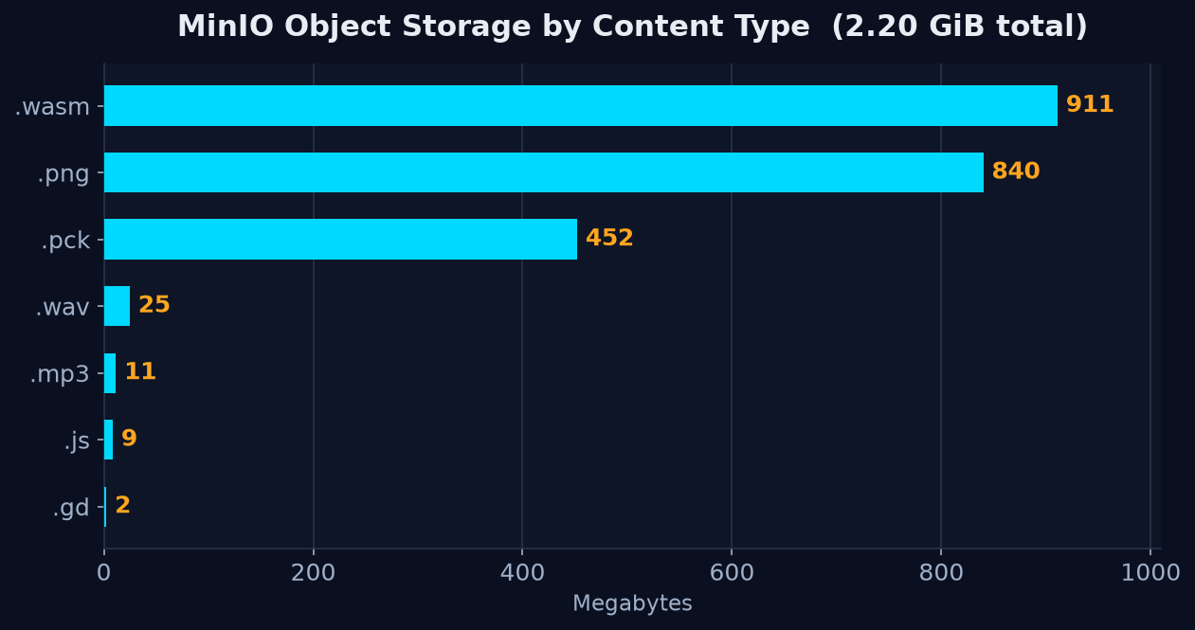
Figure 6.14 — Production: MinIO Object Storage by Content Type
Area | Objects | Size
Build outputs (bucket root, per-game) | 142 | 1,372 MB (61 %)
godot-project/assets (images) | 518 | 840 MB (37 %)
godot-project/audio | 197 | 36 MB
godot-project/scripts (GDScript) | 831 | 2.4 MB
Project scaffolding | 186 | 0.3 MB
Table 6.20 — MinIO Storage by Area

6.3.5.6 Container Resource Utilization
A docker stats snapshot at idle steady-state shows the full ten-container stack consuming approximately 841 MiB of memory — about 5.4 % of the 15.33 GiB host limit — with negligible idle CPU. MongoDB and MinIO account for the largest shares; the four generation workers and the stateless server are each under 80 MiB.
Container | CPU % | Memory | Net I/O (rx / tx) | Block I/O (r / w)
game-forge-mongo | 0.44 % | 209.9 MiB | 43.8 kB / 342 kB | 151 MB / 1.6 MB
game-forge-minio | 0.03 % | 137.5 MiB | 10.2 MB / 1.6 GB | 2.51 GB / 270 kB
game-forge-backend | 0.11 % | 63.7 MiB | 308 kB / 34.6 kB | 73.7 MB / 0
game-forge-frontend | 0.08 % | 100.5 MiB | 102 kB / 161 kB | 94.2 MB / 4.1 kB
game-forge-planner | 0.31 % | 49.5 MiB | 26.6 kB / 10 kB | 80.6 MB / 0
game-forge-asset | 0.10 % | 78.3 MiB | 27.1 kB / 12.6 kB | 22.2 MB / 0
game-forge-code | 0.00 % | 50.0 MiB | 3.6 kB / 1.9 kB | 16 MB / 0
game-forge-builder | 0.00 % | 51.2 MiB | 3.4 kB / 1.9 kB | 13.5 MB / 0
game-forge-server | 0.00 % | 26.5 MiB | 2.0 kB / 126 B | 3.7 MB / 0
assets-mcp | 0.13 % | 74.1 MiB | 1.9 kB / 126 B | 52 MB / 0
Table 6.21 — Container Resource Utilization (idle steady-state)

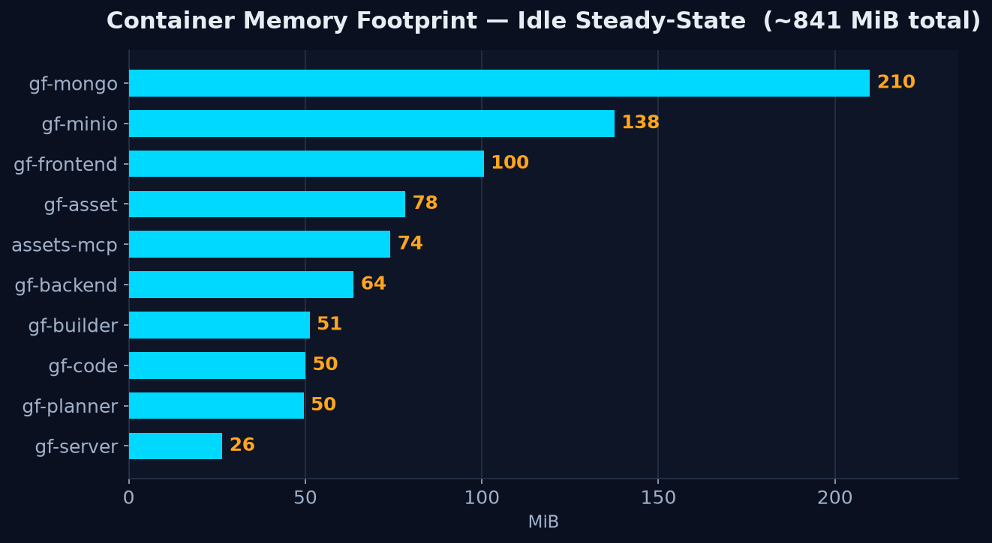
Figure 6.15 — Production: Container Memory Footprint (idle)

6.3.5.7 Reconciliation with Estimated Benchmarks and Key Findings
The production measurements broadly validate the estimated benchmarks of Sections 6.3.1–6.3.4 while sharpening several numbers. Isolated planner latency (48.6 s) and production planner latency (42.4 s) agree closely. The estimated end-to-end times, however, were optimistic: real asset generation is slower and more variable than projected, pushing the measured median (268 s) above the estimated p50 (~190 s) and raising asset generation's share of wall time from the estimated 60–70 % to about 79 %. Conversely, the Godot export proved faster than estimated (9.4 s measured vs. an assumed ~25 s).
Metric | Ch. 6.3 benchmark / estimate | Production (measured) | Assessment
Planner latency (mean) | 48.6 s (isolated benchmark) | 42.4 s | Confirmed — close
Code assembly | 0.38 s (isolated benchmark) | 0.006 s (pipeline checkpoint)* | Context differs
Asset generation (mean) | ≈ 124 s (implied by p50 estimate) | 218.4 s | Under-estimated
Builder / Godot export | ≈ 25 s (estimate) | 9.4 s | Over-estimated
End-to-end p50 / median | ≈ 190 s (estimate) | 268.2 s | Under-estimated
End-to-end p90 | ≈ 230 s (estimate) | 402.4 s | Under-estimated
Asset share of wall time | 60–70 % (estimate) | ≈ 79 % | Higher in practice
End-to-end total range | 2.5–5 min (Ch. 1 / 7) | 1.8–7.6 min | Consistent
Table 6.22 — Estimated (Ch. 6.3) vs. Measured (Production) Performance

6.4 Limitations and Known Issues
Game Forge is a working end-to-end system, but several deliberate scoping decisions and known constraints shape what it can and cannot produce. This section documents them honestly, grouped by subsystem. The recurring design theme is a preference for guaranteed playable output over open-ended flexibility: wherever the system had to choose, it constrains generation to a verified set of parts rather than risk producing a broken game.

6.4.1 Game Scope and Design Generation

6.4.1.1 Only Three Game Archetypes
The planner supports exactly three archetypes — platformer, top-down, and endless-runner. Any prompt describing a genre outside these three (RPG, puzzle, tower-defense, racing, fighting, and so on) is force-fit into the nearest supported archetype rather than rejected. This is a deliberate scoping decision that keeps every generated game within a verified template family. The pipeline is structured to extend later — the asset service already carries perspective presets for additional archetypes — but as it stands the genre coverage is narrow.

6.4.1.2 Fixed Behavior and Weapon Catalog
Enemy behaviors, player weapons, and win conditions are all drawn from a fixed catalog defined by archetype. A behavior the plan references but that is not in the catalog is silently dropped; weapons are limited to melee and ranged; and an unsupported win condition is coerced to a safe per-archetype default. This means novel or emergent mechanics a user describes cannot be realized — the game is limited to combinations of pre-written, Godot-verified parts. Optional LLM-authored custom-behavior and script-override channels exist for advanced cases, but they are validated and dropped if malformed, so they can never break a build.

6.4.1.3 Generic Fallback Plan
If the language model fails to return a usable plan after two attempts, the planner falls back to a generic hard-coded default plan, retaining the user's prompt only as a short description string. In that situation the user can receive a generic game bearing little relation to their request. The fallback is a last resort that guarantees the pipeline always returns something buildable rather than erroring out entirely.

6.4.2 Visual and Audio Asset Generation

6.4.2.1 Asset Generation Is the Pipeline Bottleneck
Image and audio calls to Stability AI are issued sequentially — one image per entity plus terrain tiles, a background, and a music track — so total asset time scales linearly with the number of entities and dominates the end-to-end latency of a generation. Code assembly, by contrast, runs in parallel and is effectively free. Batching and caching of asset calls are the identified optimizations for reducing overall generation time.

6.4.2.2 Dependence on External Image Credits
Asset generation requires a valid Stability AI key with available quota. When the key is missing or the quota is exhausted, per-asset generation fails and the game falls back to bundled placeholder sprites — a silent visual downgrade. A configuration flag allows the stack to run in a static-asset mode entirely without image credits for testing and demonstration.

6.4.2.3 No Frame-by-Frame Sprite Animation
The asset pipeline produces a single still image per entity rather than a spritesheet. All in-game motion is animated procedurally in Godot at runtime, and transparent cutouts rely on the provider's background-removal step over a solid-color prompt. This is intentional — it avoids the cost and unreliability of true multi-frame generation — but it means generated games cannot display genuine frame-by-frame character animation, and an imperfect cutout can occasionally leave a halo or clip the subject.

6.4.2.4 Art Style Is Not Always Exact
The requested art style is not always honored precisely. Some style labels are remapped — for example "hand-drawn" is served through a full-color comic-book preset and monochrome line-art is avoided — so the delivered look can differ from the label the user chose. These substitutions are deliberate and are made to keep output full-color and visually usable.

6.4.2.5 No Asset Caching
There is no caching or reuse of generated assets — identical prompts regenerate from scratch on every run, wasting API credits and time on re-rolls and on similar games. Caching by visual description is identified as future work.

6.4.3 Code Assembly

6.4.3.1 Template-Bounded Generation
The code service performs no LLM code generation; it assembles pre-written, Godot-verified GDScript fragments selected by the plan. This is the system's core reliability guarantee — assembled projects almost always compile and run — but it also means the universe of possible games is bounded by the archetype libraries. Anything that cannot be expressed through the catalog's behaviors, weapons, and hooks cannot be built.

6.4.3.2 The Repair Loop Degrades Rather Than Repairs
When validation fails, the retry loop strips the offending file's authored extras and re-assembles; after the retry cap it proceeds despite the failure. This keeps the build alive but does so by silently removing authored content, so the final game can be simpler than the plan described. Built-in behaviors are never the cause of such a failure, so the core game is preserved.

6.4.3.3 Bounded Level Variety
Level layouts are generated procedurally from a limited set of sections, room, and pattern templates driven by a seeded random generator. Variety is real but bounded by the template library, so layouts can begin to feel repetitive across many generations. A stored seed makes each run reproducible while keeping successive generations different.

6.4.4 Build and Export

6.4.4.1 Environment-Sensitive Godot Export
Full HTML5 export is sensitive to the environment and pinned to a specific Godot CLI version, and it is retried only once before failing. A toolchain mismatch or a transient export error can therefore fail the entire build. A skip-export stub mode is provided so the rest of the orchestration can be exercised without a real Godot export.

6.4.5 Orchestration, Scale, and Reliability

6.4.5.1 No Partial Recovery or Cancellation
Any stage failure fails the whole generation and discards partial artifacts, so a late-stage error throws away an already-successful plan and its assets. Users also cannot cancel an in-flight build. Failure states are marked cleanly and surfaced to the interface.

6.4.5.2 Polling-Based Progress and Best-Effort Status
Build progress is delivered by client polling with exponential backoff rather than a live stream, so updates lag by the poll interval and there is no live log feed. In addition, the cross-record status updates between the job, build, and project documents are best-effort and swallow errors, so their status can briefly drift out of sync if an update call fails. Both are simple, robust choices whose terminal states converge in the common path.

6.4.6 Authentication and Security

6.4.6.1 Shared Inter-Service Secret
Services authenticate one another with a single shared static secret, and an empty secret disables that check entirely — the development default. There is no per-service identity or mutual TLS, so a leaked secret would be authenticated as any service. This is adequate inside a trusted internal network, and the production configuration refuses to start with the secret unset.

6.4.6.2 Publicly Addressable Game Files
Generated game files are served publicly by game ID with no ownership check (downloads are verified only when a user session is present), so anyone who knows or guesses a game's URL can play it. The game ID is a random UUID that is unguessable in practice, and public playback is desirable for sharing.

Chapter 7: Conclusion and Future Work

7.1 Summary of Achievements
This project sets out to answer a deceptively simple question: can a natural-language prompt be turned into a complete, playable video game with no human in the loop? Game Forge demonstrates that it can. The system takes a single English description from a user, guides them through a short design conversation, and produces a fully playable Godot 4 HTML5 game — sprites, background art, terrain, music, level layout, enemy behaviour, and win conditions included — that runs directly in the browser and can be downloaded as a self-contained bundle.
The concrete achievements of the project are as follows:
A complete, end-to-end generation pipeline. We designed and implemented a ten-service platform that carries a prompt through five distinct stages — design → planning → assets + code (in parallel) → build. Each stage is an independently deployable service, and the entire flow is orchestrated by a single stateless coordinator. From the user's perspective, the experience is one click: they confirm a design and receive a running game roughly two-and-a-half to five minutes later.
A robust microservice architecture. The platform is composed of seven Node.js (ES-module) services and one Python FastMCP server, wired together with Docker Compose. We established a set of design principles that recur throughout the codebase and that proved essential to keeping a system of this size coherent: a shared provider abstraction for LLMs (so Groq and OpenRouter can each be selected by environment variable), MinIO object storage as the single shared filesystem between stages, MongoDB as the single shared state store, and a shared-secret header for inter-service authentication. No service streams files directly to another; they communicate through storage and through the database, which keeps each service testable and independently restartable.
Separation of AI creativity from deterministic assembly. One of the most important architectural decisions was to not let a language model write game code. Instead, the planner LLM chooses behaviours and weapons by name from a fixed, engine-verified catalogue and fills in numeric parameters, while the code service performs pure, deterministic assembly of GDScript from a pre-written template library — in roughly 0.4 seconds and with no LLM call at all. This split gives us the creativity of generative AI where it adds value (game design, art prompts) and the reliability of conventional software everywhere correctness matters (the actual runtime code). Anything the plan references that is not in the library is simply dropped before assembly, so the model can never inject invalid or unsafe code.
A solution to the naming-and-ordering problem. A central technical challenge was that the code service finishes in under half a second while asset generation takes minutes — yet the generated code must reference asset files that do not yet exist. We solved this with a name-as-contract design: the entity's plan name (e.g. hero, skeleton, coin) is the shared key that every service independently derives the same way. The code hard-codes res://assets/hero.png before any asset exists; the asset service stores each generated file under a random storage key but records it in a MongoDB Asset document keyed on the human name; and the builder — the join point — resolves that document back to the exact filename the code expects. The build never starts until both the fast and slow branches complete, because they are awaited together, so by the time the game is exported every referenced file has been laid down.
Graceful degradation throughout. Every stage of the pipeline is designed to survive partial failure. A failed asset never breaks the build — the game falls back to flat-colored rectangles. A malformed LLM plan falls back to a hard-coded default plan. A Godot parse error strips only the offending authored snippet and re-assembles, up to a retry cap. A misclassified win condition is coerced to one the engine actually implements, guarding against the "silently unwinnable game" failure mode. This defensive posture means the system almost always produces something playable rather than failing outright.
Procedural, physics-aware level generation. Rather than emitting static layouts, we built seeded procedural level generators for each game archetype (platformer, top-down, endless-runner). The platformer generator, for example, derives a jump-and-gap reachability envelope from the game's actual physics tuning and stitches levels from a library of hand-authored, guaranteed-reachable prefab chunks arranged into a difficulty ramp — so a generated level is never impossible to complete.
A verified, tested system. The platform is backed by 672 automated tests across all services, using Vitest and Supertest for the Node services and pytest for the Python MCP server, with every external dependency (LLMs, Stability AI, Godot, MongoDB, MinIO) mocked so that no test requires real secrets, API quota, or network access. We complemented this with performance benchmarks that characterized each stage: the code service assembles a project in 0.36–0.53 seconds regardless of size, and the full pipeline's latency is shown to be almost entirely asset-bound.
Taken together, these achievements deliver working, reproducible, and thoroughly tested proof that generative AI can be combined with deterministic software engineering to automate the creation of complete, playable games from natural language.

7.2 Lessons Learned
Building a system of this complexity taught us as much about software architecture and the practical realities of working with generative AI as it did about game generation itself.
Constrain the language model; don't trust it to be correct. The single most valuable lesson was that reliable systems built on LLMs come from narrowing what the model is allowed to do, not from prompting it more cleverly. Our early instinct might have been to have the model generate code directly, but this is fragile and unverifiable. By reducing the model's role to picking from a fixed catalogue of names and filling numeric parameters — and by validating and dropping anything outside that catalogue — we turned an unpredictable component into a well-behaved one. Similarly, keeping the asset-prompt LLM out of the tool-calling loop (code, not the model, decides what to generate and how many times) eliminated an entire class of double-invocation and formatting bugs.
Wall-clock ordering is not dependency ordering. It is tempting to reason about a pipeline as "A happens, then B, then C." In practice, the code branch finishes ~200× faster than the asset branch, and confusing when something finishes with what it depends on leads to broken assumptions. Making the dependency explicit — awaiting both branches together and designating the builder as the deliberate join point — was cleaner and more robust than trying to coordinate services by timing.
Design for failure from the start, not as an afterthought. Because we are chaining together non-deterministic components (LLMs) and external APIs with quotas and latency variance (Stability AI, Godot), failure is the normal case, not the exception. The habit of asking "what happens if this returns null / times out / produces garbage?" at every boundary — and always having a fallback — is what makes the difference between a demo that works once and a system that works repeatedly. The fallbacks (placeholder sprites, default plans, snippet-stripping retries) were not polish; they were load-bearing.
Decouple services through shared storage and state, not direct calls. Choosing MinIO as a shared filesystem and MongoDB as shared state — rather than having services stream data to one another — paid off repeatedly. It meant each service could be developed, tested, and restarted in isolation, and it made the flow of data easy to inspect (you can look in the bucket and see exactly what each stage produced). The one stateful coordinator that holds no state of its own and mutates everything through the backend's internal routes proved to be a clean pattern.
A shared naming convention beats runtime negotiation. The fact that five different services can agree on where a file lives without ever talking to each other about it — simply by all applying the same safeName() slug rule to the same plan name — was one of the most elegant outcomes of the design. Conventions, when enforced consistently, remove entire categories of coordination logic.
Practical friction with real tooling. Working with the Godot CLI, the FastMCP protocol, and undici's HTTP client surfaced concrete lessons that generic tutorials do not teach: that FastMCP requires arguments nested under a params object, that an AbortSignal alone cannot override undici's aggressive 30-second header timeout (forcing us to configure a custom agent for the multi-minute asset and build stages), and that Godot's threaded WASM export requires specific cross-origin isolation headers (COOP/COEP/CORP) to run in an iframe. These small, hard-won details consumed real time and reinforced the value of writing them down.
Test coverage percentage is a measurement, not a goal. Our coverage numbers vary by service, from about 32% on the browser frontend to about 96% on the orchestration server, and we learned to treat these as honest measurements rather than targets to be gamed. We concentrated testing effort on the surfaces where correctness matters most — validators, the orchestration pipeline, the naming resolver, middleware, and the code assembler — which are all well covered, while the browser UI remains the least-exercised area in this first pass. Being explicit about what is and isn't covered, and why, is more useful than chasing a single headline number.
Honest evaluation reveals real limitations. Our benchmarking discovered a genuine weakness — the planner misclassifies certain endless-runner prompts as platformers — that we chose to document rather than hide. Building the measurement infrastructure to find such issues was as important as the features themselves.

7.3 Future Work
Game Forge is a solid foundation, but there are many directions in which the platform can be extended and strengthened. We group the most promising avenues below.
Broaden the range of generatable games. The system currently supports three archetypes — platformer, top-down, and endless-runner. The architecture was explicitly designed to make new archetypes additive: each is a self-contained directory of a manifest, runtime scripts, behaviors, weapons, and a level generator. Natural next additions include puzzle games, shoot-'em-ups, tower-defense, and simple RPGs. Each new archetype widens the space of games a user can describe.
Improve plan classification and design fidelity. Our benchmarks identified that certain prompts are assigned the wrong archetype (notably endless-runner prompts being read as platformers). Future work should strengthen the classification step — for example, with better few-shot examples, a fine-tuned classifier, or a confirmation step that surfaces the detected archetype to the user for correction. More broadly, richer plan schemas could capture narrative, progression, and difficulty preferences that the current design conversation does not yet express.
Animated and stylistically consistent assets. At present each entity has a single still image that is animated procedurally in Godot (breathing, walk-bob, jump squash, hurt flash). A significant enhancement would be true generated sprite sheets or animation frames, and mechanisms to enforce a consistent art style across all assets in a game (shared palette, coherent character proportions), which single-image generation does not currently guarantee.
End-to-end and load testing. The test suite is strong at the unit and service-integration level but, by design, mocks the live LLMs, Stability AI, Godot, and databases. Priorities here include a Playwright browser end-to-end test that drives the real UI through a full generation, load and concurrency testing to understand how the system behaves under many simultaneous builds, and a CI stage that periodically exercises the live external services to catch integration drift.
Performance and cost optimization. Benchmarking shows the pipeline is almost entirely asset-bound: image and audio generation are sequential and quota-limited, dominating the 2.5–5-minute total. Parallelizing asset generation across entities, caching or reusing assets between similar games, streaming partial progress (e.g. letting the user play with placeholder art while final art generates), and offering a "fast draft" mode would all meaningfully improve the user experience and reduce costs.
Iterative editing and refinement. Today the flow is one-shot: describe, confirm, generate. A powerful extension would be conversational iteration — allowing a user to say, "make the enemies faster," "add a boss," or "change the theme to space" and have the system re-plan and re-build only what changed. The seeded, deterministic level generation already supports exact reproduction, which is a natural foundation for targeted re-rolls.
Scalability and production hardening. For real-world deployment beyond a single Docker Compose host, the platform would benefit from a proper job queue (rather than fire-and-forget HTTP), horizontal scaling of the asset and builder workers, orchestration under Kubernetes, observability (structured metrics, tracing across the service hops), and rate-limiting and quota management per user.
Richer user-facing features. Finally, there is a long tail of product features that would increase the platform's value: user galleries and sharing of generated games, remixing another user's game as a starting point, exporting to native desktop or mobile targets in addition to HTML5, and in-browser fine-tuning controls (difficulty sliders, level count, palette pickers) layered on top of the natural-language flow.
Collectively, these directions would take Game Forge from a compelling proof of concept to a robust, scalable, and genuinely delightful tool for turning ideas into playable games.

References
- [1] Rosebud AI, "Rosebud AI: Free AI Game Maker — Create Games Online," Rosebud AI, Inc. [Online]. Available: https://rosebud.ai/.
- [2] H. Al-Ali, O. Jarrah, and S. Kiswani, "Launch YC: Playabl.ai — TikTok for User-Generated Games," Y Combinator. [Online]. Available: https://www.ycombinator.com/launches/QeI-playabl-ai-tiktok-for-user-generated-games.
- [3] "Playabl Review: Free AI Game Builder for Everyone 2026," HokAI. [Online]. Available: https://hokai.io/hub/tools/playabl.
- [4] Astrocade, "About Astrocade — Our Mission to Democratize Game Creation," Astrocade, Inc. [Online]. Available: https://www.astrocade.com/about-us.
- [5] Astrocade, "Astrocade 2.0: World's First Agentic AI Game Creation Platform," Astrocade Blog, Jul. 30, 2025. [Online]. Available: https://www.astrocade.com/blog/astrocade-2-worlds-first-agentic-ai-game-creation-platform.
- [6] J. Batchelor, "Astrocade Raises $56m to Expand AI-Powered Games Creation Platform," PocketGamer.biz, May 7, 2026. [Online]. Available: https://www.pocketgamer.biz/astrocade-raises-56m-to-expand-ai-powered-games-creation-platform/.
- [7] StoneLeap, "StoneLeap AI — AI First Game Development Platform," StoneLeap AB. [Online]. Available: https://www.stoneleap.ai/.
- [8] Ludo.ai, "Ludo.ai — AI Sprite Generator and Game Asset Pipeline," Ludo.ai. [Online]. Available: https://ludo.ai/.
- [9] Ludo.ai, "Turn Game Ideas into Playable Prototypes with Ludo.ai's Playable Generator," Ludo.ai. [Online]. Available: https://ludo.ai/features/playable-generator.
- [10] Anthropic, "Introducing the Model Context Protocol," Anthropic. [Online]. Available: https://www.anthropic.com/news/model-context-protocol.
- [11] GDevelop, "GDevelop: Free, Fast, Easy Game Engine — No-Code, AI-Assisted," GDevelop. [Online]. Available: https://gdevelop.io/.
- [12] GDevelop, "GDevelop's AI Agent: Create Game Features Automatically," GDevelop Blog, Oct. 9, 2025. [Online]. Available: https://gdevelop.io/blog/make-games-with-ai-agent-gdevelop-automated-prompt.
- [13] GDevelop, "Ask AI (Build/Chat with AI)," GDevelop Documentation. [Online]. Available: https://wiki.gdevelop.io/gdevelop5/interface/ai/.
- [14] GitHub, "GitHub Copilot — Your AI Pair Programmer," GitHub, Inc. [Online]. Available: https://github.com/features/copilot.
- [15] N. Shaker, J. Togelius, and M. J. Nelson, Procedural Content Generation in Games. Cham, Switzerland: Springer, 2016. [Online]. Available: http://pcgbook.com.
- [16] Meta Open Source, "React – The Library for Web and Native User Interfaces." [Online]. Available: https://react.dev/.
- [17] "Vite – Next Generation Frontend Tooling." [Online]. Available: https://vite.dev/.
- [18] Tailwind Labs, "Tailwind CSS – Rapidly Build Modern Websites Without Ever Leaving Your HTML." [Online]. Available: https://tailwindcss.com/.
- [19] Motion, "Motion (formerly Framer Motion): A Modern Animation Library for React and JavaScript." [Online]. Available: https://motion.dev/.
- [20] OpenJS Foundation, "Node.js – Run JavaScript Everywhere." [Online]. Available: https://nodejs.org/.
- [21] OpenJS Foundation, "Express – Fast, Unopinionated, Minimalist Web Framework for Node.js." [Online]. Available: https://expressjs.com/.
- [22] "Mongoose ODM v8 – Elegant MongoDB Object Modeling for Node.js." [Online]. Available: https://mongoosejs.com/.
- [23] MongoDB, Inc., "MongoDB: The Developer Data Platform." [Online]. Available: https://www.mongodb.com/.
- [24] MinIO, Inc., "MinIO: S3-Compatible High-Performance Object Storage." [Online]. Available: https://min.io/.
- [25] Groq, Inc., "GroqCloud – Fast AI Inference." [Online]. Available: https://groq.com/.
- [26] OpenRouter, "OpenRouter – A Unified Interface for LLMs." [Online]. Available: https://openrouter.ai/.
- [27] Zhipu AI (Z.ai), "GLM – Z.ai Large Language Models." [Online]. Available: https://z.ai/.
- [28] Meta AI, "Llama 3.3." [Online]. Available: https://www.llama.com/.
- [29] Qwen Team, Alibaba Cloud, "Qwen3." [Online]. Available: https://qwenlm.github.io/blog/qwen3/.
- [30] OpenAI, "Introducing gpt-oss." [Online]. Available: https://openai.com/index/introducing-gpt-oss/.
- [31] DeepSeek, "DeepSeek – Into the Unknown." [Online]. Available: https://www.deepseek.com/.
- [32] Stability AI, "Stable Image Core – Stability AI Image Models." [Online]. Available: https://stability.ai/stable-image.
- [33] Stability AI, "Introducing Stable Audio 2.0." [Online]. Available: https://stability.ai/news/stable-audio-2-0.
- [34] Prefect, "FastMCP – The Fast, Pythonic Way to Build MCP Servers." [Online]. Available: https://gofastmcp.com/.
- [35] Godot Engine, "Godot Engine – Free and Open Source 2D and 3D Game Engine." [Online]. Available: https://godotengine.org/.
- [36] Docker, Inc., "Docker: Accelerated Container Application Development." [Online]. Available: https://www.docker.com/.
- [37] Docker, Inc., "Docker Compose." [Online]. Available: https://docs.docker.com/compose/.
- [38] GitHub, Inc., "Working with the Container Registry." [Online]. Available: https://docs.github.com/packages/working-with-a-github-packages-registry/working-with-the-container-registry.
- [39] GitHub, Inc., "GitHub Actions – Automate Your Workflow from Idea to Production." [Online]. Available: https://github.com/features/actions.
- [40] "ESLint – Find and Fix Problems in Your JavaScript Code." [Online]. Available: https://eslint.org/.
- [41] "JSON Web Tokens – jwt.io." [Online]. Available: https://jwt.io/.
- [42] "bcryptjs – Optimized bcrypt in JavaScript." [Online]. Available: https://www.npmjs.com/package/bcryptjs.
- [43] "Helmet.js – Secure Express Apps by Setting HTTP Response Headers." [Online]. Available: https://helmetjs.github.io/.
- [44] "express-rate-limit – Basic Rate-Limiting Middleware for Express." [Online]. Available: https://www.npmjs.com/package/express-rate-limit.
- [45] "xss-clean – Middleware to Sanitize User Input Coming from Request Body, Query, and Params." [Online]. Available: https://www.npmjs.com/package/xss-clean.
- [46] "express-mongo-sanitize – Sanitize Your Express Payload to Prevent MongoDB Operator Injection." [Online]. Available: https://www.npmjs.com/package/express-mongo-sanitize.
- [47] "Vitest – Next Generation Testing Framework." [Online]. Available: https://vitest.dev/.
- [48] "pytest – Helps You Write Better Programs." [Online]. Available: https://docs.pytest.org/.
- [49] Testing Library, "React Testing Library." [Online]. Available: https://testing-library.com/docs/react-testing-library/intro/.
- [50] "jsdom – A JavaScript Implementation of WHATWG DOM and HTML Standards." [Online]. Available: https://github.com/jsdom/jsdom.
- [51] "SuperTest – Super-Agent Driven Library for Testing Node.js HTTP Servers." [Online]. Available: https://www.npmjs.com/package/supertest.
- [52] "pytest-asyncio – Pytest Support for asyncio." [Online]. Available: https://pytest-asyncio.readthedocs.io/.
- [53] "pytest-cov – Coverage Plugin for pytest." [Online]. Available: https://pytest-cov.readthedocs.io/.

