# Web Space

You can acquire your web space by simply searching in Google for ‘ITS Sussex Web Space’ — the link needed will be obvious:

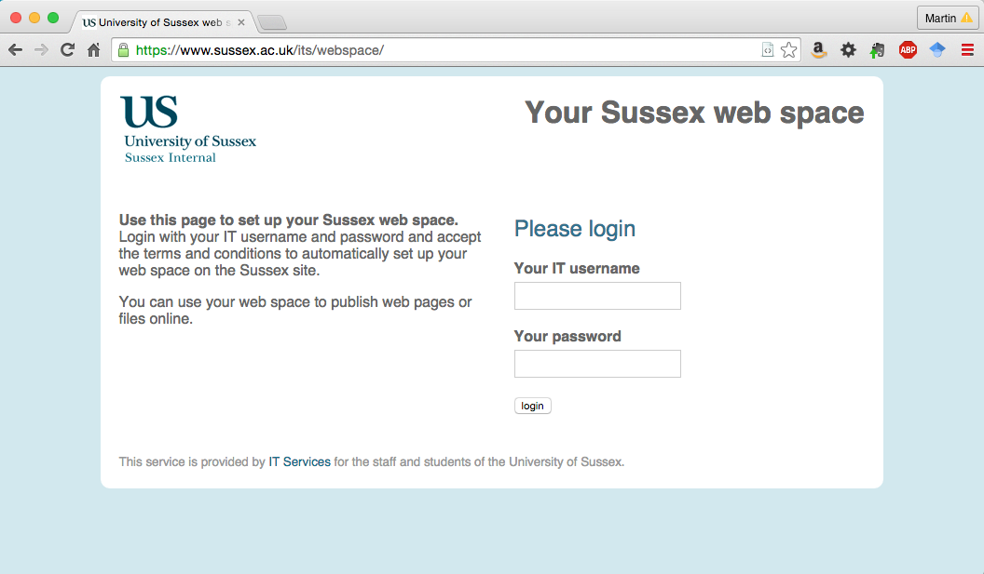

Login and accept the conditions. Your public_html directory will then be automatically created and setup for HTML and PHP.

**Note: that this personal web space you set up for your assignment is on the ITS Web Server, and will appear in your Home Share: drive as public_html.**

**You will need to test that your 3D content works on the actual University web server before any assignment deadline!**

In order for your web files to be available on the server, you will need to transfer your web page files (including the directory structure) in one of several ways:

1. If you are outside the University you need to use SFTP (Secure File Transfer Protocol) to transfer your files to your public_html directory that has been created for you:
   * You could use FileZilla, Win SCP, CyberDuck, etc. (Google it and download, etc
   * You will need to SFTP to unix.sussex.ac.uk
   * Use your standard ITS/Informatics username and password
2. If you are inside the University, you can simply copy files to your public_html directory from your working Home Share: drive directory.
3. Check the assignment specification for the assignment URL.

Also,

1. ITS Help has very good instructions showing how to access your Home Share (N Drive) from home: <http://www.sussex.ac.uk/its/help/guide?id=49> usng Web Drive. Using Web Drive, which is very useful. Web Drive also uses SFTP and your University Username and Password.
   * **It may be , at some time in the future, and at very short notice that the University may switch from Username and Password to a Public and Private Key method for access University machines including the ITS Web Sever. If so, they will update their instructions for access over SFTP.**

# IMPORTANT TIPS!

1. Unix is a case sensitive operating system, Your PC is not case sensitive. Try to ensure that you stick to lowercase filenames and extensions when you use them in your html source code or you may get broken links when you transfer your pages to the ITS Web Server.

* Regular testing on the Unix based ITS Web Server will reveal this problem

1. If the Home Page for your 'site' is an HTML file, then it should be called index.html NOT index.htm
2. When you reference textures, e.g. in your VRML files, ensure they are referenced through relative paths, not fixed paths. Otherwise, when you copy your work to your public_html directory, the web server will not know where the texture files are located
3. IMPORTANT — if using SFTP, pages that are ASCII Text (the html files) MUST be transferred as TEXT. Images MUST be transferred as BINARY.

Please refer to the documentation for your FTP client.