**Assignment #3: Optional Extra Credit (10 pts) – due in class Tues Nov 9th**

We can use our set-up for the magnetic induction, **B** due to a dipole to model more complicated situations by dividing up the crust carrying a magnetization **M** into elemental volumes (dV), each carrying a dipole moment **m**, where **m** = **M** dV.

A classic problem in marine geophysics is that of finding the magnetic induction, **B**, due to alternating regions of normal and reverse polarity crust that form as crust is created at mid-ocean ridges (MOR), and cools below the Curie temperature in the Earth’s field (temperature at which the rocks can retain a permanent magnetization) as the crust moves away from the MOR. Since over geological times scales the magnetic field reverses, alternating bands of positively and reversely magnetized material are seen that run parallel to the MOR. We will calculate **B** along a profile shown by the blue line, due to such a crustal magnetization model, over crust extending away from the MOR to a distance corresponding to an age of 5 Myr. See figure below for geometry of the problem.

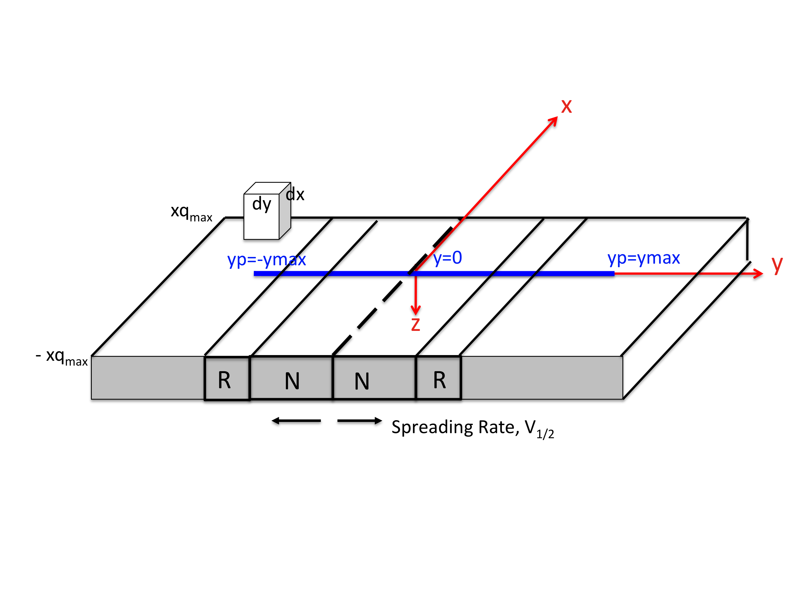

Assume:

1. x points in the direction of magnetic north, and that this is the direction of strike of the MOR. (This is not a bad approximation to first order, many MORs are oriented approximately north-south). The trace of the MOR is shown by the long black dashed line in the figure.
2. You take a vector **B** profile, (Bx, By, Bz) as well as the total field |B| = (Bx2+By2+Bz2)1/2, at the ocean floor along the x=0 line from yp= -ymax to y=+ymax in steps of dyp. (i.e. you have an E-W oriented profile as shown by the blue line shown in the figure.)
3. The magnetization is carried in the oceanic crust which is ~ 6km thick. You can put your elemental dipoles at ~3km depth. Typical magnetization values are ~ 1Am-1
4. The normal / reverse magnetized regions extend infinitely in the ± x direction.
5. You can represent the magnetization as that due to equivalent magnetic dipoles in small volumes with spatial dimensions dx, dy, and dz, where dz=6km.
6. Your profile is taken a latitude corresponding to an ambient magnetic field direction that points north (D=0°) and downwards at an inclination (I=60°) for a normal polarity period, and opposite to this (D=180°, I=-60°) for a reverse polarity period. (We’ll calculate only the magnetic field due to the magnetized crust and ignore the fact we’d really be measuring this plus the ambient field)

To give you an idea for the spatial dimensions of the problem, typical half-spreading rates (the rate at which one side of crust spreads away from the MOR) V1/2 are 5 to 60 mm yr-1 or 5 to 60 km Myr-1. Over the last 5 Myr, the magnetic field has reversed several times, the most recent stable polarity interval (the one we are in now) has lasted 0.78 Myr, so for a spreading rate of 30 mm yr-1 this would correspond to a physical distance from the MOR to the first “N/R” boundary in the sketch above of 30 km Myr-1 * 0.78 Myr = 23.4 km.

**Setting up the problem.** Most of the work is in the set-up for the problem. You can do much of this by hand, using sketches, and some simple calculations, and I will give almost all of the extra credit for this. You can if you wish actually build toward calculating a **B** profile in MATLAB: this is some extra work in terms of coding….

1. Assume a spreading rate of v1/2 = 30 mm yr-1 and that you have observations for 0-5 Myr on either side of the spreading ridge at 0.5 km intervals along the y-axis. Your profile goes from yp = –ymax to yp= +ymax where ymax = ?
2. Building a reversal model for the past ~ 6Myr. Get a geomagnetic polarity time scale from the web or text book, and convert the N/R time boundaries into distance from the MOR in km, assuming v1/2 = 30 mm yr-1. Retain the reversal info to ~6Myr (see below for reason).
3. Next we need to determine the spatial extent of the magnetized crust (in both the x- and y- directions) needed to properly model the magnetic field along our profile. Clearly we could just make the region arbitrarily large but this would involve needless computations, so the computational trick is to make it just large enough.
   1. First: how far out beyond the ends of the profile do we need to extend the region of magnetized crust in order to model the ends of the profile correctly? You can determine this by using your results for the field due to a single dipole. Take a profile along the y-axis for a dipole at position (xq=0, yq=0, zq), where zq=3 km. You should only need to take you profile out to about ± 30 km, sample it at 0.5 km intervals. See how far away you need to be from y=0, for your magnetic field components to essentially fall to zero. Express this distance as an (approximate) integer multiple of the dipole depth. You need to make your magnetized region extend beyond the end of your profile by this amount.
   2. Second, how big do we need to make our region in the ± x direction for it to effectively be infinite? You can determine this by now moving your dipole to be at a position (xq, 0, zq), where zq=3 km. As you move your dipole further away in the xq direction the magnetic field will gradually fall to zero. Again approximate the distance as an integer multiple of zq.
4. Next, decide how small/large your elemental dipole volumes should be. Let’s assume you’ve decided your magnetized crust region needs to extend from –xqmax to + xqmax and from –yqmax to +yqmax. The region extends from zq=0 to 6km. This volume needs to be subdivided into smaller volumes with an elemental dipole positioned at the center of each volume. Let’s assume for simplicity that we need only divide up our region in the x, y directions (not exactly true), and that in the z direction we can have a single layer of dipoles at 3km depth (half the crustal thickness).

How small do you need to make your regions in the xq and yq directions? Let’s say that the xq dimension is dxq and yq dimension is dyq. If you have made dxq and dyq small enough, then the field due to a single dipole, moment m, at position (0,0,zq) will be the same as that calculated from two dipoles, each moment m/2 separated by a distance dyq and positioned at (–dyq/2, 0, zq) and (+dyq/2,0,zq). In other words your observations are essentially the same distance from your single dipole as from each of the 2 dipoles. We can cast the dipole separation distance again in terms of the dipole depth here, zq. dxq, dyq will be some fraction of zq.

* Since the field due to a dipole falls off as 1/r3 you can draw a sketch and determine geometrically how big dyq could be for a specified fractional error in Bx, By, Bz. (Put your initial dipole at (0,0,zq and your second dipole at dyq/2, 0, zq), calculate r (the observer – dipole distance) for an observer at (0,0,0) for each dipole and specify that the difference in B (which is proportional to 1/r3) must be less than some fraction (say 0.1 for a 10% error).
* Alternatively you can investigate this with your code. I did this by calculating the field along my y profile due to a dipole, moment m, at (0,0,zq). Then I calculated the field due to 2 dipoles, each moment m/2 at (0,-dyq/2, zq) and (0,dyq/2, zq). I initially separated the dipoles by a distance zq=2dyq. You’ll see this results in a field that is not like the field due to the single dipole. You can then move the dipoles closer together until the difference in your **B** profiles is less than some specified amount. A good way to do this search efficiently is to keep halving the separation distance until you reach the desired error level. dyq will be equal to = zq /f1, where f1 is an integer. You can use the same value for dxq. This is the concept of *convergence* in numerical calculations.

1. You’ve now decided on the setup for the whole problem! Your final **B** profile will be the sum of all the contributions from your elemental dipoles, spaced dxq in the x-direction, dyq in the y-direction over the region ± xqmax and ±yqmax. Each dipole has a moment moment magnitude given by m = M dV where dV = dxq dyq dzq and dzq = 6000m. (Use SI units to compute dipole moment in Am-2). The dipoles will have a direction D=0°, I=60° for regions with normal polarity and D=180°, I-60° for regions with reverse polarity. Note that the setup is quite general since you have specified the dimensions of the region and the elemental volumes in terms of multiples or fractions of zq, the dipole depth, and the desired time interval (0-5 Myr) of interest.

If you’re up for it you can try to calculate the resulting magnetic profile! Once it’s working you could if you wanted experiment with different spreading rates to see under what conditions short polarity intervals are detectable. Or you could try adding noise and then upward continuing your profile to the ocean surface (zp=-4km).