Slope Stability Program

by Michael Weber

This document is the instruction manual for using my slope stability program. When you boot up the program you get the following screen:

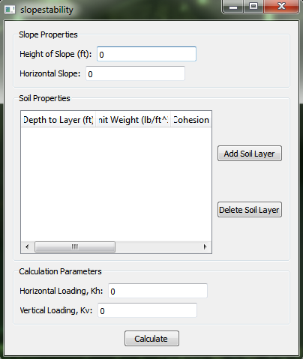

This program calculates the factor of safety for the slope using a psuedostatic method and the failure surface is assumed to be circular. The program needs to know the height of the slope and what the horizontal factor of the slope. The horizontal factor should be the slope in the form of X/1. The values of Kh can be determined from Terzaghi as 0.1, 0.2 or 0.5 depending on the severity of the earthquake. To add a layer of soil you click on the ‘Add Soil Layer’ button and you get the window bellow:

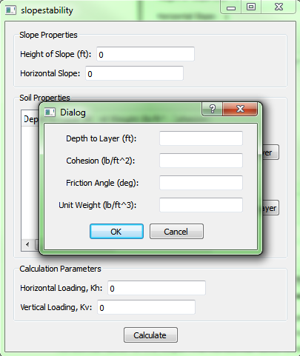

The depth to layer is where the soil starts in relation to the height of the slope. So the top layer of soil would be at depth 0 ft. The remaining parameters are the properties of the soil.

For an example we will run the following slope (you can resize the window):

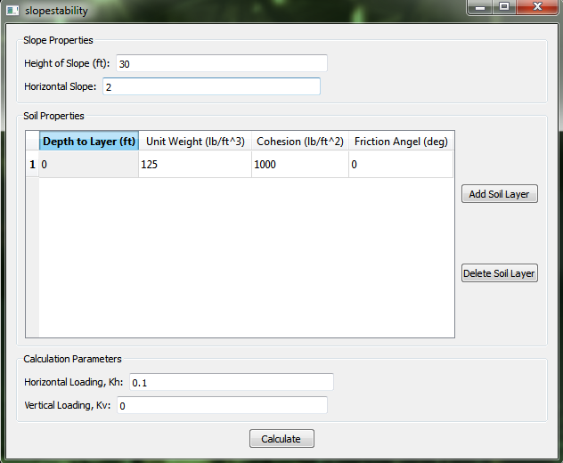

The next step is to click on the calculate button. When this is done the program will calculate 30 different radius points. The radius will be selected by creating three rows with ten points in each. The results will show where the points were selected to be. They then calculate the moments according to example 10.2 to the best that I could follow. You can view the exact code in src/algorithm.h/.cpp

The results look as follow:

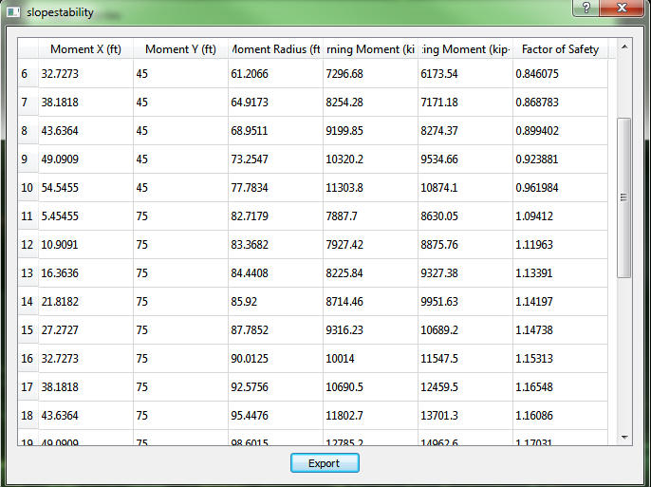

The moment x and y are the center points of the failure circle with the moment radius. The overturning and resisting moments are the results of the calculations. Finally the ‘export’ button converts the table into a .csv file that can be opened by Excel.