Chapter 3 — Methodology
3.1 Overview of the Proposed Model
This research proposes a computationally efficient analytical model for impulse Ground Penetrating Radar (GPR) signal simulation in multilayer subsurface environments. The model is derived from the physical principles governed by Maxwell’s equations, particularly electromagnetic wave propagation, reflection at interfaces, and attenuation in lossy media.
Unlike full-wave numerical approaches such as FDTD, which compute electromagnetic fields across space and time, the proposed model focuses on signal-level representation. The received GPR signal is constructed as a superposition of delayed and attenuated reflections from subsurface interfaces.
This approach enables efficient parameter analysis while maintaining physical interpretability.
Model pipeline:
- Transmitted impulse generation
- Multilayer propagation (velocity & travel time)
- Reflection at interfaces (impedance contrast)
- Attenuation along propagation paths
- Signal superposition to form A-scan
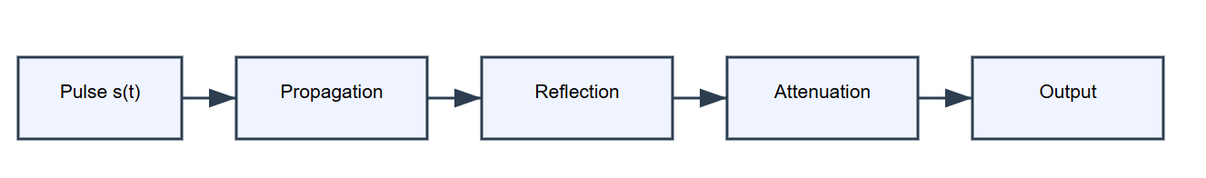
- Lateral sweep to generate B-scan

3.2 Transmitted Signal Model
Impulse GPR systems transmit short-duration electromagnetic pulses. In this study, the transmitted waveform is modeled using a Gaussian monocycle, which approximates practical antenna signals:
$$s\left(t\right)=\left(1 − \frac{\left(t − t_{0})^{2}\right.}{σ^{2}}\right)exp\left( − \frac{\left(t − t_{0})^{2}\right.}{2σ^{2}}\right)$$
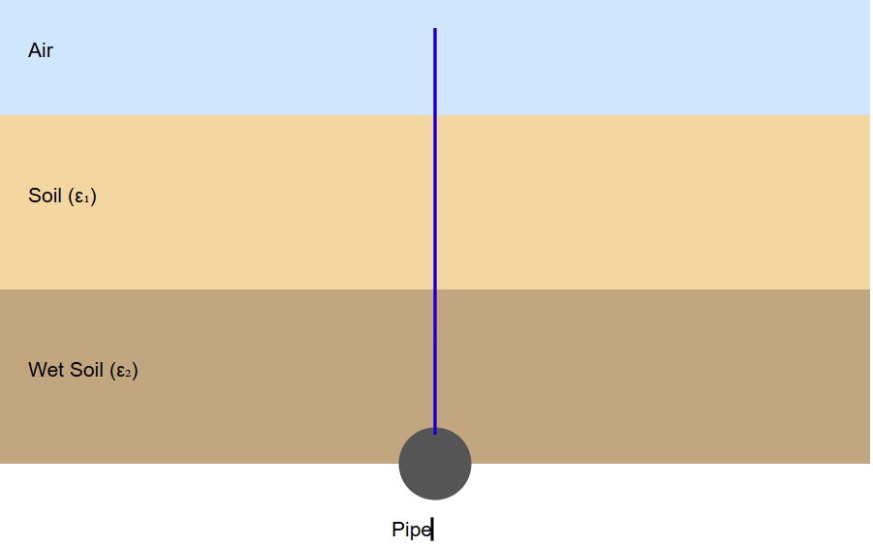
where $t_{0}$is the pulse center and $σ$controls pulse width (bandwidth).
This choice provides a compact time-domain signal with realistic spectral content for impulse radar.
3.3 Multilayer Propagation Model
The subsurface is modeled as $M$horizontal layers, each characterized by relative permittivity $ε_{r,i}$, conductivity $σ_{i}$, and thickness $d_{i}$.
3.3.1 Propagation Velocity
Wave velocity in each layer is:
$$v_{i}=\frac{c}{\sqrt{ε_{r,i}}}$$
where $c$is the speed of light in free space.
C is the speed of light in free space
$ε_{r,i }$is the relative permittivity of layer $i$
3.3.2 Two-Way Travel Time
For a reflection originating at depth across multiple layers, the two-way travel time is:
$$τ_{k}=2\sum_{i=1}^{M_{k}}{\frac{d_{i}}{v_{i}}}$$
where $M_{k}$is the number of layers traversed by the $k$-th reflection path.
$d_{i}$is the thickness of layer $i$

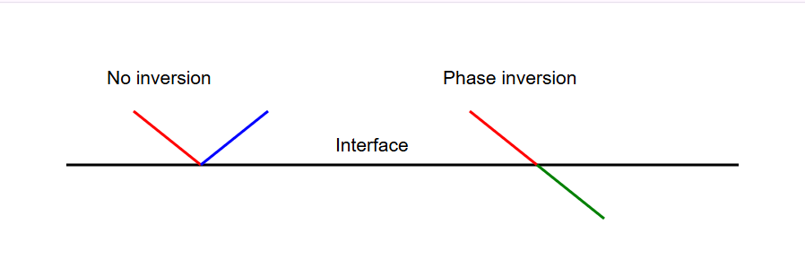

3.4 Reflection Model at Interfaces
Reflection arises due to impedance mismatch at boundaries, following boundary conditions derived from Field and Wave Electromagnetics.
3.4.1 Intrinsic Impedance
For non-magnetic media ($μ≈μ_{0}$):
$$η_{i}=\sqrt{\frac{μ}{ε_{i}}} ∝ \frac{1}{\sqrt{ε_{r,i}}}$$

3.4.2 Reflection Coefficient (Normal Incidence)
$$Γ_{i,i+1}=\frac{η_{i+1}-η_{i}}{η_{i+1}+η_{i}} = \frac{\sqrt{ε_{r,i}}-\sqrt{ε_{r,i+1}}}{\sqrt{ε_{r,i}}+\sqrt{ε_{r,i+1}}}$$
Physical interpretation:
- $∣Γ∣$controls reflection strength
- $Γ<0$implies 180° phase inversion
- $Γ>0$implies no inversion
3.5 Attenuation Model
Subsurface materials (especially wet or clayey soils) introduce attenuation. A path-dependent exponential model is used:
$$A_{k}=A_{0} Γ_{k} e^{-α_{k}L_{k}}$$
where:
- $A_{0}$is source amplitude
- $Γ_{k}$is the net reflection coefficient for the $k$-th interface
- $L_{k}$is total propagation distance (two-way)
- $α_{k}$is an effective attenuation coefficient for the traversed media
This captures frequency-averaged losses without requiring full dispersive modeling.
3.6 Signal Construction (Core Model)
The received signal is modeled as the superposition of reflections:
$$r(t)=\sum_{k=1}^{N}{A_{k}} s\left(t − τ_{k}\right)$$
where $N$is the number of contributing reflectors (interfaces/targets).
Key idea: Each interface contributes a time-delayed, amplitude-scaled replica of the transmitted pulse.
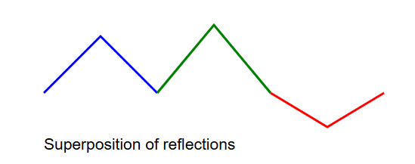
3.7 Phase Handling
Phase effects are incorporated implicitly through the sign of the reflection coefficient:
- If $Γ_{k}<0$→ polarity inversion (180° phase shift)
- If $Γ_{k}>0$→ no inversion
Thus, phase is represented without requiring complex-valued field solutions:
$$A_{k}=Γ_{k}e^{-α_{k}L_{k}}⇒\text{sign}(A_{k})\text{ encodes phase inversion}$$
This is consistent with time-domain GPR practice, where polarity of A-scan peaks is used to infer phase behavior.

3.8 B-scan Modeling (Spatial Variation)
To generate B-scans, the antenna position $x$is varied. For a point target at $\left(x_{0} , z_{0}\right)$, the two-way path length is:
$$L(x)=2\sqrt{\left(x-x_{0})^{2}+z_{0}^{2}\right.}$$

and the corresponding delay:
$$τ(x)=\frac{L(x)}{v_{\text{eff}}}$$
where $v_{\text{eff}}$is an effective velocity (or computed layer-wise). This produces the characteristic hyperbolic signature in radargrams.
3.8 B-scan Modeling (Spatial Variation)
To generate B-scans, the antenna position $x$is varied. For a point target at $\left(x_{0} , z_{0}\right)$, the two-way path length is:
$$L(x)=2\sqrt{\left(x-x_{0})^{2}+z_{0}^{2}\right.}$$
and the corresponding delay:
$$τ(x)=\frac{L(x)}{v_{\text{eff}}}$$
where $v_{\text{eff}}$is an effective velocity (or computed layer-wise). This produces the characteristic hyperbolic signature in radargrams.
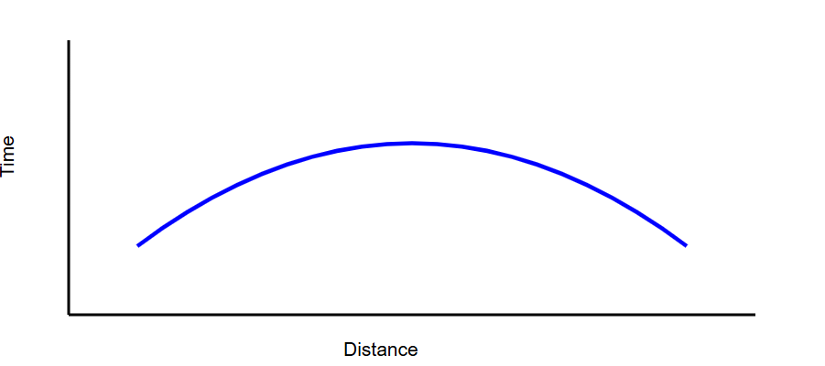
3.9 Implementation Plan (for Validation)
The analytical model is implemented in Python as a validation platform (not the primary contribution).
Inputs
- Layer properties: $ε_{r,i},σ_{i},d_{i}$
- Target parameters: depth $z$, lateral position $x_{0}$
- Pulse parameters: $σ,t_{0}$
Processing
- Compute $v_{i}$for each layer
- Compute $τ_{k}$for each reflector
- Compute $Γ_{k}$and attenuation $A_{k}$
- Construct $r(t)$via superposition
- Sweep $x$to build B-scan
Outputs
- A-scan: amplitude vs time
- B-scan: amplitude vs (time, position)
3.10 Validation Strategy
Validation is conducted in three stages:
- Theoretical consistency
  - Depth ↑ → delay ↑
  - $ε_{r}$↑ → velocity ↓ → delay ↑
  - higher loss → amplitude ↓

- Comparative trends
  - Compare behavior with known GPR responses and published results
  - (Optional) compare trends with FDTD-based tools (e.g., gprMax)
- Scenario-based analysis
  - Multilayer cases (dry/wet soil)
  - Point targets (hyperbola formation)
  - Sensitivity to parameters ($ε_{r},d_{i},z$
3.11 Assumptions and Limitations
- Normal incidence approximation
- Horizontally layered media
- Effective attenuation (no full dispersion modeling)
- No detailed antenna coupling or 3D scattering
- Metal layers act as strong reflectors (limited transmission beyond)
These assumptions are appropriate for fast, interpretable signal-level modeling, while acknowledging differences from full-wave solvers.

